MINUTES
Development Assessment Committee Meeting
Wednesday, 16 December 2020
Time: | 6.00pm
Location: | The Pavilion Room, Darley Civic Hub

Order Of Business
1 Opening 3
2 Present and Apologies 3
3 Recording of Meeting 3
4 Confirmation of Minutes 3
5 Matters Arising from Previous Minutes 4
6 Disclosure of Conflicts of Interests 4
7 Community Planning Reports 5
7.1 PA2019156 - 2 Lot Subdivision (house lot excision) at 70 Dunbar Road, Pentland Hills 5
7.2 PA2019207 - Development of a Replacement Place of Assembly (Scout Hall), Alter Access to RDZ1 and Removal of Vegetation (10 Trees) at 60 Inglis Street, Ballan 19
7.3 PA2020038 - Five shops and a Medical Centre at Halletts Village, Halletts Way, Darley 33
7.4 PA2020023 - Use of land for a Poultry Farm (egg production) and the development of Two Farm Sheds at 137 Woolpack Road, Maddingley 47
7.5 PA2020076 - Development and Use of a Dwelling and Ancillary Shed in association with a Farm Management Plan at Ti Tree Road, Dunnstown 60
7.7 PA2020136 - Development of an Outbuilding and Water Tank Ancillary to an Existing Dwelling at 19 Faheys Road, Gordon 77
7.8 PA2020124 - Use of the land for a Tradesperson Depot at 15 Eden Crescent, Hopetoun Park 89
7.6 PA2019216 - Development of Three Offices and One Dwelling, Use and Development of Two Dwellings and a Reduction of Car Parking (12 Spaces) at 148C and 150 Inglis Street, Ballan 101
8 Update on Trends, Issues and Other Matters 119
9 Process Forward and Work Program 119
10 Update on VCAT Decisions 119
11 Other Business 119
12 Date of Next Meeting 119
13 Meeting Close 119

1 Opening
The Mayor opened the meeting at 6.00pm

2 Present and Apologies
Cr Tom Sullivan, Mayor West Moorabool Ward
Cr Rod Ward, Deputy Mayor East Moorabool Ward
Cr Moira Berry East Moorabool Ward
Cr Tonia Dudzik East Moorabool Ward
Cr David Edwards East Moorabool Ward
Cr Ally Munari Woodlands Ward
Cr Paul Tatchell Central Moorabool Ward

Officers:
Mr Derek Madden Chief Executive Officer
Mr Henry Bezuidenhout Executive Manager Community Planning & Economic Development
Mr Rob Fillisch Manager Statutory Planning & Building Services
Ms Yvonne Hansen Manager Governance, Risk & Corporate Planning
Mr Mark Lovell Coordinator Statutory Planning

APOLOGIES:
Nil.

3 Recording of Meeting
The Mayor advised that the meeting is being livestreamed via Council’s website.

4 Confirmation of Minutes
Committee Resolution
Moved: Cr Tonia Dudzik
Seconded: Cr David Edwards
That the minutes of the Development Assessment Committee Meeting held on Wednesday 16 September 2020 be confirmed.
Carried

5 Matters Arising from Previous Minutes
Nil.

6 Disclosure of Conflicts of Interests
Cr Tom Sullivan declared a general Conflict of Interest in Item 7.1 due to acting for the applicant in his capacity as a Surveyor.

PRESENTATIONS AND DEPUTATIONS
Item | Community Planning and Economic Development | Speaker/s | Position
7.2 | PA2019207 - Development of a Replacement Place of Assembly (Scout Hall), Alter Access to RDZ1 and Removal of Vegetation (10 Trees) at 60 Inglis Street, Ballan | Mr. and Mrs. Anton and Kirsten Jeandet | Objectors
7.2 | PA2019207 - Development of a Replacement Place of Assembly (Scout Hall), Alter Access to RDZ1 and Removal of Vegetation (10 Trees) at 60 Inglis Street, Ballan | Mr. John Fish | Objector
7.3 | PA2020038 - Five shops and a Medical Centre at Halletts Village, Halletts Way, Darley | Mr. David Djordjevich and Mr. Brian Pol | Applicants
7.3 | PA2020038 - Five shops and a Medical Centre at Halletts Village, Halletts Way, Darley | Mr. David Spiteri | Objector
7.4 | PA2020023 - Use of land for a Poultry Farm (egg production) and the development of Two Farm Sheds at 137 Woolpack Road, Maddingley | Mr. Cameron Dawson | Applicant
7.5 | PA2020076 - Development and Use of a Dwelling and Ancillary Shed in association with a Farm Management Plan at Ti Tree Road, Dunnstown | Mr. Neil Haydon | Applicant’s Representative
7.6 | PA2019216 - Development of Three Offices and One Dwelling, Use and Development of Two Dwellings and a Reduction of Car Parking (12 Spaces) at 148C and 150 Inglis Street, Ballan | Mr. Merv Bartleman | Owner’s Representative
7.6 | PA2019216 - Development of Three Offices and One Dwelling, Use and Development of Two Dwellings and a Reduction of Car Parking (12 Spaces) at 148C and 150 Inglis Street, Ballan | Mr. John Kowarsky | Objector

Having declared a General Conflict of Interest in Item 7.1, Cr Tom Sullivan vacated the Chair and left the meeting at 6.01pm, prior to the discussion of this Item.
The Deputy Mayor, Cr Rod Ward, assumed the Chair.

7 Community Planning Reports

7.1 PA2019156 - 2 Lot Subdivision (house lot excision) at 70 Dunbar Road, Pentland Hills
Author: Victoria Mack, Statutory Planner
Authoriser: Henry Bezuidenhout, Executive Manager Community Planning & Economic Development
Attachments: 1. Proposed plan of subdivision (house lot excision) (under separate cover)

Application Summary
Permit No: PA2019156
Lodgement Date: 9 July 2019
Planning Officer: Victoria Mack
Address of the land: 70 Dunbar Road, Pentland Hills 3341
Proposal: 2 Lot Subdivision (House lot excision)
Lot size: 18.20ha
Why is a permit required? Clause 35.07-3 Subdivide land (House lot excision)

Committee Resolution
Moved: Cr Tonia Dudzik
Seconded: Cr Paul Tatchell
That Council, at the request of the applicant, defer the matter to the next Development Assessment Committee meeting.
Carried

Public Consultation
Was the application advertised? | Yes
Notices on site: | Yes
Notice in Moorabool Newspaper: | No.
Number of objections: | Three objections
Consultation meeting: | Not held.

Policy Implications
The Council Plan 2017-2021 provides as follows:
Strategic Objective 2: Minimising Environmental Impact
Context 3A: Land Use Planning
The proposal to subdivide the land (house lot excision) is consistent with the Council Plan 2017 – 2021.

Victorian Charter of Human Rights & Responsibilities Act 2006
In developing this report to Council, the officer considered whether the subject matter raised any human rights issues. In particular, whether the scope of any human right established by the Victorian Charter of Human Rights and Responsibilities is in any way limited, restricted or interfered with by the recommendations contained in the report. It is considered that the subject matter does not raise any human rights issues.

Officer’s Declaration of Conflict of Interests
Under section 130 of the Local Government Act 2020, officers providing advice to Council must disclose any interests, including the type of interest.
General Manager – Henry Bezuidenhout
In providing this advice to Council as the Executive Manager, I have no interests to disclose in this report.
Author – Victoria Mack
In providing this advice to Council as the Author, I have no interests to disclose in this report.

Executive Summary
Application referred? | Melbourne Water and Council’s Environmental Health and Infrastructure Departments.
Any issues raised in referral responses? | No.
Preliminary concerns? | The location of existing dwelling creates an irregular shaped lot in the centre of the property accessed via a long driveway which bisects the land.
Any discussions with applicant regarding concerns? | No.
Any changes made to the application since being lodged? | The proposed lot with the existing dwelling was increased in area from 1.40ha to 1.52ha.
Brief history. | The owners have lived on the subject property for many years. They currently breed dogs on the property, predominantly Welsh Corgis, and have run cattle on the property. They have advised that remaining in the existing dwelling on a smaller land parcel best meets their retirement needs.
Previous applications for the site? | Nil.
General summary. | The proposed house lot excision creates a vacant lot of 16.68ha and a house lot of 1.52ha. Because the dwelling is in the centre of the site, accessed via a long driveway from the north-east corner, the proposed excision dissects the land into two awkward shaped parcels.  The owners also wish to retain access to the dam on the property in the north-west corner of the site and to enable this a water supply easement to the dam has been added to the Plan of Subdivision.  It is not considered that this proposal is an orderly planning outcome for this land.
Summary Recommendation
That Council, having considered all matters as prescribed by the Planning and Environment Act 1987, issue a refusal to grant a permit for a two-lot subdivision (house lot excision) on Lot 7 on TP 000918E otherwise known as 70 Dunbar Road, Pentland Hills.

Site Description
The land is undulating with the existing dwelling located in the centre of the property on an elevated part of the site with prominent views of the surrounding area, particularly to the east. The land generally slopes away from the house site to the west, south and east. To the north the land contains the driveway to Dunbar Road and is generally flat. The driveway is currently fenced on both sides. It is assumed that the current fences accord with the proposed subdivision boundaries.
The Myrniong Creek runs along the whole of the south boundary. The land slopes sharply to the creek with the escarpment width being approximately 100m. This sloped area has scattered vegetation. A tributary of the Myrniong Creek also dissects the north-west corner of the site. There is a dam on this waterway with a surface area of approximately 800sq m. The current owner wishes to retain access to this dam for domestic water supply purposes.
Surrounding land to the south is also steeply dissected and includes a floodplain at the bottom of the escarpment. Further to the south is the Werribee River. Land to the west, north and east is generally grazing land. Land on the north side boundary of the site has been significantly revegetated.
There is another small dam on the site located half-way along, and close to, the west side boundary.
There are trees around the dwelling site, but the balance of the land is pastured land without any plantations or paddock trees.
The single storey dwelling is older in style with several sheds and dog runs to the side and rear of the dwelling. The effluent field is located to the north of the dwelling within the proposed lot 1.
The site has historically been used for grazing cattle. There are cattle yards on the property located near the front entrance at Dunbar Road.
An aerial photograph of the site is shown below.

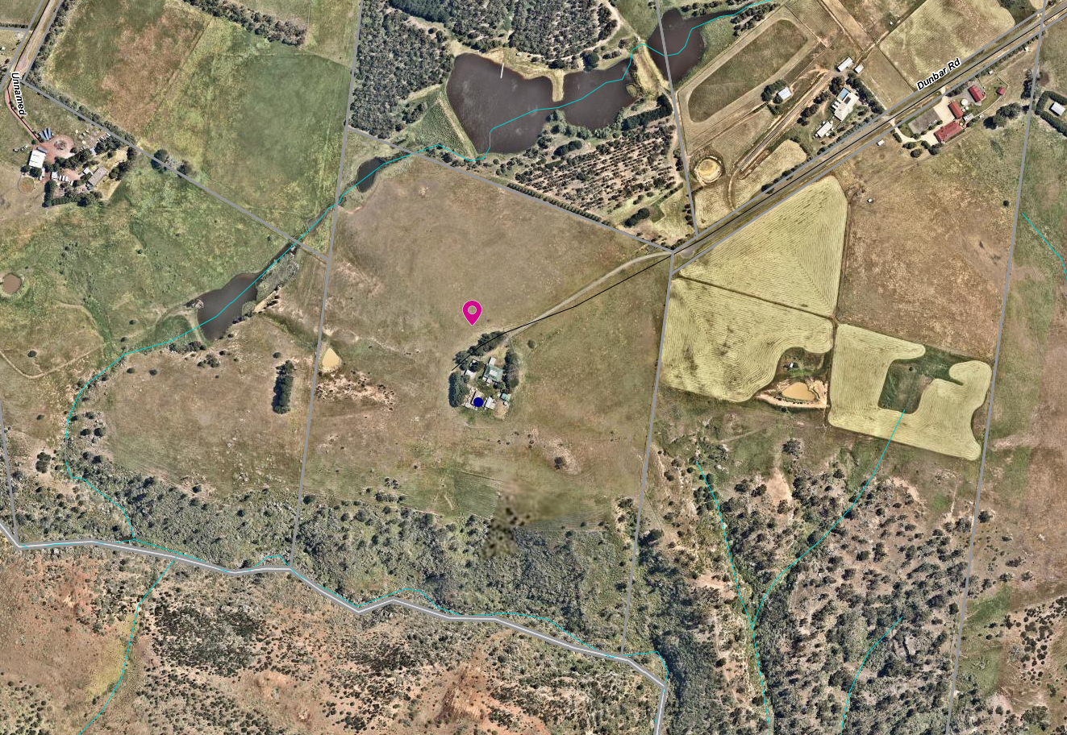
Figure 1: Aerial map

Proposal
It is proposed to subdivide the land into two lots. Under Clause 35.07-3 of the Farming Zone an application can be made for a two-lot subdivision to create a lot for an existing dwelling.
Lot 1 would be 1.52ha and would contain the dwelling, sundry sheds and the driveway to Dunbar Road. The lot would be irregular in shape with a narrow strip of land containing the driveway and then a roughly circular area around the dwelling and sheds.
Lot 2 would be approximately 16.68ha (by deduction) and would contain two dams and the cattle yards. The yards are located close to the entrance of the property at Dunbar Road.
A water supply easement from the dam in the north-east corner of the site is also proposed to supply the dwelling and for domestic purposes.
The proposed Lot 1 is not currently fenced to the proposed new boundary around the dwelling, but the driveway is fenced. It is assumed that the driveway fencing accords with the proposed driveway boundary.
The proposed plan of subdivision is included as an attachment to this report and also below).

fi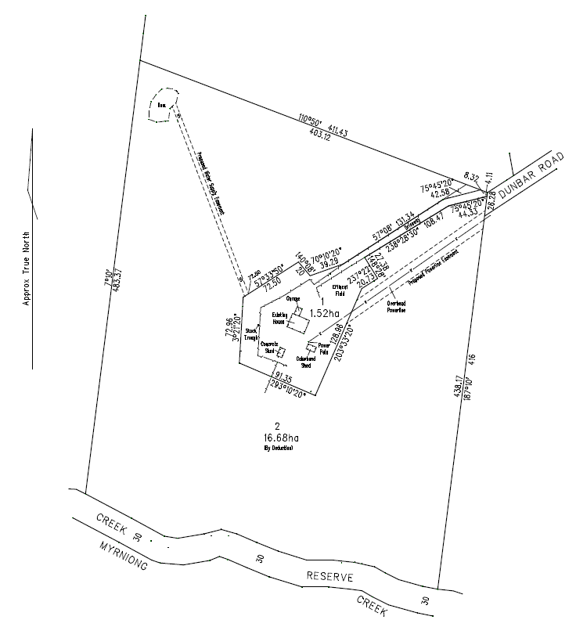
Figure 2: plan of subdivision

Background to Current Proposal
At a meeting with the owner at the Council office he requested that a Section 173 Agreement is not applied to any future permit to restrict a dwelling on Lot 2. He felt that the larger lot would make a very suitable site for another dwelling as a lifestyle choice. He said that the land cannot be cropped and should only be lightly grazed due it being in a low rainfall area (rain shadow), and that the property was not suitable for highly productive agriculture.

History
A search of Council records revealed that no permits have been issued on the subject site. There are no compliance issues relevant to the site.

RESTRICTIVE COVENANT
There is a covenant registered on the title with number Y000705A dated 19 December 1975. It was applied as part of a subdivision of the land in this area at that time. The covenant restricts various development matters relating to the design, siting and materials to be used for dwellings. It also prohibits the use of the land for pig and poultry farming and boarding kennels.

Public Notice
The application was notified to adjoining and surrounding landowners. Three objections were received.

Summary of Objections
The objections received are detailed below with officer’s comments accompanying them:
Objection | Any Relevant Requirement
The covenants on these lots prohibit subdivision and various farm industries. Yet dog breeding has been allowed by Council which many locals are not happy with it. | Covenant number Y000705A
Officer’s Response: The covenant does not restrict subdivision. It does restrict a boarding kennel; however, dog breeding is not a boarding kennel and is not prevented by the covenant.
The development of a second dwelling on the land following the subdivision would set a precedent for future subdivision and such development in this area would detrimentally affect the landscape values.
Officer’s Response: The application is for subdivision. No dwellings are being applied for.
The subdivision meets the “material detriment” definition and is likely to have an adverse impact on the enjoyment of our property. We share a 400m boundary (north) with the site and have planted 18,000 native and indigenous plants which demonstrates that degraded land can be returned to its natural state. This is compared to the broad scale destruction of land in the surrounding area. Council should ensure the exploitation of land ceases and set an example of how land should be managed in a sustainable manner.  Reducing the size of landholder allotments can only lead to further degradation of the land and negative environmental impact from excess stock loads, additional buildings and houses and increased demands on water supply. | State and local planning policies
Officer’s Response: This concern is addressed further in this report.
The proposed subdivision will have a negative environmental impact on the flora and fauna that rely on the Myrniong Creek and at least one of its tributaries. | State and local policies
Officer’s Response: This concern is addressed further in this report.
The Palmer’s Road area is dominated by 40+ acre properties, most well established. Subdivisions of this nature are inconsistent with the precinct’s agricultural landscape. | Farming Zone subdivision
Officer’s Response: This concern is addressed further in this report.
If a new vacant lot is created, it will lead to another dwelling and sheds being constructed increasing dwelling density in this area. | State and local policies; rural growth policy
Officer’s Response: This concern is addressed further in this report.
If this proposal is approved, it will set a precedent and others may use such decision to subdivide in the future. | Farming Zone
Officer’s Response: This concern is addressed further in this report.
I have no objection to the subdivision provided a condition of the permit is that no dwellings/sheds are permitted, and the agricultural use continues. | Section 173 of the Planning and Environment Act 1987
Officer’s Response: An option would be to recommend approval subject to a Section 173 Agreement to be registered on title preventing the development of a dwelling on the vacant Lot 2. This is addressed further in this report.

Locality Map
The map below indicates the location of the subject site and the zoning of the surrounding area.
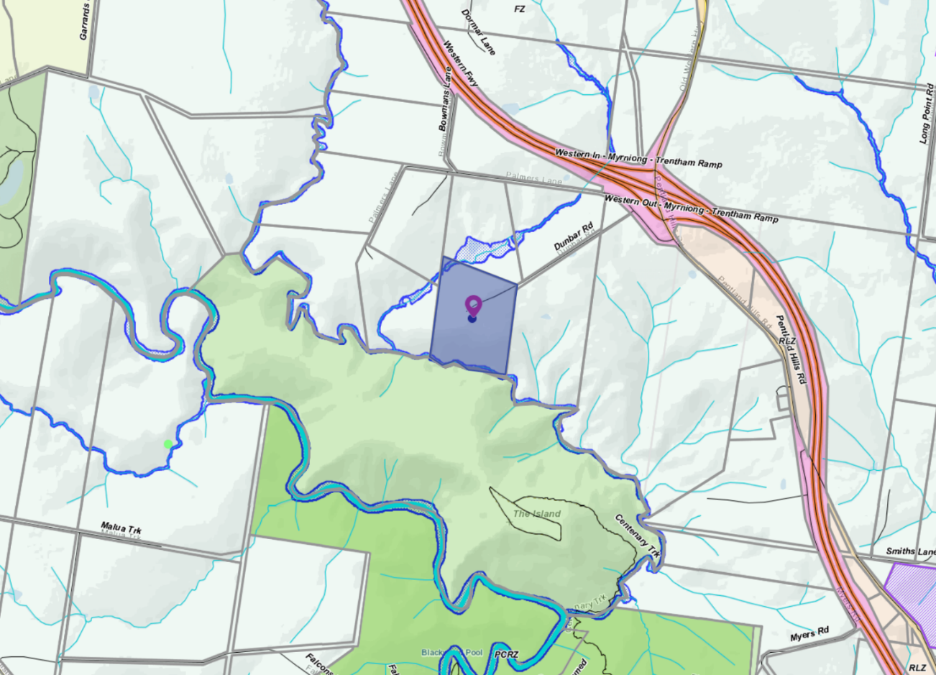
Figure 3: Zone map

Planning Scheme Provisions
Council is required to consider the Victoria Planning Provisions and give particular attention to the State Planning Policy Framework (SPPF), the Local Planning Policy Framework (LPPF) and the Municipal Strategic Statement (MSS).
The relevant clauses are:
• Clause 11.03-3S - Peri-urban areas
• Clause 12.03-1S - River corridors, waterways, lakes and wetlands
• Clause 14.01-1S - Protection of agricultural land
• Clause 15.01-6S - Design for rural areas
• Clause 16.01-5S - Rural residential development
• Clause 21.03-6 - Objective - Rural lifestyle opportunities
The proposal complies with the relevant sections of the PPF and LPPF, with the exception of the clauses outlined in the table below:
PPF | Title | Response
Clause 14.01-1S | Protection of Agricultural Land | A strategy of this clause is to limit new housing development in rural areas by discouraging development of isolated small lots in the rural zone from use for dwellings or other incompatible uses. The proposal is a small lot subdivision on farming zone land with the resultant balance lot further fragmented and further limiting its agricultural productivity.
Clause 12.03-1S 31 | River corridors, waterways, lakes and wetlands | The objective of this policy is to protect and enhance river corridors, waterways, lakes and wetlands by ensuring that development responds to and respects the significant environmental, conservation, cultural, aesthetic, open space, recreation and tourism assets of water bodies and wetlands.  Intensification of development in this area would potential have a detrimental impact on the environmental values of the precinct over time.
Clause 16.01-5S | Rural residential development | This policy aims to discourage development of small lots in rural zones for residential use or other incompatible uses.
LPPF | Title | Response
Clause 21.03-6 | Objective—Rural lifestyle opportunities | Strategy: Prevent the fragmentation of farm land through inappropriate subdivisions.
Clause 22.03 | House and House Lot Excisions in Rural Areas | See details of this policy below.
Clause 22.03 House and House Lot Excisions in Rural Areas

The objectives of this clause are:

• To ensure that subdivision and dwellings in rural areas are required to increase agricultural productivity.
• To minimise the potential for adverse impacts on farm production through land use conflicts.
Policy
It is policy to:
• Discourage subdivision and dwellings unless they are directly related to the agricultural use of land.
• Discourage non-agricultural use and development in areas of productive agricultural land. Encourage the consolidation of small lots.
• Ensure that lots created under Clause 35.07-3 have a maximum area of 2ha.
• Maintain the right of existing farms to continue their operations without being adversely affected or constrained by residential concerns.
• Include the following requirements on a permit to excise a lot for a dwelling where it is considered this would facilitate ongoing agricultural use of the remaining land:
• Consolidate of the remaining land with the title of an existing farm; or
• If the remainder land is less than 40ha, require the landowner to enter into an agreement under S173 of the Planning and Environment Act that no further applications will be made to erect a dwelling on the balance allotment.
Comment: The proposed Lot 1 would contain the existing dwelling on a lot of less than 2ha. However, its shape and location would fragment the balance of the land. The dwelling would become a lifestyle lot. Such fragmentation of agricultural land should not be supported.
This application is not an orderly planning outcome for the area

Zone
Farming Zone
In accordance with Clause 35.07-3 of the Moorabool Planning Scheme a permit is required to subdivide land. Each lot must be at least the area specified for the land in a schedule to this zone which in the Moorabool Planning Scheme specifies in this locality each lot must be 100ha.
However, this clause also states that a permit may be granted to create smaller lots if:
• The subdivision is to create a lot for an existing dwelling. The subdivision must be a two-lot subdivision.
The purpose of the zone is to:
• Implement the Municipal Planning Strategy and the Planning Policy Framework.
• Provide for the use of land for agriculture.
• Encourage the retention of productive agricultural land.
• Ensure that non-agricultural uses, including dwellings, do not adversely affect the use of land for agriculture.
• Encourage the retention of employment and population to support rural communities.
• Encourage use and development of land based on comprehensive and sustainable land management practices and infrastructure provisions.

The proposal is a 2 Lot subdivision with one lot containing an existing dwelling.

The proposal is inconsistent with the purposes of the zone as the proposal is unable to demonstrate an outcome that will result in sustainable farming and land management practices and the proposal potentially would adversely affect the use of the balance of the land for agriculture.

Overlays
Environmental Significance Overlay (ESO3)
The purpose of the ESO is to:
• Implement the Municipal Planning Strategy and the Planning Policy Framework.
• Identify areas where the development of land may be affected by environmental constraints.
• Ensure that development is compatible with identified environmental values.
Schedule 3, Environmental Significance Overlay - Long Forest and Werribee Gorge
In accordance with Schedule 3 to the Environmental Significance Overlay a permit is not required under the schedule as no vegetation would be impacted or removed by the proposed subdivision.
Design and Development Overlay and Schedule 2 (DDO2)
In accordance with Schedule 2 to the Design and Development Overlay a permit is not required to subdivide land under this overlay.

RELEVANT POLICIES
Council’s Rural Housing Policy Statement
Council’s Rural Housing Policy Statement was adopted by Council on 19 September 2012. The document applies to all land in Farming Zone under the Moorabool Planning Scheme.
The policy intent is to:
• Encourage dwellings in areas nominated in Map 1 of Council Rural Growth Policy Statement.
• Ensure the siting of any dwellings is designed to have a minimal impact on any existing or future agricultural activities on the site and on surrounding.
• Ensure it is clear whether the dwelling is required for agricultural operation use or to maintain rural communities.
• Ensure sufficient infrastructure is available or that alternative methods are available which do not require normal infrastructure.
• Encourage development of dwellings to support communities on land which is unlikely to support agricultural activity while still considering any other overlays which may impact the land. This is land which is constrained for use as agriculture by other environment factors such as vegetation, slope, soil quality, etc.
• Ensure any subdivision is undertaken in accordance with the scheme in order to discourage fragmentation of agricultural land.
It is considered that the proposed subdivision would further fragment agricultural land.
Council’s Rural Growth Policy statement - 19 September 2012
Council’s Rural Growth Policy has been developed to provide direction for how limited farming potential rural dwellings should be considered, and more broadly, rural settlement patterns. The policy seeks to articulate support for resilient and integrated rural communities and agricultural enterprises, recognising that ‘State Government Planning Policy Framework does not adequately recognise or support agriculture trends and rural settlements in the Moorabool Shire’.
The principles of the policy relevant to this application include:
• support the agriculture sector so that it can be more productive, diverse, resilient and adaptive to changing agricultural trends, including supporting agricultural activities that recognise Moorabool’s advantageous proximity to market;
• protect agricultural land use from loss and allow development that increases agricultural productivity;
• focus growth opportunities in settlements along major transport corridors, in particular where there is physical and social infrastructure and services;
• recognise that there are substantial existing lots under 40 hectares capable of supporting the viable operation of agricultural enterprises;
• promote a rural housing market that meets the needs of the Shire’s rural communities; and
• land parcels for the proposed on farm living dwellings are to have a minimum lot size of 8 hectares as identified in Map 1.
The proposed subdivision is not generally aligned with the above principles of the policy and is furthermore considered to detract from the agricultural productivity of the land.

Particular Provisions
Clause 53.10 Public Open Space Contribution and Subdivision
A person who proposes to subdivide land must make a contribution to the council for public open space in an amount specified in the schedule to this clause (being a percentage of the land intended to be used for residential, industrial or commercial purposes, or a percentage of the site value of such land, or a combination of both). If no amount is specified, a contribution for public open space may still be required under section 18 of the Subdivision Act 1988.
An open space fee can be applied under Section 18(8)(c) of the Subdivision Act for a two-lot subdivision that is likely to be further subdivided.
Comment: As neither lot could be subdivided under the Moorabool Planning Scheme there is no requirement for a public open space contribution.

Discussion
Subdivision design
The proposed subdivision results in a highly irregular shaped Lot 1 which would contain the existing dwelling and sheds. The lot does not have the advantage of direct street access, resulting in a long driveway being required to the dwelling. This design effectively cuts the north-eastern end of the land in two as the driveway is fenced. The owners also want to retain access to the waterway and dam in the north-east corner using existing pipe infrastructure. A water supply easement would therefore be required to cross Lot 2.
The subdivision design has been influenced by the existing dwelling location. It represents a poor longer-term planning outcome.
The surrounding areas reflects a subdivision which was registered in 1975. It appears that there were 8-10 lots in the subdivision each with an area of approximately 20ha which includes a covenant relating to dwelling design and siting issues and also the prohibition of three uses being pig and poultry farming or the operation of a boarding kennel.
In considering that the land is zoned for farming, further dwelling intensification on the balance Lot 2 with an area of 16.68ha would be inappropriate in this location. It is considered that the subdivision would adversely fragment the agricultural land, and potentially create future land use conflicts between neighbouring agricultural activities and a rural residential allotment.
The creation of the vacant 16.68ha lot does not comply with the Farming Zone provisions which seeks to encourage the retention of productive agricultural land. The owner has stated that the land is affected by the Pentland Hills rainfall shadow and is therefore not highly productive grazing land. However, State and local planning policies do not support the creation of lots in the Farming Zone for rural residential or lifestyle uses.
It is considered that the subdivision of the land would create a parcel that would be unviable unless sold to a neighbour for expansion of the neighbour’s holding. The applicant has not provided a farm management plan associated with this subdivision or justification for the ongoing use of the vacant lot. The subdivision arrangement is considered to adversely fragment the agricultural land to an unsustainable level.
Objectors generally felt that this proposal was inappropriate for the land and the wider area. They were concerned about a precedent being created where others could also apply to excise their dwellings. This raised wider concerns about sustainable land management and environmental impact particularly in relation to the waterways as well as the land itself.
It is understood that land in the Pentlands Hills is relatively fragile due to the lower rainfall and lighter and more erodible soils. Such land needs to be managed carefully and not overstocked. It is noted that no native vegetation planting has occurred on the site.
Objector concerns could be addressed by a Section 173 Agreement to prevent a future dwelling or any further subdivision of the land, however, it is considered that the creation of Lot 1 is a poor planning outcome and should not be supported.
Objectors also expressed concern, if the subdivision was approved, that other landholders within the same subdivision could apply for a similar house lot excision. It is noted that each planning application must be assessed on own its individual merit and if such applications were received then a similar assessment would be made against Council policies and the policies contained in the Moorabool Planning Scheme.

Servicing
As this is a two-lot subdivision, all servicing authorities would be notified during the certification stage in accordance with Clause 66.01 and the three mandatory conditions can be included if a permit was to issue. The mandatory telecommunication conditions under Clause 66.01-1 do not apply to subdivide land in a rural zone.

General Provisions
Clause 65 – Decision Guidelines have been considered by officers in evaluating this application.
Clause 66 – Stipulates all the relevant referral authorities to which the application must be referred.

Referrals
Authority | Response
Melbourne Water | Consent with conditions.
Infrastructure  Environmental Health | Consent with conditions.  Consent with conditions.

Financial Implications
There is no financial implication associated with this refusal to grant a permit.

Risk & Occupational Health & Safety Issues
The recommendation of refusal of the planning application does present any OH&S issues to Council.

Communications Strategy
Notice was undertaken for the application, in accordance with s.52 of the Planning and Environment Act 1987, and further correspondence is required to all interested parties to the application as a result of a decision in this matter. All submitters and the applicant were invited to attend this meeting and invited to address Council if required.

Options
Council could consider the following options:
• issue a refusal to grant a permit in accordance with the recommendations of this report; or
• issue a permit with conditions outside of the recommendations of this report.

Conclusion
The proposed subdivision of the land into two lots with one containing an existing dwelling and the other to remain vacant is considered inconsistent with the planning provisions and the State and Local Planning Policy Framework.
The house lot is awkwardly shaped which would result in permanent fragmentation of the balance of the agricultural land. It provides an unacceptable subdivision layout.
The proposal is also considered inconsistent with the objectives of the Farming Zone.
While objector concerns could be addressed by permit conditions including that a restriction is registered on the title of the vacant lot to prohibit a future dwelling, the proposal does not address the fundamental concern that creating a small lot in the Farming Zone will not encourage the sustainable agricultural use of the land, not protect the areas environmental and landscape values.
The proposed subdivision of land into two lots is not recommended for the reasons outlined in this report.

Cr Sullivan returned to the meeting at 6.02pm.

Mr. and Mrs. Anton and Kirsten Jeandet addressed Council as objectors to the recommendation for Item 7.2.

Mr. John Fish addressed Council as an objector to the recommendation for Item 7.2.

7.2 PA2019207 - Development of a Replacement Place of Assembly (Scout Hall), Alter Access to RDZ1 and Removal of Vegetation (10 Trees) at 60 Inglis Street, Ballan
Author: Mark Lovell, Coordinator Statutory Planning
Authoriser: Henry Bezuidenhout, Executive Manager Community Planning & Economic Development
Attachments: 1. Landscape Plan (under separate cover)

Application Summary
Permit No: PA2019207
Lodgement Date: 26 August 2019
Planning Officer: Mark Lovell
Address of the land: 60 Inglis Street, Ballan
Proposal: Development of a Replacement Place of Assembly (Scout Hall), Alter Access to RDZ1 and Removal of Vegetation (10 Trees)
Lot size: 3144sqm
Why is a permit required? Clause 32.08-9 Construct a building (Scout Hall) for a use in Section 2 (Place of Assembly) in the General Residential Zone Schedule 4.
Clause 42.01-2 Construct a building (Scout Hall) in the Environmental Significance Overlay Schedule 1.
Clause 42.01-2 Remove vegetation (10 trees) in the Environmental Significance Overlay Schedule 1.
Clause 52.27 Alter access to a Road Zone, Category 1

Recommendation
That Council, having considered all matters as prescribed by the Planning and Environment Act 1987, issues a Notice of Decision to Grant a Planning Permit for the Development of a Replacement Place of Assembly (Scout Hall) and Removal of Vegetation (10 trees) subject to the following conditions:
Endorsed Plans:
1. Before the use development starts, amended plans to the satisfaction of the Responsible Authority must be submitted to and approved by the Responsible Authority. When approved, the plans will be endorsed and will then form part of the permit. The plans must be drawn to scale with dimensions and three copies must be provided. The plans must be generally in accordance with the plans submitted with the application or some other specified plans but modified to show:
(a) Vertical cladding and any fascia’s and downpipes on the south elevation upper skillion/clerestorey to be of a light colour in matte appearance.
(b) Lighting along the internal driveway and carparking with minimum one light on each northern and southern corner of the eastern wall of the hall. Any lighting that is mounted on a wall higher than an opposite fence must be appropriately baffled to mitigate light spill across boundaries.
(c) Location of any external flood lighting on site and elevation plans. Any external flood lighting must be appropriately baffled to avoid light spill across boundaries.
(d) Bicycle facilities provided on site specifying a minimum of two bicycle spaces consistent with Clause 52.34-6, and signage consistent with Clause 52.34-7 unless all bicycle spaces are readily visible and accessible from the street.
(e) Landscape Plan amended to include additional trees within the grass mound fronting Inglis Street and additional native screen trees with a maturity height of at least 3m to be placed in the north-west corner of the building and the western property boundary adjacent to the rear car park.

  - New side fencing as shown on the landscape plan to continue for the full length to the rear property boundary and to be a timber paling fence, minimum 2.0m in height.
Unless otherwise approved in writing by the Responsible Authority, all buildings and works are to be constructed and or undertaken in accordance with the endorsed plans to the satisfaction of the Responsible Authority prior to the commencement of the use.
Materials:
2. All external walls and roof areas of the proposed building/s are to be clad with non-reflective materials (zincalume prohibited) to the satisfaction of the Responsible Authority.
Infrastructure:
3. Prior to the use commencing, the existing crossover on Inglis Street must be altered to urban industrial standard to the satisfaction of the Responsible Authority. A vehicle crossing permit must be taken out for the construction of the vehicle crossing.
4. Prior to the development and use commencing, engineering drainage plans and computations must be submitted to the Responsible Authority for approval and shall incorporate the following:
(a) The development as a whole must be self draining and must be connected to an approved point of discharge in an approved manner to the satisfaction of the Responsible Authority.
(b) Underground piped drainage for the whole development shall cater for 10% AEP storm.
(c) Overland 1% AEP flow path(s) for the development must be shown on layout plans and shall ensure that no property is subject to inundation by such a storm to the satisfaction of the Responsible Authority.
5. Storm water drainage from the proposed buildings and impervious surfaces must be directed to the legal point of discharge to the satisfaction of the Responsible Authority. Stormwater Point of Discharge permit must be obtained from the Responsible Authority prior to the commencement of the works associated with the permit.
6. Prior to the commencement of the development and post completion, notification including photographic evidence must be sent to Council’s Asset Services department identifying any existing damage to council assets. Any existing works affected by the development must be fully reinstated at no cost to and to the satisfaction of the Responsible Authority.
7. Prior to the use commencing, the car park areas must be constructed with a sealed surface, line-marking and drainage to the satisfaction of the responsible authority, and shall incorporate the following:
(a) Parking bays and aisle widths of the car park shall comply with Australian Standard AS 2890.1:2004 Off-Street car parking. Disabled Parking bays shall comply with Australian Standard AS2890.1:2009 Off-Street Parking for People with Disabilities.
(b) Designated loading areas shall be shown on layout plans.
(c) The parking areas shall be provided with an asphalt or concrete surface and associated drainage.
(d) Concrete kerb of a minimum height of 150mm must be provided between landscaped areas and areas provided for parking and the passage of vehicles.
(e) The car park must provide sufficient space for a service truck to enter and exit the site in a forward direction. The service truck shall comply with the medium rigid vehicle detailed in AS2890.2 section 2.2. Turning templates shall be submitted for approval.
8. The building shall be provided with disabled access in accordance with the provisions of AS1428 – Design for Access and Mobility.
Southern Rural Water:
9. The development must be connected to the reticulated sewerage system and stormwater infrastructure.
10. The owner of the land must enter into an agreement with the Relevant Authority for the provision of water in accordance with the authority’s requirements and relevant legislation.
Permit Expiry:
11. This permit will expire if one of the following circumstances applies:
(a) The development is not started within two years of the date of this permit;
(b) The development is not completed within four years of the date of this permit.

Public Consultation
Was the application advertised? | Yes.
Notices on site: | Yes.
Notice in Moorabool Newspaper: | No.
Number of objections: | Five.
Consultation meeting: | Yes. Online videoconference was a held between applicant, objectors and Council officers on 8 May 2020. Issues were discussed and the applicant advised they would provide some additional detailing.

Policy Implications
The proposal is not inconsistent with the Council Plan 2017-2021.

Victorian Charter of Human Rights & Responsibilities Act 2006
In developing this report to Council, the officer considered whether the subject matter raised any human rights issues. In particular, whether the scope of any human right established by the Victorian Charter of Human Rights and Responsibilities is in any way limited, restricted or interfered with by the recommendations contained in the report. It is considered that the subject matter does not raise any human rights issues.

Officer’s Declaration of Conflict of Interests
Under section 130 of the Local Government Act 2020, officers providing advice to Council must disclose any interests, including the type of interest.
Executive Manager – Henry Bezuidenhout
In providing this advice to Council as the Executive Manager, I have no interests to disclose in this report.
Author – Mark Lovell
In providing this advice to Council as the Author, I have no interests to disclose in this report.
The application was administered in the initial stages including conducting a consultation meeting with the parties by Robert Asquith, Statutory Planner who has declared a perceived conflict of interest. The conflict of interest is Robert Asquith has been member of the Scouts Association.

Executive Summary
Application referred? | Yes. Southern Rural Water, Western Water, Department of Transport, and to Council’s Infrastructure.
Any issues raised in referral responses? | None unresolved.
Preliminary concerns? | Yes. Regarding the provision of car parking, necessity of tree loss, amenity and privacy protection.
Any discussions with applicant regarding concerns? | Yes. Extensive discussion and consultation meeting including design changes.
Any changes made to the application since being lodged? | Yes. Revegetation/landscape plan, reduction in building size, additional car parking, additional fencing, various changes to improve amenity protection.
Brief history. | The land was acquired by Girl Guides in 1970, the present hall being established in 1972. Girl Guide use has continued variously since this time. Scouts Victoria acquired the land in 2016 and the land and facilities have since been used by 1st Ballan Scout Group.
Previous applications for the site? | None.
General summary. | It is proposed to remove the existing hall and outbuildings, 10 trees across the site, and construct a new hall approximately three times larger (gross site floor area) with on-site car parking for at least 13 vehicles. The proposal is generally consistent with the relevant planning policies of the area. The application is recommended for approval.
Summary Recommendation
That, having considered all relevant matters as required by the Planning and Environment Act 1987, Council issues a Notice of Decision to grant a planning permit for the Development of a Replacement Place of Assembly (Scout Hall), Alter Access to RDZ1 and Removal of Vegetation (10 trees) at 60 Inglis Street, Ballan.

Site Description
The site is a large lot of over 3,000sqm in central Ballan, located 560m west of the Stead Street roundabout on Inglis Street. The lot is approximately 40m frontage and extends through to Simpson Street at the back of the lot. Primary access is available from Inglis Street, although access from Simpson Street is also possible. The land falls away from Inglis Street by approximately 3m over the first 25m and the remaining land at the back of the lot approximately 1,800sqm is relatively flat. Vegetation comprises over 20 trees planted primarily along the eastern and western boundaries. Most trees are native and are known to have been planted by the Ballan Girl Guides in the 1970s. The remaining land is grassed. The closest waterway is the Werribee River, approximately 220m downhill and north of the proposed location on the site.
Surrounding land uses are mostly residential on smaller sized lots to the east, west, and south on Inglis Street. To the north of the subject land across Simpson Street is the Ballan caravan park and the Werribee River frontage. The adjoining property east at 56 Inglis Street is currently being developed for three additional units as approved under PA2016243. A wide verge of nearly 8m separates the property boundary from the Inglis Street roadway which also contains separated bike/parking lane and is notably a Road Zone Category 1 Road. New street trees have recently been planted in verge which was otherwise notably absent of canopy coverage. No pedestrian footpath exists along Inglis Street at this site.
The existing neighbourhood character comprises generally single storey weatherboard dwellings, minimal front boundary setbacks, both minimal and extensive front gardens, and a variety of fencing.
Since acquired by Girl Guides Association of Victoria (Girl Guides) in 1970 and the current Hall established in 1972, the land has been used as a place of assembly by Guides. The land was transferred to the ownership of The Scout Association of Australia, Victorian Branch Council (Scouts Victoria) in 2016 and has since been used for weekly meetings and camps of the 1st Ballan Scout Group. It is noted that Guides and Scouts regularly share resources and facilities under similar organisational structures and uses. It is understood the subject land has also been historically shared.

Proposal
The applicant has proposed to remove the existing hall on the land and construct a replacement hall for the continued use of a place of assembly. The proposed development would include the removal of 10 trees from the land (Attachment 1 - Landscape Plan). The development would also include an upgraded vehicle crossing and additional car parking provided on site.
The use of the proposed hall is consistent with a place of assembly and the land generally would be for weekly meetings of the 1st Ballan Scout Group across different age group sections as well as other meetings, camps, and activities of Scouts. The applicant has also suggested that the hall may be used by other social groups through hall hiring.
The hall proposed to be constructed would have gross floor area of 426sqm replacing the existing hall and outbuildings total 184.2sqm. The building would include meeting rooms, kitchen, and toilets. The design predominately incorporating dark Colorbond steel cladding with feature elements of green brickwork. Main skillion roof pitched south with clerestory windows facing Inglis Street.
Access to the site and hall would be via an upgraded and widened vehicle crossing to Inglis Street and parking provided in front and behind the hall. Thirteen vehicle parks including one accessible park would be provided, with land available for additional overflow parking.
Ten trees would be removed for this development.
Revegetation and landscaping is also proposed, including four canopy trees as replacements along the northern Simpson Street boundary and eastern common boundary in the north-east, and front setback landscaping along eastern and western boundaries and the carpark comprising small trees, tall shrubs and grasses. All proposed revegetation species are native.

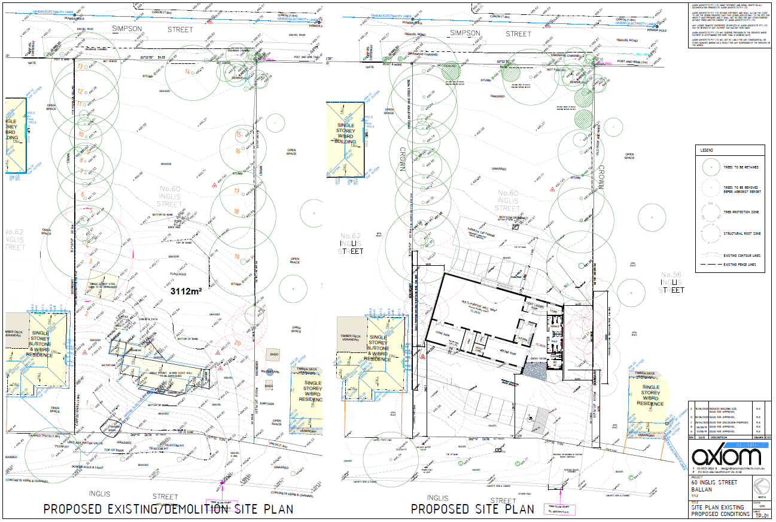
Figure 1: Site Plan (trees to be removed are identified with red circle)
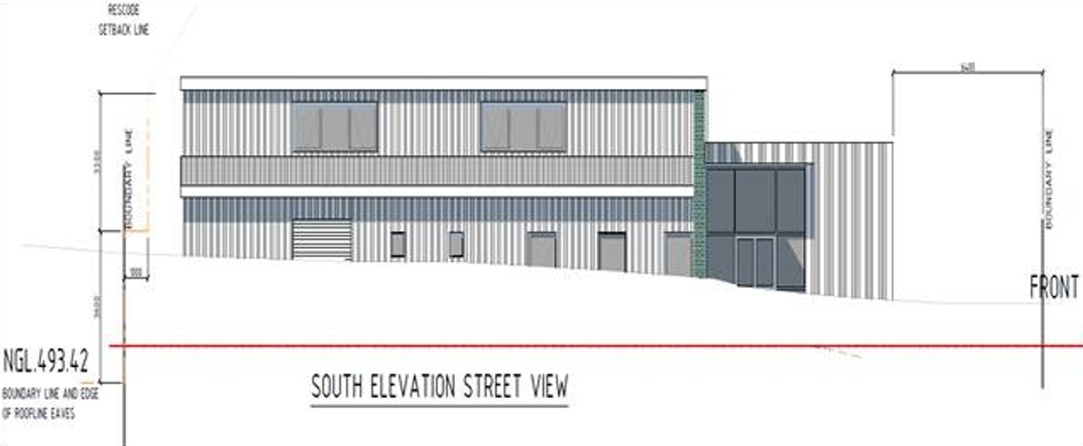
Figure 2: Elevation Plan

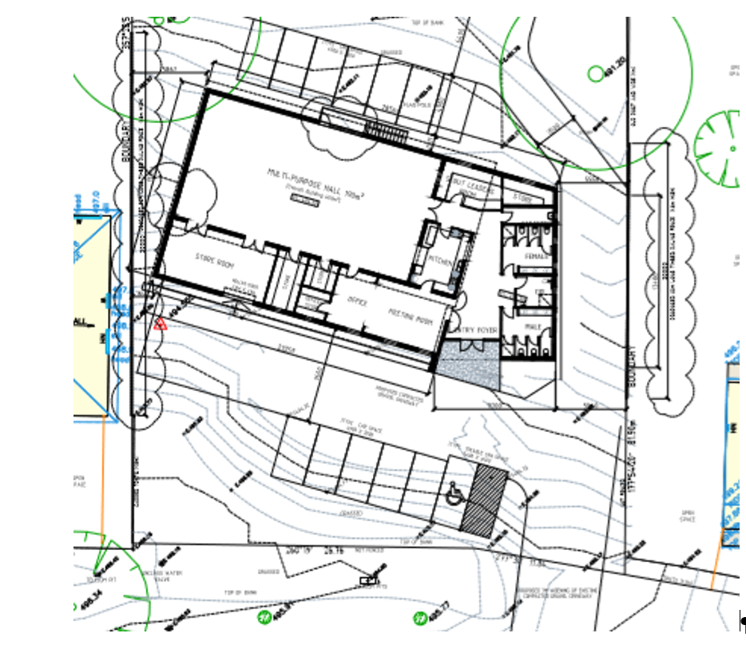
Figure 3: Floor Plan

Background to Current Proposal

History
The site has no known permit history.

Public Notice
The application was notified to adjoining and surrounding landowners by mail and a sign placed on site for 14 days. A total of five objections were received.

Summary of Objections
The objections received are detailed below with officer’s comments accompanying them:
Objection | Any Relevant Requirement
The application suggests increased use of the land and building without clear qualifications. | Place of Assembly: “Land where people congregate for parlour religious, spiritual or cultural activities, entertainment, or meetings.”
Officer’s Response:
The current use of the land has been established as place of assembly and this has not been proposed to change. A planning permit is not required for use of the land.
The trees proposed to be removed have environmental and amenity value and removal is not justified. | Environmental Objectives of Schedule 1 to Clause 42.01
Officer’s Response:
A permit is required for the removal of vegetation only under the Environmental Significance Overlay Schedule 1 (ESO1) with regard to the water supply catchment. There was no objection from the relevant catchment authority.
Insufficient on-site car parking is proposed which will create amenity and safety issues. | Clause 52.06-5 requires minimum 0.3 car parks per patron for a place of assembly.
Officer’s Response:
Adequate on site car parking for at least 13 vehicles accommodating approximately 43 concurrent patrons has been provisioned with ample capacity for overflow parking on site. It is expected that all vehicles using the site can safely enter and park on site and not rely on Inglis Street for park, drop-offs, or pick-ups.
The existing use of the hall creates amenity issues to neighbours including noise disturbance and the proposal suggests this may increase. | Clause 21.03-4 Objective—Landscape and Neighbourhood Character  Clause 13.05-1S Noise abatement  Clause 13.07-1S Land use compatibility
Officer’s Response:
The proposed modern building is expected to provide far better containment of potential amenity disturbances than the current facility by providing more internal space to keep activities indoors and higher constructions standards including noise and light insulation. It should be noted the current site has been used for the same purpose since 1972.
The proposed building design is not in keeping with the neighbourhood character of the area. | Clause 15.01-2S Building Design  Clause 15.01-5S Neighbourhood Character  Clause 21.03-4 Objective—Landscape and Neighbourhood Character  Clause 21.08-2 Objective—Character and Sense of Place
Officer’s Response:
The building design is reflective of contemporary architectural detailing.

Locality Map
The map below indicates the location of the subject site and the zoning of the surrounding area.
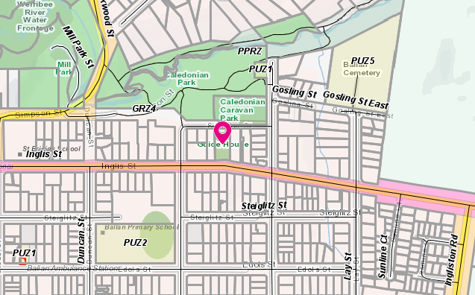
Figure 4: Zone Map
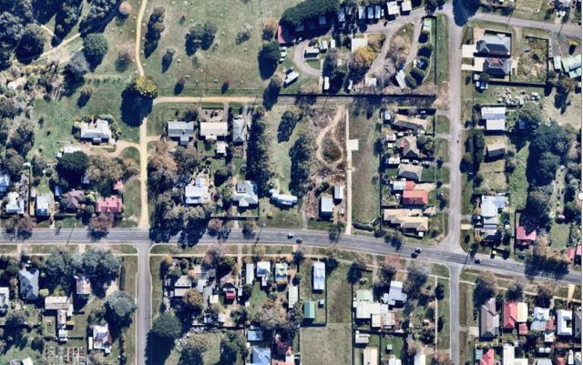
Figure 5: Aerial photograph

Planning Scheme Provisions
Council is required to consider the Victoria Planning Provisions and give particular attention to the Planning Policy Framework (PPF), the Local Planning Policy Framework (LPPF) and the Municipal Strategic Statement (MSS).
The relevant clauses are:
• Clause 11.01-1R Settlement – Central Highlands
• Clause 13.05-1S Noise abatement
• Clause 13.07-1S Land use compatibility
• Clause 14.02-1S Catchment planning and management
• Clause 14.02-2S Water quality
• Clause 15.01-1S Urban Design
• Clause 15.01-2S Building design
• Clause 15.01-5S Neighbourhood character
• Clause 19.02-4S Social and cultural infrastructure
• Clause 21.02 Natural Environment
• Clause 21.03 Settlement and Housing
• Clause 21.08 Ballan
• Clause 22.02 Special Water Supply Catchments
The proposal complies with the relevant sections of the PPF and LPPF, with the exception of the clauses outlined in the table below:

PPF | Title | Response
Clause 15.01-5S | Neighbourhood Character | The proposed building contains contemporary design features to adapt to an established residential area and has sufficient front setbacks to reduce visual bulk.

Zone
General Residential Zone - Schedule 4 (GRZ4)
A Place of Assembly is located is a Section 2 use, a permit is therefore required for the construction of buildings and construction and carrying out of works in the zone pursuant to Clause 32.08-9.
The purpose of the zone is:
• To implement the Municipal Planning Strategy and the Planning Policy Framework.
• To encourage development that respects the neighbourhood character of the area.
• To encourage a diversity of housing types and housing growth particularly in locations offering good access to services and transport.
• To allow educational, recreational, religious, community and a limited range of other non-residential uses to serve local community needs in appropriate locations.
Schedule 4 includes the following neighbourhood character objectives:
• To maintain a streetscape rhythm of detached dwellings with conventional front and side setbacks.
• To provide for built form that does not dominate the lot and allows for generous private open space and garden plantings, with minimal or low scale front fencing.
• To ensure that new development does not compromise the heritage values and character of precinct.

Overlays
Environmental Significance Overlay – Schedule 1 (ESO1)
A permit is required under the provisions of 42.01-2 for the construction of buildings and works and removal of vegetation.
The environmental objectives of the ESO1 are:
• To protect the quality and quantity of water produced within proclaimed water catchments.
• To provide for appropriate development of land within proclaimed water catchments.
In accordance with Clause 4.0 to Schedule 1, the application was referred to Southern Rural Water and Western Water.

Relevant Policies

Particular Provisions
Clause 52.06 Car Parking
Pursuant to Clause 52.06-1, the car parking provisions apply to a proposal to increase the floor area of an existing use. Consistent with the car parking table, a rate of 0.3 spaces is required per patron. The applicant advised 43 patrons will use the hall at any one time during normal scouting uses and it is accepted that the majority of these patrons would be within active transport range or need only pick-up and drop-off. The provision of 13 car spaces for 43 patrons and room for overflow is considered acceptable and complies with the requirements of the provision. There is no requirement to reduce the standard car parking rate.
Clause 52.29 Land adjacent to a Road Zone, Category 1,
Pursuant 59.29-2 permit is required for the creation or alteration of access into a RDZ1
In accordance with Clause 52.29-4, the application was referred to the Department of Transport with regards to the proposed alteration of crossover and access into the site from Inglis Street.
Clause 52.34 Bicycle Facilities
Pursuant to Clause 52.34-1, the bicycle provisions apply to a proposal to increase the floor area of an existing use. Consistent with Tables 1, 2 and 3 of 52.34-5 the required facilities for a place of assembly land use less than 1,500sqm floor area is two bicycle spaces. No change rooms or showers are required under these provisions.
While no facilities have been provisioned on plans, they are recommended to be included on any permit specifying a minimum of two spaces to comply with the standards of Clause 52.34.

Discussion
General Residential Zone
Buildings and works associated with the existing Section 2 requires planning approval. To this extent, the proposed building must address the purpose of the zone with relevant regard to neighbourhood character, adherence to the limited and appropriate allowance of non-residential uses, separation and setback of buildings, and provision of open and garden space.
The front setback of the new building is generous and increases to 13.7m. A maximum building height of up to 7.3m but is located in a lower section of the land compared to street level, which reduces any visual dominance to the streetscape. Design details proposed are considered to have appropriately mitigated concerns of excess bulk by articulating the majority of the width away from direct street frontage and increasing front setback.
A concern by resident has been side setbacks, fencing and loss of trees which screen the existing building. New fencing along each boundary (30m on west, 20m on east) along with new landscaping is expected to suitably delineate boundaries and help contain amenity within the site both in the hall and immediate outside uses.
Removal of vegetation
A total of 10 trees are proposed to be removed from the site and there will be replacement vegetation undertaken. In accordance with the referral requirements of the ESO1, the application was referred to both Southern Rural Water and Western Water. Western Water provided consent to the application with no conditions required. Southern Rural Water provided consent with two conditions. It is considered that in the context of the water catchment and site conditions, the proposed development and tree removal poses little significant consequence the quality and quantity of water entering the catchment. The conditions required by Southern Rural Water, are deemed sufficient in meeting relevant state and local policies for protecting water catchments and the ESO1 and its environmental objectives.

General Provisions
Clause 65 – Decision Guidelines have been considered by officers in evaluating this application.
Clause 66 – Stipulates all the relevant referral authorities to which the application must be referred.

Referrals
Authority | Response
Western Water  Southern Rural Water  Department of Transport | Consent  Consent with conditions  No conditions
Infrastructure | Consent with conditions

Financial Implications
There are no known financial implications with the recommendation for approval.

Risk & Occupational Health & Safety Issues
The recommendation of approval of this development does not implicate any risk or OH&S issues to Council.

Communications Strategy
Notice was undertaken for the application, in accordance with s.52 of the Planning and Environment Act 1987, and further correspondence is required to all interested parties to the application as a result of a decision in this matter. All submitters and the applicant were invited to attend this meeting and invited to address Council if required.

Options
Council could consider the following options:
• issue a Notice of Decision to Grant a Planning Permit in accordance with the conditions contained within this report; or
• issue a Notice of Decision to Grant a Planning Permit with amendment to the recommendation of this report; or
• issue a Notice of Refusal to Grant a Permit with grounds.

Conclusion
The application proposes a development which generally meets the relevant state and local planning policies, purpose and objective of the zone and overlays, and particular provisions. Concerns raised by the objectors have been considered and the applicant has made efforts in addressing many issues including fencing treatments, on site car parking and new landscaping treatments. On balance, the proposed new Scout hall is considered to be an upgrade in both facility and amenity that is expected to provide benefit to both the users of the facility as well as immediately surrounding neighbours.
It is recommended that a Notice of Decision to grant a permit be granted subject to the conditions specified.

Mr. David Djordjevich and Mr. Brian Pol addressed Council as applicants for the Planning Application being considered for Item 7.3.
Mr. David Spiteri addressed Council as an objector to the recommendation for Item 7.3

7.3 PA2020038 - Five shops and a Medical Centre at Halletts Village, Halletts Way, Darley
Author: Victoria Mack, Statutory Planner
Authoriser: Henry Bezuidenhout, Executive Manager Community Planning & Economic Development
Attachments: 1. Development Plans - Site Plans, Elevations including Signage Plan (under separate cover)

Application Summary
Permit No: PA2020038
Lodgement Date: 25 February 2020
Planning Officer: Victoria Mack
Address of the land: Halletts Way, Darley
Proposal: Use and development of Five Shops and a Medical Centre
Lot size: Parent Lot B on PS 617871C; now known as Lot 9 on PS803751B
Why is a permit required? Clause 34.01-1 Use of land as Shops and a Medical Centre
Clause 34.01-4 4 Buildings and works in the Commercial 1 Zone

Committee Resolution
Moved: Cr Tonia Dudzik
Seconded: Cr Ally Munari
That Council, having considered all matters as prescribed by the Planning and Environment Act 1987, issues a Notice of Decision to Grant a Planning Permit for the Use and Development of Five Shops and a Medical Centre on land at the corner of Ramsay Crescent and Halletts Way otherwise known as Lot B on PS 617871C subject to the following conditions:
Endorsed Plans:
1. Before the use and/or development starts, amended plans to the satisfaction of the Responsible Authority must be submitted to and approved by the Responsible Authority. When approved, the plans will be endorsed and will then form part of the permit. The plans must be drawn to scale with dimensions and three copies must be provided. The plans must be generally in accordance with the plans submitted with the application or some other specified plans but modified to show:
(a) Landscape plan as required by condition 21 contained herein and to a similar level of planting density as shown in the submitted concept plan.
(b) The site layout plan must clearly designate a loading area and the location of directional signage to alert delivery drivers to the loading area.

(c) Plan annotated showing an acoustic fence constructed along the property boundary adjacent to the residential lots. The fence should be designed to prevent access to the shops.
(d) Details of colours and finishes to the external brick walls exposed to the adjacent residential lots to reduce visual impact to these residential properties to the satisfaction of the Responsible Authority.
(e) Screen in front of the bins to the satisfaction of the Responsible Authority.
Unless otherwise approved in writing by the Responsible Authority, all buildings and works are to be constructed and or undertaken in accordance with the endorsed plans to the satisfaction of the Responsible Authority prior to the commencement of the use.
Amenity:
2. The amenity of the area must not be detrimentally affected by the use or development, through the:
(a) transport of materials, goods or commodities to or from the land;
(b) appearance of any building, works or materials;
(c) emission of noise, artificial light, vibration, smell, fumes, smoke, vapour, steam, soot, ash, dust, waste water, waste products, grit or oil;
(d) presence of vermin; and
(e) any other way.
3. Mechanical noise emanating from the premises must comply with the State Environment Protection Policy N-1 ‘Control of Noise from Commerce, Industry and Trade.
4. Goods, equipment or machinery must not be stored or left exposed in a position that can be seen from the street.
5. External lighting must be provided with suitable baffles and located so that no direct light is emitted outside the site.
6. Any security alarm or similar device installed must be of a silent type.
Operational:
7. The number of medical practitioners must not exceed five (5) for the medical centre hereby approved.
8. The public car park areas shall be free of charge and must remain open to the public and cannot be used for any other purpose, unless with the written consent of the Responsible Authority.
9. Loading and unloading of delivery vehicles must only occur within the staff car parking access area and must be signposted accordingly to the satisfaction of the Responsible Authority.
10. Waste collections are permitted between 7am to 8pm on Mondays to Saturdays and between 9am to 8pm on Sundays and public holidays
11. Waste bins cannot be located anywhere expect in the approved location as shown in the endorsed waste management plan.

12. Any truck movements beyond the site that creates sediment discharges must comply with the Environmental Guidelines for Major Construction Sites (EPA 1995) to the satisfaction of the Responsible Authority.
Infrastructure:
13. The proposed new vehicle crossings must be constructed to urban industrial standard to the satisfaction of the Responsible Authority. Any redundant vehicle crossings must be removed, and the kerb and channel and nature strip reinstated to the satisfaction of the Responsible Authority. A vehicle crossing permit must be taken out for the construction of the vehicle crossings.
14. Prior to the development and use commencing, engineering drainage plans and computations must be submitted in accordance with the Stormwater Management Strategy (prepared by ARX Consulting Engineers dated 11 August 2020) to the Responsible Authority for approval and shall incorporate the following:
(a) The development as a whole must be self draining and must be connected to an approved point of discharge in an approved manner to the satisfaction of the Responsible Authority.
(b) Underground piped drainage for the whole development shall cater for 10% AEP storm.
(c) Overland 1% AEP flow path(s) for the development must be shown on layout plans and shall ensure that no property is subject to inundation by such a storm to the satisfaction of the Responsible Authority.
(d) The Detention system must be free draining and the volume within the underground system that isn’t free draining cannot be included within the calculations for the OSD storage volume.
15. Storm water drainage from the proposed buildings and impervious surfaces must be directed to the legal point of discharge to the satisfaction of the Responsible Authority. A Stormwater Point of Discharge permit must be obtained from the Responsible Authority prior to the commencement of the works associated with the permit.
16. Sediment discharges must be restricted from any construction activities within the property in accordance with relevant Guidelines including Construction Techniques for Sediment Control (EPA 1991).
17. Unless otherwise approved by the Responsible Authority there must be no buildings, structures, or improvements located over proposed drainage pipes and easements on the property.
18. Prior to the commencement of the development and post completion, notification including photographic evidence must be sent to Council’s Asset Services department identifying any existing damage to council assets. Any existing works affected by the development must be fully reinstated at no cost to and to the satisfaction of the Responsible Authority.
19. Prior to the use commencing, the car park areas must be constructed with a sealed surface, line-marking and drainage to the satisfaction of the Responsible Authority, and shall incorporate the following:
(a) Parking bays and aisle widths of the car park shall comply with Australian Standard AS 2890.1:2004 Off-Street car parking. Disabled Parking bays shall comply with Australian Standard AS2890.1:2009 Off-Street Parking for People with Disabilities.
(b) Designated loading areas shall be shown on layout plans.
(c) The parking areas shall be provided with an asphalt or concrete surface and associated drainage.
(d) Concrete kerb of a minimum height of 150mm must be provided between landscaped areas and areas provided for parking and the passage of vehicles.
(e) The car park must provide sufficient space for a service truck to enter and exit the site in a forward direction. The service truck shall comply with the medium rigid vehicle detailed in AS2890.2 Section 2.2. Turning templates shall be submitted for approval.
20. The building shall be provided with disabled access in accordance with the provisions of AS1428 – Design for Access and Mobility.
Landscape Plans:
21. Before the development starts, a landscape plan to the satisfaction of the Responsible Authority must be submitted to and approved by the Responsible Authority. When approved, the plan will be endorsed and will then form part of the permit. The plan must be drawn to scale with dimensions and three copies must be provided. The landscape plan must be generally in accordance with the landscape concept plan dated (insert date) prepared by (specify consultant), except that the plan must show:
(a) a survey (including botanical names) of all existing vegetation to be retained and/or removed;
(b) buildings and trees (including botanical names) on neighbouring properties within three metres of the boundary;
(c) details of surface finishes of pathways and driveways;
(d) details of finishes to the retaining walls including any cascading plantings;
(e) a planting schedule of all proposed trees, shrubs and ground covers, including botanical names, common names, pot sizes, sizes at maturity, and quantities of each plant;
(f) landscaping and planting within all open areas of the site;
(g) canopy trees ( minimum 2m tall when planted) across the site. All species selected must be to the satisfaction of the Responsible Authority.
22. Before the use/occupation of the development starts or by such later date as is approved by the Responsible Authority in writing, the landscaping works shown on the endorsed plans must be carried out and completed to the satisfaction of the Responsible Authority.
23. The landscaping shown on the endorsed plans must be maintained to the satisfaction of the Responsible Authority, including that any dead, diseased or damaged plants are to be replaced.
Signage:
24. The location, design, content, colours and materials of all advertising signs must not be altered without the written consent of the Responsible Authority.
25. The advertising signs must be not contain any moving parts or flashing lights.
26. The signs must be constructed and maintained to the satisfaction of the Responsible Authority.
27. The signs must not be illuminated by external or internal light except with the written consent of the Responsible Authority.
Permit Expiry:
28. This permit will expire if one of the following circumstances applies:
(a) the development and use is not started within two years of the date of this permit;and
(b) the development is not completed within four years of the date of this permit.
Permit Note:
The total area of all Business Identification signage permitted in The Commercial 1 Zone is 8sqm. If additional signage is required this permit will need to be amended or a new permit obtained.

Carried

Public Consultation
Was the application advertised? | Yes.
Notices on site: | Yes.
Notice in Moorabool Newspaper: | No.
Number of objections: | Six. Two were later withdrawn
Consultation meeting: | Not held, but the Planning Officer spoke to each of the objectors and also communicated with them via email.

Policy Implications
The Council Plan 2017-2021 provides as follows:
Strategic Objective 3: Stimulating Economic Development
Context 2A: Built Environment
The proposal is not provided for in the Council Plan 2017-2021 and can be actioned by utilising existing resources.

Victorian Charter of Human Rights & Responsibilities Act 2006
In developing this report to Council, the officer considered whether the subject matter raised any human rights issues. In particular, whether the scope of any human right established by the Victorian Charter of Human Rights and Responsibilities is in any way limited, restricted or interfered with by the recommendations contained in the report. It is considered that the subject matter does not raise any human rights issues.

Officer’s Declaration of Conflict of Interests
Under section 130 of the Local Government Act 2020, officers providing advice to Council must disclose any interests, including the type of interest.
Executive Manager – Henry Bezuidenhout
In providing this advice to Council as the Executive Manager, I have no interests to disclose in this report.
Author – Victoria Mack
In providing this advice to Council as the Author, I have no interests to disclose in this report.

Executive Summary
Application referred? | Yes, to Council’s Infrastructure and Council’s Strategic Planning.
Any issues raised in referral responses? | Infrastructure requested a Storm Water Management Strategy was provided in accordance with Clause 53.18-3 of the Moorabool Planning Scheme.
Preliminary concerns? | No concerns until Council received objections from neighbours to the proposed pylon sign.
Any discussions with applicant regarding concerns? | Yes, in relation to the provision of the Storm Water Management Strategy and the objections to the pylon sign.
Any changes made to the application since being lodged? | The Plans were amended to remove the pylon sign and replace it with a 1.5m high sign at the front of the site and a Storm Water Management Strategy was provided.
Brief history. | The lot is part of the 21-lot subdivision known as the Summerfield North Estate. The subject site was zoned Commercial 1 Zone to provide for a small activity centre in this location.
Previous applications for the site? | PA2005-036 Staged Subdivision  PA2009282 20 Lot Subdivision  PA2017010 21 Lot Subdivision
General summary. | The application is for a retail precinct on the site including five shops/food and drink premises and a medical centre with five medical practitioners/health service providers. It is expected that this small activity centre will provide a range of services to surrounding residents but indicative tenancies for the shops have not been nominated.  The subject site has been earmarked for a commercial use for many years and is zoned Commercial 1 Zone.  The site is also included in the Schedule to the Commercial 1 Zone along with other current or future activity centre sites in Bacchus Marsh.  The proposed building would be well setback from both Halletts Way and Ramsay Crescent and the building is well designed with the required car parking and bicycle spaces provided.  The proposal meets the requirements of the Moorabool Planning Scheme.  It is recommended that the application is supported.
Summary Recommendation
That, having considered all relevant matters as required by the Planning and Environment Act 1987, Council issues a Notice of Decision to Grant a Planning Permit for the Development and Use of Five Shops and a Medical Centre on land at the corner of Ramsay Crescent and Halletts Way, Darley otherwise known as Lot B on PS 617871C.

Site Description
The site has an area of 2,262sqm. The site is located on the north-western side of Hallett’s Way at the intersection with Ramsay Court, Darley. It is cleared and vacant land.
The site slopes from 166 to 160 AHD (Australian Height Datum), a fall of 6m from the western corner of the site downwards to the eastern corner of the site abutting Halletts Way.
The site is zoned Commercial 1 and has always been earmarked for a retail activity centre as part of the subdivision known as the Summerfield North Estate.
The site is located approximately 1.6km north of the Western Freeway at the Halletts Way interchange, and approximately 3.6km from the Bacchus Marsh town centre, via Main Street. The site is approximately 2.4km north-west of the Darley Plaza shopping centre via Grey Street.
The site is approximately 2.5km west of the small mixed-use shopping centre at Albert Street.
A public bus service travels along Halletts Way providing a service approximately every 30 minutes. The bus service provides access to the Bacchus Marsh township, the Darley Plaza and the Bacchus Marsh Railway Station.
The balance of this site surrounding this retail precinct is a residential subdivision comprising 20 lots to the north of the site. To the east of the site across Halletts Way is a public reserve owned by the Moorabool Shire Council. To the south-east of the site, across Halletts Way is the Moorabool Shire Council offices.
To the west of the site is a fully developed residential area with dwellings on lots that range in size from 650 – 800sqm. There remains a limited number of vacant lots in this subdivision.
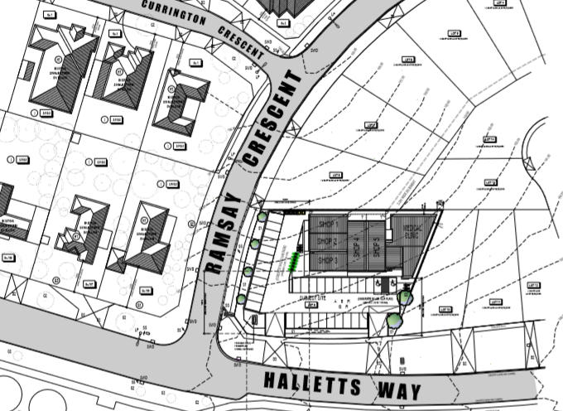
Figure 1: Site Context Plan

Proposal
It is proposed to construct five single shops and a medical centre in the northern corner of the site. Shops 1-5 would each have floor areas ranging from 71sqm - 99sqm. Each would contain a small kitchenette and a disabled accessible toilet for staff which may be available to customers. Additionally Shops 4 and 5 would have access to a rear private, courtyard of 12sqm. The total leasable floor area of all five shops would be 417.75sqm.
The medical centre would be for five medical practitioners and would have a floor area of 226sqm and includes:
• reception and waiting area;
• five consulting rooms;
• a multipurpose room;
• a staff room with kitchen;
• an office with attached file room;
• and a bathroom with two toilets and an accessible toilet; and
• access to a 15.5sqm courtyard.
Externally the site would contain:
• 34 car parking spaces including two accessible spaces designed for people with limited mobility close the centre, with seven of these car spaces designated for staff parking in the south west side of the development;
• 8.4m accessways;
• a waste bin and recycling bin storage area;
• eight bicycle parking racks with four spaces in each of two locations on the site; two crossovers to the precinct from Halletts Way; and
• pathways constructed around the building including rear access to the shops and the medical centre and front pathways for public access to the facility. The front pathways would be covered by a verandah.
The proposal is to cut into the site to provide for a flat area for development. Retaining walls up to 5 metres in height would be constructed on the north, east and west boundaries as required. A 1.8 metre paling fence will be constructed above the retaining walls.
The centre would be constructed with face brick and with selected rendered areas. The external colours would be brown and dark greys.
The centre would be identified by a sign to be located at the front of the site on the eastern boundary centrally located between the two crossovers. The sign would have the words Halletts Village in powder coated metal text located on top of a brick plinth. The sign including the plinth would be 4.9m long, 1.1m wide and 1.55m high, with a total area of 7.59sqm. The area of the text alone would be 2.4sqm. The sign would be externally illuminated with baffled lighting during opening hours.
The site would be fully landscaped, but a detailed landscape plan was not provided with the application.

Background to Current Proposal
The site is part of the residential estate known as Summerfield North Estate.
PUBLIC NOTICE
The application was notified to adjoining and surrounding landowners and six objections were received.
Four of these objections were specifically concerned with a large 5.8m high pylon sign proposed to be located in the southern corner of the site at the intersection of Ramsay Crescent and Halletts Way. Discussion with the applicant resulted in the pylon sign being removed and a smaller business identification sign located at the front of the premises. This resulted in two objections being withdrawn.

Summary of Objections
The objections received are detailed below with officer’s comments accompanying them:
Objection | Any Relevant Requirement
This is a residential area with more than enough services to cater for our needs. | Commercial 1 Zone
Officer’s Response: The site is specially zoned for commercial activity.
This proposal will encourage gatherings by possible youth and young adults and promote anti-social behaviour that is not wanted in our community. | Victoria Police
Officer’s Response: Limited justification was provided in relation to this concern. Anti-social behaviour is a police matter.
Increase of traffic in this area is not desirable. | Council’s Infrastructure
Officer’s Response: The application was accompanied by a Traffic Report which was referred to Council’s Infrastructure which did not express concern about the impact of the development on local traffic. The proposal provides the required number of car spaces on the site for patrons.
This development may devalue the area. | VCAT
Officer’s Response: VCAT has determined property values are not a valid planning consideration.
This proposal is totally out of character for residential area. A commercial development such as this will detract from the areas character and it will be detrimental to the residents who live in the area. | Bacchus Marsh Retail Strategy
Officer’s Response: Conversely the centre may provide valued services in close proximity to residents. The Bacchus Marsh Retail Strategy identified a future need for small activity centres close to residential area as Bacchus Marsh population increases. The land is zoned for Commercial 1 and the proposal uses of shops and medical centre are consistent with the zone objectives.
The proposed development is not in line with the rural setting. | Neighbourhood character
Officer’s Response: Darley is not a rural setting but a residential area. A small proximate activity centre may provide services that are valued by local residents.
Currently have adequate medical facilities in Darley and a dental clinic as well as shopping facilities in Albert Street, Nelson Street and Darley Plaza. Feasibility study should be provided that demonstrates that such a development is warranted. | Bacchus Marsh Retail Strategy
Officer’s Response: The lot is zoned to support a small commercial activity centre and the site is included in Schedule 1 of the Commercial 1 Zone as a future small activity centre. The developers have made a commercial decision that the proposal is worthy of their investment. The Bacchus Marsh Retail Strategy identified a future need for small activity centres close to residential area as population increases.

Locality Map
The map below indicates the location of the subject site and the zoning of the surrounding area.
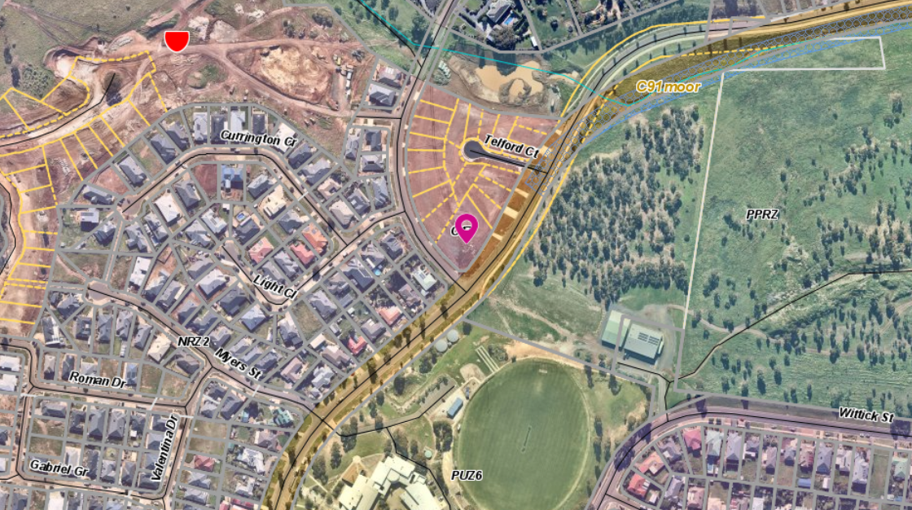
Figure 2: Aerial photograph

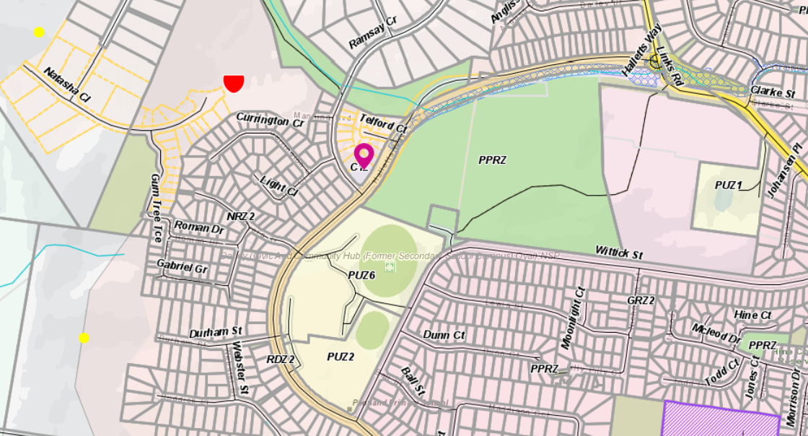
Figure 3: Zone Map

Planning Scheme Provisions
Council is required to consider the Victoria Planning Provisions and give particular attention to the Planning Policy Framework (PPF), the Local Planning Policy Framework (LPPF) and the Municipal Strategic Statement (MSS).
The relevant clauses are:
• Clause 11 Settlement
• Clause 15.01-1S Urban design
• Clause 15.01-2S Building design
• Clause 17.02-1S Business
• Clause 17.02-2S Out-of-centre development
• Clause 21.04-3 Objectives Commercial
• Clause 21.04-5 Objective—Local employment
The proposal complies with the relevant sections of the PPF and LPPF.

Zone
Clause 34.01 – Commercial 1 Zone (C1Z)
Medical Centre: In accordance with Clause 34.01-1, a permit is required to use land for a medical centre.
Shops: In accordance with Clause 34.01-1, a permit is required if the leasable floor area exceeds any amount specified in the schedule to this zone. The schedule to the C1Z specifies a maximum leasable floor area of 240sqm for Land on the corner of Halletts Way and Ramsey Crescent, Darley. The leasable floor areas of the five shops in this application is 417.75sqm which is greater than 240sqm and a permit is required for use as shops.
Buildings and works: In accordance with Clause 34.01-4 a permit is required to construct a building or construct or carry out works.

Overlays
No overlays apply to the subject land.

Relevant Policies

Bacchus Marsh Retail Strategy 2041 – March 2016.

The relevant recommendations from the Strategy are:

• Optimise the retail mix and encourage a concentration of facilities within the Bacchus Marsh Town Centre.
• Position the Bacchus Marsh Town Centre for growth, in keeping with its role as the key activity centre for Moorabool and improve movement in the Town Centre.
• Provide a broader range of facilities and services in and around Bacchus Marsh Town Centre.

The proposal is in a designated commercial zone does not undermine the Bacchus Marsh Town Centre.

Particular Provisions
Clause 52.05 Signage
In the Commercial 1 Zone, Category 1 for signage controls apply. In accordance with Clause 52.05-11 no permit is required for business identification signage less than 8sqm. In this proposal the total area of the business identification sign at the front of the property would be 7.59sqm.
Clause 52.06 Car parking
In accordance with Clause 52.06-5 Table 1 the following car spaces are required:
Medical Centre: the number of doctors proposed to operate from the medical centre would be five. The number of car spaces required is five car spaces for the first practitioner and three car spaces for every other person providing health services. The medical centre requires a total of 17 car spaces.
Shop (or food and drink premises): total floor area of the five shops is 417.75sqm. Four car spaces are required for each 100sqm of leasable floor area. The shops would require a total of 16 car spaces.
The total number of car spaces required is 33. The total car parking provided on site is 34. Therefore, the proposal exceeds the minimum car parking requirement of the Moorabool Planning Scheme and no car parking reduction is required.
Clause 52.34 Bicycle facilities
Table 1 of Clause 52.34 states that the medical centre must have 2 bicycle spaces and shops would require no bicycle spaces. The proposal provides eight bicycle spaces which exceeds the requirements of Clause 52.34.

Discussion
The subject site has been earmarked for a small commercial activity centre for some years with a maximum floor area of 240 square metres for a shop without requiring a permit. As the floor area for the shops is 420 square metres a permit is required for the use of the shops. The site is included in the Schedule to the Commercial 1 Zone where a number of current and proposed activity centres for Bacchus are listed. The applicant has allowed for a well-designed layout to achieve a greater floor area while satisfying the minimum requirements for on-site car parking.
The building incorporating the shops and medical centre have been well setback from both street frontages thereby exposing the car parking areas and landscaping areas. The generous setbacks of the modest commercial building ensures there is no negative streetscape impacts. The design has utilised large glassed areas along the shop frontages, up to 5m in height which softens the built form and reduces visual bulk impacts. The generous setbacks are respectful especially to the nearest residential properties on the opposite side of Ramsay Crescent.
Landscaping is positioned along both street frontages and is of sufficient depth to allow for extensive landscaping treatments and canopy trees with spreading crowns. A detailed landscaping plan can be addressed through the submission of revised plans.
The accessway width and car parking provisions which complies with the minimum requirements of Clause 52.06 will allow all staff and visitors to park on site and the dual access points can allow for the ease of traffic movements. The applicant has well exceeded the minimum bicycle parking rate which encourages local residents to use their bicycles rather than be reliant on a car to access the site. The site also has bus access and the accessible car spaces for people with limited mobility assisting effective use of the medical centre.
The applicant has also considered how the shops and medical centre will function by providing separate pedestrian access to the rear, a separate staff parking area and two shops having service yards which can be used for storage or as an open recreational area for staff. The high quality site layout will ensure long term occupations and usage.
The design and location of the buildings on the site is appropriate, being low scale and constructed to compliment the surrounding neighbour character. The site will be excavated so the bulk of the buildings are on level ground which will be viewed from the streetscape. This will require retaining walls to be constructed on the north, east and west boundaries. The retaining walls will also have a paling fence constructed on top of them. The adjoining residential properties sit above the development with the paling fences screening the development from those adjoining properties.
The proposal generally complies with the zone requirements of the Moorabool Planning Scheme. There is good separation with the nearest established residential properties in Ramsay Crescent. An interface issue can exist with the two adjacent north-west properties and the adjacent northern property which are currently vacant lots for future dwellings. These future dwellings will be adjacent to a commercial centre and can experience noise such as car movements to and from the site and people using the area. The applicant rather than build a blank wall against these interfaces has instead provided a side setback for staff pedestrian access only and placed retaining walls along the property boundary. Further protection can be utilised including acoustic fencing along the common property boundary and providing colours and finishes to external brick wall to reduce visual impact. Revised plans will be required.
There are also several amenity conditions proposed to mitigate off site impacts to these future residences.
The application was advertised with six objections received. Two of these objectors withdrew their objections once a proposed pylon sign was removed from the application.
The application is a high quality commercial design and it is considered that the siting and layout provides a provide design response. It is considered that the retail shops and medical centre could provide a range of services closer to residents than presently available. The proposal will support economic activity in Darley.
It is considered that the application should be approved with standard amenity conditions.

General Provisions
Clause 65 – Decision Guidelines have been considered by officers in evaluating this application.
Clause 66 – Stipulates all the relevant referral authorities to which the application must be referred.
The application was referred as follows:

Referrals
Authority | Response
Infrastructure  Strategic Planning | Consent with 14 conditions.  No comment.

Financial Implications
It is not considered that the recommendation of approval represents any financial risk or implications to Council.

Risk & Occupational Health & Safety Issues
The recommendation of approval of this development does not implicate any risk or OH&S issues to Council.

Communications Strategy
Notice was undertaken for the application, in accordance with s.52 of the Planning and Environment Act 1987, and further correspondence is required to all interested parties to the application as a result of a decision in this matter. All submitters and the applicant were invited to attend this meeting and invited to address Council if required.

Options
Council could consider the following options:
• issue a Notice of Decision to Grant a Planning Permit in accordance with the recommendations contained within this report; or
• issue a Refusal to grant a Planning Permit. Council would need to consider how the proposal does not comply the Moorabool Planning Scheme.

Conclusion
The site has been earmarked for a commercial development for some years. It was zoned Commercial 1 that seeks to encourage retail activity. The use and development are consistent with the objectives of the Commercial 1 Zone. The site would provide local residents with a range of services that is accessible by pedestrian traffic. The proposed use and development should be supported.

Mr. Cameron Dawson addressed Council as the applicant for the planning application being considered as Item 7.4.

7.4 PA2020023 - Use of land for a Poultry Farm (egg production) and the development of Two Farm Sheds at 137 Woolpack Road, Maddingley
Author: Victoria Mack, Statutory Planner
Authoriser: Henry Bezuidenhout, Executive Manager Community Planning & Economic Development
Attachments: 1. Farm Management Plan (under separate cover)

Application Summary
Permit No: PA2020023
Lodgement Date: 30 January 2020
Planning Officer: Victoria Mack
Address of the land: 137 Woolpack Road, Maddingley
Proposal: Use of the Land for Animal Production (Poultry Farm) and Development of Two Farm Sheds
Lot size: 5.094ha
Why is a permit required? Use and development of a Poultry Farm (egg production) greater than 100 birds

Committee Resolution
Moved: Cr Rod Ward
Seconded: Cr David Edwards
That Council, having considered all matters as prescribed by the Planning and Environment Act 1987, issues a Notice of Decision to Grant a Planning Permit for the use of the land for animal production (poultry farm) and development of two sheds at 137 Woolpack Road, Maddingly otherwise known as Lot 2 on PS607883B subject to the following conditions:
Endorsed plans
1. Before the use and/or development starts, plans to the satisfaction of the Responsible Authority must be submitted to and approved by the Responsible Authority. When approved, the plans will be endorsed and will then form part of the permit. The plans must be drawn to scale with dimensions and two copies must be provided. The plans must show:
(a) Shed plans with external cladding to be of non-reflective materials and in muted earth tones to compliment the colour of the natural environment. The use of zincalume is not permitted.
(b) A detailed waste and odour management plan to ensure waste is removed from the site at regular intervals to the satisfaction of the Responsible Authority.
(c) A detailed Land Management Plan in accordance with Condition 2.

Unless otherwise approved in writing by the Responsible Authority, all buildings and works are to be constructed and or undertaken in accordance with the endorsed plans to the satisfaction of the Responsible Authority prior to the commencement of the use.
Farm and Land Management Plan:
2. A Land Management Plan to the satisfaction of the Responsible Authority must be endorse as part of this permit and must include:
(a) Details of how the free-range areas will be sustainably managed and improved over a 5 year period.
(b) A detailed annual weed control program.
3. A Farm Management Plan to the satisfaction of the Responsible Authority must be endorsed as part of this permit, and cannot be varied without the written consent of the Responsible Authority.
4. The maximum number of birds on site is 4,500
General Conditions
5. The approved Waste Management Plan must be compiled with at all times to the satisfaction of the Responsible Authority
6. No litter spreading, litter stockpiles, composting of dead birds and spreading of dead birds can occur on the subject land.
7. The land must be maintained in an orderly and neat manner at all times to the satisfaction of the Responsible Authority
8. Wash down/egg cleaning water, waste water or water which has been in contact with manure or putrescible matter must not directly or indirectly enter any watercourse or beyond the property boundary.
9. The amenity of the area must not be detrimentally affected by the use or development to the satisfaction of the Responsible Authority through the:
(a) transport of materials, goods or commodities to or from the land
(b) emission of noise, artificial light, vibration, smell, fumes, smoke, vapour, steam, soot, ash, dust, waste water, waste products; and
(c) presence of vermin.
Materials and Colour:
10. All external walls and roof areas of the proposed building/s are to be clad with non-reflective materials (zincalume prohibited) to the satisfaction of the Responsible Authority.
Environmental Health:
11. The egg production must comply with the ‘Primary production and processing standard for eggs (Chapter 4) under the Food Standards Code.
12. Odour emissions from the premises must be controlled so as not to cause a nuisance (as defined by the Public Health & Wellbeing Act 2008) to nearby properties.
13. The water from the egg washing must be disposed of appropriately and not be irrigated onto the vegetable garden (anything edible).
14. An EPA approved onsite waste water management system with the capacity to treat effluent to a primary standard must be installed for the wastewater from the shed.
Infrastructure:
15. Storm water drainage from the proposed buildings and impervious surfaces must be retained and disposed of within the boundaries of the subject land to the satisfaction of the Responsible Authority. Overflows from on-site storage systems must be directed away from any waste water disposal areas.
16. Sediment discharges must be restricted from any construction activities within the property in accordance with relevant Guidelines including Construction Techniques for Sediment Control (EPA 1991).
17. Unless otherwise approved by the Responsible Authority there must be no buildings, structures, or improvements located over proposed drainage pipes and easements on the property
18. Prior to the commencement of the development and post completion, notification including photographic evidence must be sent to Council’s Asset Services department identifying any existing damage to council assets. Any existing works affected by the development must be fully reinstated at no cost to and to the satisfaction of the Responsible Authority.
Permit Expiry:
19. This permit will expire if one of the following circumstances applies:
(a) the development and the use are not started within two years of the date of this permit; and
(b) the development is not completed within four years of the date of this permit.
Permit Note:
Environmental Health
A permit to install an onsite wastewater management system must be submitted to Environmental Health.
Strategic and Sustainable Development
The subject land is located within the Parwan Station Precinct, in an area identified as ‘Buffer no sensitive uses’, as per the Bacchus Marsh Urban Growth Framework Plan in clause 21.07 of the Moorabool Planning Scheme. The subject land is located approximately 570m west of potential future residential zones within the Parwan Station Precinct.
Carried

Public Consultation
Was the application advertised? | Yes.
Notices on site: | Yes.
Notice in Moorabool Newspaper: | No.
Number of objections: | 2.
Consultation meeting: | Not held.

Policy Implications
The Council Plan 2017-2021 provides as follows:
Strategic Objective 2: Minimising Environmental Impact
Context 3A: Land Use Planning
The proposal is not provided for in the Council Plan 2017-2021 and can be actioned by utilising existing resources.

Victorian Charter of Human Rights & Responsibilities Act 2006
In developing this report to Council, the officer considered whether the subject matter raised any human rights issues. In particular, whether the scope of any human right established by the Victorian Charter of Human Rights and Responsibilities is in any way limited, restricted or interfered with by the recommendations contained in the report. It is considered that the subject matter does not raise any human rights issues.

Officer’s Declaration of Conflict of Interests
Under section 130 of the Local Government Act 2020, officers providing advice to Council must disclose any interests, including the type of interest.
Executive Manager – Henry Bezuidenhout
In providing this advice to Council as the Executive Manager, I have no interests to disclose in this report.
Author – Victoria Mack
In providing this advice to Council as the Author, I have no interests to disclose in this report.

Executive Summary
Application referred? | Yes, Agriculture Victoria, and Council’s Strategic and Sustainable Development; Infrastructure and Community Safety and Environmental Health.
Any issues raised in referral responses? | Yes, Environmental Health raised questions about the treatment of egg washing water and whether there would be plumbing fittings in the sheds.
Preliminary concerns? | The initial application lacked the required information. Agriculture Victoria assisted the applicant in the preparation of a competent application.
Any discussions with applicant regarding concerns? | A Request for Further Information was sent to the applicant of the poultry farm (egg production). Discussion was also held with Agriculture Victoria about this application.
Any changes made to the application since being lodged? | The application was considerably amended with the requested information provided.
Brief history. | The owner of the land had previously been producing eggs on the site without the required planning approval.
Previous applications for the site? | PA2015024 – Development and use of a dwelling and outbuilding;  PA2008289 – Development of a Second dwelling;  PA2008-140 - Development of an Outbuilding (Machinery Shed) Ancillary to the Use of the Land for Agriculture
General summary. | The application is for a small-scale poultry farm for egg production with a maximum of 3,000 hens in two sheds each capable of holding 1,500 birds.  The birds will be free range during each day with access to the shed for laying. The application was accompanied by a comprehensive Farm Management Plan. It is considered if this plan is adhered to the operator should be able to operate a successful small-scale egg producing enterprise.  The key elements of the proposal that need to be carefully managed are: wastes, odour, animal welfare, animal hygiene, range area management including weed management and biosecurity.
Summary Recommendation
That, having considered all relevant matters as required by the Planning and Environment Act 1987, Council issue a Notice of Decision to Grant a Planning Permit for the Use of the Land for Poultry Farm (Egg Production) and Development of Two Farm Sheds at 137 Woolpack Road, Maddingly otherwise known as Lot 2 on PS607883B.

Site Description
The property is in the Farming Zone, but it is unsuitable for any type of cropping or grazing. The site is comprised of rocky gravel soil surface and a burden of woody and other weeds. The land is generally not trafficable due to the rocks. The owner has previously constructed access ways around the property to the dwelling and shed sites with heavy equipment.
The land is undulating and generally slopes from the east side boundary downwards to the west boundary abutting Woolpack Road.
The site is located approximately 300m north of the Geelong-Bacchus Marsh Road, and approximately 1,600m south of the Avenue of Honour intersection with Woolpack Road.
Surrounding land use to the north-west, north and north-east, below the escarpment, include horticulture farms within the Bacchus Marsh Irrigation District. To the west are similar sized lots in the Farming zone used for a range of lifestyle, agricultural and equine activities. Abutting the eastern boundary of the site is the Brown’s Lane broiler farm consisting of four large broilers sheds.
To the south-east and south of the site are a range of mixed uses including industrial and similar operations. To the south-west and west of the site is the pet crematorium and Maddingley Brown Coal. Immediately to the west across Woolpack Road is the Genetics Australia Co-Operative farm.
There are two existing sheds on the property and a garage that is being used for storage. The existing agricultural shed at the northern end of the site has been used for egg producing hens but will be used to rear replacement pullets in the future.
At the southern end of the site is a large building with the front section used as a dwelling and the rear section used for the egg washing and packaging.
Internal access driveways connect all these buildings.
Below is an aerial photo of the site:
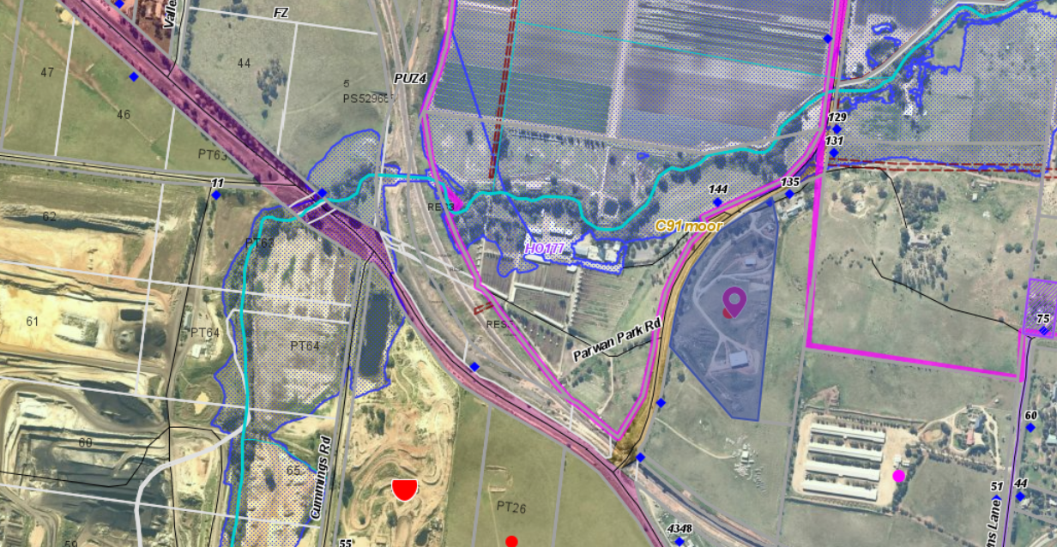
Figure 1: Aerial Photograph

Proposal
The proposal is to use the land for a poultry farm for egg production.
There would be a maximum of 3,000 laying hens kept in two new sheds to be constructed over 12 months. For up to four months each year there would be up to 4,500 chickens on the site before the new pullets replace retiring birds.
Each shed would be 12m x 24m. The shed floors would be compacted to prevent permeability. Rafters and beams would be wild bird proofed. All feeding and watering will take place within the sheds. Communal laying areas would be constructed within the sheds. Permanent ventilation will be installed on the roofs, chicken access would be via pop doors and the main doors would be fully opened in hot weather.
All range areas would be fenced with chicken mesh to a height of 1.8m and the boundary fencing would be 1.2m high to act as a second barrier. The range areas will provide 6.7sqm per bird which greater that the 1sqm per bird in the Low-Density Mobile Poultry Guidelines. Young replacement chickens will be provided with 3sqm per bird.
There are no specific guidelines for buffer distances and the Low-Density Mobile Poultry Guidelines offer the best guide. This would require a distance to a sensitive use of 100m. In this instance the nearest dwelling from any part of the chicken producing areas is 105m to the north.
No more than two staff will be required to operate the enterprise. Eggs produced would be sold to local retailers, cafes and supermarkets. Free range systems provide for adherence to animal welfare guidelines.
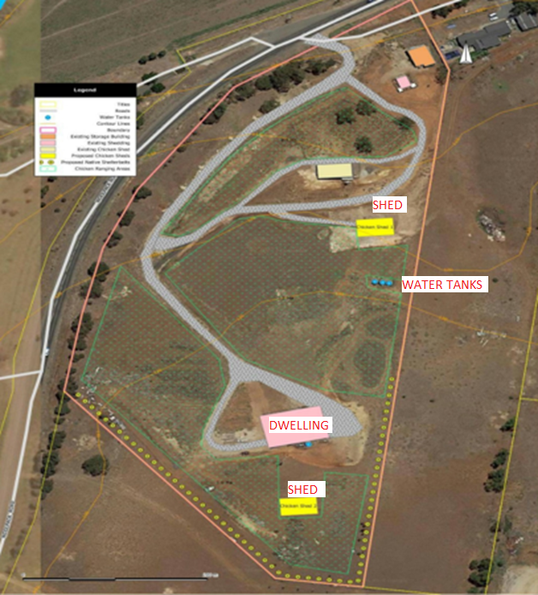
Figure 2: Site plan

History
PA2015024 – Development and use of a dwelling and outbuilding;
PA2008289 – Development of a Second dwelling;
PA2008140 - Development of an Outbuilding (Machinery Shed) Ancillary to the Use of the Land for Agriculture.
The owner had been running laying hens on the farm for some time and selling the eggs local markets successfully. However, he did not have planning permission.
It is understood that there are no hens currently on the property.

Public Notice
The application was notified to adjoining and surrounding landowners and two objections were received.

Summary of Objections
The objections received are detailed below with officer’s comments accompanying them:
Objection | Any Relevant Requirement
The impact of the proposal on planning for the Parwan Station Precinct Structure Plan and Urban Growth Framework Plan and the amenity buffers that may be required. | Bacchus Marsh Urban Growth Framework Plan
Officer’s Response: See Strategic and Sustainable Development Department’s comments in the discussion section of this report.
The decision guidelines of the Farming Zone include whether the site is suitable for the use or development and whether the proposal is compatible with adjoining and nearby land uses. | Clause 35.07 Farming Zone
Officer’s Response: Surrounding land is in the Farming Zone and proposal is consistent with the objectives of the Farming Zone by supporting a farming activity.
Table 1 of Clause 53.09 requires setback distances of 400m from land in a residential zone and 100m from a sensitive use. | Clause 53.09 Poultry Farm
Officer’s Response: The proposal meets the setbacks required in Table 1 of Clause 53.09-4.
The application does not represent orderly planning.
Officer’s Response: See Strategic and Sustainable Development Department’s comments in the discussion section of this report.
The proposal fails to provide justification against the current strategic policies and provisions of the Moorabool Planning Scheme.
Officer’s Response: These concerns are addressed in this report.

The proposal also fails to address the provisions of the Environmental Significance Overlay Provisions of Clause 42.01 – Schedule 2 and Schedule 8 as the subject site abuts to its northern and western lot boundaries very significant and environmentally sensitive waterways areas inclusive.
Officer’s Response: The Environmental Significance Overlay Schedule 2 and Schedule 8, does not apply to the subject site.
The application lodged to Council has also not been provided with a detailed waste management assessment report prepared by a suitably qualified environmentally consultant.
Officer’s Response: See recommended conditions.

Locality Map
The map below indicates the location of the subject site and the zoning of the surrounding area.

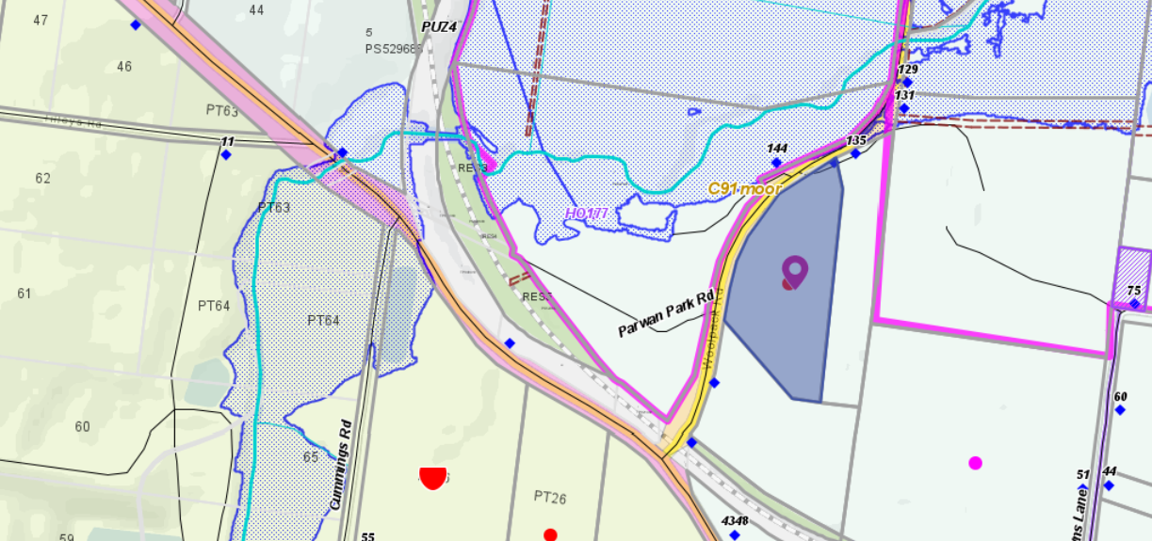
Figure 3: Zone Map. Light blue dotted pattern to the north of the site represents the area subject to flooding.

Planning Scheme Provisions
Council is required to consider the Victoria Planning Provisions and give attention to the Planning Policy Framework (PPF), the Local Planning Policy Framework (LPPF) and the Municipal Strategic Statement (MSS).

The relevant clauses are:
• Clause 14.01-1S Protection of agricultural land.
• Clause 14.01-2S Sustainable agricultural land use.
• Clause 17.01-1S Diversified economy
• Clause 21.04-1 Key issues and influences: Agriculture and horticulture.
• Clause 21.04-2 Objectives—Agriculture
The proposal complies with the relevant sections of the PPF and LPPF.

Zone
Farming Zone
In accordance with Clause 35.07-1, Section 2 a permit is required to use land for a poultry farm.
The purposes of the Farming Zone include:
• To implement the Municipal Planning Strategy and the Planning Policy Framework.
• To provide for the use of land for agriculture.
• To encourage the retention of productive agricultural land.
• To ensure that non-agricultural uses, including dwellings, do not adversely affect the use of land for agriculture.
• To encourage the retention of employment and population to support rural communities.
• To encourage use and development of land based on comprehensive and sustainable land management practices and infrastructure provision.

Overlays
Significant Landscape Overlay, Schedule 1
In accordance with Clause 42.03 a permit is required to construct a building or construct or carry out works.
The decision guidelines state that the Responsible Authority must consider as appropriate:
• The Municipal Planning Strategy and the Planning Policy Framework.
• The statement of the nature and key elements of the landscape and the landscape character objective contained in a schedule to this overlay.
• The conservation and enhancement of the landscape values of the area.
• The need to remove, destroy or lop vegetation to create a defendable space to reduce the risk of bushfire to life and property.
• The impact of the proposed buildings and works on the landscape due to height, bulk, colour, general appearance or the need to remove vegetation.
• The extent to which the buildings and works are designed to enhance or promote the landscape character objectives of the area.
• The impact of buildings and works on significant views.
• Any other matters specified in a schedule to this overlay
Design and Development Overlay, Schedule 2
In accordance with Clause 43.02-1 and Schedule 2 a permit is not required under this overlay provided the external cladding of buildings and works are constructed with non-reflective materials.

Particular Provisions
Clause 53.09 Poultry Farm
This clause applies to permit applications to use land or construct a building or construct or carry out works for a poultry farm. While the provision generally applies to larger broiler farms, smaller egg producing farms are also mentioned.
The application meets the exemption from notice and review under clause 52.09-4 for most of the of the criteria including:
• The number of chickens is less than 5,000;
• The outdoor stocking density does not exceed 1,500 chickens per hectare; and
• The minimum distance to a building used for a sensitive use (accommodation) is greater than 100m as detailed in Table 1.

However, the proposal does not meet the following criteria that:
• Mobile housing and feeding infrastructure must relocated at least every two weeks.

Therefore, this application is not exempt from notice under Clause 53.09.

Discussion
The application is for a small-scale poultry farm for egg production. The production system is a barn laid eggs with free range on set range areas. A maximum 4,500 birds will be on the site at any one time with a maximum of 3,000 laying hens. The laying will be replaced after approximately 70 weeks with pullets purchased at eight weeks of age and to commence laying generally at 16 weeks.
The site has been operating free range chickens for a period of time without planning approval. The continued use of the land will not increase any detriment to any surrounding properties. This farming zoned land is constrained by undulating and rocky terrain. There are very few viable farming enterprises that could occur on this land. Free range chickens for egg laying is a use that allows productive utilisation of farming land. The proposed suitable small-scale enterprise that accords with the purposes of the Farming Zone to provide for the use of land for agriculture.
The application does not undermine or compromise any future rezoning under the Parwan Structure Plan. The use of land has less amenity impacts compared to existing broiler farm that are located in the surrounding area.
The application was referred to Council’s Infrastructure which consented with conditions. The application was also referred to Council’s Environmental Health which also consented with conditions, specifically relating to egg washing and waste water management.
The application was referred to Agriculture Victoria. Agricultural Victoria as a result of the referral however did provide direct assistance to the permit applicant in the preparation of the Farm Management Plan.
The application was not exempt from notice and 2 objections were received.
Both objectors expressed concern that the proposed poultry farm was not orderly planning and would create a buffer requirement that would impact on the future development of the area under investigations as part of the Bacchus Marsh Urban Growth Framework plan. The application was referred to Council’s Strategic and Sustainable Development (SSD), with reference to future residential areas they noted the proposal satisfies the guidelines. The subject land is located approximately 570m west of potential future residential zones (and thus sensitive uses) within the Parwan Station Precinct. The proposed poultry farm is much smaller scale than the existing broiler farms in the surrounding area which is meat production rather than egg production. A broiler farm is a more intensive use of land compared to the proposed free range egg production. They considered that the proposed poultry farm is unlikely to result in adverse amenity impacts on future sensitive uses, due to the small scale of the poultry farm and its location approximately 570m from potential future residential zones. The proposal also satisfies the minimum 500m separation distance specified in the Environmental Guidelines for the Australian Egg Industry.
One objector was concerned that the application did not accord with any aspect of the Moorabool Planning Scheme: state and local policies, the zone, the overlays, the particular provisions or the decision guidelines at Clause 65. The operation of a small poultry farm in the Farming Zone accords with the purpose and decision guidelines of the zone. The concerns being raised relate to future land use of whether the site is suitable considering proposed residential areas as part of the Bacchus Marsh Urban Growth Framework Plan. The proposal allows effective agricultural use of Farming Zoned land. A productive use of farming land is consistent with the purpose of the Farming Zone. The propose use does not undermine any of Council’s strategic planning work and future rezoning.
In relation to the Significant Landscape Overlay, Schedule 1, it is considered that the two sheds proposed should have Colorbond cladding and the colour must be or earth tones compatible with the colours of the surrounding landscape. It is recommended that this is made a condition of the permit.
It is considered that the Poultry Farm proposal on a small rocky parcel of land in the Farming Zone is unlikely to have a detrimental impact on the amenity of the area provided the Farm Management is adhered to and waste is effectively managed. A waste management plan should be provided and can be made a condition of the permit.

General Provisions
Clause 65 – Decision Guidelines have been considered by officers in evaluating this application.
Clause 65 states that before deciding on an application or approval of a plan, the Responsible Authority must consider, as appropriate a range of matters. The following matters are considered relevant to this application:
• The Municipal Planning Strategy and the Planning Policy Framework.
• The purpose of the zone overlay or other provision.
• Any matter required to be considered in the zone, overlay or other provision.
• The orderly planning of the area.
• The effect on the amenity of the area.
• The proximity of the land to any public land.
• Factors likely to cause or contribute to land degradation, salinity or reduce water quality.
Clause 66 – Stipulates all the relevant referral authorities to which the application must be referred.
The application was referred as referenced below:

Referrals
Authority | Response
Agriculture Victoria | No objection
Infrastructure  Environmental Health  Community Health and Safety  Strategic and Sustainable Development | Consent with conditions  Consent with conditions  No comment  Consent with a permit note.

Financial Implications
It is not considered that the recommendation of approval represents any financial risk or implications to Council.

Risk & Occupational Health & Safety Issues
The recommendation of approval of this use and development does not implicate any risk or OH&S issues to Council.

Communications Strategy
Notice was undertaken for the application, in accordance with s.52 of the Planning and Environment Act 1987, and further correspondence is required to all interested parties to the application as a result of a decision in this matter. All submitters and the applicant were invited to attend this meeting and invited to address Council if required.

Options
Council could consider the following options:
- issue a Notice of Decision to Grant a Planning Permit in accordance with the recommendations contained within this report; or
- issue a Refusal to grant a Planning Permit. Council would need to consider how the proposal does not comply the Moorabool Planning Scheme.

Conclusion
The application is for a small-scale poultry farm for egg production with a maximum of 4,500 birds with 3,000 egg laying chickens at any one time.
The site can operate effectively in accordance with the Farm Management Plan submitted. The farm would provide fresh eggs to local businesses and the local market.
Concern expressed about odour and amenity impacts can be managed by permit conditions that require a waste management plan.
The proposed use is consistent with the objectives of the Farming Zone and provides an opportunity to use land not suitable for cropping for a productive agricultural activity in egg laying. The proposed use and development of two sheds to facilitate the egg production should also be supported.

Mr. Neil Haydon addressed Council as the representative for the applicant associated with
Item 7.5.

7.5 PA2020076 - Development and Use of a Dwelling and Ancillary Shed in association with a Farm Management Plan at Ti Tree Road, Dunnstown
Author: Victoria Mack, Statutory Planner
Authoriser: Henry Bezuidenhout, Executive Manager Community Planning & Economic Development
Attachments: 1. Site Plan (section) showing location of dwelling, shed and effluent field (under separate cover)
2. Dwelling Floor Plan (under separate cover)
3. Dwelling Elevations (under separate cover)
4. Site Plan (under separate cover)
5. Farm Management Plan (under separate cover)

Application Summary
Permit No: PA2020076
Lodgement Date: 22 April 2020
Planning Officer: Victoria Mack
Address of the land: Ti Tree Road, Dunnstown
Proposal: Development and Use of a Dwelling and ancillary Shed in association with a Farm Management Plan
Lot size: 8.09ha
Why is a permit required? Farming Zone: Development and Use of a dwelling on less than 40ha
Environmental Significance Overlay, Schedule 1 – Buildings and works

Committee Resolution
Moved: Cr Paul Tatchell
Seconded: Cr Tonia Dudzik

That Council, having considered all matters as prescribed by the Planning and Environment Act 1987, issues a planning permit for the Development and Use of a Dwelling and Ancillary Shed in association with a Farm Management Plan at Ti Tree Road Dunnstown with the following conditions:

Endorsed Plans:
- Before the use and/or development starts, a plan of consolidation of the lots must be submitted to and approved by the Responsible Authority. When approved, the plan will be endorsed and will then form part of the permit.
Unless otherwise approved in writing by the Responsible Authority, all buildings and works are to be constructed and or undertaken in accordance with the endorsed plans to the satisfaction of the Responsible Authority prior to the commencement of the use.

Subdivision:
- Before the issue of a Building Permit, the applicant is prepare a Plan of Consolidation in accordance with the Subdivision Act for both lots and it must be registered at the Titles Office to the satisfaction of the Responsible Authority.

Farm Management Plan:
- A Farm Management Plan to the satisfaction of the Responsible Authority must be endorsed as part of this permit, and cannot be varied without the written consent of the Responsible Authority.

Section 173 Agreements:
- Before the issue of a Building Permit the owner must enter into an agreement with the Responsible Authority made pursuant to Section 173 of the Planning and Environment Act 1987 to the satisfaction of the Responsible Authority:
  - The owner of the land must acknowledge that while the land remains zoned as Farming Zone or its equivalent successor the primary use of the land is for agricultural activities and the use of the dwelling must be in conjunction with an approved agricultural activity.
  - Agricultural activities and environmental management identified in the endorsed Farm and Land Management Plan must be undertaken on the land and must be in accordance with the Farm Management Plan endorsed under Condition 3 of the Planning Permit and cannot be varied without the written consent of the Responsible Authority.
  - Before a Building Permit is issued for the dwelling, application must be made to the Register of Titles to register the Section 173 Agreement on the title to the land under Section 181 of the Act and the owner must provide evidence of that registration of the Agreement to the Responsible Authority.
  - The owner must pay the reasonable costs for the preparation, execution and registration of the Section 173 Agreement.

Materials and Colour:
- All external walls and roof areas of the proposed building/s are to be clad with non-reflective materials (zincalume prohibited) to the satisfaction of the Responsible Authority.

Environmental Health:
- The land application area and all conditions must be in accordance to the Land Capability Assessment prepared by Ballarat Soil Testing, ref number NH130718 dated 16 July 2018 or any approved amendment are to be strictly adhered to.
- An onsite waste water management system with the capacity to treat effluent to a minimum of 20mg/L BOD and 30mg/L Suspended Solids must be installed.
- The wastewater management system including all effluent must be wholly contained within the property boundaries at all times.
- The effluent disposal area must be kept free of buildings, driveways, vehicular traffic and services trenching.

- All setback distances must be adhered to as dictated by Table 5 of the Code of Practice, Onsite Wastewater Management, EPA Publication Number 891.4.
- A shallow surface water cut off drain or surface water diversion mound, should be provided on the high side of the disposal areas to divert any surface water flows around the effluent fields.
- Subsurface Irrigation system needs to be installed to a depth of 150mm in situ or if the soil is of poor quality, imported good quality topsoil may be required, with a 1m spacing in between lines.
- The owner will maintain all drainage lines at all times to divert surface water and subsurface water clear of the effluent disposal field.

Infrastructure:
- A standard rural vehicle crossing must be provided on Ti Tree Road to the satisfaction of the Responsible Authority. A vehicle crossing permit must be taken out for the construction of the vehicle crossing.
- Storm water drainage from the proposed buildings and impervious surfaces must be retained and disposed of within the boundaries of the subject land to the satisfaction of the Responsible Authority. Overflows from on-site storage systems must be directed away from any waste water disposal areas.
- Sediment discharges must be restricted from any construction activities within the property in accordance with relevant Guidelines including Construction Techniques for Sediment Control (EPA 1991).
- Unless otherwise approved by the responsible authority there must be no buildings, structures, or improvements located over proposed drainage pipes and easements on the property.
- Prior to the commencement of the development and post completion, notification including photographic evidence must be sent to Council’s Asset Services department identifying any existing damage to council assets. Any existing works affected by the development must be fully reinstated at no cost to and to the satisfaction of the Responsible Authority.

Dwelling Requirements:
- The dwelling must be connected to a reticulated sewerage system or if not available, the waste water must be treated and retained on-site in accordance with the State Environment Protection Policy (Waters of Victoria) under the Environment Protection Act 1970.
- The dwelling must be connected to a reticulated potable water supply or have an alternative potable water supply with adequate storage for domestic use as well as for firefighting purposes.
- The dwelling must be connected to a reticulated electricity supply or have an alternative energy source.
- Access to the dwelling must be provided via an all-weather road with dimensions adequate to accommodate emergency vehicles.

Central Highlands Water:
- The dwelling and effluent disposal system must be located generally in accordance with the Land Capability Assessment by Ballarat Soil Testing reference NH130718 dated 16th July 2018.
- The owner must install a wastewater management system that provides a secondary level treatment of wastewater, in accordance with the recommendations in Section 5 of Land Capability Assessment by Ballarat Soil Testing reference NH130718 dated 16th July 2018.
- The owner must install and maintain a stock proof fence, generally in a north-south orientation, across the full width of the lot at an offset of not less than 10 metres east of the centre of the existing waterway that is located close to the western boundary of the lot. The fence must be installed to the satisfaction of Central Highlands Water.
- Prior to a building permit being issued for a new dwelling on the land:

(i) the land known as Certificate of Title Vol. 932 Fol. 348 and Certificate of Title Vol. 2654 Fol. 625 (Lot 1 on TP561972Q and Lot 1 TP918629T) must have been consolidated and the plan registered to the satisfaction of CHW; and

(ii) the owner must enter into an agreement with Central Highlands Region Water Corporation (CHW) and the responsible authority under Sections 173 and 174 of the Planning and Environment Act 1987, requiring that:
  - The owner must have any wastewater treatment facility and effluent disposal system for the dwelling inspected annually by a qualified environmental health officer (“the EHO”) and must provide annually to both the Council and to CHW a written report from the EHO on the condition of the wastewater treatment and effluent disposal system.
  - The Owner must have the wastewater treatment facility desludged at least once every 3 years or as otherwise determined by the EHO and evidence of this desludging must be provided in the EHO report referred to in Clause (a) herein.
  - The Owner must carry out any works considered necessary by the EHO to ensure the satisfactory operation of the wastewater treatment facility and effluent disposal system.
  - The owner will maintain all drainage lines at all times to divert surface water and subsurface water clear of the effluent disposal field.
  - the owner must maintain the stock proof fence required by Condition 3 above to the satisfaction of Central Highlands Water.
  - The Owner and the Council agree to do all things necessary to register a memorandum of this Agreement on the title of the land pursuant to Section 181 of the Planning and Environment Act 1987.
  - The Owner must meet all costs of inspections, reports and works referred to in Clauses (a), (b), (c), (d) & (e) herein and all costs of the Council in relation to stamping and registration of this Agreement.
  - The Owner must not sell or enter into any contract to sell the land until this Agreement has been registered pursuant to Clause (f) herein.
  - The landowners must meet all costs of preparing and recording this agreement.
- Any plan lodged for certification will be referred to the Central Highlands Region Water Corporation pursuant to Section 8(1)(a) of the Subdivision Act

Permit Expiry:
- This permit will expire if one of the following circumstances applies:
  - The development and the use are not started within two years of the date of this permit;
  - The development is not completed within four years of the date of this permit.

Permit Note:
- A permit to install an onsite wastewater management system must be submitted to Environmental Health.
Carried

A Division was called:
For: Crs Tonia Dudzik, Paul Tatchell, Ally Munari and Moira Berry.
Against: Crs David Edwards, Tom Sullivan and Rod Ward.
The motion was carried

Public Consultation
Was the application advertised? | Yes.
Notices on site: | Yes.
Notice in Moorabool Newspaper: | No.
Number of objections: | No objections.
Consultation meeting: | Not required.

Policy Implications
The Council Plan 2017-2021 provides as follows:
Strategic Objective 2: Minimising Environmental Impact
Context 3A: Land Use Planning
The proposal is not provided for in the Council Plan 2017-2021 and can be actioned by utilising existing resources.

Victorian Charter of Human Rights & Responsibilities Act 2006
In developing this report to Council, the officer considered whether the subject matter raised any human rights issues. In particular, whether the scope of any human right established by the Victorian Charter of Human Rights and Responsibilities is in any way limited, restricted or interfered with by the recommendations contained in the report. It is considered that the subject matter does not raise any human rights issues.

Officer’s Declaration of Conflict of Interests
Under section 130 of the Local Government Act 2020, officers providing advice to Council must disclose any interests, including the type of interest.
Executive Manager – Henry Bezuidenhout
In providing this advice to Council as the Executive Manager, I have no interests to disclose in this report.
Author – Victoria Mack
In providing this advice to Council as the Author, I have no interests to disclose in this report.

Executive Summary
Application referred? | Yes, Central Highlands Water and Council’s Infrastructure and Environmental Health.
Any issues raised in referral responses? | Central Highlands Water raised the issue of the existing Section 173 Agreement registered on the larger Lot 1 on Title Plan 918629T in 1993 of the two lots that make up the subject site. This Agreement prohibits a dwelling or further subdivision of the land.  A separate application to end this Agreement was submitted at the same time as this application for a dwelling.  Central Highlands Water’s response to end this Agreement was consent subject to conditions that a new agreement was required with effectively the same restrictions as are contained on the current Agreement as well as requiring both lots to be consolidated. The application to amend the Agreement under Section 178 of the Planning and Environment Act 1987 has been assessed separately with a recommendation for refusal.
Preliminary concerns? | The Farm Management Plan was provided for a cattle enterprise. It was proposed to run 20 breeding cows on 7.7ha excluding the proposed dwelling area and the riparian area around the waterway. This was considered to be an excessive stocking density. The dwelling will fragment highly productive agricultural land.
Any discussions with applicant regarding concerns? | The applicant was asked to revise the Farm Management plan.
Any changes made to the application since being lodged? | The Farm Management Plan was amended to run 10 -12 cows along with some other production details.
Brief history. | No development history.
Previous applications for the site? | None recorded
General summary. | The application proposes the development and use of a dwelling and shed on the land with an area of 8.09ha. The dwelling and shed would be ancillary to the use of the land for a breeding cow enterprise.  Excluding the areas of the land required for the dwelling and shed, and the area along the waterway to be fenced off from stock, the land available to the proposed cattle enterprise would be approximately 6.5ha.  It is considered that to run 10-12 breeding cows on the site as provided in the Farm Management Plan is overstocking and, even then, such a small number of cows does not justify the development and use of a dwelling on the site.  The Dunnstown agricultural district has some of the most highly productive soils in the Shire. Approval of a dwelling on this site would fragment high quality agricultural land for a residential use and a small-scale farming use. It is considered that the application should not be supported.
Summary Recommendation
That, having considered all relevant matters as required by the Planning and Environment Act 1987, Council issue a Refusal to Grant a Planning permit for the Development and Use of a Dwelling and ancillary Shed in association with a Farm Management Plan on land known as Ti Tree Road, Dunnstown otherwise known as Lot 1 on TP561972 and Lot 1 on (18629T.

Site Description
The site comprises two lots in the same ownership. Lot 1 on Title Plan 918629T has an area of 7.689ha which is vacant agricultural land. This lot has a Section 173 Agreement registered on title that prevents the construction of a dwelling and subdivision of the land. Lot 2 on Title Plan 561972Q has an area of 0.405ha which is vacant land located in the south-east corner of the larger lot. There are no restrictions registered on this title.
The combined land is rectangular in shape and flat and at the time of the site inspections there was evidence of a medic, trefoil or leafy Lucerne crop having been grown on the site.
The land is located on the north side of Ti Tree Lane. There is an unnamed waterway on the site running approximately parallel to the west side boundary within a riparian swampy area which takes up approximately 1.5ha of the site.
The site is located approximately 615m west of the centre of the Dunnstown township.
Surrounding land is generally used for cropping and grazing. The nearest neighbouring dwelling is located approximately 14m from the east side boundary. This dwelling is on a small parcel of land with an area of 8,080sqm. The land is in the same ownership as the subject site. The next nearest neighbouring dwelling is approximately 120m north of the site.

Proposal
The application is for a dwelling and shed on the site. The dwelling would be located on Lot 2 on TP 561972Q with an area of 4,075sqm located in the south-east corner of the site. It would be setback 20m from Ti Tree Road and 10m from the east side boundary.
The dwelling would be single storey in height and constructed with face brickwork walls with a Colorbond roof in Woodland Grey and powder coated aluminium windows. The floor area of the dwelling would be 339sqm. It would contain four bedrooms, the master with ensuite and walk in robe, an open plan kitchen, dining and family room with an adjoining living room, a separate family bathroom, separate laundry and separate toilet. There would be a covered front entrance and a rear alfresco area accessible from the kitchen family room via bi-fold doors. The dwelling would have verandas on all four sides. No garage has been proposed. A new crossover and driveway would be constructed to the dwelling site from Ti Tree Road.
A waste water treatment area of 682sqm (40m x 17m) would be located behind the dwelling and setback 3m from both the east and north side boundaries of this lot.
The proposed shed would be 24m long and 14m wide and would be located in the north-west corner of this lot setback 5m from both boundaries. The shed would have Colorbond external cladding in Merino and a roller door at one end and an access door.
Below is a site plan showing the location of the dwelling, shed and effluent field in the south-east corner of the site.
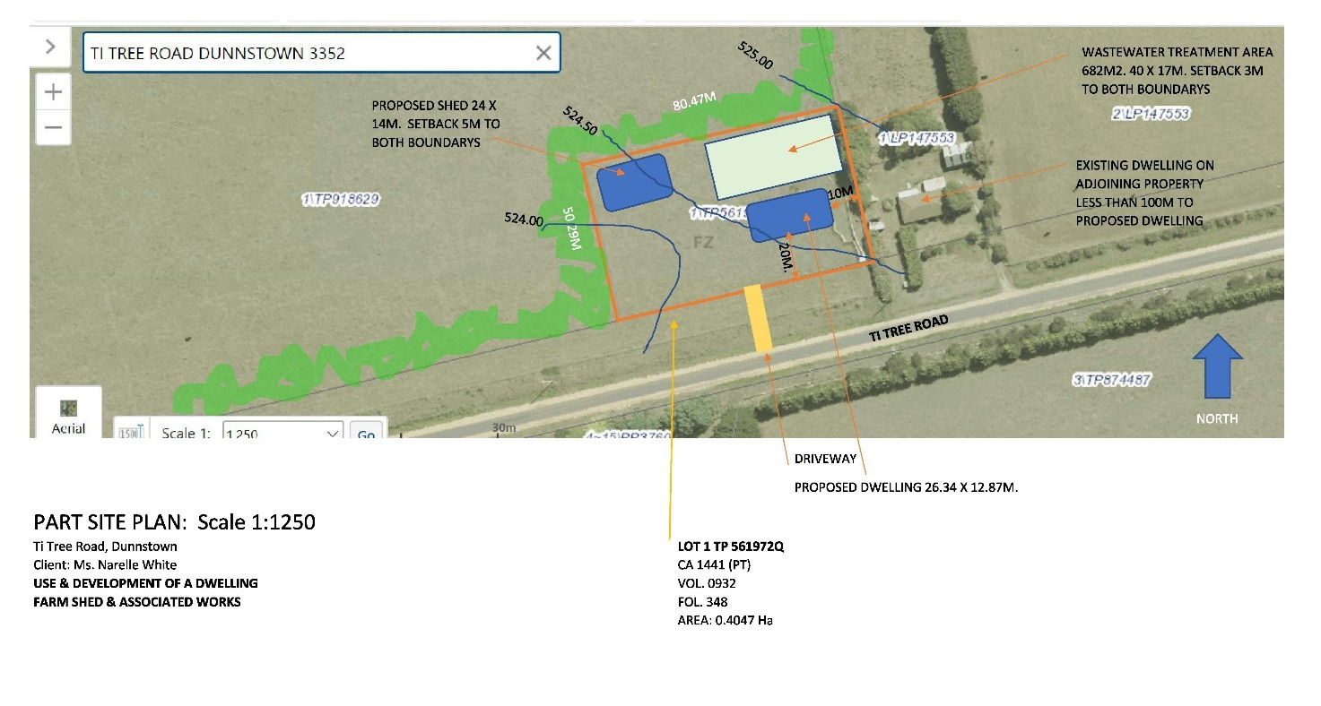
Figure 1: Site Plan.
Figure 2: Proposed dwelling floor plan and elevations
A 5m wide, double-row tree plantation would be established around perimeter of the site but the species to be planted has not been provided. The riparian area at the western end of the site would be fenced from stock. The house site would also be fenced from stock.
It is proposed that the two lots would be consolidated.
A Farm Management Plan (FMP) was included with the application. The FMP stated that a cattle breeding enterprise would be commenced on the site with 10-12 breeding cows and calves and a bull to be run. The applicant has stated the construction and use of a dwelling on this property is reasonably needed to allow the owners to carry out this activity in a viable and best practice manner while attending to the welfare of the stock. A two year timetable of actions required to establish the dwelling and the cattle enterprise was provided, as well as an estimate of the capital and establishment costs required.
The enterprise would require a very high level of productivity to carry 10-12 breeding cows on approximately 6.34ha, excluding the dwelling site and the fenced off riparian area. This would represent a carrying capacity of 26 – 30 Dry Sheep Equivalents per hectare (DSEs/Ha) over the year which would be exceptional productivity without the use of irrigated pastures, or significant supplementary feeding.

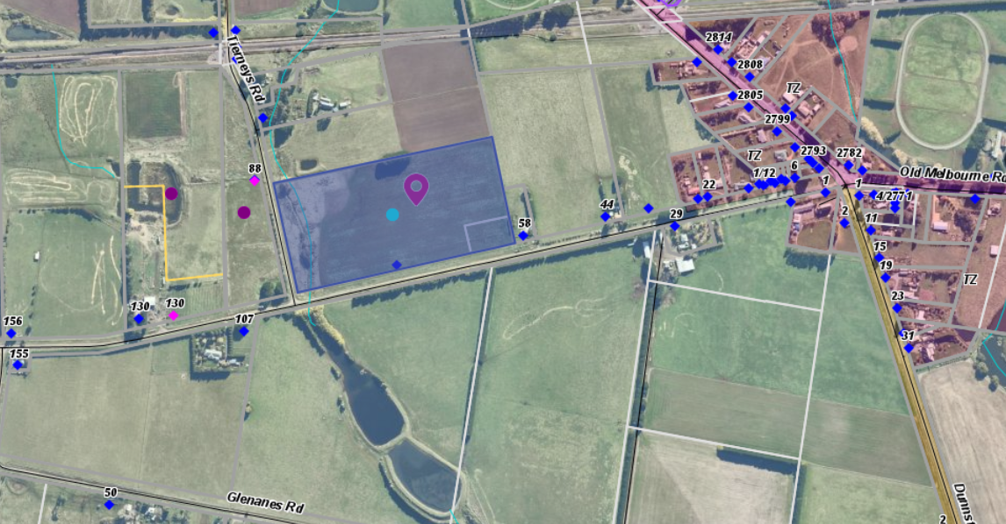
Figure 3: Aerial photo of the site

History
Permit No. PA89/322 issued by the Shire of Buninyong on 29 June 1990 for the development of a dwelling on land at the corner of Torpys and Britts and Howard Road, Dunnstown some three kilometres from the land in this application. This approval included a Section 173 Agreement which Central Highlands Water, formerly the West Moorabool Water Board required. A requirement within the Section 173 Agreement restricted a dwelling and subdivision of land in this application. This dwelling permitted under PA89/322 was been constructed.
Council has a separate application to end the Section 173 Agreement that applies to the land related to the current planning application.

Background to Current Proposal
Legal advice was obtained by Council in relation to the processing of the application for the Planning Permit and a concurrent application to end the Section 173 Agreement on Lot 1 on TP 918629T. The advice is each application should be processed separately as they are under different sections of the Planning and Environment Act 1987 and the permit preamble should not include a reference to end a Section 173 Agreement.

Council’s legal advice that should the titles be consolidated, which is likely to be a requirement of any permit issued, that the agreement on Lot 1 on TP918629T would remain only on that part of the land to which it applied once the lots were consolidated.

Public Notice
The application was notified to adjoining and surrounding landowners.
No objections were received.

Locality Map
The map below indicates the location of the subject site and the zoning of the surrounding area.

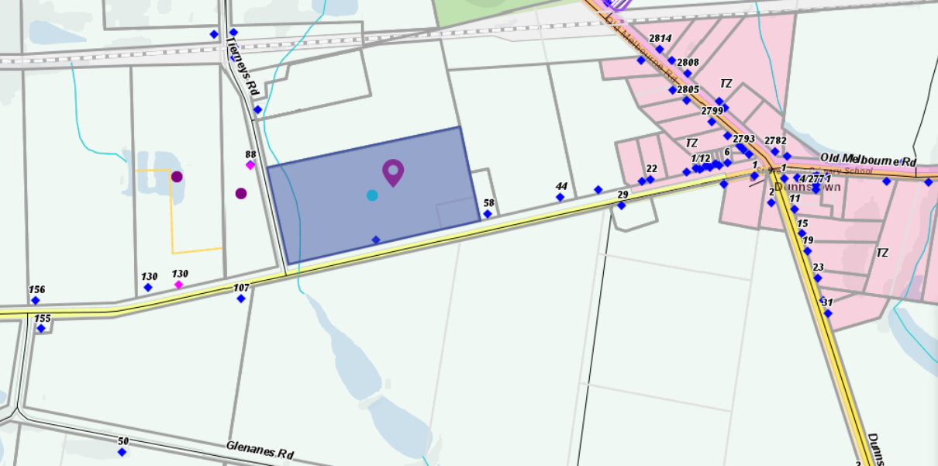
Figure 4: Zone Map – green is Farming Zone, pink is Township Zone

Planning Scheme Provisions
Council is required to consider the Victoria Planning Provisions and give particular attention to the Planning Policy Framework (PPF), the Local Planning Policy Framework (LPPF) and the Municipal Strategic Statement (MSS).
The relevant clauses are:
• Clause 11.03 Peri Urban Areas
• Clause 14 Natural Resource Management
• Clause 14.01-1S Protection of agricultural land
• Clause 14.02-1S Catchment planning and management
• Clause 14.02-2S Water quality
• Clause 15.01-6S Design for rural areas
• Clause 16.01-5S Rural residential development
• Clause 22.03 Houses and House Lot Excisions in Rural Areas
• Clause 21.02-3 Objective—Water and catchment management
• Clause 21.03-4 Objective—Landscape and neighbourhood character
• Clause 21.03-6 Objective—Rural lifestyle opportunities
• Clause 21.04-Economic Development and Employment
• Clause 21.04-1 Key issues and influences Agriculture and horticulture
• Clause 21.04-2 Objectives—Agriculture
The proposal complies with the relevant sections of the PPF and LPPF, with the exception of the clauses outlined in the table below:

PPF | Title | Response
Clause 11.03-3S | Peri-urban areas | The proposal would intensify residential use of the site, resulting in the loss of farming land.
Clause 14 | Natural Resource Management Planning should ensure agricultural land is managed sustainably, while acknowledging the economic importance of agricultural production. | It is considered that the 10-12 breeding cows plus calves proposed on the 8ha site (less the land removed along the waterway and dwelling site) would overstock the property and would ensure this high-quality farming land is not managed sustainably.
Clause 14.01-1S | Protection of agricultural land  Objective To protect the state’s agricultural base by preserving productive farmland. | The proposal increases residential use of farming land and diminishes the capacity of the site to support agriculture activity.
Clause 16.01-5S | Rural residential development  Objective To identify land suitable for rural residential development. | The proposal does not protect high quality agricultural land and is considered to be inappropriate rural residential development located within Farming Zone.

LPPF
Clause 21.02-2 | Non-Urban Landscapes. | The proposal would increase residential development in a rural location which erodes the rural character of the area.
Clause 21.03-4 | Landscape and Neighbourhood Character | The proposed dwelling’s benefit to agriculture is not sufficiently justified.
Clause 21.03-6 | Objective—Rural lifestyle opportunities | The proposal would fragment valuable agricultural land.
Clause 21.04-2 | Objectives—Agriculture  To protect good quality agricultural land and support the productivity and sustainability of existing and future agricultural and horticultural activities. | The proposal would not support productive, sustainable farming.

Zone
Farming Zone
The purposes of the Zone is:
• To implement the Municipal Planning Strategy and the PPF.
• To provide for the use of land for agriculture.
• To encourage the retention of productive agricultural land.
• To ensure that non-agricultural uses, including dwellings, do not adversely affect the use of land for agriculture.
• To encourage the retention of employment and population to support rural communities.
• To encourage use and development of land based on comprehensive and sustainable land management practices and infrastructure provision.
• To provide for the use and development of land for the specific purposes identified in a schedule to this zone.
In accordance with Clause 35.07-1, a permit is required to use land for a dwelling where the land is less than 40ha.
In accordance with Clause 35.07-4 a permit is required for a building or works associated with a use in Section 2 of Clause 35.07-1, and where a building or works is within 100m of a dwelling not in the same ownership.
The nearest neighbouring dwelling is located within 14m of the site and is in the same ownership, so this permit trigger does not apply. There is no neighbouring dwelling within 100m of the site.

Overlays
Environmental Significance Overlay, Schedule 1
In accordance with Clause 42.01-2 a permit is required for buildings and works.
Design and Development Overlay, Schedule 2
In accordance with Clause 43.02 Schedule 2 of the this overlay a permit is not required where all external cladding of buildings is non-reflective. In this application as no reflective materials are proposed a permit is not required under this overlay.

Relevant Policies
Council’s Rural Growth Policy Statement
Council’s Rural Growth Policy Statement was adopted by Council on 19 September 2012. The document applies to all land in Farming Zone. This Council policy is not incorporated into the Moorabool Planning Scheme.
The policy states:
• Encourage dwellings in areas nominated in Map 1 of Council Rural Growth Policy Statement.
• Ensure the siting of any dwellings is designed to have a minimal impact on any existing or future agricultural activities on the site and on surrounding land.
• Ensure it is clear whether the dwelling is required for agricultural operation, use or to maintain rural communities.
• Ensure sufficient infrastructure is available or that alternative methods are available which do not require normal infrastructure.
• Encourage development of dwellings, to support communities, on land which is unlikely to support agricultural (use) while still considering any other overlays which may impact the land. This is land which is constrained for use as agriculture by other environmental factors such as vegetation, slope, soil quality, etc.
The policy requires sufficient justification for the dwelling based on the proposed agricultural activity. Running 10-12 breeding cows plus calves on this site with approximately 6.34ha of available farming land is considered overstocking. The site might sustainably run six cows. Such a small enterprise does not justify the use of a dwelling on the site, especially where the owner has a dwelling on neighbouring land.
Council’s Rural Housing Policy
Council’s Rural Housing Policy 2012 was adopted by Council on 19 September 2012 and has been developed to provide direction for how limited farming potential rural dwellings should be considered, and more broadly, rural settlement patterns. This Council policy is not incorporated into the Moorabool Planning Scheme.
The principles of the policy relevant to this application include to:
• Support the agricultural sector so that it can be more productive, diverse, resilient and adaptive to changing agricultural trends, including supporting agricultural activities that recognise Moorabool’s advantageous proximity to market.
• Protect agricultural land use from loss and allow development that increases agricultural productivity.
• Focus growth opportunities in settlements along major transport corridors, in particular where there is physical and social infrastructure and services.
• Recognise that there are substantial existing lots under 40ha capable of supporting the viable operation of agricultural enterprises.
• Promote a rural housing market that meets the needs of the Shire’s rural communities
• Land parcels for the proposed on-farm living dwellings are to have a minimum lot size of 8ha as identified in Map 1.
The proposed development and use of a dwelling does not align with the above principles and furthermore it is considered to undermine the agricultural potential of the land in the highly productive Dunnstown agricultural district.
The lot is small in area and with the land taken by the dwelling and it associated effluent field, leaves limited area for a production agricultural use that can be sustained in the long term. The proposal does not meet the principle of Council’s Rural Housing Policy of having an existing lot less than 40ha capable of supporting a viable operation of agricultural enterprise.

Discussion
The Moorabool Planning Scheme provides discretion for a permit to be granted to use and develop land for a dwelling on a lot less than 40ha. Where a permit is required, the decision guidelines of the Farming Zone require a range of matters be considered.
The application does not accord with the purposes of the Farming Zone. The proposal does not support the retention of productive agricultural land. It does not encourage the use and development of land based on comprehensive and sustainable land management practices and infrastructure provision. It is considered that this application does not encourage the retention of highly productive agricultural land.
In relation to dwellings in the Farming Zone, the decision guidelines require that the Responsible Authority to consider whether a dwelling will result in the loss or fragmentation of productive agricultural land.
The proposed dwelling to support the cattle enterprise would be sited on the smaller lot with the balance of the land dedicated to the cattle enterprise. Central Highlands Water would require that the waterway on the western end of the site is fenced off from stock. This area is approximately 1-1.5ha. Therefore, the area of land available to run the cattle is approximately 6.5ha.
The Farm Management Plan originally stated that 20 breeding cows would be run on the site which was considered excessive stocking density. The applicant in response to this concern reduced the number of breeding cows to 10-12. It is considered that even this number is likely to significantly overstock the land.
Based on an assessment against the Prograze Manual which assesses Dry Sheep Equivalent (DSE) values for different classes of Cattle, a breeding cow is rated between 10-22 DSE depending on the weight of the cow and assuming calves are weaned at eight months with an average DSE over the year of 15DSE/Ha. The site would therefore support between 6-7 cows. The proposed operation would require that the land had excellent pastures to carry 10-12 cows and a bull over a 12-month breeding cycle supporting a stocking rate from 166 to 196 DSE. This equals a carrying capacity of 26DSE/ha to 30DSE/ha. The DSE values based on records from district agronomists can be adjusted by pasture types and soil types with the disclaimer that are many variables that can affect the ultimate pasture performance so figures can be used only as a basic guide for normal seasonal conditions. This excessive stocking density can only be achieved on irrigated pastures of the highest quality that has not been demonstrated by the submitted Farm Management Plan with the current site.
The application does provide for supplementary feeding on an “as needs” basis but specific details were not provided.
The proposal is not supported by either the PPF or the LPPF which includes protection of the state’s agricultural base by preserving productive farmland. (Clause 14.01-1S.) and maintaining and enhancing the natural environment and the Shire’s rural identity and character. (Clause 21.02-2).
It is considered that the proposal would adversely affect high quality agricultural land from being used for a wholly productive purpose with the introduction of rural residential use. A dwelling on such a small holding is not justified in the context of a small herd of cows. The land is considered ideally suited to cropping within a larger holding. Agricultural Victoria has stated that the Dunnstown area is suitable for growing almost any temperate crop, given adequate water. These soils are also used for growing cereals, oil seeds, peas, potatoes, fodder crops, pastures and Lucerne. Several successive crops can be grown with little deterioration in soil structure or fertility.
The small herd of cows nominated at 10-12 cows exceeds the density rates using DSE and does not indicate that the site can have a productive farming use in the long term.
Overall, the proposed use and development for a dwelling is considered to be inconsistent with the PPF and LPPF, the Farming Zone objectives and the relevant decision guidelines at Clause 65 of the Moorabool Planning Scheme.

General Provisions
Clause 65 – Decision Guidelines have been considered by officers in evaluating this application.
Clause 66 – Stipulates all the relevant referral authorities to which the application must be referred.

Referrals

The application was referred to the following authorities:
Authority | Response
Central Highlands Water | Consent with conditions
Infrastructure  Environmental Health | Consent with conditions  Consent with conditions

Financial Implications
There is no financial implication associated with this refusal to grant a permit for this use and development of a dwelling.

Risk & Occupational Health & Safety Issues
The recommendation of refusal of the planning application does present any OH&S issues to Council.

Communications Strategy
Notice was undertaken for the application, in accordance with s.52 of the Planning and Environment Act 1987, and further correspondence is required to all interested parties to the application as a result of a decision in this matter. All submitters and the applicant were invited to attend this meeting and invited to address Council if required.

Communications Strategy
Notice was undertaken for the application, in accordance with s.52 of the Planning and Environment Act 1987, and further correspondence is required to all interested parties to the application as a result of a decision in this matter. The applicant was invited to attend this meeting and invited to address Council if required.

Options
Council could consider the following options:
• issue a refusal to grant a permit in accordance with the recommendations of this report; or
• issue a permit with conditions outside of the recommendations of this report.

Conclusion
The Dunnstown agricultural district has some of the most productive agricultural soils in the Shire. The planning policies and Farming Zone provisions seek to prevent the loss or fragmentation of agricultural land with dwellings. The small lot size has site constraints including the riparian area at the western end of the property. The Farm Management Plan submitted did not demonstrate the need for dwelling to support such a small number of breeding cows which exceeds the density rates. It is unlikely a productive farming use of the land in the long term can be sustained due to the small land area and the type of farming activity. Additional residential development on prime agricultural land does not accord with the planning policies of the Moorabool Planning Scheme. It is recommended the application be refused with specified grounds.

Committee Resolution
Moved: Cr David Edwards
Seconded: Cr Rod Ward
That Item 7.6, PA2019216 - Development of Three Offices and One Dwelling, Use and Development of Two Dwellings and a Reduction of Car Parking (12 Spaces) at 148C and 150 Inglis Street, Ballan, be moved and considered as the last Item of tonight’s agenda to provide speakers the opportunity to join the meeting.
Carried

7.7 PA2020136 - Development of an Outbuilding and Water Tank Ancillary to an Existing Dwelling at 19 Faheys Road, Gordon
Author: Thomas Tonkin, Statutory Planner
Authoriser: Henry Bezuidenhout, Executive Manager Community Planning & Economic Development
Attachments: 1. Proposed Site Plan (under separate cover)
2. Outbuildings Plans (under separate cover)

Application Summary
Permit No: PA2020136
Lodgement Date: 9 July 2020
Planning Officer: Tom Tonkin
Address of the land: 19 Faheys Road, Gordon, 3345
Proposal: Development of a Shed Ancillary to an Existing Dwelling
Lot size: 7.2ha
Why is a permit required? Clause 35.03 Rural Living Zone – Buildings and works within 100m of a waterway
Clause 42.01 Environmental Significance Overlay, Schedule 1 – Buildings and works

Committee Resolution
Moved: Cr Ally Munari
Seconded: Cr Rod Ward
That Council, having considered all matters as prescribed by the Planning and Environment Act 1987, issues a Planning Permit PA2020136 for Development of an Outbuilding and Water Tank Ancillary to an Existing Dwelling at Crown Allotment 3, Section 11A, Parish of Kerrit Bareet known as 19 Faheys Road, Gordon 3345, subject to the following conditions:
Endorsed Plans:
1. The development as shown on the endorsed plans must not be altered without the written consent of the Responsible Authority. All buildings and works must be constructed or undertaken in accordance with the endorsed plans to the satisfaction of the Responsible Authority.
Buildings and Works:
2. Within 12 months of the issue of a Certificate of Final Inspection for the approved outbuilding, the existing outbuilding must be removed or demolished to the satisfaction of the Responsible Authority.
Materials and Colour:
3. All external walls and roof areas of the proposed buildings are to be clad with non-reflective materials (zincalume prohibited) to the satisfaction of the Responsible Authority.
Infrastructure:
4. Storm water drainage from the proposed buildings and impervious surfaces must be disposed of to the satisfaction of the Responsible Authority. Overflows from on-site storage systems must be directed away from any waste water disposal areas.
5. Sediment discharges must be restricted from any construction activities within the property in accordance with relevant Guidelines including Construction Techniques for Sediment Control (EPA 1991).
6. Unless otherwise approved by the Responsible Authority there must be no buildings, structures, or improvements located over any drainage pipes and easements on the property.
7. Prior to the commencement of the development and post completion, notification including photographic evidence must be sent to Council’s Asset Services identifying any existing damage to Council assets. Any existing works affected by the development must be fully reinstated at no cost to and to the satisfaction of the Responsible Authority.
Barwon Water:
8. The permitted building must not be used for any habitable purpose and must not be used for any commercial or industrial purpose, except in accordance with the provisions of the Moorabool Planning Scheme.
9. The existing effluent disposal areas must be kept free from stock, buildings, driveways and service trenching.
10. Stormwater must not be released directly into any waterway and must be directed away from any existing or approved effluent fields.
11. Sediment control measures outlined in the EPA’s publication No 275, Sediment Pollution Control, shall be employed during construction and maintained until the disturbed area has been revegetated.
12. The use, storage and disposal of fuel and chemicals must be managed in accordance with EPA’s publication 1698 Liquid storage and handling guidelines. Chemicals and fuels used on site must be registered by the Australian Pesticides and Veterinary Medicines Authority and must be stored in their own, labelled containers above flood levels to avoid water contamination in flood or overland flow events.
13. Appropriate farm waste management must be carried out, as outlined in EPA’s publication IWRG641.1 Industrial Waste Resource Guideline.

Permit Expiry:
14. This permit will expire if one of the following circumstances applies:
  - the development is not started within two years of the date of this permit; and
  - the development is not completed within four years of the date of this permit.
Carried

Public Consultation
Was the application advertised? | No. See ‘Public Notice’ below.
Notices on site: | None.
Notice in Moorabool Newspaper: | No.
Number of objections: | None.
Consultation meeting: | Not applicable.

Policy Implications
The Council Plan 2017-2021 provides as follows:
Strategic Objective 2: Minimising Environmental Impact
Context 2A: Built Environment
The proposal does not conflict with the Council Plan 2017 – 2021.

Victorian Charter of Human Rights & Responsibilities Act 2006
In developing this report to Council, the officer considered whether the subject matter raised any human rights issues. In particular, whether the scope of any human right established by the Victorian Charter of Human Rights and Responsibilities is in any way limited, restricted or interfered with by the recommendations contained in the report. It is considered that the subject matter does not raise any human rights issues.

Officer’s Declaration of Conflict of Interests
Under section 130 of the Local Government Act 2020, officers providing advice to Council must disclose any interests, including the type of interest.
Executive Manager – Henry Bezuidenhout
In providing this advice to Council as the Executive Manager, I have no interests to disclose in this report.
Author – Tom Tonkin
In providing this advice to Council as the Author, I have no interests to disclose in this report.
Statutory Planner, Victoria Mack declared a Direct Conflict of Interest in relation to PA2020136 Development of an Outbuilding Ancillary to an Existing Dwelling due to being the permit applicant/land owner’s partner and consequently was not involved in any preparation or deliberations of this report for Council’s consideration.

Executive Summary
Application referred? | Yes, Barwon Water, Corangamite Catchment Management Authority (CCMA) and Council’s Infrastructure.
Any issues raised in referral responses? | No.
Preliminary concerns? | Insufficient information on the proposed plans.
Any discussions with applicant regarding concerns? | Nil.
Any changes made to the application since being lodged? | Appropriately detailed site plan submitted.
Brief history. | None applicable.
Previous applications for the site? | See ‘History’ below.
General summary. | Proposed 200.8sqm shed and water tank ancillary to an existing dwelling, located approximately 80m from a small waterway. No sanitary fixtures are proposed, and the proposal meets the requirements of the relevant referral authorities, subject to conditions. Both siting and design of the outbuilding respects the rural character of the area.
Summary Recommendation
That, having considered all relevant matters as required by the Planning and Environment Act 1987, Council issue a Planning Permit for the Development of an Outbuilding and Water Tank Ancillary to an Existing Dwelling at 19 Faheys Road, Gordon, in accordance with Section 61 of the Planning and Environment Act 1987, subject to the conditions included in this report.

Site Description
The subject site, identified as Crown Allotment 3, Section 11A, Parish of Kerrit Bareet and known as 19 Faheys Road, Gordon, is located on the north side of Faheys Road approximately 300m west of Stanley Street. The site is an irregular shape with an area of 7.2ha, falling generally from north to south by several metres and contains a dwelling and ancillary outbuilding located towards the western title boundary. There is a dam located towards the front of the site and a small waterway that flows southwards through the southwest corner of the site. The site contains only scattered vegetation.
The subject site and surrounding land to the east, west and north is in the Rural Living Zone and characterised by lots of varying sizes developed with dwellings. Vegetation cover is varied, with some lots substantially cleared having only scattered trees and other lots heavily vegetated. Land to the south is in the Neighbourhood Residential Zone and also characterised by dwellings on lots generally less than 2,000sqm in size.
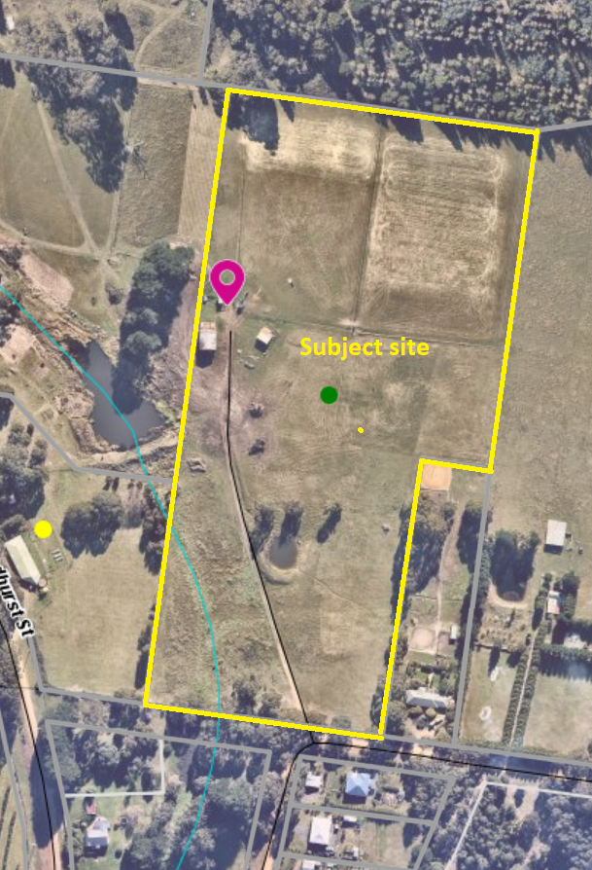
Figure 1: Aerial photograph

Proposal
It is proposed to construct a shed ancillary to the existing dwelling, replacing the existing dilapidated shed. The proposed shed would be set back 5m from the west title boundary, 127m from the north boundary and approximately 20m north of the existing shed. The shed would comprise a 120sqm fully enclosed section and a 16sqm verandah under a pitched gable rood and a 64.8sqm semi-enclosed section under a skillion roof, yielding an overall area of 200.8sqm. The shed would have a varied wall height of 2.97m – 3.6m, an overall height of 5.216m and be clad with Colorbond ‘Monument’. A 250sqm site cut of no more than 1m in depth has been prepared for the shed site. It is also proposed to construct a 100,000L water tank on the south side of the proposed shed, also clad with Colorbond ‘Monument’, with a 6.8m diameter and 2.2m height. No vegetation removal would be required.
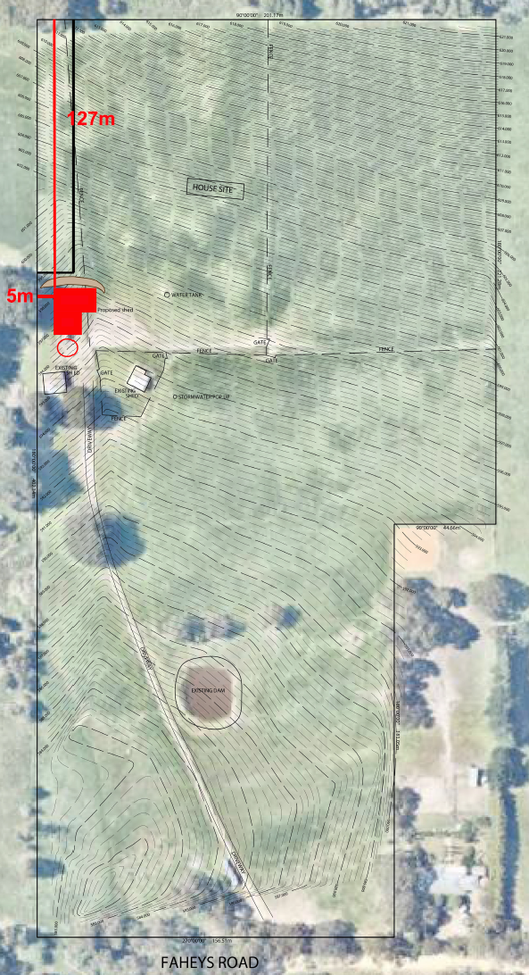
Figure 2: Site Plan
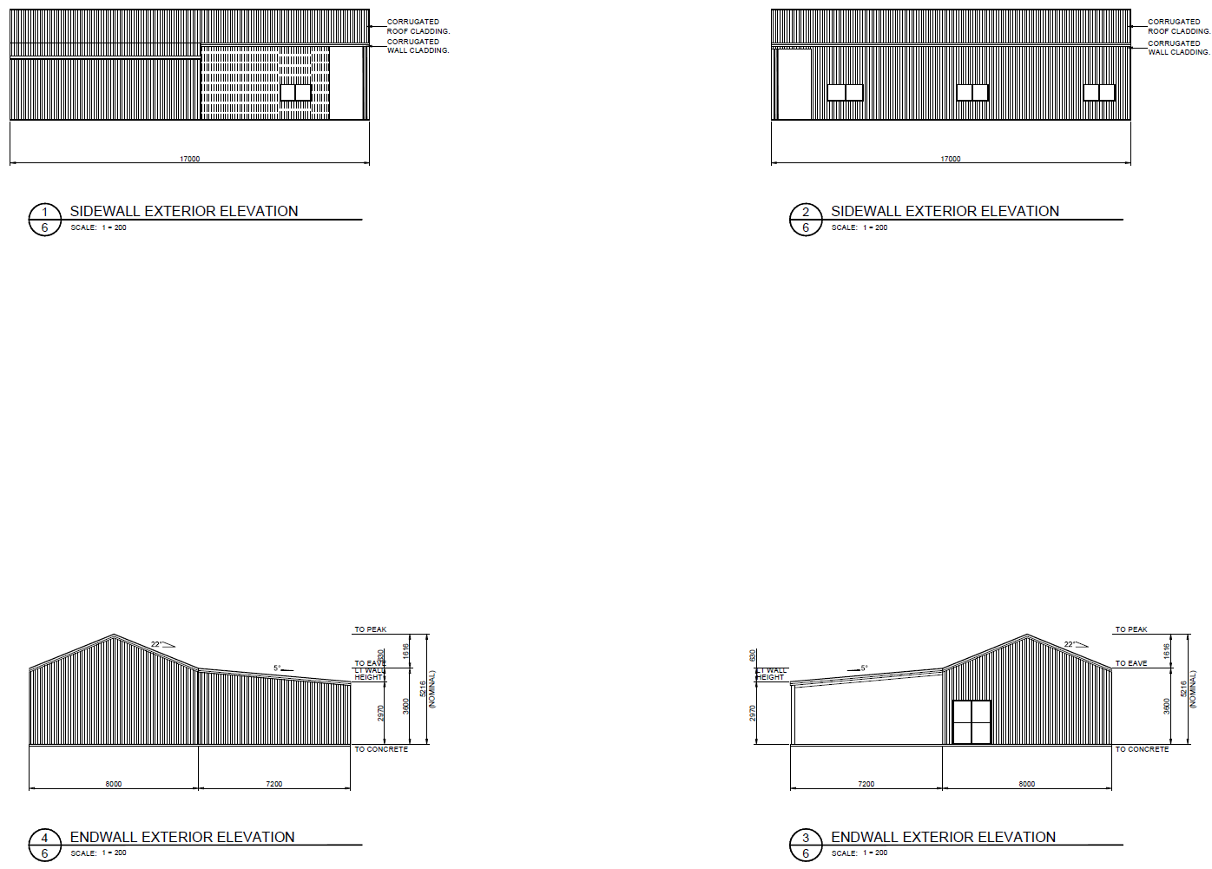
Figure 3: Shed elevations

History
Previous applications for the site are as follows:
• PA2019264 for Removal of Vegetation (27+ Cypress Trees) approved on 18 March 2020.
• PA2003008 for Development and Use of a Dam approved on 19 March 2003.

Public Notice
No notice of the application was given to adjoining and surrounding landowners for the following reasons:
• The proposed use of the outbuilding ancillary to a dwelling is of ‘as of right’ under the zone controls.
• Under the Environmental Significance Overlay Schedule 1, Barwon Water received notification of the proposal and consented.
• Under the Environmental Significance Overlay Schedule 1 no notification is required to surrounding properties.
• Due to flooding affecting the property, CCMA received notification of the proposal and consented.
• Subject to conditions, the proposed development meets the applicable design requirements of the Design and Development Overlay, Schedules 2 and 5.
For the above reasons, the proposed development was not advertised.

Locality Map
The map below indicates the location of the subject site and the zoning of the surrounding area.
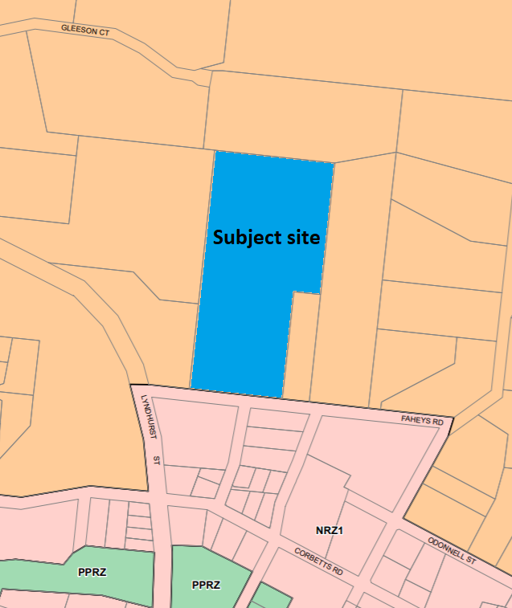
Figure 4: Zone map

Planning Scheme Provisions
Council is required to consider the Victoria Planning Provisions which includes the Planning Policy Framework (PPF), the Local Planning Policy Framework (LPPF) and the Municipal Strategic Statement (MSS).
The relevant clauses are:
• Clause 11.03-3S Peri-urban areas
• Clause 14.02-2S Water quality
• Clause 15.01-5S Neighbourhood character
• Clause 21.02-2 Non-urban landscapes
• Clause 21.02-3 Water and Catchment Management
• Clause 21.03-4 Landscape and Neighbourhood Character
• Clause 21.09-2 Gordon
• Clause 22.02 Special Water Supply Catchments
The proposal generally complies with the relevant sections of the PPF and LPPF.

Zone
The subject site is in the Rural Living Zone (RLZ). The purpose of the Zone is:
• To implement the Municipal Planning Strategy and the Planning Policy Framework.
• To provide for residential use in a rural environment.
• To provide for agricultural land uses which do not adversely affect the amenity of surrounding land uses.
• To protect and enhance the natural resources, biodiversity and landscape and heritage values of the area.
• To encourage use and development of land based on comprehensive and sustainable land management practices and infrastructure provision.
Under Clause 35.03-4 a permit is required to construct a building within 100m of a waterway.

Overlays
The site is affected by several planning overlays.
Environmental Significance Overlay, Schedule 1 (ESO1)
The ESO1 applies to land in a Special Water Supply Catchment. Under Clause 42.01-2 a permit is required to construct buildings and works. There are no applicable exemptions under Schedule 1. Subject to conditions, the proposal would satisfy the provisions of the ESO1.
Design and Development Overlay, Schedules 2 and 5 (DDO2 & 5)
The DDO2 applies to development using reflective exterior cladding.
In this instance a permit is not required.
The DDO5 applies to the Gordon township and rural surrounds. Under Clause 43.02-3 a permit is required to construct buildings and works, and Clause 2.0 of Schedule 5 stipulates that a permit is not required for buildings which meet specific requirements, including for site coverage, building footprint, height and boundary setbacks, earthworks and external cladding.
In this instance, no permit is required, subject to the demolition of the existing outbuilding as proposed by the applicant. It is recommended that a condition of approval require the existing outbuilding to be demolished or removed within one month of the proposed shed’s completion.
Significant Landscape Overlay, Schedule 2 (SLO2)
Under the SLO2, a permit is required to construct buildings and works only within 4m of existing trees.
In this instance, no permit is required.
Bushfire Management Overlay (BMO)
A section of the site affected by the BMO does not include the location of the proposed shed,
In this instance no permit is required.
Relevant Policies
Gordon Structure Plan 2013
The Structure Plan sets out requirements for the preferred form and scale of future development. Consultation with the community indicated a strong community desire to retain the small town feel and the quality of the rural setting.
The town’s landscape character was also acknowledged as quite complex, comprised of a diverse range of elements – natural, introduced and built – with considerable care needed to ensure that the location, scale and form of new development reinforces the qualities and character of that landscape. It acknowledged there are considerable opportunities to reinforce the landscape and character of the town particularly through further carefully selected and sited planting associated with new development and along key roads and routes.
It was noted that future development based on higher density and smaller lot residential development should be focused in the area bound by Urquhart, Lyndhurst, Tennyson Streets and the western edge of the established township area.
An identified principle of the Structure Plan was ‘the retention of the rural character of the township area and surrounds is paramount to retaining the lower density scale residential and vegetated areas in the surrounds and the wider rural living setting of the township’.

Particular Provisions
There are no applicable Particular Provisions.

Discussion
Overall, the proposed development is considered to be generally consistent with the applicable planning policy in the Moorabool Planning Scheme.
The proposed shed would be ancillary to an existing dwelling and setback approximately 80m from the nearest waterway to the south-west. The shed would not contain any fixtures which generate wastewater and stormwater runoff into the waterway would be mitigated by being diverted to the proposed water tank. The application was referred to Barwon Water, as the relevant catchment management authority given the site’s location in a potable water supply catchment, and conditional consent was provided. The application was also referred to CCMA who gave unconditional consent, noting that the proposed development is beyond the area mapped as subject to flooding in a 1 in 100 year flood event. No vegetation removal is proposed and, subject to conditions, the proposal would not have any detrimental impacts on the waterway.
The siting and design of the ancillary shed would be generally consistent with surrounding development. Non-reflective cladding is proposed, and the building would have low pitched hipped and skillion roof forms. The proposed boundary setbacks would be sufficient to accommodate screening vegetation as proposed by the applicant.

General Provisions
Clause 65 – Decision Guidelines have been considered by officers in evaluating this application.
Clause 66 – Stipulates all the relevant referral authorities to which the application must be referred.

Referrals
Authority | Response
Barwon Water  Corangamite Catchment Management Authority | Consent with conditions  Consent
Infrastructure | Consent with conditions

Financial Implications
There are no financial implications for Council in approving the application.

Risk & Occupational Health & Safety Issues
The recommendation to approve this application does not have any risk or OH&S implications for Council.

Communications Strategy
As outlined above, apart from referrals to relevant agencies no notice was undertaken for the application under s.52 of the Planning and Environment Act 1987, and further correspondence is required only to the applicant as a result of a decision in this matter. The applicant was invited to attend this meeting and address Council if required.

Options
Council could consider the following options:
• issue a Planning Permit in accordance with the conditions in the recommendation of this report; or
• issue a Planning Permit with amendments to the conditions in the recommendation of this report. For either of these options, the permit applicant is entitled to appeal permit conditions at VCAT; or
• issue a Refusal to Grant a Permit on grounds. Council would need to consider what reasonable grounds there would be to refuse the application. This option may result in the applicant appealing Council’s decision to VCAT.

Conclusion
Overall, the proposed development of ancillary shed to an existing dwelling is consistent with the relevant planning policies in the Moorabool Planning Scheme. The proposed structures would be ancillary to an existing dwelling and, subject to conditions, sited and designed to protect water quality within a catchment area. The proposed development is consistent with the objectives of the Environmental Significance Overlay Schedule 1. It is recommended that the application be approved.

7.8 PA2020124 - Use of the land for a Tradesperson Depot at 15 Eden Crescent, Hopetoun Park
Author: Thomas Tonkin, Statutory Planner
Authoriser: Henry Bezuidenhout, Executive Manager Community Planning & Economic Development
Attachments: 1. Site Plan (under separate cover)

Application Summary
Permit No: PA2020124
Lodgement Date: 25 June 2020
Planning Officer: Tom Tonkin
Address of the land: 15 Eden Crescent, Hopetoun Park
Proposal: Use of the land for a Tradesperson Depot
Lot size: 8522sqm
Why is a permit required? Clause 32.03 Low Density Residential Zone – Use of the land for a Tradesperson Depot

Committee Resolution
Moved: Cr David Edwards
Seconded: Cr Paul Tatchell
That Council, having considered all matters as prescribed by the Planning and Environment Act 1987, issues a Refusal to Grant a Permit for Use for a Tradesperson Depot at Lot 604 on PS 713320G known as 15 Eden Crescent, Hopetoun Park 3340, on the following grounds:
- The proposed use is inconsistent with relevant State and local planning policy for the protection of residential amenity and appropriate separation of conflicting land uses.
- The proposed use is inconsistent with the purpose of the Low Density Residential Zone.
- The proposed use is inconsistent with the orderly planning of the area.
- The proposed use would have an unreasonable impact on the amenity of the area.
Carried

Public Consultation
Was the application advertised? | Yes
Notices on site: | Yes, one.
Notice in Moorabool Newspaper: | No.
Number of objections: | Three.  Additionally, one submission was received in support of the application.
Consultation meeting: | No.

Policy Implications
The Council Plan 2017-2021 provides as follows:
Strategic Objective 2: Minimising Environmental Impact
Context 3A: Land Use Planning
The proposal does not conflict with the Council Plan 2017 – 2021.

Victorian Charter of Human Rights & Responsibilities Act 2006
In developing this report to Council, the officer considered whether the subject matter raised any human rights issues. In particular, whether the scope of any human right established by the Victorian Charter of Human Rights and Responsibilities is in any way limited, restricted or interfered with by the recommendations contained in the report. It is considered that the subject matter does not raise any human rights issues.

Officer’s Declaration of Conflict of Interests
Under section 130 of the Local Government Act 2020, officers providing advice to Council must disclose any interests, including the type of interest.
Executive Manager – Henry Bezuidenhout
In providing this advice to Council as the Executive Manager, I have no interests to disclose in this report.
Author – Tom Tonkin
In providing this advice to Council as the Author, I have no interests to disclose in this report.

Executive Summary
Application referred? | Yes, to Council’s Infrastructure.
Any issues raised in referral responses? | No.
Preliminary concerns? | The Council officer wrote to the applicant to request further information about the land use, including operational information.
Any discussions with applicant regarding concerns? | No further discussions.
Any changes made to the application since being lodged? | The applicant provided a written response to the preliminary concerns outlined above.
Brief history. | See ‘History’ below.
Previous applications for the site? | None.
General summary. | Retrospective approval is sought to use the site for a tradesperson depot associated with a skid steer business doing site cleans and landscaping. The proprietor lives in an on-site dwelling and employs up to nine people in the business who use the site as a base to transport trucks, machinery, equipment and materials to work sites, returning each afternoon.  Various business related activities occur onsite such as the refuelling and washing of vehicles.  Three objections were received expressing a range of concerns broadly relating to the loss of residential amenity due to vehicle movements, noise, dust and the appearance of the site and safety concerns.  Overall, the proposal is inconsistent with the relevant provisions of the Moorabool Planning Scheme for a site located within a residential area and is not supported.
Summary Recommendation
That, having considered all relevant matters as required by the Planning and Environment Act 1987, Council issue a Refusal to Grant a Permit for Use of the land for a Tradesperson Depot at Lot 604 on PS 713320G known as 15 Eden Crescent, Hopetoun Park 3340, on the grounds included in this report.

Site Description
The site, identified as Lot 604 on PS713320G and known as 15 Eden Crescent, Hopetoun Park, is 8522sqm in size and located on the north side of the street approximately 345m east of Carberry Drive and 230m west of View Gully Road. The site contains a single storey dwelling positioned towards the centre of the site and a shed with dimensions of 35.0m x 21m and an overall height of 6.949m. The shed is located in the north-west corner of the site with a gravelled area in front of the shed. Vehicle access is via two existing crossovers.
The subject site and surrounding land is in the Low Density Residential Zone and characterised by mostly single storey dwellings on spacious allotments, a number of which are also developed with sheds of varying sizes. The shed on the subject site is one of the largest sheds in the surrounding neighbourhood.

Proposal
Retrospective approval is sought to use the site for a tradesperson depot to store vehicles and equipment including three utility vehicles, two large heavy rigid trucks and one medium rigid truck within the existing shed. The business, which operates skid steer (Bobcat) vehicles for site cleaning and landscaping activities, employs between 7-10 people and their vehicles would also be parked in the shed during business hours. The proponent has nominated the business hours as Monday-Friday 6.30AM to 6.00PM and occasional Saturdays from 7.00AM to 4.00PM, varied in summer months to occasionally start at 6.00AM. No major vehicle repairs occur onsite unless machines need to be greased or a wheel changed due to a puncture. Noise generated by the business would be generally confined to employees’ vehicles entering and leaving the site in the morning and evening, trucks being started at the commencement of business hours for 15 minutes and trucks returning to the site between 3.00PM and 6.00PM. Machines are operated or loaded onto trucks only in the afternoons. The only other activity to occur during the day would be the occasional delivery of plants or parcels. Vehicle movements to and from the site across the day are estimated to be on average 25. There is an external sensor light on the house and on the shed to discourage burglary.

Background to Current Proposal
See ‘History’ below.

History
On 23 October 2019, at the request of the permit applicant and as provided for by the covenants registered on the title to the land, Council gave prior written consent to the existing shed being constructed to a maximum height of 6.949m, exceeding the 5.4m stipulated on the covenant.
In late January 2020, Council commenced enforcement investigations in response to concerns raised by a nearby resident (“the complainant”) regarding the shed and activities associated with the use now subject to the current permit application. Since January the complainant has corresponded with Council about ongoing concerns regarding activities on the site. Council liaised with the permit applicant to gain agreement that activities progress on site subject to specified conditions until a decision is made on the current permit application. The complainant has since notified Council that these conditions are not being complied with. The complainant has subsequently submitted an objection to the permit application.

Public Notice
Notice of the application was given to adjoining and surrounding landowners and occupiers by post and a sign erected on site from 16-30 September 2020. Three objections were received, one of which was anonymous. A fourth submission was received in support of the proposal.

Summary of Objections
The objections received are detailed below with officer’s comments accompanying them:
Objection | Any Relevant Requirement
The existing shed far exceeds the covenant restrictions and was built without consultation with those impacted. Furthermore, the building is of a commercial scale and inconsistent with the residential and rural character and aesthetic of the area. | N/a.
Officer’s Response:
Construction of the shed is not subject to an assessment under this application as it was previously approved by Council, as allowed for by the applicable covenants.
The permit for the shed stipulates it must only be used ancillary to the existing dwelling. | Clause 32.03.
Officer’s Response:
Council’s approval of the shed was only in relation to its height exceeding what the covenant stipulates. The use of the shed is subject to the current permit application.
The shed is used to store a combination of 20 vehicles, trailers, earthmoving machinery and other ancillary equipment. which include, in addition to that described under ‘Proposal’, one Landcruiser, one 2,000L refuelling trailer, four caged tandem axle trailers, one single axle trailer, four skid steer loaders, one excavator, one tandem axle plant trailer and one dog trailer. | Clause 32.03.
Officer’s Response:
This information is noted. The applicant stated in the application documents that the shed is also used to store belongings for personal use which would appear to include some but not all vehicles and goods additional to those advised of by the applicant.
On Monday-Friday up to 10 staff arrive in at least seven vehicles between 5.45AM and 7.00AM, park outside the shed and transfer to, on average, seven work vehicles and trailers before returning to the site between 2.30PM and 6.00PM. On Saturdays there is slightly reduced activity. In total there are a minimum of 14 vehicle movements from the property between 5.45AM and 7.00AM. There are deliveries of plants, general supplies and maintenance items and stockpiles of gravel and soil are dumped on site suggesting the site is used as a quasi-landscape supplies business.  The number of vehicle movements associated with the business far exceeds that associated with normal domestic activity. | Clauses 32.03 and 65.01.
Officer’s Response:
This information is noted, particularly the arrival times on site being earlier than that stated by the applicant and deliveries appearing to exceed what the applicant described in the proposal.
Noise from trucks starting up and idling in the morning for more than 15 minutes and for up to half an hour when trucks start at different times. The high beam headlights of vehicles departing of a morning cast light into our house. Noise in the afternoons associated with trucks returning to the site and employees leaving includes vehicles reversing with beeper sounds, skid steers being loaded and unloaded, materials being moved around and general industrial type noise. Employees perform maintenance such as refuelling, servicing and washing of equipment and congregate and socialise over a prolonged period. Employees work in the shed doing grinding, welding and maintenance.  Servicing and maintenance of vehicles is carried out onsite, both in and outside the shed. A mobile service truck attends the site to perform maintenance for extended periods as required and has involved revving of truck engines as late as 11.00PM. Other maintenance is carried out at different hours and has included grinding and welding at 6.45AM.  Three sensor lights are affixed to the front of the shed and shine across the street onto properties directly opposite, flicking on and off up to 20 times a morning and casting light into our house. | Clauses 13.05-1S, 13.07-1S, 32.03 and 65.01.
Officer’s Response:
This information is noted, particularly that it appears to exceed the scope of repairs, maintenance and activities described in the applicant’s proposal.

Sunday is often used as a maintenance day with various activities carried out on site such as pressure washing of vehicles. | Clauses 32.03 and 65.01.
Officer’s Response:
This information is noted.
The use and appearance of the site is more in keeping with that of an industrial estate and is not in keeping with the neighbourhood character. | Clauses 32.03 and 65.01.
Officer’s Response:
See ‘Discussion’ below.
Refuelling of vehicles is carried out daily with a refuelling trailer kept on site. but refilled offsite several times a week. In recent times a 38,000L refuelling tanker has attended the site at least once a week to refill the trailer. When vehicles are refuelled the site has the appearance of a pop-up service station with a procession of vehicles waiting to be refuelled. | Clause 32.03.
Officer’s Response:
This information is noted, particularly that it was not included in the applicant’s description of the proposal.
Large amounts of dust are created from vehicles on site and when material is loaded and unloaded from trucks. | Clauses 13.07-1S, 32.03 and 65.01.
Officer’s Response:
This information is noted.
EPA regulations for residential areas impose limits on machinery being operated in residential areas before 7.00AM. | Clauses 13.05-1S, 13.07-1S, 32.03 and 65.01.
Officer’s Response:
This information is noted.
Construction waste has been observed in trucks and trailers entering and being stored outdoors on site. | Clauses 13.07-1S, 32.03 and 65.01.
Officer’s Response:
This information is noted.
The proposal directly impacts on the amenity of the neighbourhood, such as staff drinking alcohol within view of the public and doing burnouts in vehicles. | Clauses 32.03 and 65.01.
Officer’s Response:
This information is noted.
Diminished property values based on the site’s visual appearance and the nature of the land use being incompatible with surrounding residential use. | N/A.

Officer’s Response:
Property values are subject to a variety of factors including beyond the concerns raised by the objector.
The washing, servicing and maintenance of vehicles on site as part of a commercial enterprise is defined as ‘Industry’ under the Victoria Planning Provisions and is prohibited in the LDRZ. | Clauses 32.03 & 73.03.
Officer’s Response:
It is agreed that this component of the use appears to be prohibited.
The site plan included with the application misrepresents the location of the shed and use. | N/a.
Officer’s Response:
It is agreed that the site plan is inaccurate, and the measurements claimed by the objector are much more accurate.
Increased heavy vehicles in the area pose possible safety impacts for children, pedestrians and cyclists. | Clause 65.01.
Officer’s Response:
This information is noted and discussed in more detail in the discussion section of the Report.
It is naïve to think that onsite vehicle maintenance would not occur, which would be subject to EPA regulations regarding noise, fuel storage, emissions and fire prevention. | Clauses 13.05-1S, 13.07-1S and 65.01.
Officer’s Response:
The proposed use would be subject to the State Environment Protection Policy (Control of Noise from Commerce, Industry and Trade) No. N-1 (SEPP N-1).
How will the proposed use be monitored to ensure compliance, such as vehicle noise in the mornings? | Clauses 13.05-1S, 13.07-1S, 32.03 and 65.01.
Officer’s Response:
Any breach of permit conditions is subject to enforcement action by Council officers.
Approval of this proposal is likely to set a precedent which would destroy the amenity of the area and have safety consequences. | Clauses 13.05-1S, 13.07-1S, 32.03 and 65.01.
Officer’s Response:
Each application is considered on its merits and the assessment based upon the relevant provisions of the Moorabool Planning and Scheme. Prior planning decisions may also inform an assessment.

The submission received in support of the application was from a resident who received direct notice of the application. The submitter stated they have observed activities on the site and would not experience any disruption or loss of quality of life if the application is approved.

Locality Map
The map below indicates the location of the subject site and the zoning of the surrounding area.
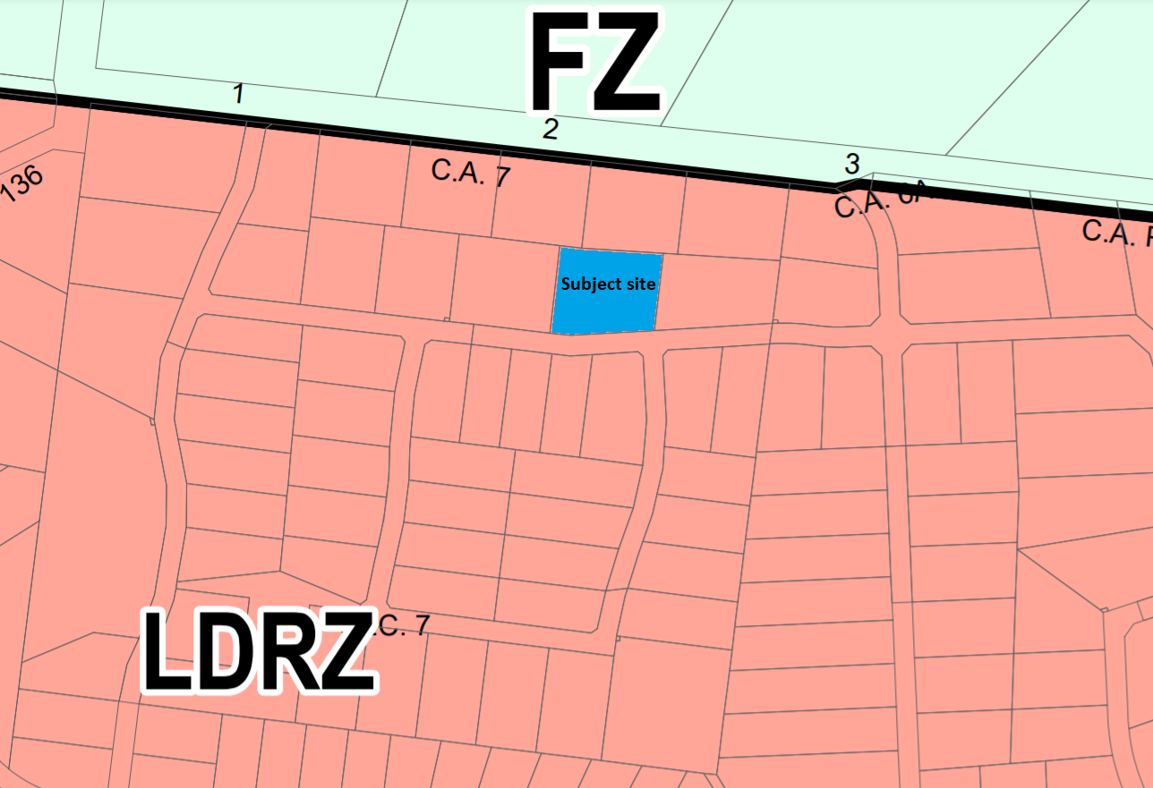
Figure 1: Zone map
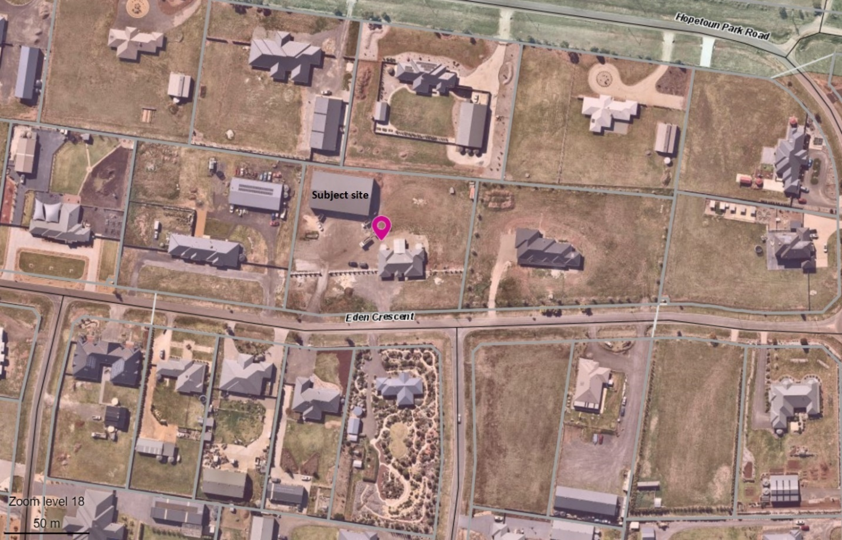
Figure 2: Aerial photograph

Planning Scheme Provisions
Council is required to consider the Victoria Planning Provisions and give particular attention to the Planning Policy Framework (PPF), the Local Planning Policy Framework (LPPF) and the Municipal Strategic Statement (MSS).
The relevant clauses are:
• Clause 11.03-3S Peri-urban areas
• Clause 13.05-1S Noise abatement
• Clause 13.07-1S Land use compatibility
• Clause 17.01-1R Diversified economy – Central Highlands
• Clause 21.03-3 Residential development
• Clause 21.07-2 Managing urban growth
The proposal is not compliant with the following clauses of the PPF and LPPF, as outlined in the table below:

PPF | Title | Response
Clause 11.03-3S | Peri-urban areas | The proposed use is inconsistent with the policy which seeks to enhance the attractiveness and amenity of peri-urban towns.
Clause 13.05-1S | Noise abatement | The proposed use is inappropriately located in respect of adjoining residential land uses and the impact of noise on residential amenity.
Clause 13.07-1S | Land use compatibility | The nature and scale of the proposed use is incompatible with surrounding residential amenity and is unsuited to this location.
LPPF

Clause 21.03-3 | Residential development | The proposed non-residential use is incompatible with the scale and character of the surrounding area.
Clause 21.07-2 | Managing urban growth | The subject site does not enable appropriate separation between the proposed use and surrounding dwellings to mitigate off-site impacts.

Zone
The subject site is in the Low Density Residential Zone (LDRZ). The purpose of the Zone is:
• To implement the Municipal Planning Strategy and the Planning Policy Framework.
• To provide for low-density residential development on lots which, in the absence of reticulated sewerage, can treat and retain all wastewater.
A tradesperson depot is an innominate land use in the Moorabool Planning Scheme and is therefore a Section 2, permit required use under the zone.
VCAT has advised that a depot is not defined but that, in lay terms, it is to serve as a base where staff come to work or collect vehicles and machinery, where administrative functions are carried out, where vehicles are parked and kept, where equipment and materials are kept and other ancillary functions occur, such as the repair and maintenance of vehicles and equipment.
Overall the proposed use is inconsistent with the purpose of the LDRZ.

Overlays

The site is affected by Development Plan Overlay, Schedule 2 (Hopetoun Park Estate) (DPO2).

There is no permit requirement under the overlay provisions relating to the proposed land use.

Relevant Policies
There are no Council policies applicable to the assessment of this application.

Particular Provisions
There are no Particular Provisions relevant to this application.

Discussion
The site has operated for less than 12 months as a tradesperson depot without planning approval. The current operation provides a good understanding of how the site will operate and impacts caused to adjacent and nearby property owners.
A tradesperson depot is not a prohibited land use and may be appropriate in residential areas provided the nature and scale of activities do not cause adverse off-site impacts. Consideration should be given to distances to the nearest dwellings, impacts on local roadways (including safety), hours of operation, and amenity impacts from noise, vibration and dust, etc. With the intent of residential areas to protect residential amenity, a tradesperson depot will only be suited to a limited number of properties in a residential area.
The overall assessment of the Officer is that the proposed use is inconsistent with relevant state and local planning policy, the Low-Density Residential Zone and Clause 65.01 of the Moorabool Planning Scheme. Relevant State and local planning policies relate to a range of matters including support for business, land use compatibility and amenity. It is considered that the proposed use for a tradesperson depot on the scale proposed is incompatible with the purpose of the zone and the residential amenity of the area. It is considered that the proposed use would be better suited to an industrial area where amenity impacts on sensitive land uses are less likely.

The nature of the proposed land use involves the following:
• multiple vehicle movements to and from the site across the day, including early in the morning;
• onsite activities associated with loading and unloading of vehicles, machinery, goods and materials and the onsite storage of goods and materials; and
• refuelling and maintenance of vehicles, equipment and machinery.
Given the site’s proximity to properties primarily used for residential purposes, the likelihood of land use conflict and loss of residential amenity is exacerbated. Consideration must be given to whether the proposed use can occur under specified conditions which would ensure that off-site impacts can be mitigated to an extent where residential amenity is not unreasonably impacted.
In this instance, the scale and frequency of activities occurring on site has a significant impact on nearby residents. The frequency and number of daily vehicle movements, business related activities occurring on site, storage of goods and materials, the associated appearance of the site and noise, dust and light emissions combine to create an environment which is incompatible with adjoining residential activities and the associated amenity reasonably expected in a predominantly residential area. Potential permit conditions which might lessen the impacts on nearby residents would be likely to have a detrimental impact on the business’ viability and hinder its operations to the extent that it would be unable to properly operate from the site. It is considered that there is a high likelihood such permit conditions would be breached, in part exemplified by the proponent appearing not to have complied with the interim operational conditions imposed by Council. For the reasons outlined above it is considered that the proposed tradesperson depot is fundamentally incompatible with its residential location, imposes unacceptable impacts on the amenity of the surrounding neighbourhood and does not represent proper or orderly planning of the area.
The applicant is still able to use the shed for personal storage purposes associated with the existing dwelling on the land.

General Provisions
Clause 65 – Decision Guidelines have been considered by officers in evaluating this application.
Clause 66 – Stipulates all the relevant referral authorities to which the application must be referred.

Referrals
Authority | Response
Infrastructure | Consent with conditions.

Financial Implications
There are no financial implications for Council in refusing this use application.

Risk & Occupational Health & Safety Issues
The recommendation to refuse this use application does not have any risk or OH&S implications for Council.

Communications Strategy
Notice was undertaken for the application, in accordance with s.52 of the Planning and Environment Act 1987, and further correspondence is required to all interested parties to the application as a result of a decision in this matter. All submitters, except for the anonymous objector, and the applicant were invited to attend this meeting and address Council if required.

Options
Issue a Refusal to Grant a Permit on the grounds in the recommendation of this report; or
Issue a Refusal to Grant a Permit with amendments to the grounds of refusal in the recommendation of this report.
Either of these options may result in the applicant appealing Council’s decision to VCAT; or
Issue a Notice of Decision to Grant a Permit subject to conditions.
Council would need to consider what suitable permit conditions could be imposed to regulate the proposed use.
This option may result in the objectors appealing Council’s decision to VCAT.

Conclusion
Overall, the proposed use for a tradesperson depot is inconsistent with the relevant provisions of the Moorabool Planning Scheme which generally seek to protect the amenity of residential areas, avoid land use conflicts and direct commercial activities to locations best suited for those purposes. The proposed use is unsuited to the site and would impose unreasonable amenity impacts on the surrounding residential neighbourhood.

Mr. Merv Bartleman addressed Council as the representative for the owner associated with
Item 7.6.
Mr. John Kowarsky addressed Council as an objector to the recommendation for Item 7.6.

7.6 PA2019216 - Development of Three Offices and One Dwelling, Use and Development of Two Dwellings and a Reduction of Car Parking (12 Spaces) at 148C and 150 Inglis Street, Ballan
Author: Thomas Tonkin, Statutory Planner
Authoriser: Henry Bezuidenhout, Executive Manager Community Planning & Economic Development
Attachments: 1. Plans of existing conditions and proposed development (under separate cover)
2. Plan of subdivision approved under PA2017281 (under separate cover)

Application Summary
Permit No: PA2019216
Lodgement Date: 6 September 2019
Planning Officer: Tom Tonkin
Address of the land: 148C and 150 Inglis Street, Ballan
Proposal: Development of Three Offices and One Dwelling, Use and Development of Two Dwellings and a Reduction of Car Parking (12 Spaces)
Lot size: 773sqm
Why is a permit required? Clause 34.01 Commercial 1 Zone – Use for Dwellings and Buildings and works
Clause 42.01 Environmental Significance Overlay, Schedule 1 – Buildings and works
Clause 52.06 Car Parking – Reduction of car parking

Committee Resolution
Moved: Cr Paul Tatchell
Seconded: Cr Rod Ward
That Council, having considered all matters as prescribed by the Planning and Environment Act 1987, issue a Notice of Decision to Grant Planning Permit PA2019216 for Development of One Dwelling and Three Offices, Use and Development of Two Dwellings and a Reduction of Car Parking (12 Spaces) at Lot 2 on PS 147970J and Lot 1 on TP 913157M known as 148C and 150 Inglis Street, Ballan 3342, subject to the following conditions:
Endorsed Plans:
- Before the use and development starts, amended plans to the satisfaction of the Responsible Authority must be submitted to and approved by the Responsible Authority. When approved, the plans will be endorsed and will then form part of the permit. The plans must be drawn to scale with dimensions and must be generally in accordance with the plans identified as Job no. 19010, Sheet no.’s 7 & 10-14 prepared by Quality Home Design & Developments and submitted to Council on 12 June 2020 but modified to show:
  - The double carport converted to a single carport and positioned against the northern boundary for the dwelling tenancy and the southern side car space for the office tenancy and subsequent change to the pedestrian entry to the secluded private open from the northern side to the western side
  - Plan annotated that the open car space for the offices will be line marked with the corresponding office tenancy number
  - Each ground floor tenancy labelled as Office
  - The two westernmost first floor dwellings’ living rooms modified/rearranged or measures detailed to the satisfaction of the Responsible Authority to prevent conversion to a third bedroom.
  - Provision of 2 bicycle parking spaces.
Unless otherwise approved in writing by the Responsible Authority, all buildings and works are to be constructed and or undertaken in accordance with the endorsed plans to the satisfaction of the Responsible Authority prior to the commencement of the use.
Section 173 Agreement:
- Before the issue of a building permit for the approved development, the owner must enter into an agreement with the Responsible Authority made pursuant to Section 173 of the Planning and Environment Act 1987 to provide the following:
  - Before the issue of a Certificate of Occupancy, a payment of $2,000 per car space waived (12 car spaces) under planning permit PA2019216 must be paid to Moorabool Shire Council as a financial contribution towards car parking.
(b) Before the issue of a Certificate of Occupancy, the Inglis Street verge adjoining the property must be upgraded to match nearby streetscape works to the satisfaction of the Responsible Authority.
- Before the issue of a Certificate of Occupancy for the development, application must be made to the Registrar of Titles to register the Section 173 Agreement on the title to the land under section 181 of that Act. The owner must provide evidence of registration of the Agreement to the Responsible Authority as soon as possible after registration has occurred. The owner/operator under this permit must arrange for the preparation of the Section 173 Agreement at his/her cost before submitting it to the Responsible Authority for approval. The owner/operator under this permit must pay the costs of execution and registration of the Section 173 Agreement. The amenity of the area must not be detrimentally affected by the use or development, through the:
(a) transport of materials, goods or commodities to or from the land;
(b) appearance of any building, works or materials;
(c) emission of noise, artificial light, vibration, smell, fumes, smoke, vapour, steam, soot, ash, dust, waste water, waste products, grit or oil;
(d) presence of vermin; and
(e) any other way.
4. External lighting must be designed, baffled and located so as to prevent any adverse effect on adjoining land to the satisfaction of the Responsible Authority.
5. All security alarms or similar devices installed on the land must be of a silent type.
6. The walls on the boundary of the adjoining properties must be cleaned and finished to the satisfaction of the Responsible Authority.
7. Mechanical noise emanating from the premises must comply with the State Environment Protection Policy N-1 ‘Control of Noise from Commerce, Industry and Trade.’
8. Goods, equipment or machinery must not be stored or left exposed in a position that can be seen from the street.
Infrastructure:
9. The common property driveway must be constructed in reinforced concrete to a depth of 125mm. The layout of the driveway must be designed and constructed in accordance with Clause 52.06-8 of the Moorabool Planning Scheme.
10. The development must be provided with a storm water drainage system, in accordance with the drainage plan endorsed under Planning Permit PA2017281 issued by the Moorabool Shire Council, to the satisfaction of the Responsible Authority.
11. Storm water drainage from the development must be directed to a legal point of discharge to the satisfaction of the Responsible Authority. A legal point of discharge permit must be taken out prior to the construction of the stormwater drainage system.
12. Unless otherwise approved by the Responsible Authority there must be no buildings, structures, or improvements located over proposed drainage pipes and easements on the property.
13. Sediment discharges must be restricted from any construction activities within the property in accordance with the relevant Guidelines including “Construction Techniques for Sediment Control” (EPA 1991).
14. A landscape plan must be prepared and submitted to the Responsible Authority for approval detailing all proposed landscaping and proposed tree removal, ensuring that no tree or shrub is planted over existing or proposed drainage infrastructure and easements. The landscape plan must include a plant legend with botanical name, quantity, pot size at time of planting and details of ground treatments.
15. Prior to the commencement of the development, a tree protection fence must be erected around the existing street tree in at the front of the subject land in Inglis Street, at a radius of 1.5 metres from the base of the trunk to define a “Tree Protection Zone”, to the satisfaction of the Responsible Authority.
16. The tree protection fence must be constructed of materials approved by the Responsible Authority and remain in place until construction is completed. The Tree Protection Zone must be covered by a 100mm deep layer of approved mulch and receive regular watering to the satisfaction of the Responsible Authority.
17. Except with the written consent of the responsible authority, within the Tree Protection Zone:
(a) No vehicular or pedestrian access, trenching or soil excavation is to occur.
(b) No storage or dumping of tools, equipment or waste is to occur.
(c) Any pruning of the canopy or the root system of the existing street tree must be undertaken by a qualified arborist in accordance with the Australian Standard AS4373-1996 Pruning of Amenity Trees, in consultation with and to the satisfaction of the Responsible Authority.
18. Prior to the commencement of the development, notification including photographic evidence must be sent to Council’s Asset Services department identifying any existing change to Council assets. Any existing works affected by the development must be fully reinstated at no cost to and to the satisfaction of the Responsible Authority.
19. Prior to the commencement of the development, plans and specifications of all road and drainage works must be prepared and submitted to the Responsible Authority for approval, detailing but not limited to the following:
(a) location of vehicle crossings.
(b) details of the underground drainage.
(c) location of drainage legal points of discharge.
(d) standard details for vehicle crossing and legal point of discharge.
(e) civil notes as required to ensure the proper construction of the works to the satisfaction of the Responsible Authority.
Southern Rural Water:
20. Each dwelling must be connected to the reticulated sewerage system and storm water infrastructure.
21. The owner of the land must enter into an agreement with the relevant authority for the provision of water in accordance with the authority’s requirements and relevant legislation.
22. Storm water must be managed appropriately to ensure minimization of sediment runoff from the site.
Permit Expiry:
23. This permit will expire if one of the following circumstances applies:
(a) the use and development is not started within two years of the date of this permit; or
(b) the development is not completed within four years of the date of this permit.
Permit Note:
Except where no permit is required under the Moorabool Planning Scheme, advertising signage must not be erected or displayed without further planning approval.
Carried

Public Consultation
Was the application advertised? | Yes.
Notices on site: | Two.
Notice in Moorabool Newspaper: | No.
Number of objections: | Two.
Consultation meeting: | No.

Policy Implications
The Council Plan 2017-2021 provides as follows:
Strategic Objective 2: Minimising Environmental Impact
Context 2A: Built Environment
The proposal does not conflict with the Council Plan 2017 – 2021.

Victorian Charter of Human Rights & Responsibilities Act 2006
In developing this report to Council, the officer considered whether the subject matter raised any human rights issues. In particular, whether the scope of any human right established by the Victorian Charter of Human Rights and Responsibilities is in any way limited, restricted or interfered with by the recommendations contained in the report. It is considered that the subject matter does not raise any human rights issues.

Officer’s Declaration of Conflict of Interests
Under section 130 of the Local Government Act 2020, officers providing advice to Council must disclose any interests, including the type of interest.
Executive Manager – Henry Bezuidenhout
In providing this advice to Council as the Executive Manager, I have no interests to disclose in this report.
Author – Tom Tonkin
In providing this advice to Council as the Author, I have no interests to disclose in this report.

Executive Summary
Application referred? | Yes, Western Water and Southern Rural Water, Council’s Infrastructure and Strategic Planning.
Any issues raised in referral responses? | Infrastructure requested the applicant provide a Car Parking Demand Assessment in support of the proposed parking reduction. Strategic Planning requested changes to the plans to address concerns about the impact of the proposed design on the identified heritage building at 152 Inglis Street.
Preliminary concerns? | In addition to the above matters: manoeuvrability for vehicles using Unit 3’s carport, car space widths and availability of natural light to the proposed open plan living areas.
Any discussions with applicant regarding concerns? | Council advised the applicant in writing of the above concerns and there were subsequent discussions, particularly in relation to resolving impacts on the adjacent heritage building.
Any changes made to the application since being lodged? | Yes, the plans were amended to address the abovementioned concerns and the application was amended in process on 26 March 2020  The amended plan identified that the use of the proposed ground floor premises are for offices.
Brief history. | None applicable.
Previous applications for the site? | PA2017281 – Six Lot Staged Subdivision, Development of Four Dwellings and Vegetation Removal was approved by Council on 9 November 2018. Certification of the plan of subdivision and Statement of Compliance were concurrently issued on 3 September 2020 and the vegetation has been removed.  See Attachment 2 for a copy of the approved plan of subdivision.
General summary. | It is proposed to develop the site for three offices and three dwellings and to reduce car parking by 12 spaces. The offices would have a ground level frontage to Inglis Street with the dwellings above, accessed from both the front and rear. Six on-site car spaces would be provided at the rear of the site, one per premises, accessed from Simpson Street. Two objections were received which raised concerns about car parking and traffic. The parking assessment submitted by the applicant and reviewed by Council’s Infrastructure shows there is sufficient on-street parking to meet demand. The proposal is supported by State and local planning policy and would contribute to the orderly development of Ballan’s town centre.
Summary Recommendation
That, having considered all relevant matters as required by the Planning and Environment Act 1987, Council issue a Notice of Decision to Grant a Permit for this application for the development of three offices and one dwelling, use and development of two dwellings and reduction of car parking (12 car spaces) at 148C and 150 Inglis Street, Ballan in accordance with Section 61 of the Planning and Environment Act 1987, subject to the conditions included in this report.

Site Description
The subject site is located between Inglis and Simpson Streets roughly equidistant from Fisken and Cowie Streets to the east and west respectively and has an overall total area of 1924sqm. The site has a slight fall from south to north. The site is comprised of vacant land. Vehicle access to the site is via a single crossover to Simpson Street adjacent to the east boundary, with no vehicle access available from Inglis Street.
The site comprises two lots identified as follows:
• Lot 1 on TP 913157M, known as 150 Inglis Street Ballan, an irregular shape with an 11.73m frontage to Inglis Street, 20.12m frontage to Simpson Street, depth of 100.58m and area of 1,602sqm, located in the Commercial 1 Zone and General Residential Zone.
• Lot 2 on PS 147970J, also known as 148C Inglis Street Ballan, a rectangular shape with a 6.62m width, 44.09m depth and area of 291.87sqm, located in the Commercial 1 Zone.

The site is within two zones, with the south part of the site in the Commercial 1 Zone and the north part of the site in the General Residential Zone, the division being generally consistent with adjoining land to the east and west, delineating the town’s commercial core from the surrounding mainly residential area. It is noted however, that apart from utilising the existing crossover and accessway, the proposed buildings and works are wholly contained within the Commercial 1 zoned portion of the site.
To the west, fronting Simpson Street, is a three unit development, and fronting Inglis Street is the former Ballan Times Printing Office. To the east, fronting Simpson Street, is a four unit development, and fronting Inglis Street a double storey building approved for retail/office space at ground level and a dwelling on the upper storey on a lot of 291.87sqm. To the north, across Simpson Street and in the General Residential Zone, are several single storey dwellings on lots of 884sqm. To the south, across Inglis Street and in the Commercial 1 Zone, is a hotel, retail premises and a vacant lot with current planning approval for a two storey building comprising an office at ground level and a dwelling on the upper storey and associated two lot subdivision. Refer to Figure 3 below.

Proposal
It is proposed to develop Commercial 1 Zoned portion of the site with a double storey building comprising three offices at ground level and three dwellings at the upper level and to reduce the car parking requirement by 12 spaces.
Each office would have direct pedestrian access to Inglis Street, with frontages of 3.21m for Offices 1 and 2 and 4.57m for Office 3 and floor areas of 127.26sqm for Offices 1 and 2 and 165.94sqm for Office 3. Each office would include a staff kitchen and toilet, with access provided to the rear of the building where a single car space for each premises would be located. The common accessway from Simpson Street would provide access for delivery vehicles.
Each dwelling would be accessed by both front and rear staircases and each would have a ground floor frontage to Inglis Street – 2.2m for Units 1 and 2 and 1.6m for Unit 3. Unit 1 and 2’s front entries would also incorporate storage space under the staircase. Rear access to Units 1 and 2 would be via their respective garages and for Unit 3 via its ground level secluded private open space. Unit 3 would have a 3.8m x 5.0m ground floor storage space with external roller door access to the secluded private open space. Unit 1 and 2’s garages would each incorporate 7.45sqm of storage space. The upper storey of each dwelling would comprise two bedrooms, main with ensuite, second bathroom, laundry, front living room with direct access to an 8.5sqm balcony overlooking Inglis Street, and an open plan kitchen, meals and family area leading to a rear covered alfresco area. Roof windows would provide light and ventilation to the first floor dwellings
The proposed building would be of concrete construction, painted in neutral tones of predominantly white with black detailing. Roofing would be low pitched hipped forms clad with Colorbond. The front fascia of each office is provided for future signage. The building’s design, in particular the Inglis Street frontage detailing, responds to the heritage features of the former Ballan Times Printing Office building on the adjoining property.
The six proposed car spaces would be accessed from Simpson Street via a 3.0m wide common property accessway with a turning area abutting the proposed development site to enable vehicles to exit in a forward direction.
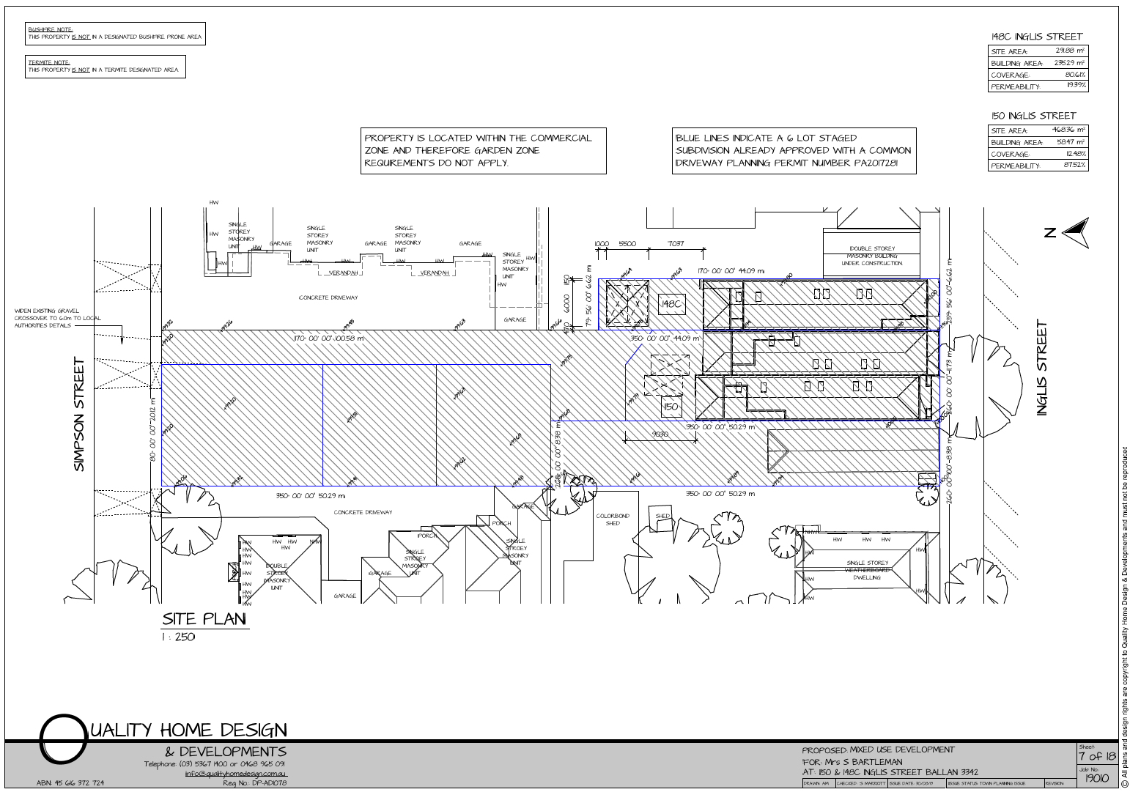
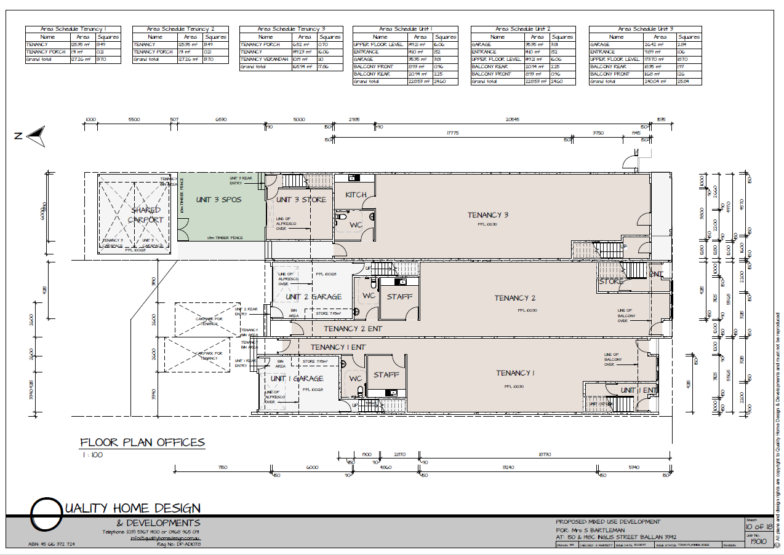
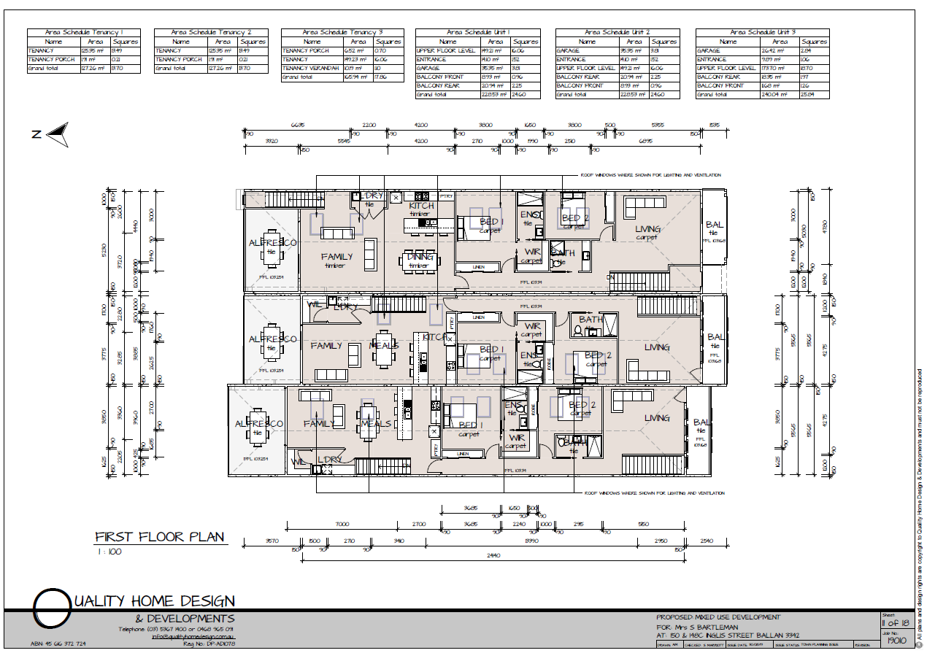
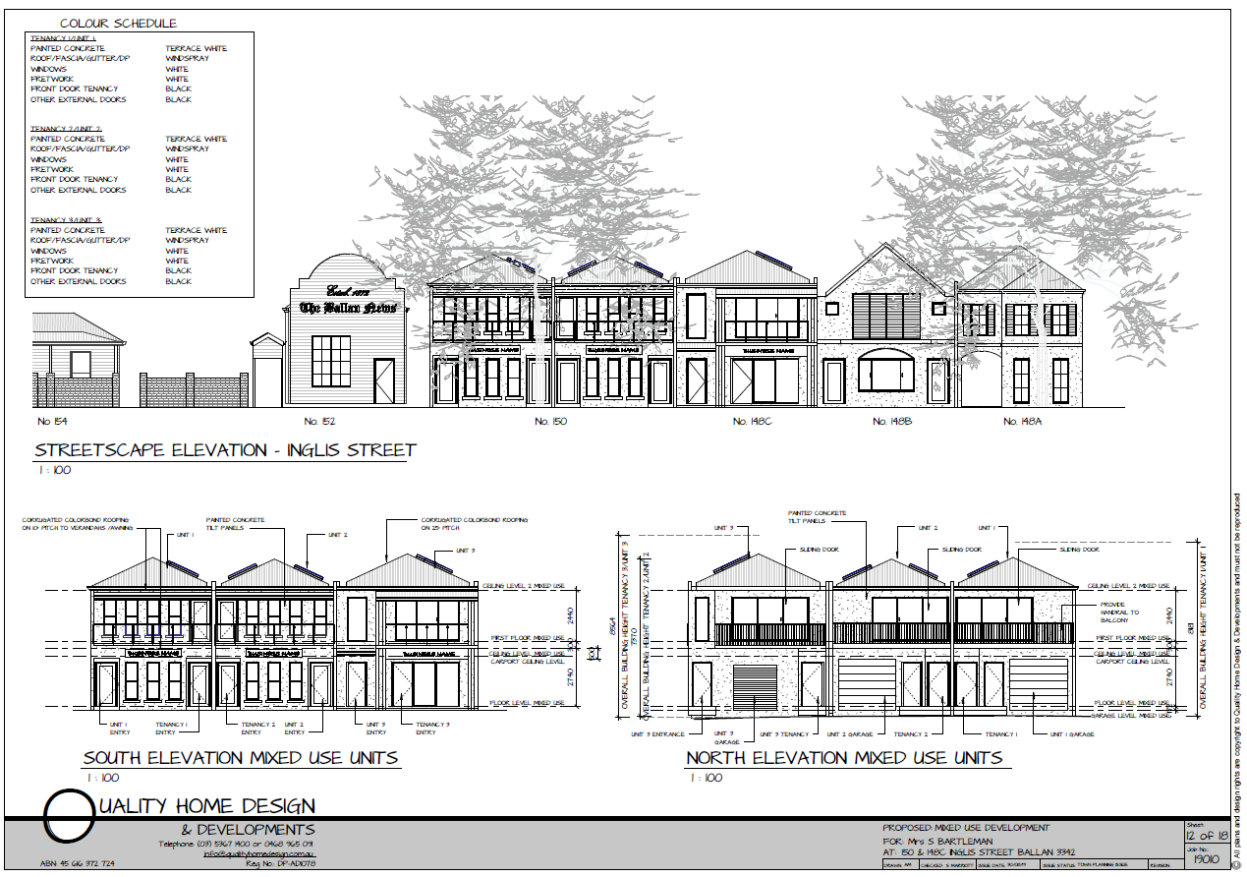
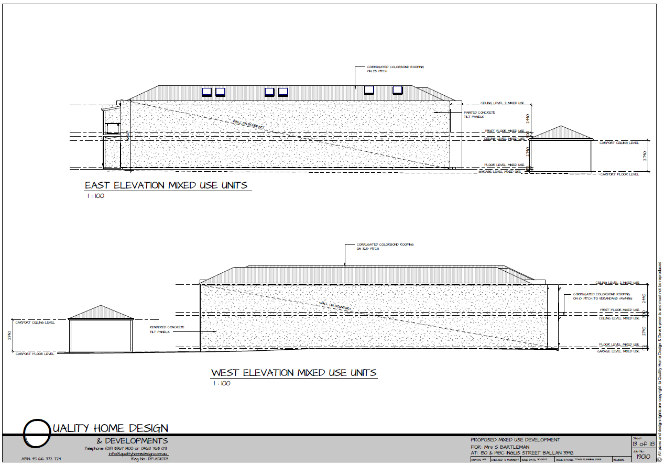
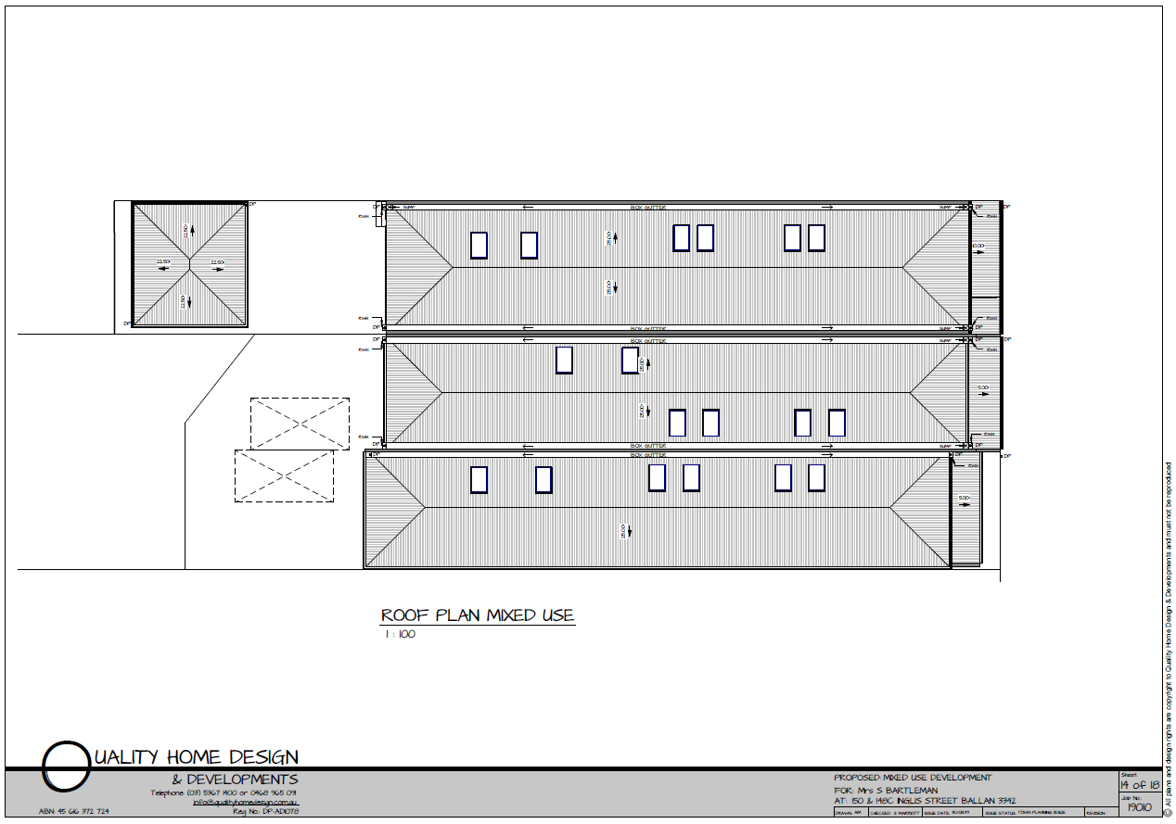
Figure 1: Proposed floor plans, elevations and roof plan.

Background to Current Proposal
148C and the portion of 150 Inglis Street proposed to be developed are contained within Lots 4 and 6 on proposed Plan of Subdivision 829390M, pursuant to Council’s approval of PA2017281, referred to in the ‘Executive Summary’ above. A copy of the approved plan is at Attachment 2.

History
None applicable.

Public Notice
Notice of the application was given to adjoining and nearby land owners and occupiers by mail and two signs erected on site from 28 June until 14 July 2020. Two objections were received.

Summary of Objections
The objections received are detailed below with officer’s accompanying comments:
Objection | Any Relevant Requirement
There is no information on future uses of the commercial tenancies. Shouldn’t a future business catering to seated patrons, such as a café, be responsible for providing parking spaces for customers? | Clauses 34.01 and 52.06.
Officer’s Response:
The application states that the ground floor premises would be used for Offices, and accordingly a car parking demand assessment was submitted by the applicant in support of the proposed parking reduction and reviewed by Council’s Infrastructure unit. Under the provisions of the Moorabool Planning Scheme, Council has discretion to consider a parking reduction for a range of land uses, including a café. A business which provides seating for customers can be considered for a parking reduction through the planning permit process. See ‘Discussion’ below for an assessment of the proposed parking reduction.
Removing parking for the proposed dwellings denies an occupant safe, secure parking close to their residence. | Clause 52.06.
Officer’s Response:
On-site parking is proposed for each dwelling in accordance with the relevant parking requirements in the Moorabool Planning Scheme.
Parking in the Ballan CBD, particularly on Inglis and Fisken Streets, is at capacity and many shoppers are forced to park some distance from shops, noting that the IGA car park is only for their customers, not the general public. | Clause 52.06.
Officer’s Response:
The parking demand assessment submitted by the applicant and reviewed by Council’s Infrastructure unit finds that public parking in the Ballan CBD is sufficient to readily accommodate the proposed parking reduction. It is to be expected that there will be peak periods where availability is more limited, but the analysis indicates that there is sufficient on-street parking to meet overall demand. See ‘Discussion’ below.
The lack of car parking for the proposed dwellings will pose a problem for Simpson Street which experiences heavy traffic flow during morning drop-off and afternoon pick-up peak times for local services including a pre-school and maternal child health clinic. | Clause 52.06.
Officer’s Response:
On-site parking is proposed for each dwelling in accordance with the relevant parking requirements in the Moorabool Planning Scheme.
Further traffic and parking demand in Simpson Street will impact on existing residents and their visitors. | Clause 52.06.
Officer’s Response:
Simpson Street would provide access to the six on-site car spaces and possibly also be used by small commercial vehicles such as for the delivery or dispatch of goods. Customers of the future commercial tenancies would most likely park in Inglis Street as it is unlikely that customers would be provided access to the rear of the premises. Employees and other visitors could potentially park in Simpson Street, subject to availability of on-street car spaces. If parking issues arise in future Council would assess the situation to determine whether parking restrictions should be implemented.
The recent creation of additional on-street parking in Inglis Street is undermined by the cumulative impact of parking reductions granted, citing four applications approved by Council since 2014 which resulted in a total reduction of 32 spaces. | Clause 52.06.
Officer’s Response:
The parking demand assessment submitted by the applicant and reviewed by Council’s Infrastructure unit finds that public parking in the Ballan CBD is sufficient to readily accommodate the proposed parking reduction. It is noted that at the time the parking study was conducted construction had been completed and the premises occupied for one of the four approved developments cited by the objector, accounting for 13 of the 32 car spaces. However, based on the car parking assessment and noting the recent increase in on-street parking provision, it is not expected that the currently proposed parking reduction would exceed parking availability in the vicinity of the site. See ‘Discussion’ below.
Granting resident parking permits for landowners in Inglis Street results in further on-street spaces being permanently occupied. | Clause 52.06.
Officer’s Response:
Approval of resident parking permits is assessed by Council on a property specific basis. There are currently a small number of resident parking permits issued for properties in Ballan, in particular in Inglis Street. All permits apart from one were granted well before the parking assessment was conducted. Permit parking occupies a small share of on-street parking supply.

Locality Map
The map below indicates the location of the subject site and the zoning of the surrounding area.
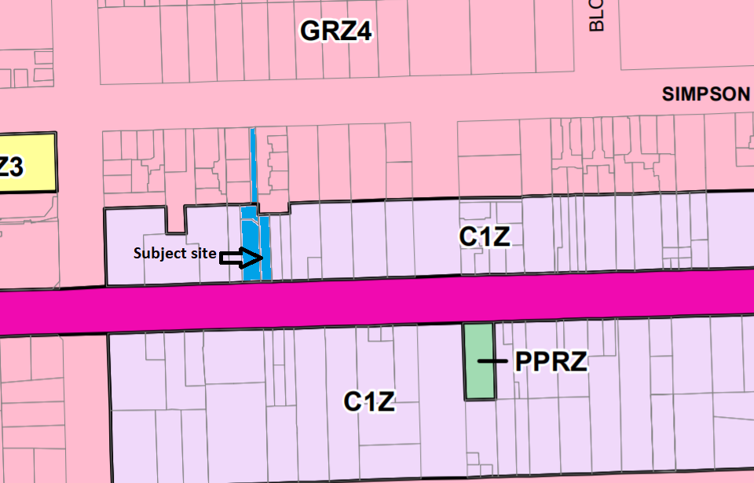
Figure 2: Zone map

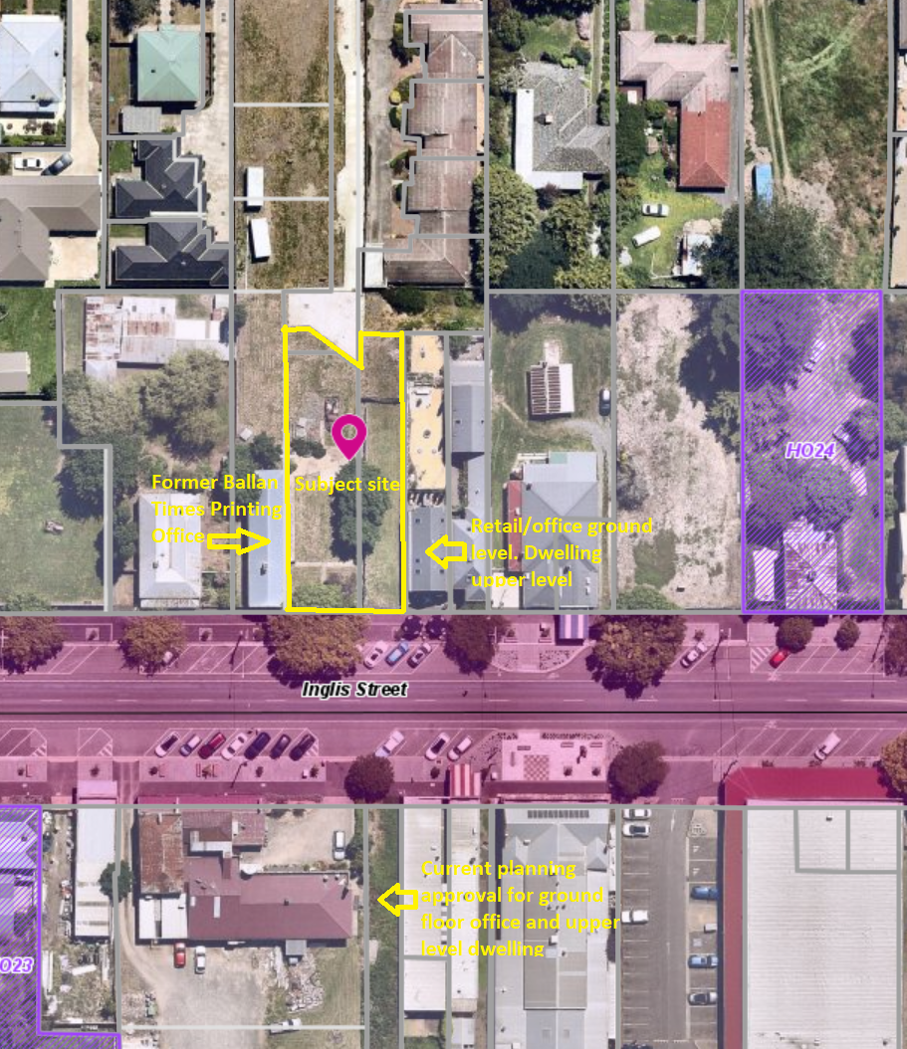
Figure 3: Aerial photograph

Planning Scheme Provisions
Council is required to consider the Victoria Planning Provisions and give particular attention to the Planning Policy Framework (PPF), the Local Planning Policy Framework (LPPF) and the Municipal Strategic Statement (MSS).
The relevant clauses are:
• Clause 11.03-3S Peri-urban areas
• Clause 14.02 Water
• Clause 15.01-2S Building design
• Clause 15.01-5S Neighbourhood character
• Clause 16.01-2S Location of residential development
• Clause 16.01-3S Housing diversity
• Clause 17.01-1R Diversified economy – Central Highlands
• Clause 21.02-3 Water and catchment management
• Clause 21.03-2 Urban Growth Management
• Clause 21.03-3 Residential Development
• Clause 21.03-4 Landscape and Neighbourhood Character
• Clause 21.04-3 Commercial
• Clause 21.08 Ballan
• Clause 22.02 Special Water Supply Catchments
The proposal generally complies with the relevant sections of the PPF and LPPF.

Zone
The subject site is in the Commercial 1 Zone (C1Z). The purpose of the Zone is:
• To implement the Municipal Planning Strategy and the Planning Policy Framework.
• To create vibrant mixed use commercial centres for retail, office, business, entertainment and community uses.
• To provide for residential uses at densities complementary to the role and scale of the commercial centre.
Under the table of uses at Clause 34.01-1, an Office is a Section 1 use not requiring a permit (noting there are no applicable requirements under the Schedule). A Dwelling is also a Section 1 use, subject to the condition that any ground floor frontage does not exceed 2m. Units 1 and 2 do not satisfy this condition, therefore a use permit is required for those two dwellings only.
Under Clause 34.01-4 a permit is required to construct buildings and works.
Subject to conditions, the proposal is generally consistent with the zone provisions.

Overlays
The site is affected by Environmental Significance Overlay, Schedule 1 (Proclaimed Water Catchment Areas).
Under Clause 42.01-2 a permit is required to construct buildings and works. There are no relevant exemptions under Schedule 1. The proposed development would be connected to reticulated sewer and permit conditions would require drainage to be designed to meet Council’s requirements.
Subject to conditions, the proposal would not detrimentally affect potable water quality or supply.

Relevant Policies
The Ballan Strategic Directions (June 2018) policy underpins Planning Scheme Amendment C88 which was gazetted on 6 March 2020. The proposal is generally consistent with Amendment C88 adopted by Council.

Particular Provisions
Clause 52.06 Car Parking
Under Clause 52.06-5 each two bedroom dwelling requires one car space, which would be provided on site, and an office requires 3.5 spaces to each 100sqm of net floor area. The 420.46sq m combined floor area of the offices equates to a requirement for 15 car spaces. Each premises proposed for office use would be provided with one car space, therefore a combined reduction of 12 car spaces for the offices would be required. Overall, the proposed parking reduction is acceptable, as discussed throughout this report. The dimensions of the proposed parking spaces meet the minimum requirements of Clause 52.06-9.
Clause 52.34 Bicycle Facilities
No bicycle parking facilities are required because the proposed development does not meet the threshold for the minimum provision of bicycle parking facilities listed in Clause 52.34-5.

Discussion
Policy Considerations
Overall, the proposal is considered to be generally in accordance with relevant State and Local planning policy, the Commercial 1 Zone, Clause 52.06 and the decision guidelines at Clause 65.01 of the Moorabool Planning Scheme.
The proposed development of the site for offices and dwellings would contribute to the growth of the town centre, with the additional commercial floor space providing opportunities for local economic growth and two bedroom dwellings contributing to the mix of housing supply with convenient access to infrastructure and services including Ballan railway station.
Heritage Consideration
The site adjoins the former Ballan Times Printing Office which was identified in the West Moorabool Heritage Study (2016) as being of heritage significance, and the applicant and Council officers worked together extensively to achieve a design sympathetic to the building’s heritage features. The proposed design responds to the building’s heritage values with regard to frontage setbacks, roof form, building height, building colours and materials and balcony and window designs. The proposed design would ensure that the heritage building’s integrity and prominence in the streetscape is maintained.
Built Form/Urban Design
The proposed building is also considered to be an appropriate design response to Inglis Street, contributing to visual interest and passive surveillance of the street. The building’s interface with residential zoned land to the north is acceptable, with a minimum setback of 16m and the overall form and bulk of the building is generally consistent with adjoining properties on Inglis Street and would complement the streetscape. The proposed dwellings comply with the ResCode standards for internal amenity without any unreasonable amenity impacts on adjoining properties. All residential and commercial premises are provided with waste storage areas at the rear, accessible to Simpson Street. The proposed frontages to Inglis Street are generally consistent with adjoining frontage widths and the dwelling ground floor frontage widths, in particular for Units 1 and 2, maintain sufficient frontage widths for the offices below to be visible to passing vehicular and pedestrian traffic.
A recommended condition of approval will require footpath works in the Inglis Street verge adjoining the property to match recent streetscape works undertaken by Council.
Car Parking
The proposed parking reduction was raised by objectors as a critical concern. The applicant submitted a parking demand assessment prepared by a qualified traffic engineer who undertook a demand analysis in February 2020. The analysis was made based on three weekdays spanning hours between 9.00AM and 5.00PM within 250m of the site along Inglis Street and found the average demand to be 44% of all available public parking. Council’s Infrastructure unit studied 12 samples of aerial photography over five years to verify the parking availability in Inglis Street between Cowie and Fisken Streets (i.e. within 100m of the site). For most of that period there were 38 spaces, the demand for which during business hours was approximately 62% (24 spaces), leaving on average 14 spaces available. Streetscape works completed in early 2020 increased the parking supply to 60 spaces and based on Council’s single sample from 2020 there were 23 parked vehicles, equating to 38% demand, similar to the applicant’s parking assessment. Furthermore, on-street parking in the section of Inglis Street adjoining the site is subject to a one-hour time limit between 8.30AM-5.00PM which promotes regular turnover of vehicles to support parking availability.
Council’s Infrastructure advise that the proposed parking reduction would not create a substantial burden on parking availability. Given the subject site is within Ballan’s commercial centre, there is a high likelihood that customers would make multi-purpose trips but use only a single car space and recent streetscape works in Inglis Street would encourage pedestrian movements. Given the results of the parking assessment and Council’s Infrastructure review, it is not considered that the parking reduction would have any adverse impacts on the economic viability of Ballan’s commercial centre.
Based on current data collected from the Traffic Engineering assessment, there is justification for a reduction in the standard car parking requirement consistent with the decision guidelines of Clause 52.06, however this does not consider projected future demand. Therefore, Council officers have negotiated with the proponent to pay a financial contribution towards public car parking as a condition of approval. The financial contribution is $2,000 per car space waived, equating to $24,000 in this instance, to be enforced by way of a Section 173 Agreement registered on title.

General Provisions
Clause 65 – Decision Guidelines have been considered by officers in evaluating this application.
Clause 66 – Stipulates all the relevant referral authorities to which the application must be referred.

Referrals
Authority | Response
Western Water  Southern Rural Water | Consent.  Consent with conditions.
Infrastructure  Strategic Planning | Consent with conditions.  Consent with conditions.

Financial Implications
There are no financial implications for Council in approving the use and development application.

Risk & Occupational Health & Safety Issues
The recommendation to approve this application does not have any risk or OH&S implications for Council.

Communications Strategy
Notice was undertaken for the application, in accordance with s.52 of the Planning and Environment Act 1987, and further correspondence is required to all interested parties to the application as a result of a decision in this matter. The objectors and the applicant were invited to attend this meeting and address Council if required.

Options
• Issue a Notice of Decision to Grant a Permit in accordance with the conditions in the recommendation of this report; or
• issue a Notice of Decision to Grant a Permit with amendments to the conditions in the recommendation of this report. Either of these options may result in the objector appealing Council’s decision to VCAT; or
• issue a Refusal to Grant a Permit on grounds. Council would need to consider what reasonable grounds there would be to refuse the application. This option may result in the applicant appealing Council’s decision to VCAT.

Conclusion
Overall, the proposed use and development for offices and dwellings and an associated reduction of car parking satisfies the relevant provisions of the Moorabool Planning Scheme, subject to conditions, and would contribute to the orderly development of land in Ballan’s commercial centre. The proposal would contribute to local economic activity and diversity in housing choice without any unreasonable amenity impacts. The proposed design would enhance the streetscape and respect the heritage characteristics of the adjoining building to the west. It is recommended that the application be approved and a Notice of Decision to grant a permit be issued.

8 Update on Trends, Issues and Other Matters
Nil.

9 Process Forward and Work Program
Nil.

10 Update on VCAT Decisions
Nil.

11 Other Business
Nil.

12 Date of Next Meeting
Wednesday 17 February 2021.

13 Meeting Close
The Meeting closed at 7.11pm.

...................................................
CHAIRPERSON

