AGENDA
S86 Development Assessment Committee Meeting
Wednesday, 19 August 2020

In accordance with s. 395 of the COVID-19 Omnibus (Emergency Measures) Bill 2020, this meeting will not be available for public attendance, however will be streamed live via accessing the Council Internet site

I hereby give notice that a S86 Development Assessment Committee Meeting will be held on:
Date: | Wednesday, 19 August 2020
Time: | 6.00pm
Location: | Online
Derek Madden
Chief Executive Officer

Order Of Business
1 Opening 5
2 Present and Apologies 5
3 Recording of Meeting 5
4 Confirmation of Minutes 5
5 Matters Arising from Previous Minutes 5
6 Disclosure of Conflicts of Interests 5
7 Community Planning Reports 7
7.1 PA2019156 - 2 Lot Subdivision (house lot excision) at 70 Dunbar Road, Pentland Hills 7
7.2 PA2018189 - Development and Use of a Dwelling at Osborne Street, Maddingley 21
7.3 PA2020012 - Use and Development of a Dwelling and Outbuilding and Removal of Vegetation at 7 O'Donnell Street Gordon 32
7.4 PA2019288 - The re-subdivision of five lots into two lots, Use of the land for agriculture on proposed Lot 1 and Development and Use of a Dwelling on proposed Lot 2 at Pearces Road Bullarto South 48
7.5 PA2020096 - Development and Use of Five Retail Shops and Four Dwellings, Staged 9 Lot Subdivision and Reduction of Car Parking at 22 Fisken Street Ballan 64
8 Update on Trends, Issues and Other Matters 78
9 Process Forward and Work Program 78
10 Update on VCAT Decisions 78
11 Other Business 78
12 Date of Next Meeting 78
13 Meeting Close 78

1 Opening

2 Present and Apologies

3 Recording of Meeting
As well as the Council for its minute taking purposes, the following organisations have been granted permission to make an audio recording of this meeting:
- The Moorabool News; and
- The Star Weekly.

4 Confirmation of Minutes
S86 Development Assessment Committee Meeting - Wednesday 15 July 2020

5 Matters Arising from Previous Minutes

6 Disclosure of Conflicts of Interests
Under the Local Government Act (1989), the classification of the type of interest giving rise to a conflict is; a direct interest; or an indirect interest (section 77A and 77B). The type of indirect interest specified under Section 78, 78A, 78B, 78C or 78D of the Local Government Act 1989 set out the requirements of a Councillor or member of a Special Committee to disclose any conflicts of interest that the Councillor or member of a Special Committee may have in a matter being or likely to be considered at a meeting of the Council or Committee.
Definitions of the class of the interest are:
- A direct interest (section 77A, 77B)
- An indirect interest (see below)
- indirect interest by close association (section 78)
- indirect financial interest (section 78A)
- indirect interest because of conflicting duty (section 78B)
- indirect interest because of receipt of gift(s) (section 78C)
- indirect interest through civil proceedings (section 78D)
- indirect interest because of impact on residential amenity (section 78E)
Time for Disclosure of Conflicts of Interest
In addition to the Council protocol relating to disclosure at the beginning of the meeting, section 79 of the Local Government Act 1989 (the Act) requires a Councillor to disclose the details, classification and the nature of the conflict of interest immediately at the beginning of the meeting and/or before consideration or discussion of the Item.
Section 79(6) of the Act states:
While the matter is being considered or any vote is taken in relation to the matter, the Councillor or member of a special committee must:
- Leave the room and notify the Mayor or the Chairperson of the special committee that he or she is doing so; and
- Remain outside the room and any gallery or other area in view of hearing of the room.
The Councillor is to be notified by the Mayor or Chairperson of the special committee that he or she may return to the room after consideration of the matter and all votes on the matter.
There are important reasons for requiring this disclosure immediately before the relevant matter is considered.
- Firstly, members of the public might only be in attendance for part of a meeting and should be able to see that all matters are considered in an appropriately transparent manner.
- Secondly, if conflicts of interest are not disclosed immediately before an item there is a risk that a Councillor who arrives late to a meeting may fail to disclose their conflict of interest and be in breach of the Act.

7 Community Planning Reports

7.1 PA2019156 - 2 Lot Subdivision (house lot excision) at 70 Dunbar Road, Pentland Hills
Author: Victoria Mack, Statutory Planner
Authoriser: Henry Bezuidenhout, Executive Manager Community Planning & Economic Development
Attachments: 1. Proposed plan of subdivision (house lot excision) (under separate cover)

Application Summary
Permit No: PA2019156
Lodgement Date: 9 July 2019
Planning Officer: Victoria Mack
Address of the land: 70 Dunbar Road, Pentland Hills 3341
Proposal: 2 Lot Subdivision (House lot excision)
Lot size: 18.20ha
Why is a permit required? Clause 35.07-3 Subdivide land (House lot excision)

Recommendation
That Council, having considered all matters as prescribed by the Planning and Environment Act 1987, issue a refusal to grant a permit for a two-lot subdivision (house lot excision) on Lot 7 on TP 000918E otherwise known as 70 Dunbar Road, Pentland Hills, on the following grounds:
1. The proposed subdivision results in the fragmentation of agricultural land;
2. The proposal subdivision does not comply with the policies contained in Clause 22.03, House and House Lot Excisions in Rural Areas, of the Moorabool Planning Scheme;
3. The proposed subdivision is not directly related to the agricultural use of the land; and
4. The proposed subdivision does not comply with the objectives of the Farming Zone at Clause 35.07 of the Moorabool Planning Scheme.

Public Consultation
Was the application advertised? | Yes
Notices on site: | Yes
Notice in Moorabool Newspaper: | No.
Number of objections: | Three objections
Consultation meeting: | Not held.

Policy Implications
The Council Plan 2017-2021 provides as follows:
Strategic Objective 2: Minimising Environmental Impact
Context 3A: Land Use Planning

Victorian Charter of Human Rights & Responsibilities Act 2006
In developing this report to Council, the officer considered whether the subject matter raised any human rights issues. In particular, whether the scope of any human right established by the Victorian Charter of Human Rights and Responsibilities is in any way limited, restricted or interfered with by the recommendations contained in the report. It is considered that the subject matter does not raise any human rights issues.

Officer’s Declaration of Conflict of Interests
Under section 80C of the Local Government Act 1989 (as amended), officers providing advice to Council must disclose any interests, including the type of interest.
General Manager – Henry Bezuidenhout
In providing this advice to Council as the Executive Manager, I have no interests to disclose in this report.
Author – Victoria Mack
In providing this advice to Council as the Author, I have no interests to disclose in this report.

Executive Summary
Application referred? | Melbourne Water and Council’s Environmental Health and Infrastructure Departments.
Any issues raised in referral responses? | No.
Preliminary concerns? | The location of existing dwelling creates an irregular shaped lot in the centre of the property accessed via a long driveway which bisects the land.
Any discussions with applicant regarding concerns? | No.
Any changes made to the application since being lodged? | The proposed lot with the existing dwelling was increased in area from 1.40ha to 1.52ha.
Brief history. | The owners have lived on the subject property for many years. They currently breed dogs on the property, predominantly Welsh Corgis, and have run cattle on the property. They have advised that remaining in the existing dwelling on a smaller land parcel best meets their retirement needs.
Previous applications for the site? | Nil.
General summary. | The proposed house lot excision creates a vacant lot of 16.68ha and a house lot of 1.52ha. Because the dwelling is in the centre of the site, accessed via a long driveway from the north-east corner, the proposed excision dissects the land into two awkward shaped parcels.  The owners also wish to retain access to the dam on the property in the north-west corner of the site and to enable this a water supply easement to the dam has been added to the Plan of Subdivision.  It is not considered that this proposal is an orderly planning outcome for this land.
Summary Recommendation
That Council, having considered all matters as prescribed by the Planning and Environment Act 1987, issue a refusal to grant a permit for a two-lot subdivision (house lot excision) on Lot 7 on TP 000918E otherwise known as 70 Dunbar Road, Pentland Hills.

Site Description
The land is undulating with the existing dwelling located in the centre of the property on an elevated part of the site with prominent views of the surrounding area, particularly to the east. The land generally slopes away from the house site to the west, south and east. To the north the land contains the driveway to Dunbar Road and is generally flat. The driveway is currently fenced on both sides. It is assumed that the current fences accord with the proposed subdivision boundaries.
The Myrniong Creek runs along the whole of the south boundary. The land slopes sharply to the creek with the escarpment width being approximately 100m. This sloped area has scattered vegetation. A tributary of the Myrniong Creek also dissects the north-west corner of the site. There is a dam on this waterway with a surface area of approximately 800sq m. The current owner wishes to retain access to this dam for domestic water supply purposes.
Surrounding land to the south is also steeply dissected and includes a floodplain at the bottom of the escarpment. Further to the south is the Werribee River. Land to the west, north and east is generally grazing land. Land on the north side boundary of the site has been significantly revegetated.
There is another small dam on the site located half-way along, and close to, the west side boundary.
There are trees around the dwelling site, but the balance of the land is pastured land without any plantations or paddock trees.
The single storey dwelling is older in style with several sheds and dog runs to the side and rear of the dwelling. The effluent field is located to the north of the dwelling within the proposed lot 1.
The site has historically been used for grazing cattle. There are cattle yards on the property located near the front entrance at Dunbar Road.
An aerial photograph of the site is shown below.

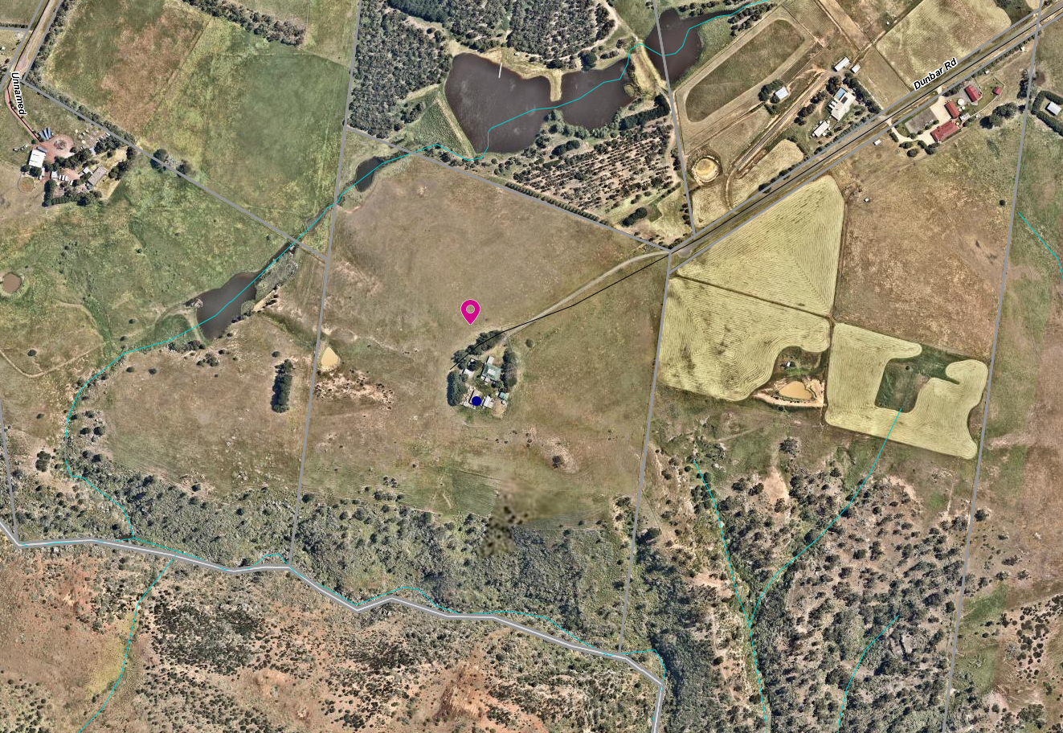
Figure 1: Aerial map

Proposal
It is proposed to subdivide the land into two lots. Under Clause 35.07-3 of the Farming Zone an application can be made for a two-lot subdivision to create a lot for an existing dwelling.
Lot 1 would be 1.52ha and would contain the dwelling, sundry sheds and the driveway to Dunbar Road. The lot would be irregular in shape with a narrow strip of land containing the driveway and then a roughly circular area around the dwelling and sheds.
Lot 2 would be approximately 16.68ha (by deduction) and would contain two dams and the cattle yards. The yards are located close to the entrance of the property at Dunbar Road.
A water supply easement from the dam in the north-east corner of the site is also proposed to supply the dwelling and for domestic purposes.
The proposed Lot 1 is not currently fenced to the proposed new boundary around the dwelling, but the driveway is fenced. It is assumed that the driveway fencing accords with the proposed driveway boundary.
The proposed plan of subdivision is included as an attachment to this report and also below).

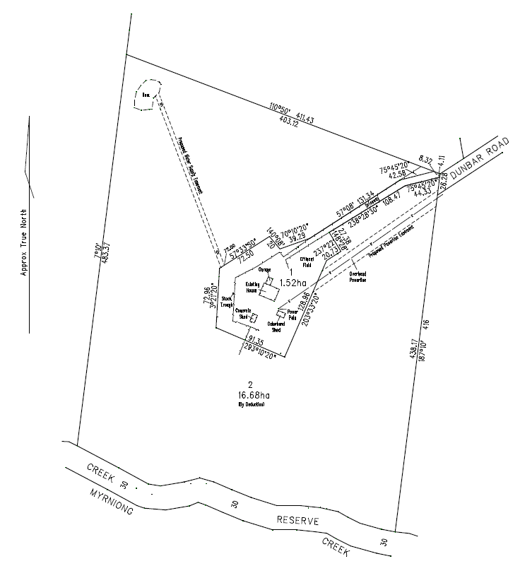
Figure 2: plan of subdivision

Background to Current Proposal
At a meeting with the owner at the Council office he requested that a Section 173 Agreement is not applied to any future permit to restrict a dwelling on Lot 2. He felt that the larger lot would make a very suitable site for another dwelling as a lifestyle choice. He said that the land cannot be cropped and should only be lightly grazed due it being in a low rainfall area (rain shadow), and that the property was not suitable for highly productive agriculture.

History
A search of Council records revealed that no permits have been issued on the subject site. There are no compliance issues relevant to the site.

RESTRICTIVE COVENANT
There is a covenant registered on the title with number Y000705A dated 19 December 1975. It was applied as part of a subdivision of the land in this area at that time. The covenant restricts various development matters relating to the design, siting and materials to be used for dwellings. It also prohibits the use of the land for pig and poultry farming and boarding kennels.

Public Notice
The application was notified to adjoining and surrounding landowners. Three objections were received.

Summary of Objections
The objections received are detailed below with officer’s comments accompanying them:
Objection | Any Relevant Requirement
The covenants on these lots prohibit subdivision and various farm industries. Yet dog breeding has been allowed by Council which many locals are not happy with it. | Covenant number Y000705A
Officer’s Response: The covenant does not restrict subdivision. It does restrict a boarding kennel; however, dog breeding is not a boarding kennel and is not prevented by the covenant.
The development of a second dwelling on the land following the subdivision would set a precedent for future subdivision and such development in this area would detrimentally affect the landscape values.
Officer’s Response: The application is for subdivision. No dwellings are being applied for.
The subdivision meets the “material detriment” definition and is likely to have an adverse impact on the enjoyment of our property. We share a 400m boundary (north) with the site and have planted 18,000 native and indigenous plants which demonstrates that degraded land can be returned to its natural state. This is compared to the broad scale destruction of land in the surrounding area. Council should ensure the exploitation of land ceases and set an example of how land should be managed in a sustainable manner.  Reducing the size of landholder allotments can only lead to further degradation of the land and negative environmental impact from excess stock loads, additional buildings and houses and increased demands on water supply. | State and local planning policies
Officer’s Response: This concern is addressed further in this report.
The proposed subdivision will have a negative environmental impact on the flora and fauna that rely on the Myrniong Creek and at least one of its tributaries. | State and local policies
Officer’s Response: This concern is addressed further in this report.
The Palmer’s Road area is dominated by 40+ acre properties, most well established. Subdivisions of this nature are inconsistent with the precinct’s agricultural landscape. | Farming Zone subdivision
Officer’s Response: This concern is addressed further in this report.
If a new vacant lot is created, it will lead to another dwelling and sheds being constructed increasing dwelling density in this area. | State and local policies; rural growth policy
Officer’s Response: This concern is addressed further in this report.
If this proposal is approved, it will set a precedent and others may use such decision to subdivide in the future. | Farming Zone
Officer’s Response: This concern is addressed further in this report.
I have no objection to the subdivision provided a condition of the permit is that no dwellings/sheds are permitted, and the agricultural use continues. | Section 173 of the Planning and Environment Act 1987
Officer’s Response: An option would be to recommend approval subject to a Section 173 Agreement to be registered on title preventing the development of a dwelling on the vacant Lot 2. This is addressed further in this report.

Locality Map
The map below indicates the location of the subject site and the zoning of the surrounding area.
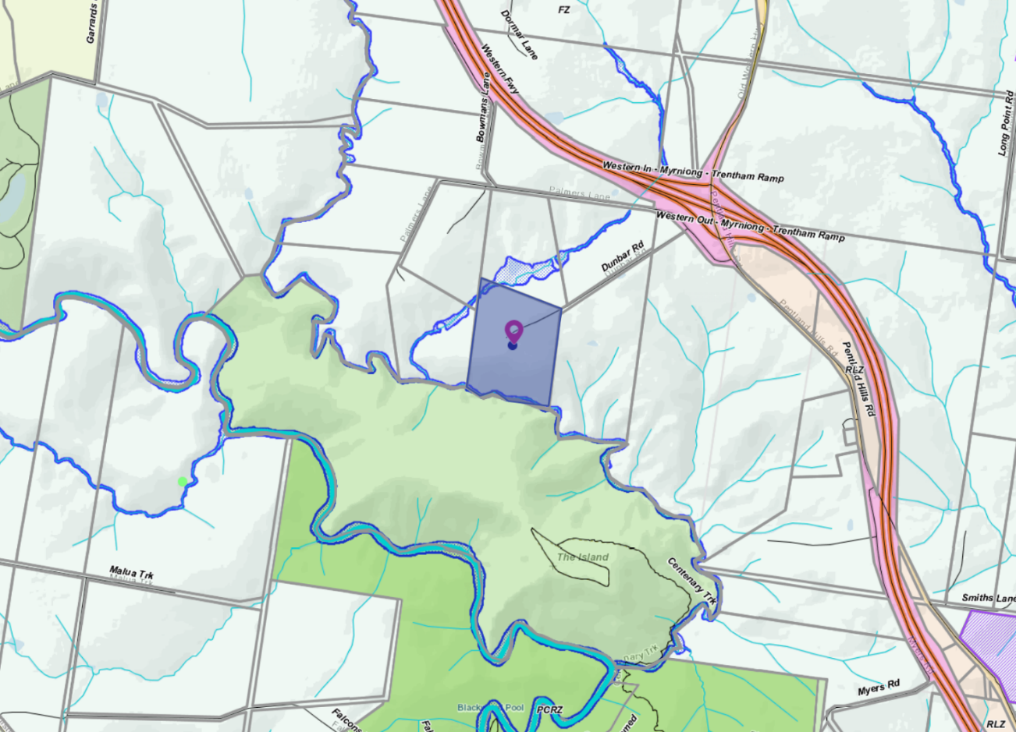
Figure 3: Zone map

Planning Scheme Provisions
Council is required to consider the Victoria Planning Provisions and give particular attention to the State Planning Policy Framework (SPPF), the Local Planning Policy Framework (LPPF) and the Municipal Strategic Statement (MSS).
The relevant clauses are:
• Clause 11.03-3S - Peri-urban areas
• Clause 12.03-1S - River corridors, waterways, lakes and wetlands
• Clause 14.01-1S - Protection of agricultural land
• Clause 15.01-6S - Design for rural areas
• Clause 16.01-5S - Rural residential development
• Clause 21.03-6 - Objective - Rural lifestyle opportunities
The proposal complies with the relevant sections of the PPF and LPPF, with the exception of the clauses outlined in the table below:
PPF | Title | Response
Clause 14.01-1S | Protection of Agricultural Land | A strategy of this clause is to limit new housing development in rural areas by discouraging development of isolated small lots in the rural zone from use for dwellings or other incompatible uses. The proposal is a small lot subdivision on farming zone land with the resultant balance lot further fragmented and further limiting its agricultural productivity.
Clause 12.03-1S 31 | River corridors, waterways, lakes and wetlands | The objective of this policy is to protect and enhance river corridors, waterways, lakes and wetlands by ensuring that development responds to and respects the significant environmental, conservation, cultural, aesthetic, open space, recreation and tourism assets of water bodies and wetlands.  Intensification of development in this area would potential have a detrimental impact on the environmental values of the precinct over time.
Clause 16.01-5S | Rural residential development | This policy aims to discourage development of small lots in rural zones for residential use or other incompatible uses.
LPPF | Title | Response
Clause 21.03-6 | Objective—Rural lifestyle opportunities | Strategy: Prevent the fragmentation of farm land through inappropriate subdivisions.
Clause 22.03 | House and House Lot Excisions in Rural Areas | See details of this policy below.
Clause 22.03 House and House Lot Excisions in Rural Areas

The objectives of this clause are:

• To ensure that subdivision and dwellings in rural areas are required to increase agricultural productivity.
• To minimise the potential for adverse impacts on farm production through land use conflicts.
Policy
It is policy to:
• Discourage subdivision and dwellings unless they are directly related to the agricultural use of land.
• Discourage non-agricultural use and development in areas of productive agricultural land. Encourage the consolidation of small lots.
• Ensure that lots created under Clause 35.07-3 have a maximum area of 2ha.
• Maintain the right of existing farms to continue their operations without being adversely affected or constrained by residential concerns.
• Include the following requirements on a permit to excise a lot for a dwelling where it is considered this would facilitate ongoing agricultural use of the remaining land:
• Consolidate of the remaining land with the title of an existing farm; or
• If the remainder land is less than 40ha, require the landowner to enter into an agreement under S173 of the Planning and Environment Act that no further applications will be made to erect a dwelling on the balance allotment.
Comment: The proposed Lot 1 would contain the existing dwelling on a lot of less than 2ha. However, its shape and location would fragment the balance of the land. The dwelling would become a lifestyle lot. Such fragmentation of agricultural land should not be supported.
This application is not an orderly planning outcome for the area

Zone
Farming Zone
In accordance with Clause 35.07-3 of the Moorabool Planning Scheme a permit is required to subdivide land. Each lot must be at least the area specified for the land in a schedule to this zone which in the Moorabool Planning Scheme specifies in this locality each lot must be 100ha.
However, this clause also states that a permit may be granted to create smaller lots if:
• The subdivision is to create a lot for an existing dwelling. The subdivision must be a two-lot subdivision.
The purpose of the zone is to:
• Implement the Municipal Planning Strategy and the Planning Policy Framework.
• Provide for the use of land for agriculture.
• Encourage the retention of productive agricultural land.
• Ensure that non-agricultural uses, including dwellings, do not adversely affect the use of land for agriculture.
• Encourage the retention of employment and population to support rural communities.
• Encourage use and development of land based on comprehensive and sustainable land management practices and infrastructure provisions.

The proposal is a 2 Lot subdivision with one lot containing an existing dwelling.

The proposal is inconsistent with the purposes of the zone as the proposal is unable to demonstrate an outcome that will result in sustainable farming and land management practices and the proposal potentially would adversely affect the use of the balance of the land for agriculture.

Overlays
Environmental Significance Overlay (ESO3)
The purpose of the ESO is to:
• Implement the Municipal Planning Strategy and the Planning Policy Framework.
• Identify areas where the development of land may be affected by environmental constraints.
• Ensure that development is compatible with identified environmental values.
Schedule 3, Environmental Significance Overlay - Long Forest and Werribee Gorge
In accordance with Schedule 3 to the Environmental Significance Overlay a permit is not required under the schedule as no vegetation would be impacted or removed by the proposed subdivision.
Design and Development Overlay and Schedule 2 (DDO2)
In accordance with Schedule 2 to the Design and Development Overlay a permit is not required to subdivide land under this overlay.

RELEVANT POLICIES
Council’s Rural Housing Policy Statement
Council’s Rural Housing Policy Statement was adopted by Council on 19 September 2012. The document applies to all land in Farming Zone under the Moorabool Planning Scheme.
The policy intent is to:
• Encourage dwellings in areas nominated in Map 1 of Council Rural Growth Policy Statement.
• Ensure the siting of any dwellings is designed to have a minimal impact on any existing or future agricultural activities on the site and on surrounding.
• Ensure it is clear whether the dwelling is required for agricultural operation use or to maintain rural communities.
• Ensure sufficient infrastructure is available or that alternative methods are available which do not require normal infrastructure.
• Encourage development of dwellings to support communities on land which is unlikely to support agricultural activity while still considering any other overlays which may impact the land. This is land which is constrained for use as agriculture by other environment factors such as vegetation, slope, soil quality, etc.
• Ensure any subdivision is undertaken in accordance with the scheme in order to discourage fragmentation of agricultural land.
It is considered that the proposed subdivision would further fragment agricultural land.
Council’s Rural Growth Policy statement - 19 September 2012
Council’s Rural Growth Policy has been developed to provide direction for how limited farming potential rural dwellings should be considered, and more broadly, rural settlement patterns. The policy seeks to articulate support for resilient and integrated rural communities and agricultural enterprises, recognising that ‘State Government Planning Policy Framework does not adequately recognise or support agriculture trends and rural settlements in the Moorabool Shire’.

The principles of the policy relevant to this application include:
• support the agriculture sector so that it can be more productive, diverse, resilient and adaptive to changing agricultural trends, including supporting agricultural activities that recognise Moorabool’s advantageous proximity to market;
• protect agricultural land use from loss and allow development that increases agricultural productivity;
• focus growth opportunities in settlements along major transport corridors, in particular where there is physical and social infrastructure and services;
• recognise that there are substantial existing lots under 40 hectares capable of supporting the viable operation of agricultural enterprises;
• promote a rural housing market that meets the needs of the Shire’s rural communities; and
• land parcels for the proposed on farm living dwellings are to have a minimum lot size of 8 hectares as identified in Map 1.
The proposed subdivision is not generally aligned with the above principles of the policy and is furthermore considered to detract from the agricultural productivity of the land.

Particular Provisions
Clause 53.10 Public Open Space Contribution and Subdivision
A person who proposes to subdivide land must make a contribution to the council for public open space in an amount specified in the schedule to this clause (being a percentage of the land intended to be used for residential, industrial or commercial purposes, or a percentage of the site value of such land, or a combination of both). If no amount is specified, a contribution for public open space may still be required under section 18 of the Subdivision Act 1988.
An open space fee can be applied under Section 18(8)(c) of the Subdivision Act for a two-lot subdivision that is likely to be further subdivided.
Comment: As neither lot could be subdivided under the Moorabool Planning Scheme there is no requirement for a public open space contribution.

Discussion
Subdivision design
The proposed subdivision results in a highly irregular shaped Lot 1 which would contain the existing dwelling and sheds. The lot does not have the advantage of direct street access, resulting in a long driveway being required to the dwelling. This design effectively cuts the north-eastern end of the land in two as the driveway is fenced. The owners also want to retain access to the waterway and dam in the north-east corner using existing pipe infrastructure. A water supply easement would therefore be required to cross Lot 2.
The subdivision design has been influenced by the existing dwelling location. It represents a poor longer-term planning outcome.
The surrounding areas reflects a subdivision which was registered in 1975. It appears that there were 8-10 lots in the subdivision each with an area of approximately 20ha which includes a covenant relating to dwelling design and siting issues and also the prohibition of three uses being pig and poultry farming or the operation of a boarding kennel.
In considering that the land is zoned for farming, further dwelling intensification on the balance Lot 2 with an area of 16.68ha would be inappropriate in this location. It is considered that the subdivision would adversely fragment the agricultural land, and potentially create future land use conflicts between neighbouring agricultural activities and a rural residential allotment.
The creation of the vacant 16.68ha lot does not comply with the Farming Zone provisions which seeks to encourage the retention of productive agricultural land. The owner has stated that the land is affected by the Pentland Hills rainfall shadow and is therefore not highly productive grazing land. However, State and local planning policies do not support the creation of lots in the Farming Zone for rural residential or lifestyle uses.
It is considered that the subdivision of the land would create a parcel that would be unviable unless sold to a neighbour for expansion of the neighbour’s holding. The applicant has not provided a farm management plan associated with this subdivision or justification for the ongoing use of the vacant lot. The subdivision arrangement is considered to adversely fragment the agricultural land to an unsustainable level.
Objectors generally felt that this proposal was inappropriate for the land and the wider area. They were concerned about a precedent being created where others could also apply to excise their dwellings. This raised wider concerns about sustainable land management and environmental impact particularly in relation to the waterways as well as the land itself.
It is understood that land in the Pentlands Hills is relatively fragile due to the lower rainfall and lighter and more erodible soils. Such land needs to be managed carefully and not overstocked. It is noted that no native vegetation planting has occurred on the site.
Objector concerns could be addressed by a Section 173 Agreement to prevent a future dwelling or any further subdivision of the land, however, it is considered that the creation of Lot 1 is a poor planning outcome and should not be supported.
Objectors also expressed concern, if the subdivision was approved, that other landholders within the same subdivision could apply for a similar house lot excision. It is noted that each planning application must be assessed on own its individual merit and if such applications were received then a similar assessment would be made against Council policies and the policies contained in the Moorabool Planning Scheme.

Servicing
As this is a two-lot subdivision, all servicing authorities would be notified during the certification stage in accordance with Clause 66.01 and the three mandatory conditions can be included if a permit was to issue. The mandatory telecommunication conditions under Clause 66.01-1 do not apply to subdivide land in a rural zone.

General Provisions
Clause 65 – Decision Guidelines have been considered by officers in evaluating this application.
Clause 66 – Stipulates all the relevant referral authorities to which the application must be referred.

Referrals
Authority | Response
Melbourne Water | Consent with conditions.
Infrastructure  Environmental Health | Consent with conditions.  Consent with conditions.

Financial Implications
There is no financial implication associated with this refusal to grant a permit.

Risk & Occupational Health & Safety Issues
The recommendation of refusal of the planning application does present any OH&S issues to Council.

Communications Strategy
Notice was undertaken for the application, in accordance with s.52 of the Planning and Environment Act 1987, and further correspondence is required to all interested parties to the application as a result of a decision in this matter. All submitters and the applicant were invited to attend this meeting and invited to address Council if required.

Options
Council could consider the following options:
• issue a refusal to grant a permit in accordance with the recommendations of this report; or
• issue a permit with conditions outside of the recommendations of this report.

Conclusion
The proposed subdivision of the land into two lots with one containing an existing dwelling and the other to remain vacant is considered inconsistent with the planning provisions and the State and Local Planning Policy Framework.
The house lot is awkwardly shaped which would result in permanent fragmentation of the balance of the agricultural land. It provides an unacceptable subdivision layout.
The proposal is also considered inconsistent with the objectives of the Farming Zone.
While objector concerns could be addressed by permit conditions including that a restriction is registered on the title of the vacant lot to prohibit a future dwelling, the proposal does not address the fundamental concern that creating a small lot in the Farming Zone will not encourage the sustainable agricultural use of the land, not protect the areas environmental and landscape values.
The proposed subdivision of land into two lots is not recommended for the reasons outlined in this report.

7.2 PA2018189 - Development and Use of a Dwelling at Osborne Street, Maddingley
Author: Thomas Tonkin, Statutory Planner
Authoriser: Henry Bezuidenhout, Executive Manager Community Planning & Economic Development
Attachments: 1. Proposed plans (under separate cover)

Application Summary
Permit No: PA2018189
Lodgement Date: 23 July 2018
Planning Officer: Tom Tonkin
Address of the land: Lot 1 on PS 127052, Osborne Street Maddingley
Proposal: Development and Use of a Dwelling
Lot size: 4.065ha
Why is a permit required? Clause 37.01 Special Use Zone, Schedule 1 – Use and development of a Dwelling

Recommendation
That Council, having considered all matters as prescribed by the Planning and Environment Act 1987, issues a Refusal to Grant Permit PA2018189 for Use and Development of a Dwelling at Lot 1 on PS127052 known as Osborne Street, Maddingley 3340, on the following grounds:
1. The proposal is inconsistent with current State and Local Planning policy in the Moorabool Planning Scheme which aims to protect mining and industrial land uses from encroachment by residential development.
2. The proposal does not meet the purpose of the existing Special Use Zone, Schedule 1 (Coal Mining) of the Moorabool Planning Scheme.
3. The Department of Jobs, Precincts and Regions request for a site-specific assessment undertaken to Environment Protection Authority requirements has not been met by the applicant.

Public Consultation
Was the application advertised? | Yes.
Notices on site: | Yes.
Notice in Moorabool Newspaper: | No.
Number of objections: | One.
Consultation meeting: | No. The objector did not wish to mediate with the applicant.

Policy Implications
The Council Plan 2017-2021 provides as follows:
Strategic Objective 2: Minimising Environmental Impact
Context 2A: Built Environment
The proposal does not conflict with the Council Plan 2017 – 2021.

Victorian Charter of Human Rights & Responsibilities Act 2006
In developing this report to Council, the officer considered whether the subject matter raised any human rights issues. In particular, whether the scope of any human right established by the Victorian Charter of Human Rights and Responsibilities is in any way limited, restricted or interfered with by the recommendations contained in the report. It is considered that the subject matter does not raise any human rights issues.

Officer’s Declaration of Conflict of Interests
Under section 80C of the Local Government Act 1989 (as amended), officers providing advice to Council must disclose any interests, including the type of interest.
Executive Manager – Henry Bezuidenhout
In providing this advice to Council as the Executive Manager, I have no interests to disclose in this report.
Author – Tom Tonkin
In providing this advice to Council as the Author, I have no interests to disclose in this report.

Executive Summary
Application referred? | Yes, to the Department of Economic Development Jobs Transport & Resources (DEDJTR) (now Department of Jobs, Precincts and Regions [DJPR]), the Environment Protection Authority (EPA) and Council’s Infrastructure, Council’s Environmental Health, Council’s Environmental Planning, and Council’s Strategic Planning.
Any issues raised in referral responses? | Yes, DJPR objects to the proposal based on insufficient information to fully assess the proposal. DJPR request a site-specific assessment according to EPA Guidelines based on which it may reconsider its position on the proposal.  Strategic Planning objected to the proposal based on its incompatibility with nearby mining and industrial land uses and the site’s location in an area subject to further investigation of its long-term use and development where sensitive land uses are discouraged.
Preliminary concerns? | Whether the proposed use is compatible with the purpose of the zone.

Any discussions with applicant regarding concerns? | Informal discussion was had at a pre-application meeting with the applicant and the applicant’s contact.  The applicant was provided with DJPR’s request and relevant EPA guidelines to prepare a site-specific assessment but has indicated they wish to progress the application without providing the information.
Any changes made to the application since being lodged? | No.
Brief history. | Not applicable.
Previous applications for the site? | None.
General summary. | Overall, the proposal is inconsistent with relevant State and Local planning policy and the purpose of the Special Use Zone, Schedule 1 in the Moorabool Planning Scheme. The proposed dwelling is located within an area to be prioritised for coal mining and furthermore is within the buffer zone of a composting facility. State and Local planning policy aims to protect mining and industrial activities from encroachment by incompatible land uses. Furthermore, the site is in a designated investigation area where sensitive land uses such as dwellings are discouraged.  One objection was received raising concerns about proximity to the composting facility and that there is no endorsed Maddingley Brown Coal Management Plan and Development Plan to assist in the assessment of land use proposals.
Summary Recommendation
That, having considered all relevant matters as required by the Planning and Environment Act 1987, Council issue a Refusal to Grant a Permit for the development and use of a dwelling for land at Osborne Street, Maddingley in accordance with Section 61 of the Planning and Environment Act 1987, on the grounds included in this report.

Site Description
The subject site is identified as Lot 1 on PS127052 and is known as Osborne Street, Maddingley. The lot and is located on the east side of the road approximately 300m north of Kerrs Road. The site is a rectangular shape with a depth of 282.54m, frontage width of 143.92m and overall area of 4.065ha. The site is vacant, gently undulating and apart from a small grove of native trees towards the west title boundary contains no significant vegetation. There is no constructed vehicle access to the site and no easements registered on the title. Reticulated water and power services are available in this section of Osborne Street, but the site does not appear to have been previously developed and is likely to have been used for grazing.
The subject site and surrounding land to the north, south and east are in the Special Use Zone, Schedule 1 (Coal Mining). The site and surrounding lots are similar or identical in size and either vacant or developed with single dwellings which all appear to have been built in the late 1970s. Approximately 900m east of the subject site, beyond East Maddingley Road, is land occupied by the Maddingley Brown Coal. To the west, across Osborne Street, is land in the Farming Zone comprising lots both smaller and larger than the subject site, some substantially treed and either vacant or developed with single dwellings.

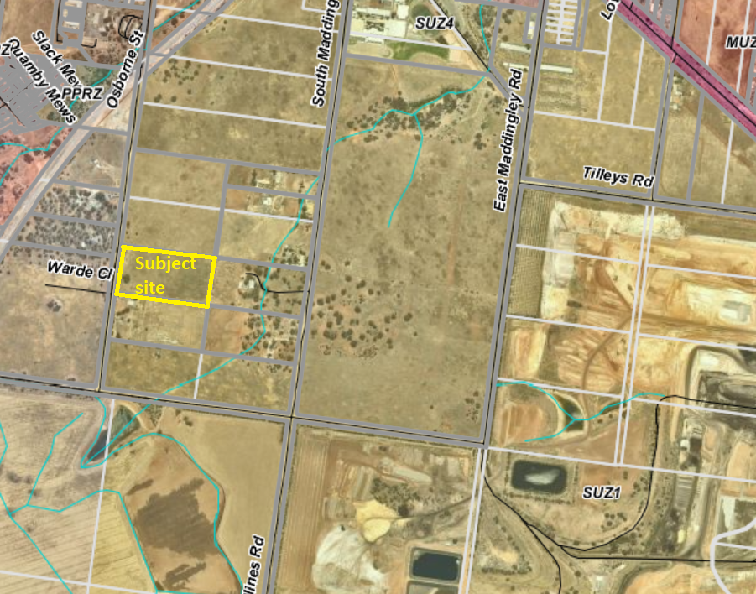
Figure 1: Aerial view of subject site and surounds

Proposal
It is proposed to use and develop the site for a single storey dwelling. The dwelling would be set back 60m from Osborne Street and 37.8m from the nearest title boundary to the north, with vehicle access provided via a proposed crossover to Osborne Street leading to a circular driveway in the front setback. The dwelling would comprise of four bedrooms, main with ensuite, media room, study, laundry, bathroom, separate toilet, games room and open plan kitchen, meals and living area with an alfresco area to the rear and an attached double garage. The dwelling would be of a traditional design, with low pitched, hipped and gabled roof forms and masonry construction. No elevation drawings were provided.

Background to Current Proposal
Not applicable.

History
Not applicable.

Public Notice
Notice of the application was given to adjoining and nearby landowners and occupiers by mail and a sign erected on site from 12 to 27 September 2018. One objection was received.

Summary of Objections
The objections received are detailed below with officer’s comments accompanying them:
Objection | Any Relevant Requirement
The proposal must be in accordance with an endorsed Maddingley Brown Coal Management Plan and Development Plan (MBC MPDP). | Clause 37.01, Schedule 1 (Coal Mining).
Officer’s Response:
The operation of the zone including its purpose and objectives are not affected with the absence of an endorsed MBC MPDP. If at a point in time such a plan is endorsed, it will not support or encourage sensitive land uses around Maddingley Brown Coal instead it provides a platform of how Maddingley Brown Coal can manage and develop their future use or uses.
The proposed dwelling is located within the recommended buffer zone for composting operations. | Clauses 11.03-3S, 13.07-1S, 21.04, 21.07,
Officer’s Response:
In accordance with EPA Publication 1588.1 Designing, Constructing and Operating Composting Facilities a minimum separation distance of 2,000m between residential development and the existing compositing facility is recommended, and it is agreed that the proposed dwelling would be located within this buffer zone. Local planning policy specifically identifies the composting facility and recommends avoidance of land use conflicts by directing sensitive land uses, such as dwellings, to locations which limit the amenity impacts on residents and ensure the appropriate operation of the composting facility. Furthermore, the site is within an area shown in the Bacchus Marsh Urban Growth Framework Plan as an Investigation Area where sensitive uses should not be located.

Locality Map
The map below indicates the location of the subject site and the zoning of the surrounding area.
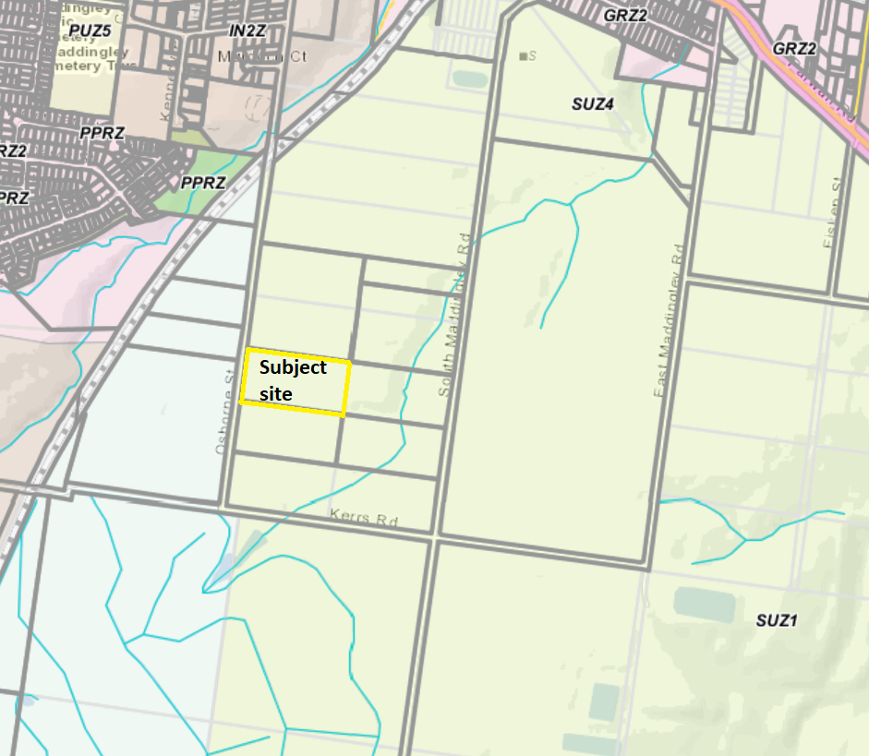
Figure 2: zoning of subject site and surrounds

Planning Scheme Provisions
Council is required to consider the Victoria Planning Provisions and give particular attention to the Planning Policy Framework (PPF), the Local Planning Policy Framework (LPPF) and the Municipal Strategic Statement (MSS).
The relevant clauses are:
• Clause 11.01-1R Settlement – Central Highlands
• Clause 11.03-3S Peri-urban areas
• Clause 13.07-1S Land use compatibility
• Clause 14.03-1S Resource exploration and extraction
• Clause 15.01-6S Design for rural areas
• Clause 16.01-5S Rural residential development
• Clause 21.02-2 Non-urban landscapes
• Clause 21.03-2 Urban growth management
• Clause 21.03-4 Landscape and neighbourhood character
• Clause 21.04-4 Industry
• Clause 21.07-2 Managing urban growth
• Clause 21.07-4 Rural living development
In assessing the application against the relevant sections of the PPF and LPPF, the following significant non-compliances were identified:

PPF | Title | Response
Clause 11.03-3S | Peri-urban areas | The proposal does not support the protection of land used for extractive and industrial uses identified in the Bacchus Marsh Urban Growth Framework Plan.
Clause 13.07-1S | Land use compatibility | The proposal is incompatible with the purpose of the zone and incompatible with existing mining and industrial activity in the nearby area.
Clause 14.03-1 | Resource exploration and extraction | The proposal does not adequately protect the existing mining resource from encroachment of sensitive land use within an established buffer zone.
Clause 16.01-5S | Rural residential development | The subject site is within an area where residential growth is discouraged due to the potential for land use conflicts with mining and industrial activities now and into the future.
LPPF

Clause 21.03-2 | Urban growth management | The subject site, in the Special Use Zone, Schedule 1 (Coal Mining) is a non-preferred location for residential growth given the potential amenity impacts on residents.
Clause 21.04-4 | Industry | The proposal is incompatible with the objective of this clause to protect the ongoing operation of the Maddingley Waste and Resource Recovery Hub (including coal mine, landfill and associated activities).
Clause 21.07-2 | Managing urban growth | The proposal is inconsistent with the objectives of this clause to protect the Maddingley Waste and Resource Recovery Hub from the encroachment of sensitive land uses such as dwellings.
Clause 21.07-4 | Rural living development | The proposal is inconsistent with the Bacchus Marsh Urban Growth Framework Plan which identifies the site as part of an area subject to investigation where sensitive uses are discouraged.

Zone
The subject site is in the Special Use Zone, Schedule 1 (Coal Mining). The purpose of Schedule 1 is:
• To recognise and provide for the use and development of land for coal mining.
• To provide for use of the land compatible with the primary purpose of the zone.
• To ensure that mining operations are carried out in an orderly manner and with due regard to the surrounding environment and adjacent land uses.
• To encourage land management practice and rehabilitation that minimises adverse impact on the use and development of nearby land.
• To ensure that use and development occurs in accordance with any endorsed Management Plan and Development Plan.
Pursuant to the table of uses under Clause 37.01-1, under Schedule 1 a Dwelling is a Section 2 use which requires a permit. Under Clause 37.01-4 a permit is required to construct associated buildings and works.
Overall, the proposal in inconsistent with the purpose of the Zone.

Overlays

The site is not affected by any Overlays.

Relevant Policies
There are no Council adopted policies relevant to this application.

Particular Provisions
None applicable.

Discussion
Overall, the proposal is considered to be inconsistent with relevant State and Local planning policy and the Special Use Zone, Schedule 1, of the Moorabool Planning Scheme.
The subject site lies south of the Bacchus Marsh township in a sparsely, undeveloped area. The subject site is located in the Special Use Zone, Schedule 1 (Coal Mining), zoned to prioritise mining operations, with the proposed dwelling located approximately 1,100m from the western title boundary of land used for coal mining, a landfill and a composting facility. Mining is regulated by the DJPR, which is a determining referral authority under the schedule to Clause 66.04 of the Moorabool Planning Scheme. DJPR, as a determining referral authority objected to the proposed development but indicated it would reconsider its position based on future advice from the EPA on an assessment which the applicant would need to initiate to address relevant matters set out in EPA Publication 1518 Recommended separation distances for industrial residual air emissions. The applicant has not provided an assessment despite being made aware of the requirement and has indicated a preference for the application to progress to a decision based on the information already submitted. The applicant has been afforded every opportunity to mediate with DJPR and Council has had this application open for almost two years without a decision. Given DJPR’s objection to the proposal and its status as a determining referral authority, Council must refuse the application under Section 61(2) of the Planning and Environment Act 1987.

Policy Objectives
Separate to DJPR’s objection to the proposal, the proposed use and development of a dwelling in this location is inconsistent with the following applicable State planning policies:
• Ensure that use or development of land is compatible with adjoining and nearby land uses (Clause 13.07-1S).
• Avoid locating incompatible uses in areas that may be impacted by adverse off-site impacts from commercial, industrial and other uses (Clause 13.07-1S).
• Protect existing commercial, industrial and other uses from encroachment by use or development that would compromise the ability of those uses to function safely and effectively (Clause 13.07-1S).
• Provide for the long-term protection of natural resources in Victoria (Clause 14.03-1S).
• Protect the opportunity for exploration and extraction of natural resources where this is consistent with overall planning considerations and acceptable environmental practice (Clause 14.03-1S).
• Develop and maintain buffers around mining and quarrying activities (Clause 14.03-1S).
Furthermore, current Local planning policy recognises the local and State significance of the Maddingley Waste and Resource Recovery Hub and seeks to ensure its ongoing operation is protected using the following strategies:
• Avoid sensitive land uses within recommended separation distances from existing industrial uses, such as the Maddingley Waste and Resource Recovery Hub, the Darley/Coimadai sand quarries and the Bacchus Marsh Recycled Water Plant (Clause 21.04-4).
• Manage off-site impacts and avoid conflict with sensitive uses to realise economic development opportunities (Clause 21.04-4).
The Bacchus Marsh Urban Growth Framework Plan identifies the subject site and surrounding land as being within an investigation area where sensitive uses are discouraged in recognition of not only the existing activities discussed above but the area’s potential to accommodate other industrial and complementary land uses to enhance economic development opportunities.
Maddingley Planning Study (Background Report)
An action in the Bacchus Marsh Urban Growth Framework is to prepare a Maddingley Planning Study. The purpose of the planning study is to
• investigation options for future non-sensitive land uses within the study area;
• determine appropriate zone and overlay controls for the study area; and
• identify existing infrastructure availability and future infrastructure requirements

The study area includes the Maddingley Waste and Resource Recovery Hub and surrounding land. The subject site is located within the study area (shown by red star). The planning study is currently being prepared with a draft due for completion in late 2020.
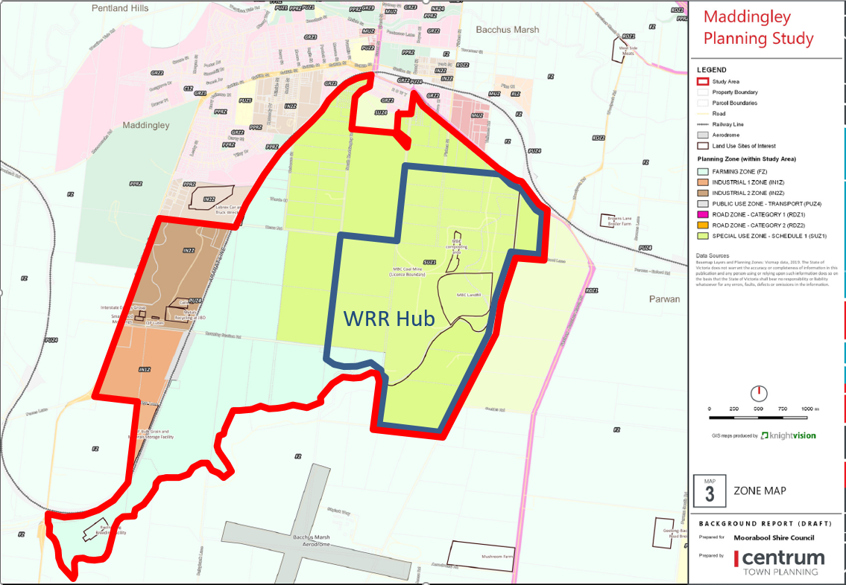
Figure 3: Land subject to the Maddingley Panning Study – subject site identified with a star
Special Use Zone
The use and development
of the subject site for a dwelling is inconsistent with the purpose of the Special Use Zone and incompatible with existing land uses in the vicinity of the site and with the Council’s strategic intent for the area. Support for the proposal in the current policy context risks compromising Council’s vision for the area, particularly in relation to economic development opportunities and the associated net community benefits. Council’s housing policy for the Bacchus Marsh area encourages the development of new housing within existing residential zoned areas or those strategically identified areas for future housing growth.
As stated above, Council must refuse the application given DJPR’s objection to the proposal as a determining referral authority. If no objection had been received from DJPR, the proposal would still fail to meet the policy objectives of the Moorabool Planning Scheme.

General Provisions
Clause 65 – Decision Guidelines have been considered by officers in evaluating this application.
Clause 66 – Stipulates all the relevant referral authorities to which the application must be referred.

Referrals
Authority | Response
DEDJTR (now DJPR)  EPA | Refusal.  Advice only.
Infrastructure  Strategic Planning  Environmental Health  Environmental Planning | Consent with conditions.  Refusal.  Consent with conditions.  Consent.

Financial Implications
There are no financial implications for Council in refusing the application.

Risk & Occupational Health & Safety Issues
The recommendation to refuse this application does not have any risk or OH&S implications for Council.

Communications Strategy
Notice was undertaken for the application, in accordance with s.52 of the Planning and Environment Act 1987, and further correspondence is required to all interested parties to the application as a result of a decision in this matter. The applicant and objector were invited to attend this meeting and address Council if required.

Options
• issue a Refusal to Grant a Permit in accordance with the grounds in the recommendation of this report; or
• issue a Refusal to Grant a Permit with amendments to the grounds in the recommendation of this report.

Conclusion
Overall, the proposed use and development for a dwelling is inconsistent with relevant State and Local planning policy and the purpose of the Special Use Zone, Schedule 1, in the Moorabool Planning Scheme. Strategically the site is unsuited to residential development and the proposal is incompatible with Council’s intent for the future use and development of land in the immediate area for non-residential uses.

7.3 PA2020012 - Use and Development of a Dwelling and Outbuilding and Removal of Vegetation at 7 O'Donnell Street Gordon
Author: Robert Asquith, Statutory Planner
Authoriser: Henry Bezuidenhout, Executive Manager Community Planning & Economic Development
Attachments: 1. Site Plan (whole and part) (under separate cover)
2. Dwelling floor plan (under separate cover)
3. Dwelling elevations (under separate cover)

Application Summary
Permit No: PA2020012
Lodgement Date: 14 January 2020
Planning Officer: Robert Asquith
Address of the land: 7 O’Donnell Street, Gordon
Proposal: Use and Development of a Dwelling and Outbuilding and Removal of Vegetation
Lot size: 1.29ha
Why is a permit required? Clause 35.03-1 Rural Living Zone. Use of land for a Dwelling
(Section 2, land less than 6ha).
Clause 42.01-2 Environmental Significance Overlay Schedule 1. Construct a building associated with a use in Section 2 (Dwelling).
Clause 42.01-2 Environmental Significance Overlay Schedule 1. Remove vegetation (22 trees).
Clause 42.03-2 Significant Landscape Overlay Schedule 2.
Construct a building (garage).
Clause 42.03-2 Significant Landscape Overlay Schedule 2.
Remove vegetation (18 trees).
Clause 43.02-2 Design and Development Overlay
Schedule 5. Construct a building.
Clause 44.06-2 Bushfire Management Overlay. Construct a building associated with the use of the land for Accommodation.

Recommendation
That Council, having considered all matters as prescribed by the Planning and Environment Act 1987, issues a Planning Permit for the Use and Development of a Dwelling and Removal of Vegetation at 7 O’Donnell Street, Gordon with the following conditions:

Endorsed Plans:
1. Before the use and/or development starts, amended plans to the satisfaction of the Responsible Authority must be submitted to and approved by the Responsible Authority. When approved the plans will be endorsed and will then form part of the permit. The plans must be drawn to scale with dimensions and three copies must be provided. The plans must be generally in accordance with the plans submitted with the application or some other specified plans but modified to show:
a) Revegetation plan to show at least 16 trees from the Gordon Native Plant List located outside the defendable space to the satisfaction of the Responsible Authority.
Unless otherwise approved in writing by the Responsible Authority, all buildings and works are to be constructed and or undertaken in accordance with the endorsed plans to the satisfaction of the Responsible Authority prior to the commencement of the use.
Dwelling Requirements:
2. Access to the dwelling must be provided via an all-weather road with dimensions adequate to accommodate emergency vehicles.
3. The dwellings must be connected to a reticulated sewerage system or if not available, the waste water must be treated and retained on-site in accordance with the State Environment Protection Policy (Waters of Victoria) under the Environment Protection Act 1970.
4. The dwelling must be connected to a reticulated potable water supply or have an alternative potable water supply with adequate storage for domestic use as well as for firefighting purposes.
5. The dwelling must be connected to a reticulated electricity supply or have an alternative energy source.
General Conditions:
6. The existing outbuildings located on the site must not be used for habitable or commercial purposes.
Infrastructure:
7. The property access and the internal driveways must be constructed in accordance with the requirements specified in Table 5 of Clause 52.47-3 of the Moorabool Planning Scheme, to the satisfaction of the Responsible Authority.
8. Storm water drainage from the proposed buildings and impervious surfaces must be retained and disposed of within the boundaries of the subject land to the satisfaction of the Responsible Authority. Overflows from on-site storage systems must be directed away from any waste water disposal areas.
9. Sediment discharges must be restricted from any construction activities within the property in accordance with relevant Guidelines including Construction Techniques for Sediment Control (EPA 1991).
10. Unless otherwise approved by the responsible authority there must be no buildings, structures, or improvements located over proposed drainage pipes and easements on the property.
11. Prior to the commencement of the development and post completion, notification including photographic evidence must be sent to Council’s Asset Services department identifying any existing damage to council assets. Any existing works affected by the development must be fully reinstated at no cost to and to the satisfaction of the Responsible Authority.
12. Prior to the commencement of the development and post completion, notification including photographic evidence must be sent to Council’s Asset Services department identifying any existing damage to council assets. Any existing works affected by the development must be fully reinstated at no cost to and to the satisfaction of the Responsible Authority.
Environmental Health:
13. The land application area and all conditions must be in accordance to the Land Capability Assessment prepared by Provincial Geotechnical Pty Ltd, reference number 13611L dated . January 2020 or any approved amendment are to be strictly adhered to.
14. An onsite waste water management system with the capacity to treat effluent to a minimum of 20/30 must be installed.
15. The wastewater management system including all effluent must be wholly contained within the property boundaries at all times.
16. All setback distances must be adhered to as dictated by Table 5 of the Code of Practice, Onsite Wastewater Management, EPA Publication Number 891.4.
17. A shallow surface water cut off drain or surface water diversion mound, should be provided on the high side of the disposal areas to divert any surface water flows around the effluent fields.
Barwon Water:
18. Wastewater treatment is to achieve a minimum water quality standard of 20mg/L BOD, 30mg/L SS and 10 orgs/100ml, i.e. secondary treatment, via an EPA approved all wastewater treatment system.
19. Effluent disposal must be undertaken via a subsurface irrigation system designed and installed by a wastewater irrigation expert as recommended in the Provincial Land Capability Assessment – Report No. 13611L, dated 8 January 2020 and to the satisfaction of Council’s Environmental Health Officer.
20. All components of the wastewater management system including the effluent disposal area must be located at least 100m from any surface waterway.
21. All stormwater must be directed away from the effluent disposal area and roof stormwater must not be disposed to the effluent disposal area.
22. Monitoring, Operation and Maintenance must be undertaken in accordance with Provincial Land Capability Assessment – Report No. 13611L, dated 8 January 2020.
23. The effluent disposal field must be protected by being isolated from any building, driveway, livestock, and vehicles.
24. Sediment control measures outlined in the EPA's publication No 275 Sediment Pollution Control, shall be employed during construction and maintained until the disturbed area has been revegetated.
25. Prior to a certificate of occupancy being issued for the dwelling the owner must enter into an Agreement with the Responsible Authority and Barwon Water in accordance with Section 173 of the Planning and Environment Act 1987 requiring that:
a) The Owner is to enter into a service contract to have any wastewater treatment facility and effluent disposal system for the dwelling inspected and maintained in accordance with the EPA Certificate of Approval for the installed system.
b) The Owner must provide to Barwon Water and the Responsible Authority an annual report on the condition and operation of the wastewater treatment system which documents the effluent quality achieved and provides laboratory, inspection and maintenance reports for the preceding 12 months.
c) The Owner shall have the wastewater treatment facility desludged at least once every three years or as otherwise determined by Council’s Environmental Health Officer. Evidence of this desludging shall be provided in the annual report referred to in Clause (b) herein.
d) The owner shall carry out any works considered necessary by the service contractor to ensure the satisfactory operation of the wastewater treatment facility and effluent disposal system.
e) The Owner will maintain all drainage lines at all times to divert surface water and subsurface water clear of the effluent disposal field.
f) The owner and the Responsible Authority agree to do all things necessary to register a memorandum of this Agreement on the title of the land pursuant to Section 181 of the Planning and Environment Act 1987.
g) The Owner shall meet all costs of inspections, reports and works referred to in Clauses (a), (b), (c), (d) and (e) herein and all costs of the Responsible Authority in relation to stamping and registration of this Agreement.
h) The Owner shall not sell or enter into any contract to sell the land until this Agreement has been registered pursuant to Clause (f) herein.

26. Barwon Water require the Section 173 Agreement to be signed by the Managing Director and Company Secretary and to state the following: THE COMMON SEAL of the BARWON REGION WATER CORPORATION was hereunto affixed in the presence of.
Country Fire Authority:
27. The Bushfire Management Plan prepared by Terramatrix (Bushfire Management Statement for 7 O’Donnell Street, Gordon VIC 3345 – Version 1.0, Map 2, Page 14, dated 9/12/2019) must be endorsed to form part of the permit and must not be altered unless otherwise agreed in writing by the CFA and the Responsible Authority.

28. The bushfire mitigation measures forming part of this permit or shown on the endorsed plans, including those relating to construction standards, defendable space, water supply and access, must be maintained to the satisfaction of the responsible authority on a continuing basis. This condition continues to have force and effect after the development authorised by this permit has been completed.
Permit Expiry:
29. This permit will expire if one of the following circumstances applies:
a) The development and the use are not started within two years of the date of this permit;
b) The development is not completed within four years of the date of this permit.

Public Consultation
Was the application advertised? | Yes.
Notices on site: | Yes.
Notice in Moorabool Newspaper: | No.
Number of objections: | One.
Consultation meeting: | No.

Policy Implications
The proposal is not inconsistent with the Council Plan 2017-202.

Victorian Charter of Human Rights & Responsibilities Act 2006
In developing this report to Council, the officer considered whether the subject matter raised any human rights issues. In particular, whether the scope of any human right established by the Victorian Charter of Human Rights and Responsibilities is in any way limited, restricted or interfered with by the recommendations contained in the report. It is considered that the subject matter does not raise any human rights issues.

Officer’s Declaration of Conflict of Interests
Under section 80C of the Local Government Act 1989 (as amended), officers providing advice to Council must disclose any interests, including the type of interest.
Executive Manager – Henry Bezuidenhout
In providing this advice to Council as the Executive Manager, I have no interests to disclose in this report.
Author – Robert Asquith
In providing this advice to Council as the Author, I have no interests to disclose in this report.

Executive Summary
Application referred? | Yes. Referred to Country Fire Authority, Barwon Water, and to Council’s Environmental Health, Council’s Infrastructure, and Council’s Environmental Planning.
Any issues raised in referral responses? | No.
Preliminary concerns? | Yes. Regarding the balance of tree loss and bushfire safety under different layout options and the general suitability of the site for development if a suitable balance was not achieved.
Any discussions with applicant regarding concerns? | Yes. Phone discussions regarding above, as well as options to alleviate objector concerns including additional revegetation.
Any changes made to the application since being lodged? | Additional revegetation plans provided including revegetation.
Brief history. | The site is vacant except for two sheds and a dam constructed at the northern end.
Previous applications for the site? | PA2003168 approved a Development of a Shed for Use as a Store  PA2001146 approved construction of a Wetland
General summary. | It is proposed to remove 22 trees and construct a dwelling. The site has been assessed for bushfire risk and the proposed design appropriately responds. The proposal is generally consistent with the relevant planning policies of the area. The application is recommended for approval.
Summary Recommendation
That, having considered all relevant matters as required by the Planning and Environment Act 1987, Council issues a Notice of Decision to Grant a permit for the Use and Development of a Dwelling and Removal of Vegetation at 7 O’Donnell Street, Gordon.

Site Description
The subject site is an irregular lot of 1.29ha within the Rural Living Zone on the northern periphery of Gordon, directly adjoining the Township Zone land to the south. It is approximately 700m north-west of the Gordon post office. The lot has a 50m street frontage to O’Donnell Street which terminates at this property, and a depth of 296m. The northern portion of the site is wider and presently accommodates the shed previously constructed.
The site rises 15m gently along the depth of the lot north from O’Donnell Street. The site has been in its present state of vegetation since at least 2001, including predominately cleared land and patches of apparent remnant vegetation remaining centrally (approximately 2,000sqm) and along the northern boundary. Access has also been made to the adjoining property east, previously in common ownership. Views into the property to either the far end, or the foremost dwelling site, are not readily accessible, owing to the significant level of coverage afforded by the existing stands of boundary conifers.
Development on the land includes a ‘workshop shed’ approved under PA2003168 and a smaller shed without record of planning approval built around 2010. A dam/wetland also exists on the land built under PA2001146 Tree planting has also occurred on site in the form of approximately 210m of exotic conifer trees stands comprising boundary separation and internal area demarcation. It has also been submitted that the 20 native trees in the previously cleared southern portion of the land—including blue gums, peppermint gums, and manna gums—were also planted. It is these 17 trees and one additional self-sown trees which are proposed to be removed for the construction of the dwelling.

Surrounding land uses include Rural Living Zone lots to the north, east, and west, all with developed dwellings and varying lot sizes and levels of cleared vegetation. This subject property can be considered as the immediate peripheral Rural Living Zone of Gordon, with the southern side of O’Donnell Street, including three existing dwellings which access it, part of the Neighbourhood Residential Zone. The nearest waterway to the proposed dwelling site is Paddock Creek, approximately 330m downhill to the south-west.

Proposal
It is proposed to remove a total of 22 trees and construct a dwelling and one separate garage as follows:
• Remove 20 native trees (variously planted and recently self-sown) for the house area.
• Remove and re-plant two exotic conifer trees from the southern boundary for increased site access.
• Construct a single storey dwelling totalling 500sqm in area of traditional style with contemporary features (see plans attached), including:
• High hipped roof with gable extensions, predominately in Colorbond Night Sky
• Central open-plan living and large alfresco area
• Four bedrooms and one office space
• Drive-through front porch
• Peak dwelling height of 6.958m
• Construct a detached double garage internally 36sqm of a matching design to the dwelling near the eastern boundary.
• On-site waste water management (no mains sewer connection available to this site) with secondary treatment and a land application area of at least 300sqm located either north of the dwelling (up slope) or across two fields south of the dwelling (down slope, against O’Donnell Street).
It has been specifically proposed to revegetate to the extent of the two conifer trees to be removed to be replanted along the boundary in available locations. Revegetation (under the Significant Landscape Overlay Schedule 2) or offsetting (under the Native Vegetation controls) of the 20 trees to be removed for the dwelling has not been specifically proposed due to available exemptions which would be applicable under Clause 52.12 (Bushfire Protection: Exemptions) of the Moorabool Planning Scheme. Clause 52.12 exempts from controls, restrictions, permit requirements or conditions any vegetation removal necessary to create an endorsed defendable space around a permitted dwelling in a Bushfire Management Overlay. In this instance, a defendable space has been proposed as follows:
• The site has been assessed for a Bushfire Attack Level (BAL) 40, provided by a defendable space of 19m around the dwelling north, south, and east, and to the boundary 6-6.3m west.
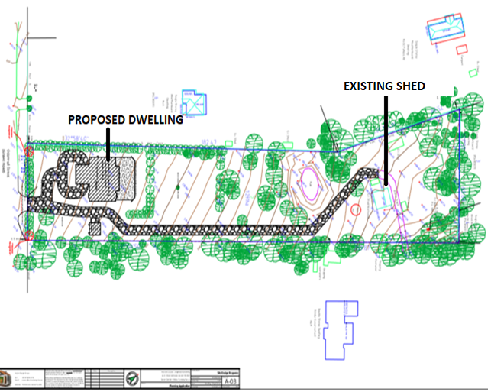
Figure 1 Site Plan

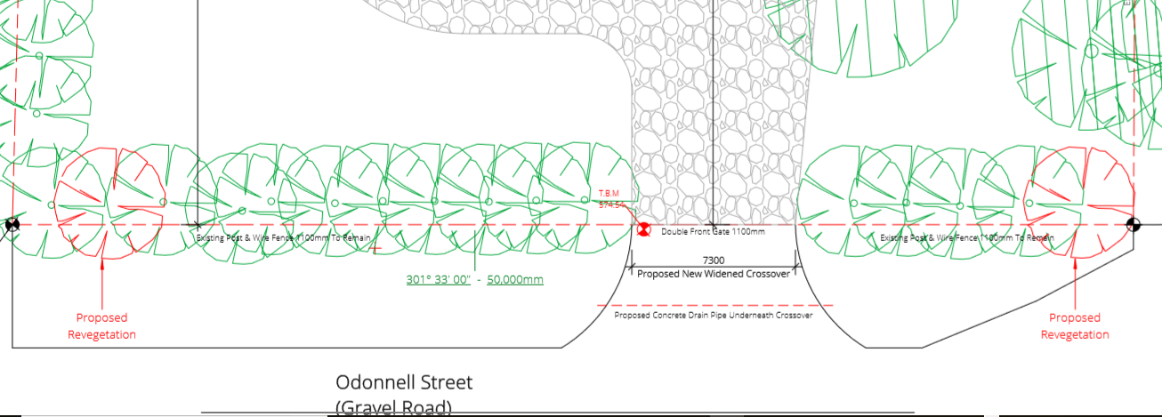
Figure 2: Location of two trees to be revegetated, marked in red facing the O’Donnell street frontage.

Background to Current Proposal
The subject lot was formerly in common ownership with the adjacent property east at 6 O’Donnell Street for which the Development and Use of a Dwelling and removal of vegetation was approved under PA2018023.

History
Planning Permits were previously issued for the property for Development of a Shed for Use as a Store and Construction of a Wetland.
No permit is recorded for the development of an additional storage shed located on the property proximate to the approved shed. Historic aerial imagery shows the shed having been built in or after 2010.

Public Notice
The application was notified to adjoining and surrounding landowners by way of letters and the placement of a sign on site for 14 days. One objection was received.

Summary of Objections
The objections received are detailed below with officer’s comments accompanying them:
Objection | Any Relevant Requirement
Proposed removal of vegetation does not accord with requirements to avoid the loss of native vegetation and respect township character. | Clause 52.17.  Clause 42.03 Schedule 2  Clause 43.02 Schedule 5
Officer’s Response:
It is acknowledged that some loss has not been entirely avoided. To achieve defendable space requirements of the Bushfire Management Overlay, the site is highly constrained with regard to vegetation. When considering net impact across vegetation, landscape, character, and safety, the proposal is acceptable for the reasons discussed below.
Alternate bushfire plans and siting were not provided. | Clause 44.06
Officer’s Response:
There is no requirement under the Bushfire Management Overlay to provide multiple or alternative responses. The submitted Bushfire Management Plan is considered appropriate and has received consent from the CFA.
The cypress trees are susceptible to ‘canker’ and should be replaced.
Officer’s Response:
The is no provision or requirement of the Moorabool Planning Scheme for requiring replacement of trees not impacted by the proposal.

Locality Map
The map below indicates the location of the subject site and the zoning of the surrounding area.

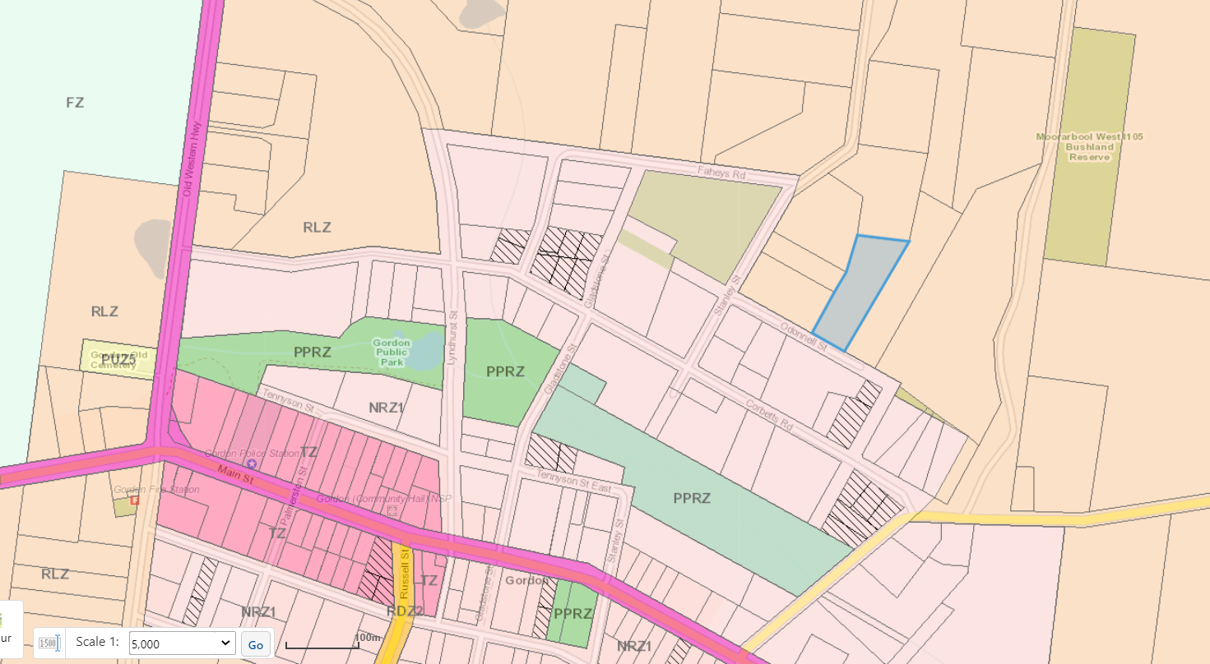
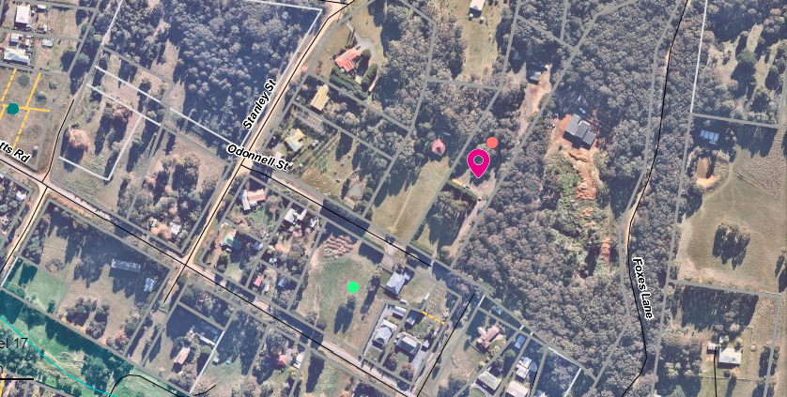
Figure 3: Zone Map
Approx. 800m

Figure 4: Aerial Photograph

Planning Scheme Provisions
Council is required to consider the Victoria Planning Provisions and give particular attention to the Planning Policy Framework (PPF), the Local Planning Policy Framework (LPPF) and the Municipal Strategic Statement (MSS).
The relevant clauses are:
• Clause 11.01-1R Settlement – Central Highlands
• Clause 12.01-2S Native vegetation management
• Clause 13.02-1S Bushfire planning
• Clause 14.02-1S Catchment planning and management
• Clause 14.02-2S Water quality
• Clause 15.01-6S Design for rural areas
• Clause 16.01-5S Rural residential development
• Clause 21.02 Natural Environment
• Clause 21.03 Settlement and Housing
• Clause 21.09 Small Towns and Settlements
• Clause 21.09-2 Gordon
• Clause 22.02 Special Water Supply Catchments
The proposal complies with the relevant sections of the PPF and LPPF, with the exception of the clauses outlined in the table below:

PPF | Title | Response
12.01-2S | Native vegetation management | The loss of native vegetation has not been avoided by the proposal. Loss has only been partly minimised.
LPPF | Title | Response
21.02-4 | Natural Environment  Objective—Biodiversity | The proposed development does not retain native all vegetation.

Zone
Clause 35.03 Rural Living Zone (RLZ)
Subject to the table of uses of Clause 35.03-1 a permit is required for the use of the land for a dwelling as than 6ha in area.
Subsequently, a permit is also required for the development of a Section 2 use pursuant to Clause 35.03-4.

The purpose of the RLZ is:
• To implement the Municipal Planning Strategy and the Planning Policy Framework.
• To provide for residential use in a rural environment.
• To provide for agricultural land uses which do not adversely affect the amenity of surrounding land uses.
• To protect and enhance the natural resources, biodiversity and landscape and heritage values of the area.
• To encourage use and development of land based on comprehensive and sustainable land management practices and infrastructure provision.

Overlays
Clause 42.01 Environmental Significance Overlay – Schedule 1 (ESO1)
A permit is required under the provisions of 42.01-2 for the removal of vegetation (22 trees) and for buildings and works. Because the ESO1 covers all vegetation loss, all 22 trees to be removed are relevant to this provision including 16 live and 4 dead trees within the house site and its defendable space, and two trees along the southern boundary.
The environmental objectives of the ESO1 are:
• To protect the quality and quantity of water produced within proclaimed water catchments.
• To provide for appropriate development of land within proclaimed water catchments.
Clause 42.03 Significant Landscape Overlay – Schedule 2 (SLO2)
A permit is required under the provisions of 42.03-2 for the removal of trees (18 relevant to the SLO2) and for buildings and works (within 4m of a tree greater than 40cm circumference at 1.3m high), being the detached garage approximately 3.8m away from trees on the adjoining lot east. Because only trees of certain sizes are covered by the SLO2, not all are relevant to this provision.
16 trees subject to this provision are within the area designated to create defendable space for the dwelling under the Bushfire Management Overlay and revegetation has not been specifically sought due to exemptions that would be available if a permit is granted under Clause 52.12.
Two trees are located outside of the defendable space and their revegetation has been specifically accounted for.
The landscape character objectives of the SLO2 are:
• To retain and protect significant trees, vegetation and windbreaks that are significant component of local identity and landscape of the township character of Gordon.
• To protect vegetation and trees of special significance, natural beauty, interest and importance.
• To retain trees where they have high amenity value, unless identified as an environmental weed.
• To support the retention and planting of further exotic and indigenous trees.

Clause 43.02 Design and Development Overlay – Schedule 2 (DDO2)
No part of the proposed buildings would be clad with reflective material. A permit is not required under the DDO2.
Clause 43.02 Design and Development Overlay – Schedule 5 (DDO5)
A permit is required under the provisions of Clause 43.02-2 for the construction of a building.
The general design objectives for the rural surrounds of the DDO5 are:
• To ensure that the design of buildings responds to the site slope and landscape features. Carefully site new development so that it does not impact on the appearance of the rural setting of the town and the views from the town to the rural areas which reinforce that setting.
• Carefully consider the landscaping and scale of new development particularly in open areas and locations on exposed hill tops and slopes.
• To discourage the use of materials, such as reflective cladding for building construction, which could have a detrimental effect on amenity.
Clause 44.06 Bushfire Management Overlay (BMO)
A permit is required under the provisions of Clause 44.06-2 for the construction of a building associated with an Accommodation use.
The purpose of the BMO is:
• To implement the Municipal Planning Strategy and the Planning Policy Framework.
• To ensure that the development of land prioritises the protection of human life and strengthens community resilience to bushfire.
• To identify areas where the bushfire hazard warrants bushfire protection measures to be implemented.
• To ensure development is only permitted where the risk to life and property from bushfire can be reduced to an acceptable level.

Particular Provisions
Clause 52.12 Bushfire Protection: Exemptions
Pursuant to Clause 52.12-5, the granting of this permit would facilitate the exemption from planning permit requirements or conditions of any permit for any prohibition or control of the removal, destruction, or lopping of vegetation within the approved defendable space.
In practice, this Clause would exempt from permit requirement or permit conditions anything relating to the 20 trees identified within the house site and defendable space.
Clause 52.17 Native Vegetation
An assessment of the native vegetation to be removed was performed by Dr Matthew Wood of Australian Ecological Research Services who determined that the trees in question are planted (due to age, arrangement, and absence from adjoining remnant forest) and therefore exempt under Clause 52.17-7.
Council officers considered this assessment to be generally appropriate. Furthermore, there is not considered to be more than 25% ground cover of native grasses or understory.
Clause 53.02 Bushfire Planning
Pursuant to Clause 44.06-4, an application under the BMO must meet the relevant requirements of Clause 53.02. For this application of one dwelling on lot within the RLZ, the application has been assessed against Clause 53.02-3.
A bushfire management statement and a bushfire management plan were prepared by Terramatrix Pty Ltd and demonstrates that the application adequately accommodates the approved measures.
The statement and plan provisioned a defendable space of up to 19m to the bushfire hazard and accordingly requires a BAL-40 construction standard.

Discussion
The key concerns of this application with regard to policy and objections received can be considered under the following categories:
Use of Land for Dwelling
The site is located in close proximity to central Gordon, adjoining the Neighbourhood Residential Zone and south of the Western Freeway. In this respect, it is considered that the site is well located for residential development and is consistent with the planning policy of Clause 11.01-1R Settlement – Central Highlands and local policies of Clause 21.09 Small Towns and Settlements. It is acknowledged that the site, at 1.29ha in area, is small compared to typical Rural Living zoned properties. However, lot size is highly varied in this part of Gordon and the five other lots west of the subject site in the same street block are each smaller than the subject site, while the eastern adjoining lot at 9 O’Donnell Street is significantly larger at 4.27ha. In this transitionary location, the lot size is not inherently restrictive to the proposed dwelling.
Furthermore, the dwelling’s design, including large hip roof with gable extensions and muted non-prominent tones, is considered appropriate to the area and consistent with broad policy objectives of Clause 15.01-6S and 16.01-5S relating to design response and residential development in rural living areas.
Protection of the Moorabool River (Sheoaks) water catchment with regard to water quality and quantity is also considered appropriate and compliant, with state and local policies at Clauses 14.02 and 22.02. Consent for the proposed development with necessary on-site waste water treatment has been given by both Council’s Environmental Health and Barwon Water as the relevant water catchment authority.
Removal of Vegetation
The removal of vegetation and this relationship with bushfire planning and safety has been identified as the primary concern with implications across local and state policy, overlays and particular provisions. The need to remove vegetation and the implications therein have also been identified as the primary concerns of the objection received for this application.
Under Significant Landscape Overlay Schedule 2 (SLO2) requires a planning permit for removal of trees if they are alive (greater than 40cm circumference) or dead (127 cm circumference). The SLO2 requires consideration of revegetation to be made and includes an application requirement of any proposed revegetation, although like-for-like replacement of tree type and number is not mandated. The SLO2 also recognises and differentiates requirements for removal of vegetation within defendable space for a dwelling in the Bushfire Management Overlay. Although the site comprises a long segment of hill which overlooks the Gordon township and Paddock Creek, it is not considered that this lot, nor the 18 subject trees, are distinguishable or independently significant in the landscape beyond their general contribution to vegetation, canopy coverage, and amenity. There are two other locations within the subject site already cleared of vegetation which may alternatively site the proposed dwelling, and which were considered during assessment: central clearing, and southern clearing.
Notwithstanding the recognised exemptions of Clause 52.12, it has been conditioned that the revegetation plan be modified to include equivalent replacement of all trees removed to be planted outside the defendable space of the dwelling to help maintain the objectives of the SLO2. This is additional to the revegetation plan already submitted identifying two conifers to be replanted.
It is considered this will adequately address the concerns of the objection, whilst also accounting for policies at Clauses 11.02-1S and 21.02-4.
With regard to Clause 52.17 Native Vegetation and the loss of potentially native trees, the applicant contended, through Dr Matthew Wood, that the 16 trees of potentially native origin in the immediate dwelling location are planted and thus exempt under the provisions of Clause 52.17-7 because of their arrangement (in rows), apparent age, and species absence from surround known remnant forest. This assessment is supported by Council officers and the vegetation is therefore exempt from permit requirement under Clause 52.17.
For the reasons above, the loss of vegetation is not considered so significant as to prevent permission being given for the development of a dwelling as proposed.
Bushfire Planning and Safety
The site is relatively more constrained with regard to bushfire planning and safety than some surrounding lots, owing to prevalence of significant vegetation north, west and within the site which restricts available egress to the south of O’Donnell Street. Furthermore, the width of the site limits the area of defendable space which can be reasonably assured and personally maintained.
Considering the above factors, the proposed dwelling siting towards the south of the lot provides the maximum separation from the main fire hazards and egress and access opportunity. Consent from the CFA was achieved for the proposed design, noting that it was recognised that alternative locations would provide worse egress and require either a high construction standard (BAL-FZ) or removal of other vegetation. Both outcomes are considered not satisfactory and the proposed design and siting is therefore the superior outcome for bushfire planning and safety having regard to Clause 13.02-1S, the Bushfire Management Overlay, and the requirements of Clause 53.02 Bushfire Planning.

General Provisions
Clause 65 – Decision Guidelines have been considered by officers in evaluating this application.
Clause 66 – Stipulates all the relevant referral authorities to which the application must be referred.

Referrals
Authority | Response
Barwon Water | Consent with conditions.
CFA | Consent with conditions.
Infrastructure | Consent with conditions.
Environmental Health | Consent with conditions.
Environmental Planning | No comment.

Financial Implications
There are no financial implications associated with this use and development application.

Risk & Occupational Health & Safety Issues
The recommendation of approval of this use and development does not implicate any risk or OH&S issues to Council.

Communications Strategy
Notice was undertaken for the application, in accordance with s.52 of the Planning and Environment Act 1987, and further correspondence is required to all interested parties to the application as a result of a decision in this matter. All submitters and the applicant were invited to attend this meeting and invited to address Council if required.

Options
Council could consider the following options:
• issue a Notice of Decision to Grant a Planning Permit in accordance with the conditions contained within this report; or
• issue a Notice of Decision to Grant a Planning Permit with amendment to the recommendation of this report; or
• issue a Notice of Refusal to Grant a Permit with grounds.

Conclusion
The application proposes a use and development which generally meets the relevant state and local planning policies, purpose and objective of the zone and overlays, and particular provisions. Concerns raised by the sole objector have been considered and determined that while relevant to the proposal, alternative vegetation response or bushfire mitigation response would not provide a better outcome.
It is recommended that a Notice of Decision to grant a permit be granted subject to the conditions specified.

7.4 PA2019288 - The re-subdivision of five lots into two lots, Use of the land for agriculture on proposed Lot 1 and Development and Use of a Dwelling on proposed Lot 2 at Pearces Road Bullarto South
Author: Victoria Mack, Statutory Planner
Authoriser: Henry Bezuidenhout, Executive Manager Community Planning & Economic Development
Attachments: 1. Plan of proposed resubdivision (under separate cover)
2. Existing 5 Lot layout (under separate cover)
3. Site Plan, Dwelling Plans and Shed Plan (under separate cover)

Application Summary
Permit No: PA2019288
Lodgement Date: 10 December 2019
Planning Officer: Victoria Mack
Address of the land: Pearces Road, Bullarto South; Lots 1, 2, 3, 4 and 5 on TP 85359L
Proposal: The re-subdivision of five lots into two lots, Use of the land for agriculture on proposed Lot 1 and Development and Use of a Dwelling on proposed Lot 2.
Lot size: Combined total area of 5 lots - 13.57ha
Why is a permit required? Rural Conservation Zone
Clause 35.06-3 Rural Conservation Zone – subdivision;
Clause 35.06-1, Section 2, Use of the land for agriculture;
Clause 36.06-1, Section 2, Use of land for a dwelling;
Clause 35.06-5, Buildings and works associated with a use in Section 2 of Clause 35.06-1.
Bushfire Management Overlay
Clause 44.06-2, Buildings and works associated with the use of land for accommodation.

Recommendation
That Council, having considered all matters as prescribed by the Planning and Environment Act 1987, issues a Refusal to Grant a Planning Permit the re-subdivision of five lots into two lots, Use of the land for agriculture on proposed Lot 1 and Development and Use of a Dwelling on proposed Lot 2 at Pearces Road, Bullarto South, otherwise known as Lots 1, 2, 3, 4 and 5 on TP85359L on the following grounds:
1. The proposed re-subdivision would create a small sized lot that is inappropriate within the Rural Conservation Zone of Bullarto South.
2. The proposed subdivision and development of a dwelling does not adequately protect the biodiversity value and the environmental significance of the land.
3. The proposal does not provide for an agricultural use consistent with the conservation values of the land and is not an orderly planning outcome for the Bullarto district.
4. The proposal does not comply with the decision guidelines of Clause 35.06 Rural Conservation Zone of the Moorabool Planning Scheme.
5. The proposal would create an unacceptable precedent in the Bullarto district that small lots can be re-subdivided to create rural residential allotments unrelated to the use of the land for environmental and conservation purposes.

Public Consultation
Was the application advertised? | Yes.
Notices on site: | Yes.
Notice in Moorabool Newspaper: | No.
Number of objections: | One.
Consultation meeting: | Not held as the recommendation is for refusal.

Policy Implications
The Council Plan 2017-2021 provides as follows:
Strategic Objective 2: Minimising Environmental Impact
Context 3A: Land Use Planning
The proposal is not inconsistent with the Council Plan 2017-2021 and can be actioned by utilising existing resources.

Victorian Charter of Human Rights & Responsibilities Act 2006
In developing this report to Council, the officer considered whether the subject matter raised any human rights issues. In particular, whether the scope of any human right established by the Victorian Charter of Human Rights and Responsibilities is in any way limited, restricted or interfered with by the recommendations contained in the report. It is considered that the subject matter does not raise any human rights issues.

Officer’s Declaration of Conflict of Interests
Under section 80C of the Local Government Act 1989 (as amended), officers providing advice to Council must disclose any interests, including the type of interest.
Executive Manager – Henry Bezuidenhout
In providing this advice to Council as the Executive Manager, I have no interests to disclose in this report.
Author – Victoria Mack
In providing this advice to Council as the Author, I have no interests to disclose in this report.

Executive Summary
Application referred? | Yes, Country Fire Authority, Southern Rural Water, Western Water and Council’s Infrastructure, Council’s Environmental Health and Council’s Environmental Planning.
Any issues raised in referral responses? | No, however Infrastructure requested that a proposed Plan of Subdivision was provided.
Preliminary concerns? | The original application showed a building envelope on the proposed northern Lot 1 in addition to the dwelling plans for the proposed southern Lot 2. Inconsistent documentation was submitted in that a dwelling on lot 1 is not applied for but documentation refer to a dwelling on lot 1.  There was concern that the two lots proposed, one of 5.637ha and the other of 7.938ha, would fragment the land in the area which is not consistent with the purpose or decision guidelines of the Rural Conservation Zone. It was considered this would not provide for orderly planning in Bullarto South.
Any discussions with applicant regarding concerns? | Further information was requested. The applicant was asked to remove the building envelope on Lot 1 and from all the documentation provided as no dwelling was being proposed on this lot and a building envelope would not be considered.  Details were requested about the unused road along the western boundary of the site which was proposed to be used for access to Lot 2.  The applicant was also asked to amend the application to include the use of the land for agriculture, and / or land management and that a Farm Management Plan (FMP) or Land Management Plan (LMP) should be provided.  The option of consolidating all five lots into one lot with a total area of 13.57ha with a single dwelling was discussed with the applicant. The applicant affirmed that the owner wished to continue with the application for two lots which can be considered under the Schedule to the Rural Conservation Zone.
Any changes made to the application since being lodged? | The following documents were provided:  • An amended Bushfire Management Statement.  • A combined LMP and FMP.  • A Plan of Subdivision.  • A copy of the agricultural grazing licence held for the unused road.
Brief history. | The land is vacant.
Previous applications for the site? | None recorded.
General summary. | The application originally submitted suggested that a dwelling was being considered for each lot, but plans were inconsistent as it only provided for a dwelling on Lot 2.  On request, the application was amended to only seek approval of one dwelling on Lot 2.  The re-subdivision would create a vacant 5.637ha lot which in this area may create an application for a future dwelling on Lot 1.  The proposed subdivision and development of a dwelling does not protect the environmental significance of the land.  On balance it is considered that this application does not provide an orderly planning outcome in a designated rural conservation area of Bullarto South.
Summary Recommendation
That, having considered all relevant matters as required by the Planning and Environment Act 1987, Council issues a Refusal to Grant a Planning Permit for the re-subdivision of five lots into two lots, Use of the land for agriculture on proposed Lot 1 and Development and Use of a Dwelling on proposed Lot 2. on proposed Lot 2 at Pearces Road, Bullarto South, otherwise known as Lots 1, 2, 3, 4 and 5 on TP85359L.

Site Description
The irregular shaped site comprises five lots with a combined area of 13.575 ha. The lots range in size from 1.317ha to 5.547ha. Pearces Road runs along the north side boundary, Bobbys Lane runs along the east side boundary, and an unused road runs along the west side boundary. The north and west boundaries of the land are the boundary between Moorabool Shire Council and Hepburn Shire Council.
Approximately 8.5ha of the site is pastured flat grazing land on the north and west sides of the property, with the balance of approximately 5ha being pristine native bushland. This bushland contains tall trees and, in places, dense understorey. This land slopes downwards to the south-east corner of the site, where there is also the commencement of an unnamed waterway. There is a farm dam located at the edge of this bushland area.
At the time of the site inspection is was noted that a water tank had been installed near to the proposed dwelling site and sundry machinery and other materials were being stored at the rear of the site, not visible from Pearces Road. The water tank does not require planning approval.
Access is to the site is from Pearces Road via a wide constructed entrance with double farm gates located in the north-west corner of the site.
The unused road running parallel to the west side boundary is currently not fenced or constructed.
Surrounding land to the north and west is in the Hepburn Shire Council and is in the Farming Zone. This land is generally cleared and pastured agricultural land. Land to the south is forested and privately owned and further south is forested crown land. Land to the east is privately owned farming land and land to the south-east is forested crown land.
Below is an aerial photo of the site and surrounds.
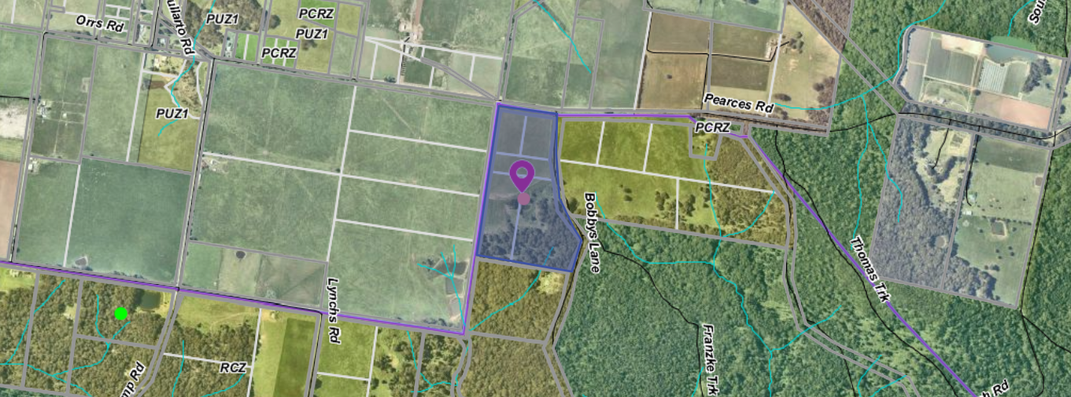
Figure 1: Aerial photograph

Proposal
The proposal provides for:
• Re-subdivision of five lots into two lots. Note: Lot 1 would be on the north side of the land and would have an area of 5.637ha. Lot 2 would be on the south side of the land and would have an area of 7.938ha.
• Proposed Lot 1 will be used for agricultural purposes which requires a permit for this use.
• Proposed Lot 2 will be used for rural living purposes and developed with a dwelling.
The applicant provided a Land Management Plan which covered basic actions including weed and feral animal control and Lucerne production. Trees would be planted in the western windbreak area, but numbers of trees were not provided.
Lot 1 would contain all the flat pastured land which would be cultivated and sown down for Lucerne production in 2020. The sowing and harvesting of Lucerne in the pastured area was documented but only at a preliminary level and for the first 12 months but with ongoing fertiliser mentioned. The Lucene production plan did not provide a five-year timeline of works and no costings or excepted returns were provided. Livestock were mentioned to manage grass, but the type or number of live stock was not provided.
The boundary between Lots 1 and 2 has been selected to follow the natural topography of the site between the proposed lots.
Lot 2 would contain all the bushland and forest and is where the proposed dwelling would be located in a small cleared section. This land slopes from the proposed boundary with Lot 1 down to the south-east corner. A detached shed would be located further to the south, closer to the forest.
The proposed single storey dwelling would have three bedrooms, two bathrooms, a laundry and an open plan kitchen and living area. There would be a verandah on two sides. A garage would be constructed near the dwelling which would be 9m x 6m, or 54sqm. The external cladding would be fire rated timber and metal cladding with toughened glazing. No reflective materials would be used, and the colours would be muted. The floor area of the dwelling would be 140sqm with an additional 120sqm of verandas.
The Bushfire Attack Level (BAL) rating for the dwelling would be 29. The dwelling would be setback 22m from the west boundary and 150m from the south boundary.
Power would be provided off-grid with solar panels and battery storage.
A barn style farm shed would be constructed south of the dwelling and would be 20m x 10.5m and would have a maximum height of 3.6m. No external cladding material has been nominated for the shed.
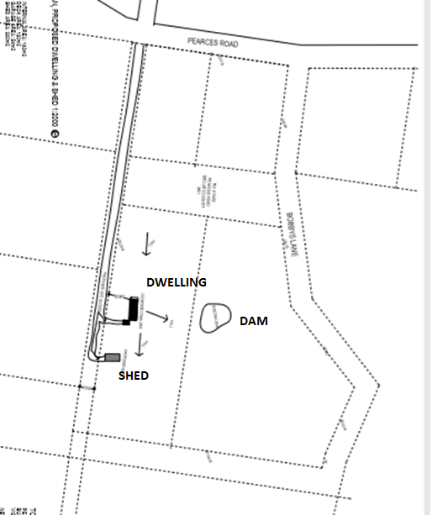

Figure 2: Dwelling and shed location plan showing all five existing lots.
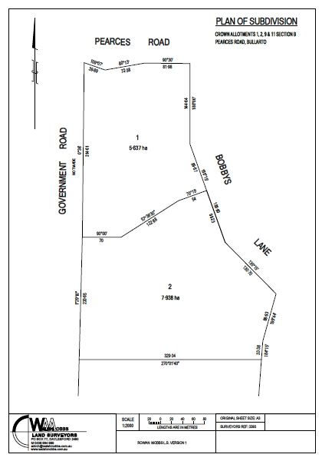
Figure 3: Proposed plan of subdivision

Background to Current Proposal
The original application included a building envelope on the proposed Lot 1. The Bushfire Management Statement also included defendable space around the building envelope on Lot 1 and a Land Capability Assessment with effluent envelope was provided for this building envelope on Lot 1.
The applicant was asked as part of further information requested to remove the building envelope from the application as there was no dwelling proposed and that all documentation should be amended to delete the building envelope on Lot 1.
This was done and the following documents were provided:
• Application form.
• Bushfire Management Statement.
• Planning Report.
• LMP/FMP for the whole of the site, with Lucerne production the primary agricultural activity proposed for the arable land area.
• A copy of the Agricultural Grazing Licence held by the owner.
• The proposed Plan of Subdivision.

History
There is no site history relevant to this application.

Public Notice
The application was notified to adjoining and surrounding landowners. One objection was received.

Summary of Objections
The objections received are detailed below with officer’s comments accompanying them:
Objection | Any Relevant Requirement
I am a farmer in the area and as such I am very passionate about the farming land in this area and its ability to be kept as farming land. I see this as eroding the planning scheme which was put in place to prevent this very development. | Rural Conservation Zone decision guidelines and purpose of the Rural Conservation Zone
Officer’s Response: The Rural Conservation Zone decision guidelines and purpose are addressed in the discussion section of this report.
The property was purchased on the understanding that it was not a lifestyle block hence its zoning. The proposal to create two parcels would enable the future sale of the other half of the property for another lifestyle development. The surrounding this land is Farming Zone and although this land is not zoned as such it has been used for farming. | Rural Conservation Zone decision guidelines and purpose of the Rural Conservation Zone
Officer’s Response: The Rural Conservation Zone decision guidelines and purpose are addressed in the discussion section of this report.
If this development goes ahead it set a precedent that zoning doesn't matter. | Rural Conservation Zone decision guidelines and purpose of the Rural Conservation Zone
Officer’s Response: The Rural Conservation Zone decision guidelines and purpose are addressed in the discussion section of this report.

Locality Map
The map below indicates the location of the subject site and the zoning of the surrounding area.
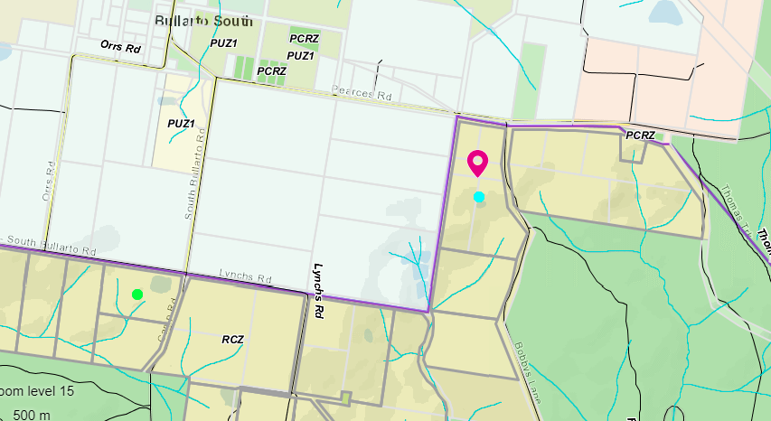
Figure 3: Zone map. Note: The northern side of Pearces Road is covered by the Hepburn Planning Scheme.

Planning Scheme Provisions
Council is required to consider the Victoria Planning Provisions and give particular attention to the Planning Policy Framework (PPF) and the Local Planning Policy Framework (LPPF) The relevant clauses are:
• Clause 12.01 Biodiversity
• Clause 12.01-1S Protection of biodiversity
• Clause 12.05-2S Landscapes
• Clause 12.05-2R Landscapes - Central Highlands
• Clause 13.02-1S Bushfire planning
• Clause 14.01-1S Protection of agricultural land
• Clause 14.01-2S Sustainable agricultural land use
• Clause 14.02-1S Catchment planning and management
• Clause 14.02-2S Water quality
• Clause 15.01-6S Design for rural areas
• Clause 16.01-5S Rural residential development
• Clause 21.02-4 Natural Environment—Biodiversity
• Clause 22.02 Special Water Supply Catchments

The proposal complies with the relevant sections of the PPF and LPPF, with the exception of the clauses outlined in the table below:

PPF | Title | Response
Clause 12.01-1S | Protection of biodiversity | The proposal does not include protection measures to enhance the conservation and biodiversity values of the property.
Clause 14.01-1S | Protection of agricultural land | Objective:  To protect the state’s agricultural base by preserving productive farmland.
Clause 14.01-2S | Sustainable agricultural land use | To ensure agricultural and productive rural land use activities are managed to maintain the long-term sustainable use and management of existing natural resources.  The proposal does not achieve these objectives due to the small land area.
Clause 16.01-5S | Rural residential development | Strategies:  Manage development in rural areas to protect agriculture and avoid inappropriate rural residential development.  Discourage development of small lots in rural zones for residential use or other incompatible uses.  Encourage consolidation of existing isolated small lots in rural zones.  The proposal does not seek the complete consolidation of small lots.
Clause 21.02-4 | Objective—Biodiversity | To positively enhance biodiversity in the Moorabool Shire.  The proposal does not seek to the biodiversity value of the site.

Zone
Rural Conservation Zone
In accordance with Clause 36.06-1, Section 2, of the Moorabool Planning Scheme, a permit is required for the use of land for a dwelling, and for the Use of the vacant second lot for agriculture.

In accordance with Clause 35.06-5, a permit is required for buildings and works associated with a use in Section 2 of Clause 35.06-1. In accordance with Clause 35.06-3 a permit is required for subdivision.
The purpose of the Rural Conservation Zone is:
• To implement the Municipal Planning Strategy and the Planning Policy Framework.
• To conserve the values specified in a schedule to this zone.
• To protect and enhance the natural environment and natural processes for their historic, archaeological and scientific interest, landscape, faunal habitat and cultural values.
• To protect and enhance natural resources and the biodiversity of the area.
• To encourage development and use of land which is consistent with sustainable land management and land capability practices, and which takes into account the conservation values and environmental sensitivity of the locality.
• To provide for agricultural use consistent with the conservation of environmental and landscape values of the area.
• To conserve and enhance the cultural significance and character of open rural and scenic non-urban landscapes.
The decision guidelines of the Rural Conservation Zone state, as relevant to this application, that the responsible authority must consider:
• Whether use or development protects and enhances the environmental, agricultural and landscape qualities of the site and its surrounds.
• Whether the site is suitable for the use or development and the compatibility of the proposal with adjoining land uses.
• Whether the use or development will have an adverse impact on surrounding land uses.
• The protection and enhancement of the natural environment of the area, including the retention of vegetation and faunal habitats and the need to revegetate land including riparian buffers along waterways, gullies, ridgelines, property boundaries and saline discharge and recharge areas.
• How the use and development relate to sustainable land management and the need to prepare an integrated LMP which addresses the protection and enhancement of native vegetation and waterways, stabilisation of soil and pest plant and animal control.
• The location of onsite effluent disposal areas to minimise the impact of nutrient loads on waterways and native vegetation.
• Whether the dwelling will result in the loss or fragmentation of productive agricultural land.
• Whether the dwelling will be adversely affected by agricultural activities on adjacent and nearby land due to dust, noise, odour, use of chemicals and farm machinery, traffic and hours of operation.
• Whether the dwelling will adversely affect the operation and expansion of adjoining and nearby agricultural uses.
• The need to minimise adverse impacts on the character and appearance of the area or features of archaeological, historic or scientific significance or of natural scenic beauty or importance.
Schedule to the Rural Conservation Zone
The schedule to this zone lists the following conservation values:
• to protect land of environmental significance.
• to ensure that the location, siting and design of any development does not adversely impact upon sensitive environments nearby.
The Schedule to the Rural Conservation Zone also shows the land is within Map 6 for Bullarto South where the minimum lot size for subdivision is 6ha.
The proposal does not meet the minimum lot size with the creation of one lot less than 6ha. However, as the application is for a re-subdivision and no additional lots are created, Lot 1 can be less than the minimum requirement.

Overlays
Bushfire Management Overlay
In accordance with Clause 44.06-2 of the Moorabool Planning Scheme a permit is required for buildings and works associated with the use of land for accommodation.

Relevant Policies
There are no relevant policies that apply to the Rural Conservation Zone.

Particular Provisions
Clause 52.12 Bushfire Protection exemptions
Exemption to create defendable space for a dwelling approved under Clause 44.06 of this planning scheme. An exemption for vegetation removal to create defendable space does not apply in the Rural Conservation Zone under Clause 52.12-5.
Clause 52.17 Native vegetation
No native vegetation would be removed as part of this application and Clause 52.17 does not apply in this instance.
Clause 53.02 Bushfire planning
To specify bushfire design and construction measures for a single dwelling or alteration and extension to an existing dwelling that reduces the risk to life and property to an acceptable level.
Clause 53.02-3.1 Decision guidelines
Before deciding on an application, in addition to the decision guidelines in Clause 65, the responsible authority must consider:
• The Municipal Planning Strategy and the Planning Policy Framework.
• The bushfire hazard site assessment and the bushfire management statement submitted with the application.
• Whether all of the approved measures have been incorporated into the application.

Discussion
The subject site is 13.57ha and comprises of five lots. If approved the application would result in the re-subdivision of the five lots into two lots and the development of a dwelling on one lot.
The vacant Lot 1 would be 5.637ha in area with the south side boundary of this lot selected to align with the topography of the land, on this basis the lot size being less than 6ha would be considered acceptable. Lot 2 would contain the proposed dwelling, separate garage and large shed and would be 7.938ha in area
The Bullarto South area is partly an agricultural district and partly native forests. Most surrounding lots to the north are cleared and used for grazing or cropping while to south are native woodland with fire access tracks. It is a sparsely settled area with the township area located to the north in Hepburn Shire Council.
The applicant was advised a better planning outcome would be achieved if the five lots were consolidated into one lot which would discourage rural residential development in the Bullarto South district and it would be more consistent with the objectives of the Rural Conservation Zone. The area is generally a mix of established agricultural enterprises and natural areas of forest and bushland.
However, the applicant advised that the owner wished to pursue the 2 lot re-subdivision with the reasoning that this is a better outcome than the potential of five lots ending up in separate ownership and that the re-subdivision of lots was not prohibited in the Rural Conservation Zone.
The creation of two relatively small allotments in the Bullarto South district is not considered to be an orderly planning outcome. It has the potential to suggest that the newly created lot is suitable for another activity such as a dwelling. There has been insufficient zoning justification on why the land needs to be re-subdivided into two lots and lack of detail about what uses could occur on the lot without the dwelling proposed. The subdivision has not been arranged to protect the environmental significance of the land and is not accordance with the objectives and purpose of the Rural Conservation Zone.
The application has also received one objection following notification. The objector is concerned that if the re-subdivision is approved it will create a precedent for further re-subdivision and rural residential development in the Bullarto South district.
One purpose of the Rural Conservation Zone specifically aims to: ‘provide for agricultural use consistent with the conservation of environmental and landscape values of the area; and to conserve and enhance the cultural significance and character of open rural and scenic non-urban landscapes.’ This has not been achieved with this proposal as the dwelling is not located in the already cleared land area (northern section) that is proposed for farming but rather on the highly vegetated area that should be retained for conversation purposes, without seeking to prevent adverse impacts on highly vegetated Lot 2. A dwelling is typically associated with the farming activities, which is not the case with this application.
A Land Management Plan (LMP) was provided with the application. The LMP divided the whole of the site into five zones: house and garden zone on Lot 2; pasture zone on Lot 1 where Lucerne would be grown; windbreak zone on the west side of Lot 1; a revegetation area on Lot 2; and a forest zone on Lot 2. The plan covered the first year of operation in some detail but did not provide a five-year plan. The LMP was a summary of activities and lacked specific implementation details. No costings or projected returns were provided.
It is not considered that the LMP comprehensively addressed the conservation and sustainable land management purposes of the zone.
It is not considered that this application meets the decision guidelines of the Rural Conservation Zone. The proposal would create two small lots, with one to be used for rural residential development and the other having limited land area for agricultural or conservation purposes. Two lots also would fragment the potential to create an integrated LMP for the whole of the site.
While the development of one dwelling over all lots which total 13.57ha may be acceptable with an integrated LMP the creation of a second lot is not acceptable. The Rural Conservation Zone in Bullarto South has been designed as a buffer between the forest land to the south and the farming land to the north and any re-subdivision which results in small sized lots or continues the fragmentation of rural conservation land should not be supported as it does not achieve the objectives of the zone.
The objectives of the Rural Conservation Zone have also been explored in detail by VCAT. In Tsourounakis vs Hepburn Shire Council 2010 [VCAT 723] Member Naylor and Potts looked at the objectives of the Rural Conservation Zone, in paragraphs 10-13 of their order.
‘10. The purpose of the RCZ is primarily aimed at conservation and protection of environmental values. There is no reference to the use of the land for dwellings or rural living in the purposes. While agricultural land use is a purpose, it is only where such use is consistent with the ‘conservation of environmental and landscape values of the area’.
11.To us it seems that the approach of the Council and Mr Tsourounakis seems to typify many applications for dwellings in a RCZ. This approach is to start by asking ‘how’ can a dwelling be accommodated. Having regard to the purposes of the zone and the overlays that apply, the question should more rightly be put as to ‘why’ a dwelling should be allowed. This is further emphasised by the fact that the use for a dwelling is a section 2, permit required use. This is to be contrasted with the use for a dwelling on other rural land, i.e. the Rural Living and Farming Zones, where a dwelling is a section 1 use, albeit even then on a conditional basis, including the ability to achieve satisfactory on-site wastewater treatment and disposal.
12. In our view if use of this land for agriculture or a rural living dwelling was seen to be strategically supported, then other zones would have been applied to this land. That other zones have not been applied to this land points clearly to a recognition that this land has other values that the purpose of RCZ seeks to support.
13. Accordingly in response to why a dwelling should be allowed, the reasoning by the Council that the land cannot be used for agriculture is irrelevant. The reasoning that there are other dwellings present, a large proportion of which are located in another zone fails to recognise the difference in intended land use as discerned from the difference in the zonings.’
This decision highlighted the importance of protecting environmental significant land from both dwelling uses and agricultural uses.
It is recommended that the application for a re-subdivision with construction of a dwelling on one lot and agricultural use on a second lot is not supported as the proposal is not consistent with the purposes or the decision guidelines of the Rural Conservation Zone.

General Provisions
Clause 65 – Decision Guidelines have been considered by officers in evaluating this application.
Clause 66 – Stipulates all the relevant referral authorities to which the application must be referred.

Referrals
Authority | Response
Western Water  Southern Rural Water  Country Fire Authority | No response.  Consent with conditions  Consent with conditions
Infrastructure  Environmental Health  Environmental Planning | Consent with conditions  Consent with conditions  No comment

Financial Implications
It is not considered that the recommendation of refusal represents any financial risk or implications to Council.

Risk & Occupational Health & Safety Issues
The recommendation of refusal of this development and re-subdivision, use and development proposal does not implicate any risk or OH&S issues to Council.

Communications Strategy
Notice was undertaken for the application, in accordance with s.52 of the Planning and Environment Act 1987, and further correspondence is required to all interested parties to the application as a result of a decision in this matter. All submitters and the applicant were invited to attend this meeting and invited to address Council if required.

Options
1. Issue a refusal to the planning permit in accordance with the recommendations of this report; or
2. Should Council wish to consider an approval of the application Council may consider including a condition on the permit that no dwellings are to be constructed on the proposed Lot 1.

Conclusion
The application includes both the re-subdivision of the land, the development and use of a dwelling on one lot and the use of the land for agriculture on a second lot. It is considered that proposal has not sought to protect environmental significance of the land and is not an orderly planning outcome in the Bullarto South district. Not supporting the re-subdivision, uses and development must result in a recommendation that the whole application is refused.

7.5 PA2020096 - Development and Use of Five Retail Shops and Four Dwellings, Staged 9 Lot Subdivision and Reduction of Car Parking at 22 Fisken Street Ballan
Author: Victoria Mack, Statutory Planner
Authoriser: Henry Bezuidenhout, Executive Manager Community Planning & Economic Development
Attachments: 1. Development plans (under separate cover)
2. Plan of subdivision (under separate cover)
3. Landscape plan (under separate cover)

Application Summary
Permit No: PA2020096
Lodgement Date: 28 May 2020
Planning Officer: Victoria Mack
Address of the land: 22 Fisken Street, Ballan
Proposal: Development and Use of Five Retail Shops and Four Dwellings, Staged 9 Lot Subdivision and Reduction of Car Parking
Lot size: 1,012sqm
Why is a permit required? Development of land in Commercial 1 Zone
Subdivision of land in Commercial 1 Zone
Reduction of car parking

Recommendation
That Council, having considered all matters as prescribed by the Planning and Environment Act 1987, issue a permit for the Development and Use of Five Retail Shops and Four Dwellings, Staged 9 Lot Subdivision and Reduction of Car parking at 22 Fisken Street, Ballan otherwise known as Lot 1 on TP015046E subject to the following conditions:
1. The development as shown on the endorsed plans must not be altered without the written consent of the Responsible Authority. All buildings and works must be constructed and or undertaken in accordance with the endorsed plans to the satisfaction of the Responsible Authority. All buildings and works must be located clear of any easements or water and sewer mains or septic tank and effluent lines unless written approval is provided by the relevant authority.
2. The formal plan of subdivision lodged for certification must be generally in accordance with the endorsed plan and must not be modified except to comply with statutory requirements or with the written consent of the Responsible Authority.
Building Works
3. The amenity of the area must not be detrimentally affected by the use or development, through the:
a) transport of materials, goods or commodities to or from the land;
b) appearance of any building, works or materials’
c) emission of noise, artificial light, vibration, small, fumes, smoke, vapour, steam, soot, ash, dust, waste water, waste products, grit or oil;
d) presence of vermin; and
e) any other way.
4. All external plant and equipment must be acoustically treated or placed in soundproof housing to reduce noise emanating from the site.
5. All pipes, fixtures, fittings and vents servicing any building on the site, other than storm water down pipes, must be concealed in service ducts or otherwise hidden from view to the satisfaction of the Responsible Authority.
6. External lighting must be provided with suitable baffles and located so that no direct light is emitted outside the site.
7. Goods, equipment or machinery must not be stored or left exposed in a position that can be seen from the street.
Telecommunications:
8. The owner of the land must enter into agreements with:
a) a telecommunications network or service provider for the provision of telecommunication service to each lot shown on the endorsed plan in accordance with the provider’s requirements and relevant legislation at the time; and
b) a suitably qualified person for the provision of fibre ready telecommunication facilities to each lot shown on the endorsed plan in accordance with any industry specifications or any standards set by the Australian Communications and Media Authority, unless the applicant can demonstrate that the land is in an area where the National Broadband Network will not be provided by optical fibre.
9. Before the issue of Statement of Compliance for any stage of the subdivision under the Subdivision Act 1988, the owner of the land must provide written confirmation from:
a) a telecommunications network or service provider that all lots are connected to or are ready for connection to telecommunications services in accordance with the provider’s requirements and relevant legislation at the time; and
b) A suitably qualified person that fibre ready telecommunication facilities have been provided in accordance with any industry specifications or any standards set by the Australian Communications and Media Authority, unless the applicant can demonstrate that the land is an area where the National Broadband Network will not be provided by optical fibre.
Subdivision
10. Prior to the issue of a Statement of Compliance, all landscaping works in accordance with the endorsed landscape plans must be completed to the satisfaction of the Responsible Authority.
11. The plan of subdivision submitted for certification under the Subdivision Act 1988 must be referred to the relevant authority in accordance with Section 8 of that Act.
12. Before the statement of compliance is issued under the Subdivision Act 1988, the applicant or owner must pay to the responsible authority a sum equivalent to 5 per cent of the site value of all the land in the subdivision for public open space purposes. The permit holder/developer must pay the reasonable costs of Council in having the land valued for this purpose
Infrastructure:
13. Prior to the issue of a Statement of Compliance for the subdivision, the vehicle crossings must be constructed to the satisfaction of the Responsible Authority. Any redundant vehicle crossings must be removed, and the kerb and channel and nature strip reinstated to the satisfaction of the Responsible Authority.
14. Prior to the issue of a Statement of Compliance for the subdivision, the common property driveway must be constructed to the satisfaction of the Responsible Authority.
15. Prior to the issue of a Statement of Compliance for the subdivision, the footpath must be constructed to the satisfaction of the Responsible Authority.
16. Prior to the issue of a Statement of Compliance for the subdivision, the development must be provided with a stormwater drainage system to the satisfaction of the Responsible Authority.
17. Sediment discharges must be restricted from any construction activities within the property in accordance with relevant Guidelines including Construction Techniques for Sediment Control (EPA 1991).
18. Unless otherwise approved by the responsible authority there must be no buildings, structures, or improvements located over proposed drainage pipes and easements on the property.
19. Prior to the commencement of the development and post completion, notification including photographic evidence must be sent to Council’s Asset Services department identifying any existing damage to council assets. Any existing works affected by the development must be fully reinstated at no cost to and to the satisfaction of the Responsible Authority.
Central Highlands Water:
20. Any plan lodged for certification will be referred to the Central Highlands Region Water Corporation pursuant to Section 8(1)(a) of the Subdivision Act 1988.
21. Reticulated sewerage facilities must be provided to each lot by the owner of the land (or applicant, in anticipation of becoming the owner) to the satisfaction of the Central Highlands Region Water Corporation. This will include the construction of works and the payment of major works contributions by the applicant.
22. A reticulated water supply must be provided to each lot by the owner of the land (or applicant, in anticipation of becoming the owner) to the satisfaction of the Central Highlands Region Water Corporation. This will include the construction of works and the payment of major works contributions by the applicant.
23. The owner will provide easements to the satisfaction of the Central Highlands Region Water Corporation, which will include easements for pipelines or ancillary purposes in favour of the Central Highlands Region Water Corporation, over all existing and proposed sewerage facilities within the proposal.
24. If the land is developed in stages, the above conditions will apply to any subsequent stage of the subdivision.
Downer Utilities:
25. The plan of subdivision submitted for certification must be referred to AusNet Services (Gas) in accordance with Section 8 of the Subdivision Act 1988.
Southern Rural Water:
26. All lots must be connected to Central Highlands Water reticulated sewerage system.
27. All lots must be connected to the towns stormwater drainage system.
28. The plan of subdivision submitted for certification must be referred to Southern Rural Water in accordance with Section 8 Subdivision Act 1988.
Powercor:
29. The applicant shall provide an electricity supply to all lots in the subdivision in accordance with the Distributor’s requirements and standards.
Notes: Extension, augmentation or rearrangement of the Distributor’s electrical assets may be required to make such supplies available, with the cost of such works generally borne by the applicant.
30. The applicant shall ensure that existing and proposed buildings and electrical installations on the subject land are compliant with the Victorian Service and Installation Rules (VSIR).
Notes: Where electrical works are required to achieve VSIR compliance, a registered electrical contractor must be engaged to undertake such works.
31. The applicant shall, when required by Powercor, set aside areas with the subdivision for the purposes of establishing a substation or substations.
Notes: Areas set aside for substations will be formalised to the Distributor’s requirements under one of the following arrangements:
• RESERVES established by the applicant in favour of Powercor.
• SUBSTATION LEASE at nominal rental for a period of 30 years with rights to extend the lease for a further 30 years. Powercor will register such leases on title by way of a caveat prior to the registration of the plan of subdivision.
32. The applicant shall establish easements on the subdivision, for all existing Powercor electric lines where easements have not been otherwise provided on the land and for any new powerlines to service the lots or adjust the positioning existing easements.
Notes:
• Existing easements may need to be amended to meet the Powercor’s requirements
• Easements required by Powercor shall be specified on the subdivision and show the Purpose, Origin and the In Favour of party as follows: Powerline, Section 88 Electricity Industry Act 2000, Powercor Australia Ltd.
Landscape Plans:
33. Before the use/occupation of the development starts or by such later date as is approved by the Responsible Authority in writing, the landscaping works shown on the endorsed plans must be carried out and completed to the satisfaction of the Responsible Authority.
34. The landscaping shown on the endorsed plans must be maintained to the satisfaction of the Responsible Authority, including that any dead, diseased or damaged plants are to be replaced.
Permit Expiry:
35. This permit will expire if one of the following circumstances applies:
a) the development and the use is not started within two years of the date of this permit;
b) the development is not completed within four years of the date of this permit;
c) the plan of subdivision is not certified within two years of the date of issue of the permit; and
d) each subsequent stage is not certified within two years of the date of certification of the previous stage.
Statement of Compliance must be achieved, and certified plans registered at Titles office, within five years from the date of certification.
Permit Notes:
36. PowerCor Note: It is recommended that applications for electricity supply to each lot be submitted at the earliest opportunity so that the precise requirements of the Distributor can then be determined and accommodated. Applications for electricity supply shall be submitted via the Distributor’s web portal, “mySupply” which can be accessed via the following link: https://customer.portal.powercor.com.au/mysupply/CIAWQuickCalculator.
37. Downer Note: The owner/developer of the land may need to enter into an agreement or request a quote from a local gas retailer for provision or altering of gas services for each lot of the endorsed plan.

Public Consultation
Was the application advertised? | The application was not advertised as the footprint of the building has been set and the development is 90% complete. The only adjoining neighbour immediately to the east was contacted as a courtesy and provided consent in writing to the application.
Notices on site: | No.
Notice in Moorabool Newspaper: | No.
Number of objections: | No.
Consultation meeting: | None required.

Policy Implications
The Council Plan 2017-2021 provides as follows:
Strategic Objective 3: Stimulating Economic Development
Context 2A: Built Environment
The proposal is not inconsistent with the Council Plan 2017-2021 and can be actioned by utilising existing resources.

Victorian Charter of Human Rights & Responsibilities Act 2006
In developing this report to Council, the officer considered whether the subject matter raised any human rights issues. In particular, whether the scope of any human right established by the Victorian Charter of Human Rights and Responsibilities is in any way limited, restricted or interfered with by the recommendations contained in the report. It is considered that the subject matter does not raise any human rights issues.

Officer’s Declaration of Conflict of Interests
Under section 80C of the Local Government Act 1989 (as amended), officers providing advice to Council must disclose any interests, including the type of interest.
Executive Manager – Henry Bezuidenhout
In providing this advice to Council as the Executive Manager, I have no interests to disclose in this report.
Author – Victoria Mack
In providing this advice to Council as the Author, I have no interests to disclose in this report.

Executive Summary
Application referred? | Yes, to Council’s Infrastructure, Central Highlands Water, Melbourne Water, Powercor, Western Water, Southern Rural Water and Downer Utilities.
Any issues raised in referral responses? | No.
Preliminary concerns? | None.
Any discussions with applicant regarding concerns? | Not applicable.
Any changes made to the application since being lodged? | Not required.
Brief history. | Prior to demolition, there was a single storey dwelling in the south west corner of the site and ancillary outbuildings.
Previous applications for the site? | The application has been made because an approved development and subdivision permit, PA2015108, expired prior to the plan of subdivision being certified. The buildings are largely complete but works cannot continue until a new permit has been granted.
General summary. | The development is nearly completed in accordance with the previously endorsed plans. The plans for this application are the identical to the previously endorsed plans.

Summary Recommendation
That Council, having considered all matters as prescribed by the Planning and Environment Act 1987, issues a permit for the Development and Use of Five Retail Shops and Four Dwellings, staged 9 Lot Subdivision and Reduction of Car parking at 22 Fisken Street, Ballan otherwise known as Lot 1 on TP 015046E subject to conditions.

Site Description
Subject Site-Locality
The site is located on a corner, on the east side of Fisken Street and on the north side of Steiglitz Street.
The site is approximately 50m south of the intersection of Fisken Street with Inglis Street, which is the main street in the Ballan township.
The site is rectangular in shape with an area of 1012sqm. The development on the site is approximately 90% completed. It is largely the internal fittings and landscape works that are yet to be completed.
Opposite the development are a range of community buildings including Fire Station, Senior Citizens, Men’s shed and the Ballan Hall.
To the north of the site is a public reserve containing a toilet block and small park.
To the south and south west of the site across Steiglitz Street is land in the General Residential Zone, Schedule 4.
Fisken Street connects the centre of the Ballan township with the Ballan Railway station which is approximately 300m to the south.
Below is an aerial photo of the site and surrounding area.
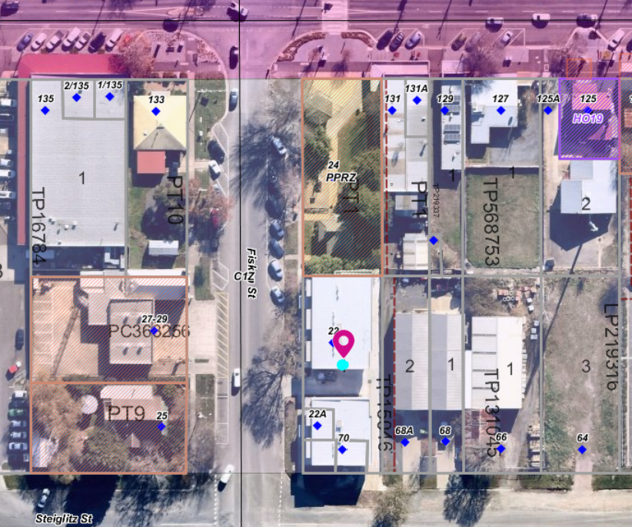
Figure 1: Aerial Photograph of nearly completed development.

Proposal
The proposal is for the development of five shops, four dwellings and the subdivision of the dwellings and shops into nine lots. The details are as follows:
Ground floor: shops
Five retail shops facing Fisken Street. The retail floor area of shops 1-4 shops would range from 45sqm and 47sqm and are located on ground floor level. The fifth shop would be located on the ground floor but also include an upper level which provides a total floor area of 210.58sqm. Windows on both levels would face to the north and west and there would be a balcony overlooking Fisken Street.
Each shop would be accessed via a doorway inset into the building façade, facing Fisken Street, and would have a large shop window also facing Fisken Street. Each shop would contain a disabled unisex toilet and hand basin.
Each shop would have a dedicated car space at the rear of the development secured by a roller door via a rear access way and rear doorway.
The access way would have two ingress and egress points - one form Steiglitz Street and the other from Fisken Street which would run through the centre of the development. The accessway would also contain a loading bay.
The bulk of the building would be broken up with distinct features including balconies, windows, a mix of external cladding materials and some landscaping.
While it is not considered that the architectural form of the proposed development would necessarily be suitable in the main street of Ballan, in Fisken Street the development provides for functionality, a diversity in accommodation choice and a number of small shops, to enable growth in the retail spaces available in Ballan.
The location of the proposed development is close to the centre of the township and also close to public off-street parking to the east along Steiglitz Street.
Upper floor: dwellings
The four upper storey dwellings would have two bedrooms, the master bedroom with a walk-in-robe and ensuite, a second bathroom, a separate laundry and an open plan kitchen living and dining room facing west. The floor area of each dwelling would range between 137sqm and 139sqm. Each dwelling would have a single car space garage which would be 22.25sqm in area.
Each dwelling would have a covered balcony overlooking Fisken street with an area of slightly greater than 8sqm. Access to each of two dwellings would be via a covered front porch and entranceway doorway from Fisken Street with a total width of 2.14m leading to a staircase to an upper floor landing which would service two dwellings. Additional access would also be provided via a rear door way from the single car space garage at the rear.
Car spaces
The development provides nine car spaces on the site, one for each of the five shops, and one for each of the four two-bedroom dwellings.
The rear access way from Steiglitz Street would service the nine car spaces and would be 4.69m wide. The access would include a driveway between Shops 1 and 2 and shops 3, 4 and 5. This accessway would be 6.6m wide. It would contain a loading bay and passing lane. Some limited landscaping would be incorporated into the rear of the site around doorways.
Subdivision:
The land would be subdivided into 9 lots. Each of the 5 shops and 4 dwellings would then have separate titles.

Background to Current Proposal

History
The original application included vegetation removal which was completed under the previous permit.
Whilst the construction of the approved shops and dwellings commenced within the required timeframes, the plan of subdivision was not certified within the two years of the date of issue of the permit. The expiry date was 29 December 2018 and the applicant had up to 29 June 2019 to apply for an extension of time under Section 69 of the Planning & Environment Act 1987. The applicant was unaware of their expiry dates and this oversight caused the whole of the permit to expire.

The applicant has been required to cease works on site until a new planning permit is issued. The applicant is unable to obtain new titles for the almost completed shops and dwelling until a new planning permit is issued.
The permit expiry conditions associated with the development and the subdivision are tied together meaning that if one has expired then the entire permit has expired.
This application is to renew the permit so that the development and subdivision can be completed. The plans submitted are identical as the endorsed plans for Planning Permit number PA2015108.

Public Notice
The application was not formally advertised but the adjoining neighbouring landowner was contacted about the application and they provided Council with written correspondence they did not object to this application. The buildings are nearly completed, and it is that the previous application PA2015108 has expired that this application is required.

Locality Map
The map below indicates the location of the subject site and the zoning of the surrounding area.

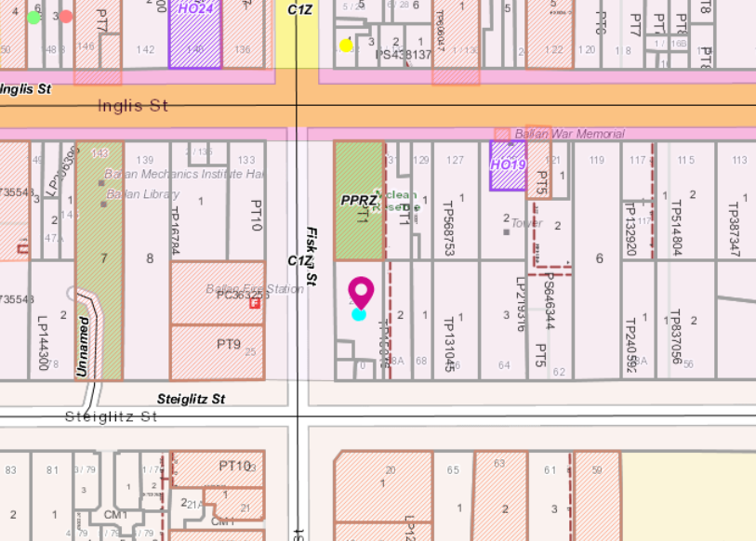
Figure 2: Zone Map

Planning Scheme Provisions
Council is required to consider the Victoria Planning Provisions and give particular attention to the Planning Policy Framework (PPF), the Local Planning Policy Framework (LPPF) and the Municipal Strategic Statement (MSS).
The relevant clauses are:
• Clause 11.03-3S Peri-urban areas
• Clause 14.02 Water
• Clause 15.01-2S Building design
• Clause 15.01-3S Subdivision design
• Clause 15.01-5S Neighbourhood character
• Clause 21.02-3 Water and Catchment Management
• Clause 21.03-2 Urban Growth Management
• Clause 21.03-3 Residential Development
• Clause 21.03-4 Landscape and Neighbourhood Character
• Clause 21.08-2 Character and Sense of Place
• Clause 21.08-6 Residential Development
• Clause 22.02 Special Water Supply Catchments
The proposal complies with the relevant sections of the PPF and LPPF

Zone
Commercial 1 Zone
In accordance with Clause 34.01-1, section 1 a permit is not required for:
1. Accommodation where any frontage at ground floor level must not exceed 2m (other than a bed and breakfast and caretaker's house).
2. A shop where the leasable floor area for all shops does not exceed any amount specified in the schedule to this zone. The schedule to this zone does not specify any limit to leasable floor area in Ballan.
In accordance with Clause 34.01-4 a permit is required for building and works.
In accordance with Clause 34.01-3 a permit is required to subdivide land.
Decision guidelines are listed under Clause 34.01-8 of the Moorabool Planning Scheme.
Overlays
Environmental Significance Overlay – Schedule 1
The site is affected by the Environmental Significance Overlay – Schedule 1 – Proclaimed Water Catchment Areas. Under Clause 42.01-2, a permit is required to subdivide land. There are no relevant exemptions under Schedule 1.
The objectives for Schedule 1 are:
• To protect the quality and quantity of water produced within proclaimed water catchments.
• To provide for appropriate development of land within proclaimed water catchments.

Relevant Policies
There are no relevant policies that would have a bearing of a granting of a permit for this proposal.

Particular / General Provisions

Clause 52.06 Car parking
In accordance with Clause 52.06 a permit is required to reduce the number of car parking spaces required under clause 52.06-5. In this application under Clause 52.06-5 the following car spaces are required:
• A shop requires four car spaces for each 100sqm of leasable floor area.
• A two-bedroom dwelling requires one car space
The total number of car spaces required for this application are:
• Four spaces for Shops 1, 2, 3 and 4 where the floor areas of each are less than 50sqm.
• Eight spaces for Shop 5 where the floor area is 210.58sqm.
• Four spaces for the four two-bedroom dwellings.
A total of 16 car spaces are required for this development, but only nine car parking spaces have been provided. Therefore, a reduction of seven car parking spaces has been requested.

Discussion
The application is a repeat application for a development of five shops and four dwellings and the staged subdivision of the development into nine lots and a reduction of seven car spaces.
The application is the same as a development and subdivision and reduction of car spaces approved by PA2015108. This permit lapsed due to the plan of subdivision not being certified by the expiry date. The plans are identical to the previously endorsed plans. However, the preamble has changed slightly to remove vegetation removal as this has already been completed. The development is about 90% completed.
The new application was referred to the required service authorities with all consenting to the application with conditions.
The most immediate adjoining neighbour was contacted about this application. This neighbour consented and notified Council in writing.
It is considered that the application should be supported and a planning permit be granted.

General Provisions
Clause 65 – Decision Guidelines have been considered by officers in evaluating this application.
Clause 66 – Stipulates all the relevant referral authorities to which the application must be referred.
Clause 65.01 Approval of an application or plan
Before deciding on an application or approval of a plan, the Responsible Authority must consider, as appropriate:
• the matters set out in section 60 of the Act;
• the Municipal Planning Strategy and the Planning Policy Framework;
• the purpose of the zone, overlay or other provision; any matter required to be considered in the zone, overlay or other provision;
• the orderly planning of the area;
• the effect on the amenity of the area;
• the proximity of the land to any public land;
• factors likely to cause or contribute to land degradation, salinity or reduce water quality;
• whether the proposed development is designed to maintain or improve the quality of stormwater within and exiting the site;
• the extent and character of native vegetation and the likelihood of its destruction;
• whether native vegetation is to be or can be protected,
• planted or allowed to regenerate; the degree of flood, erosion or fire hazard associated with the location of the land and the use, development or management of the land so as to minimise any such hazard; the adequacy of loading and unloading facilities; and
• any associated amenity, traffic flow and road safety impacts.
Clause 65.02 Approval of an application to subdivide land
• Before deciding on an application to subdivide land, the responsible authority must also consider, as appropriate: the suitability of the land for subdivision; the existing use and possible future development of the land and nearby land;
• the availability of subdivided land in the locality, and the need for the creation of further lots;
• the effect of development on the use or development of other land which has a common means of drainage;
• the subdivision pattern having regard to the physical characteristics of the land including existing vegetation; the density of the proposed development;
• the area and dimensions of each lot in the subdivision;
• the layout of roads having regard to their function and relationship to existing roads;
• the movement of pedestrians and vehicles throughout the subdivision and the ease of access to all lots;
• the provision and location of reserves for public open space and other community facilities;
• the staging of the subdivision;
• the design and siting of buildings having regard to safety and the risk of spread of fire;
• the provision of off-street parking;
• the provision and location of common property;
• the functions of any body corporate;
• the availability and provision of utility services, including water, sewerage, drainage, electricity and gas;
• if the land is not sewered and no provision has been made for the land to be sewered, the capacity of the land to treat and retain all sewage and sullage within the boundaries of each lot; and
• whether, in relation to subdivision plans, native vegetation can be protected through subdivision and siting of open space areas.

Referrals
Authority | Response
Central Highlands Water  Western Water  Southern Rural Water  Melbourne Water  Powercor  Downer Utilities | Consent with conditions  Consent no conditions  Consent with conditions  Consent no conditions  Consent with conditions  Consent with conditions
Infrastructure | Consent with conditions

Financial Implications
There is no financial implication associated with an approval to grant a permit for this development and subdivision.

Risk & Occupational Health & Safety Issues
The recommendation of approval of this application does not implicate any risk or OH&S issues to Council.

Communications Strategy
An affected party was advised of the application and correspondence was received from the consenting to the application.

Options
Council could consider the following options:
• issue a permit in accordance with the conditions recommended in this report; or
• issue a permit with varied conditions in this report; or
• issue a Refusal to grant a permit.
Conclusion
There have been no significant changes to Council policies since the issue of the original planning permit. The applicant has inadvertently been unaware of the expiry dates and let the permit expire that has forced construction to cease on site. The current application only seeks to complete the development and obtain the issue of new titles for each shop and dwelling. There are no changes compared to the original endorsed plans
As the development is nearly completed, in accordance with the permit and plans approved by PA2015108, it is recommended that this repeat application is approved subject to conditions.

8 Update on Trends, Issues and Other Matters

9 Process Forward and Work Program

10 Update on VCAT Decisions

11 Other Business

12 Date of Next Meeting

13 Meeting Close

