AGENDA

Development Assessment Committee Meeting
Wednesday, 16 September 2020
I hereby give notice that a Development Assessment Committee Meeting will be held on:
Date: | Wednesday, 16 September 2020
Time: | 6.00pm
Location: | Online
Derek Madden
Chief Executive Officer

Order Of Business
1 Opening 5
2 Present and Apologies 5
3 Recording of Meeting 5
4 Confirmation of Minutes 5
5 Matters Arising from Previous Minutes 5
6 Disclosure of Conflicts of Interests 5
7 Community Planning Reports 7
7.1 PA2019222 - Development of Two Dwellings at 6 Dugdale Street, Bacchus Marsh 7
7.2 PA2019183 - 2 Lot Subdivision at 2 Appleton Court, Darley 21
7.3 PA2019281 - Change of use to a Motel at 32 Grant Street, Bacchus Marsh 32
7.4 PA2019261 - Use of an existing dwelling as a Retail Premises (Cafe) at 15 Martin Street Blackwood 44
7.5 PA2019288 - The re-subdivision of five lots into two lots, Use of the land for agriculture on proposed Lot 1 and Development and Use of a Dwelling on proposed Lot 2 at Pearces Road Bullarto South 61
7.6 PA2019174 - 9 Lot Staged Subdivision and Vegetation Removal at 33 Crook Court Ballan 76
7.7 PA2020037 - Variation of Restrictive Covenants PS713320G and AL852514W to enable construction of an outbuilding with a maximum height of 7.344m at 17 Eden Crescent, Hopetoun Park 95
7.8 PA2018277 - 4 Lot Subdivision at 80 Steiglitz Street (previously 151 Inglis Street), Ballan 104
8 Update on Trends, Issues and Other Matters 117
9 Process Forward and Work Program 117
10 Update on VCAT Decisions 117
11 Other Business 117
12 Date of Next Meeting 117
13 Meeting Close 117

1 Opening

2 Present and Apologies

3 Recording of Meeting
As well as the Council for its minute taking purposes, the following organisations have been granted permission to make an audio recording of this meeting:
- The Moorabool News; and
- The Star Weekly.

4 Confirmation of Minutes
S86 Development Assessment Committee Meeting - Wednesday 19 August 2020

5 Matters Arising from Previous Minutes

6 Disclosure of Conflicts of Interests
Under the Local Government Act (1989), the classification of the type of interest giving rise to a conflict is; a direct interest; or an indirect interest (section 77A and 77B). The type of indirect interest specified under Section 78, 78A, 78B, 78C or 78D of the Local Government Act 1989 set out the requirements of a Councillor or member of a Special Committee to disclose any conflicts of interest that the Councillor or member of a Special Committee may have in a matter being or likely to be considered at a meeting of the Council or Committee.
Definitions of the class of the interest are:
- A direct interest (section 77A, 77B)
- An indirect interest (see below)
- indirect interest by close association (section 78)
- indirect financial interest (section 78A)
- indirect interest because of conflicting duty (section 78B)
- indirect interest because of receipt of gift(s) (section 78C)
- indirect interest through civil proceedings (section 78D)
- indirect interest because of impact on residential amenity (section 78E)
Time for Disclosure of Conflicts of Interest
In addition to the Council protocol relating to disclosure at the beginning of the meeting, section 79 of the Local Government Act 1989 (the Act) requires a Councillor to disclose the details, classification and the nature of the conflict of interest immediately at the beginning of the meeting and/or before consideration or discussion of the Item.
Section 79(6) of the Act states:
While the matter is being considered or any vote is taken in relation to the matter, the Councillor or member of a special committee must:
- Leave the room and notify the Mayor or the Chairperson of the special committee that he or she is doing so; and
- Remain outside the room and any gallery or other area in view of hearing of the room.
The Councillor is to be notified by the Mayor or Chairperson of the special committee that he or she may return to the room after consideration of the matter and all votes on the matter.
There are important reasons for requiring this disclosure immediately before the relevant matter is considered.
- Firstly, members of the public might only be in attendance for part of a meeting and should be able to see that all matters are considered in an appropriately transparent manner.
- Secondly, if conflicts of interest are not disclosed immediately before an item there is a risk that a Councillor who arrives late to a meeting may fail to disclose their conflict of interest and be in breach of the Act.

7 Community Planning Reports

7.1 PA2019222 - Development of Two Dwellings at 6 Dugdale Street, Bacchus Marsh
Author: Victoria Mack, Statutory Planner
Authoriser: Henry Bezuidenhout, Executive Manager Community Planning & Economic Development
Attachments: 1. Site plan (under separate cover)
2. Detailed floor plan (under separate cover)
3. East and west elevations (under separate cover)
4. North and south elevations (under separate cover)

Application Summary
Permit No: PA2019222
Lodgement Date: 24 September 2019. Amended proposal lodged 4 June 2020
Planning Officer: Victoria Mack
Address of the land: 6 Dugdale Street, Bacchus Marsh
Proposal: Development of two dwellings
Lot size: 505sqm
Why is a permit required? Clause 32.08-6 General Residential Zone, Schedule 2 - Development of two dwellings on a lot
Clause 43.01-1 Heritage Overlay – Building and Works

Recommendation
That Council, having considered all matters as prescribed by the Planning and Environment Act 1987, issues a Notice of Decision to Grant a Planning Permit for the development of two dwellings on land at 6 Dugdale Street, Bacchus Marsh, otherwise known as Lot 2 on PS712763A subject to the following conditions:
Endorsed plans
- Before the development starts, amended plans to the satisfaction of the Responsible Authority must be submitted to and approved by the Responsible Authority. When approved, the plans will be endorsed and will then form part of the permit. The plans must be drawn to scale with dimensions and three copies must be provided. The plans must be generally in accordance with the plans submitted with the application or some other specified plans but modified to show:
  - Mail boxes for both dwellings.
  - Secure 6 cubic metre externally accessible storage shed for both dwellings.
  - A detailed landscape plan in accordance with Condition 2.
Unless otherwise approved in writing by the Responsible Authority, all buildings and works are to be constructed and or undertaken in accordance with the endorsed plans to the satisfaction of the Responsible Authority prior to the commencement of the use.
Landscaping:
- Before the development starts, a landscape plan to the satisfaction of the responsible authority must be submitted to and approved by the responsible authority. When approved, the plan will be endorsed and will then form part of the permit. The plan must be drawn to scale with dimensions and three copies must be provided. The plan must show:
  - A survey (including botanical names) of all existing vegetation to be retained and/or removed.
  - Buildings and trees (including botanical names) on neighbouring properties within 3m of the boundary.
  - details of surface finishes of pathways and driveways.
  - A planting schedule of all proposed trees, shrubs and ground covers, including botanical names, common names, pot sizes, sizes at maturity, and quantities of each plant.
  - Landscaping and planting within all open areas of the site.
  - One canopy tree (minimum 2m tall when planted) in the following areas: front setback of the dwelling facing Dugdale Street and one canopy tree in each of the private open space areas of each dwelling. All species selected must be to the satisfaction of the Responsible Authority.
  - No trees are to be constructed over drainage assets.
- Before the use/occupation of the development starts or by such later date as is approved by the responsible authority in writing, the landscaping works shown on the endorsed plans must be carried out and completed to the satisfaction of the Responsible Authority.
- The landscaping shown on the endorsed plans must be maintained to the satisfaction of the Responsible Authority, including that any dead, diseased or damaged plants are to be replaced.
Infrastructure:
- A standard urban residential vehicle crossing must be provided to each dwelling to the satisfaction of the Responsible Authority. Any redundant vehicle crossings must be removed, and the kerb and channel and nature strip reinstated to the satisfaction of the Responsible Authority. A vehicle crossing permit must be taken out for the construction of the vehicle crossing.
- The development must be provided with a drainage system constructed to a design approved by the Responsible Authority, and must ensure that:
  - The development as a whole must be self-draining.
  - Volume of water discharging from the development in a 10% AEP storm shall not exceed the 20% AEP storm prior to development. Peak flow must be controlled by the use of a detention system located and constructed to the satisfaction of the Responsible Authority.
  - All units must be provided with a stormwater legal point of discharge at the low point of each potential lot, to the satisfaction of the Responsible Authority.

- Stormwater runoff must meet the “Urban Stormwater Best Practice Environmental Management Guidelines (CSIRO 1999)”.
- Stormwater drainage from the development must be directed to a legal point of discharge to the satisfaction of the Responsible Authority. A legal point of discharge permit must be taken out prior to the construction of the stormwater drainage system.
- Prior to the commencement of the development, design computations for drainage of the whole site must be prepared and submitted to the Responsible Authority for approval.
- Unless otherwise approved by the Responsible Authority there must be no buildings, structures, or improvements located over proposed drainage pipes and easements on the property.
- Sediment discharges must be restricted from any construction activities within the property in accordance with the relevant Guidelines including “Construction Techniques for Sediment Control” (EPA 1991) and “Environmental Guidelines for Major Construction Sites” (EPA 1995).
- Prior to the commencement of the development, notification including photographic evidence must be sent to Council’s Asset Services department identifying any existing change to Council assets. Any existing works affected by the development must be fully reinstated at no cost to and to the satisfaction of the Responsible Authority.
- Prior to the commencement of the development, plans and specifications of all road and drainage works must be prepared and submitted to the responsible authority for approval, detailing but not limited to the following:
  - location of vehicle crossings;
  - details of the underground drainage;
  - location of drainage legal points of discharge;
  - standard details for vehicle crossing and legal point of discharge; and
  - civil notes as required to ensure the proper construction of the works to the satisfaction of the Responsible Authority.
Permit Expiry:
- This permit will expire if one of the following circumstances applies:
  - The development is not started within two years of the date of this permit; and
  - the development is not completed within four years of the date of this permit.

Public Consultation
Was the application advertised? | Yes, original proposal and amended proposal were advertised separately.
Notices on site: | Yes, two notices.
Notice in Moorabool Newspaper: | No.
Number of objections: | Three.
Consultation meeting: | Not held.

Policy Implications
The Council Plan 2017-2021 provides as follows:
Strategic Objective 3: Stimulating Economic Development
Context 2A: Built Environment
The proposal is not provided for in the Council Plan 2017-2021 and can be actioned by utilising existing resources.

Victorian Charter of Human Rights & Responsibilities Act 2006
In developing this report to Council, the officer considered whether the subject matter raised any human rights issues. In particular, whether the scope of any human right established by the Victorian Charter of Human Rights and Responsibilities is in any way limited, restricted or interfered with by the recommendations contained in the report. It is considered that the subject matter does not raise any human rights issues.

Officer’s Declaration of Conflict of Interests
Under section 80C of the Local Government Act 1989 (as amended), officers providing advice to Council must disclose any interests, including the type of interest.
Executive Manager – Henry Bezuidenhout
In providing this advice to Council as the Executive Manager, I have no interests to disclose in this report.
Author – Victoria Mack
In providing this advice to Council as the Author, I have no interests to disclose in this report.

Executive Summary
Application referred? | Yes, Council’s Infrastructure and Heritage Adviser.
Any issues raised in referral responses? | No.
Preliminary concerns? | Inappropriate development to be located beside a heritage listed dwelling, HO61, known as ‘Lorraine’ at 4 Dugdale Street, Bacchus Marsh. The initial design and siting on the lot was considered to be unacceptable.
Any discussions with applicant regarding concerns? | The applicant was advised that the original design and siting of the dwellings on the lot would unlikely to be supported.  The applicant attended a meeting with Council’s Heritage Adviser who provided advice on siting and design to minimise impact on the heritage building.  The applicant had several discussions with Council officers and subsequently redesigned the development to achieve a proposal more in keeping with the neighbourhood character and location beside the Heritage property known as ‘Lorraine’.

Any changes made to the application since being lodged? | The front setback from Dugdale Street was increased to just over 9m. Council’s Heritage Adviser stated that this was the preferred setback whilst the rear setback was not such a concern.  Other minor adjustments were made to the plans.  The amended plans were re-advertised.
Brief history. | The subject allotment was created when a subdivision application was approved to create a lot on the eastern side of the heritage property known as ‘Lorraine’. The Heritage Overlay HO61 was not removed from the new lot and remains in place to ensure development is complementary to the heritage property.
Previous applications for the site? | PA2013028 being for a 2 Lot subdivision issued on 2 April 2013. No objections were received to this application.
General summary. | The application is for two dwellings with two bedrooms each on a lot with an area of 505sqm.  The dwellings would each have a floor area of 118sqm and 128sqm respectively which would include an attached single car garage.  The location of this proposal beside a Heritage building was an initial concern with this application.  A plan showing a building envelope for a single dwelling was endorsed as part of the original subdivision PA2013028 but was not transferred to the resultant title.  Since the plans have been amended and the front setback from Dugdale has been increased to equal the front setback of ‘Lorraine’ it is considered that this proposal from a ResCode perspective is acceptable.  This location has required a more sensitive design response due to the proximity of the site to the adjacent heritage building.  The amended application was re-referred to Council’s Heritage Adviser who supported the application and advised that the proposal is unlikely to have a substantive detrimental impact on the adjacent heritage house ‘Lorraine’ at 6 Dugdale Street.  It is recommended that the application is supported with conditions.
Summary Recommendation
That, having considered all relevant matters as required by the Planning and Environment Act 1987, Council issues a Notice of Decision to Grant a Planning Permit for the development of two dwellings on land at 6 Dugdale Street, Bacchus Marsh, otherwise known as Lot 2 on PS712763A subject to conditions.

Site Description
The site is relatively flat, rectangular in shape with no vegetation. The width is 13.38m at the rear (Lorraine Place) and 11.70m at the front (Dugdale Street). The side boundaries are each approximately 40m long.
The single storey heritage building called Lorraine on the west boundary has a land area of approximately 1,300sqm. The front setback of Lorraine ranges from 9-10m. The rear setback ranges from 6-7m.
The surrounding area is fully developed residential land with the majority of dwellings being older style and single storey on lots of approximately 700-800sqm, although there are also a few small lots in the order of 300sqm.
The site is approximately 800m north of the Bacchus Marsh township.
Below is an aerial photo of the subject site.
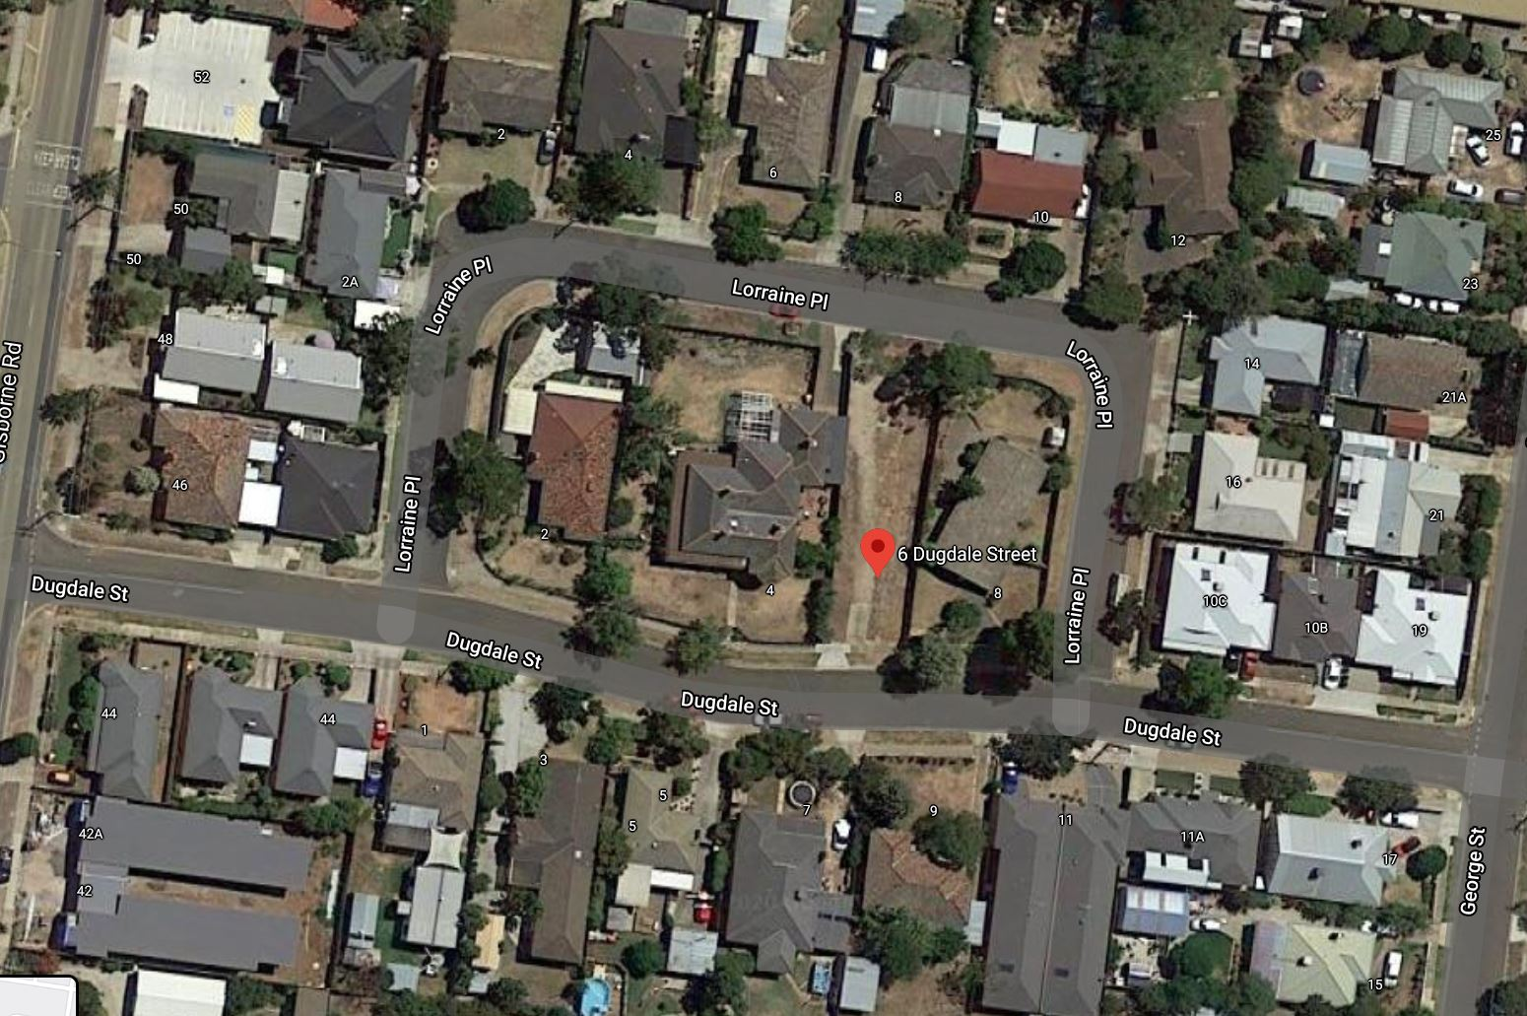
Figure 1: Aerial Photograph

Proposal
The application is for two dwellings with two bedrooms on the lot which has a total area of 505sqm. The rear dwelling facing Lorraine Place would have a floor area of 118sqm and the front dwelling facing Dugdale Street would have a floor area of 128sqm. Each would include an attached single car space garage.
Each dwelling would contain two bedrooms, two bathrooms and an open plan living, meals and kitchen area with access to an outdoor area.
The master bedroom would have an ensuite. A European laundry would be contained within a dedicated cupboard in the front hallway. Each dwelling would have at least 40sqm of private open space with northerly solar access.
No subdivision has been proposed as part of the application.
The elevation plans show that each dwelling would have a flat skillion iron roof with box-like form to be dressed up with timber effects and light grey rendered masonry.
Two crossovers would be constructed – one to Dugdale Street and the other to Lorraine Place. The two existing crossovers on the west side of the land would be removed.
A rudimentary landscape plan was provided. The garden area available on the site is 38%.
The applicant has stated that there is demand for compact affordable dwellings in Bacchus Marsh and these dwellings meet that demand. The applicant has arranged two units facing opposite street frontages to minimise streetscape impacts.
The applicant also stated that the design of the dwellings is deliberately low scale to avoid conflict with the Heritage dwelling known as ‘Lorraine’.
BACKGROUND TO CURRENT PROPOSAL
The subject site was created when an application to subdivide land at 4 Dugdale Street (HO61 Lorraine house) was approved on 2 April 2013. Statement of compliance was issued on 1 April 2014. The Heritage Overlay HO61 remained on the vacant lot in order to make sure any development is complementary to the building located on the in the Heritage Overlay HO61. A site plan was endorsed at the time showing a single building envelope on the vacant lot. The building envelope shows setbacks that accord exactly with the front and rear setbacks of Lorraine. However, this plan was not captured on title.
The land has remained vacant since that time. Lorraine has had several owners over recent years.
The Residence and its setting at 4 Dugdale Street, Bacchus Marsh is of local historical significance for its demonstration of the prosperous period in the history of Bacchus Marsh stimulated by farming, industry and closer settlement. The residence was built in 1912-13 for R.H. Dugdale a wealthy local resident and was sold to Charles Dickie, a director of Lifeguard Milk Products in around 1920.
The Residence and its setting is of aesthetic significance as an architect designed transitional Victorian and Edwardian residence. The building demonstrates key features of both periods of architecture styles. The hipped roofs and bull-nose profile verandah with cast iron Composite order posts are Victorian Italianate details while the terracotta ridge capping and Art nouveau cast iron frieze to the verandah are Edwardian details.
A large Transitional Edwardian brick house designed by the little-known architect Sydney Welson, built in 1912-13 and later occupied by Charles Dickie when its name was changed from Cholderton to ‘Lorraine’. It is the largest Edwardian house in the municipality and the largest house in the Town.
It is locally historically significant as a particularly large representative embodiment of a way of life and the social values of the confident period immediately prior to the First World War. It demonstrates an association with the locally important and influential Dickie family.

permit History
PA2013028 was approved for a two lot subdivision of 4 Dugdale Street on 2 April 2013. The subdivision created two lots: Lot 1 with the heritage dwelling, Lorraine, on a 1325 sqm lot; and Lot 2, which is the subject site, which is a 505 sqm lot.

Public Notice
The application was notified to adjoining and surrounding landowners with one objection received after the first round of advertising and two additional objectors after the second round of advertising.

Summary of Objections
The objection received is detailed below with the officer’s comments accompanying them:
Objection | Any Relevant Requirement
The difference in ground level, and drainage issues. Due to the steep drop on the boundary between 6 and 4 Dugdale St, a retaining wall would appear necessary for the Lorraine Place unit, as per the proposed Dugdale Street unit (for the corresponding boundary). It would therefore be impossible to site the proposed ‘Lorraine’ Place unit on the side boundary. | Building regulations
Officer’s Response: These matters are addressed at the Building Permit stage.
The original subdivision was approved with an indicative building envelope on the plan which retains both front and rear setbacks in line with those of ‘Lorraine’. The lot is not appropriate for two units and one single storey dwelling would be more appropriate. | Planning Permit PA2013028
Officer’s Response: The original subdivision clearly identified that a centrally located building envelope was the intention, but this was not transferred to the title as a restriction. The site does not contain any restriction of two or more dwellings on the land.
We are of the opinion that this section of Dugdale Street is already clogged with cars by some residents who have inadequate space on-site, or by more car-owners living in small units (or houses) than could reasonably be expected. | Clause 52.06 – car parking
Officer’s Response: The requirement under Rescode is that each two bedroom dwelling must have one on site car space.
The lack of information about the elevation of any windows which may affect our privacy is concerning.
Officer’s Response: Rescode requires minimum standards to address privacy which will be dealt with under a building permit.
The site plan dated 28 May 2020 indicates that the proposed building is to be built in part up to the boundary between 6 and 8 Dugdale Street. This is totally unacceptable.
Officer’s Response: The application meets the requirement for the length of a wall on a boundary under ResCode.
The degree of oversight and shading cannot be determined without knowledge of building elevations and their separation as well as the height of the fence.
Officer’s Response: The dwellings are low scale and it is not considered that overlooking would be an issue. The fence would be required to be 1.95m high.
This is not the Bacchus Marsh we moved to. The beauty of Bacchus Marsh in this area has already been lost. There has been a large number of medium density developments approved in the area and there is terrible congestion in the street. There are now safety concerns for children. There is increased noise pollution from high density living. | Infrastructure Department
Officer’s Response: Council’s Infrastructure did not express any traffic management concern from this development.
What were reasonable sized family blocks has become high density living, many cars, a thoroughfare and unsafe roads The developer has developed other properties in Lorraine Place. They simply build, sell and move on without considering the impact on the other people in the community. I do hope you consider the community and not another development which will be sold on the market, will attract cars, noise and congestion. What were reasonable sized family blocks has become high density living, many cars, a thoroughfare and unsafe roads.
Officer’s Response: This is discussed in the discussion section of this report.
The setback from garage face to Lorraine Place boundary (2842mm) is inadequate, as a vehicle cannot be parked within that space. The standard applied on nearby 10A and 10B Dugdale St works effectively, where the setback is approximately 4,500mm, allowing space for a small to medium car to park without obstructing the footpath. The proposed Lorraine Place unit has a setback of 2842mm, which is grossly insufficient. | Clause 52.06 Car Parking
Officer’s Response: There is only one car space required for a two-bedroom dwelling and this has been provided in a dedicated garage.
The difference in ground level, and drainage issues. Due to the steep drop on the boundary between 6 and 4 Dugdale St, a retaining wall would appear necessary for the Lorraine Place unit, as per the proposed Dugdale St unit (for the corresponding boundary). It would therefore be impossible to site the proposed Lorraine Place unit on the side boundary. | Building regulations
Officer’s Response: These matters are addressed at the Building Permit stage.

Locality Map
The map below indicates the location of the subject site and the zoning of the surrounding area.
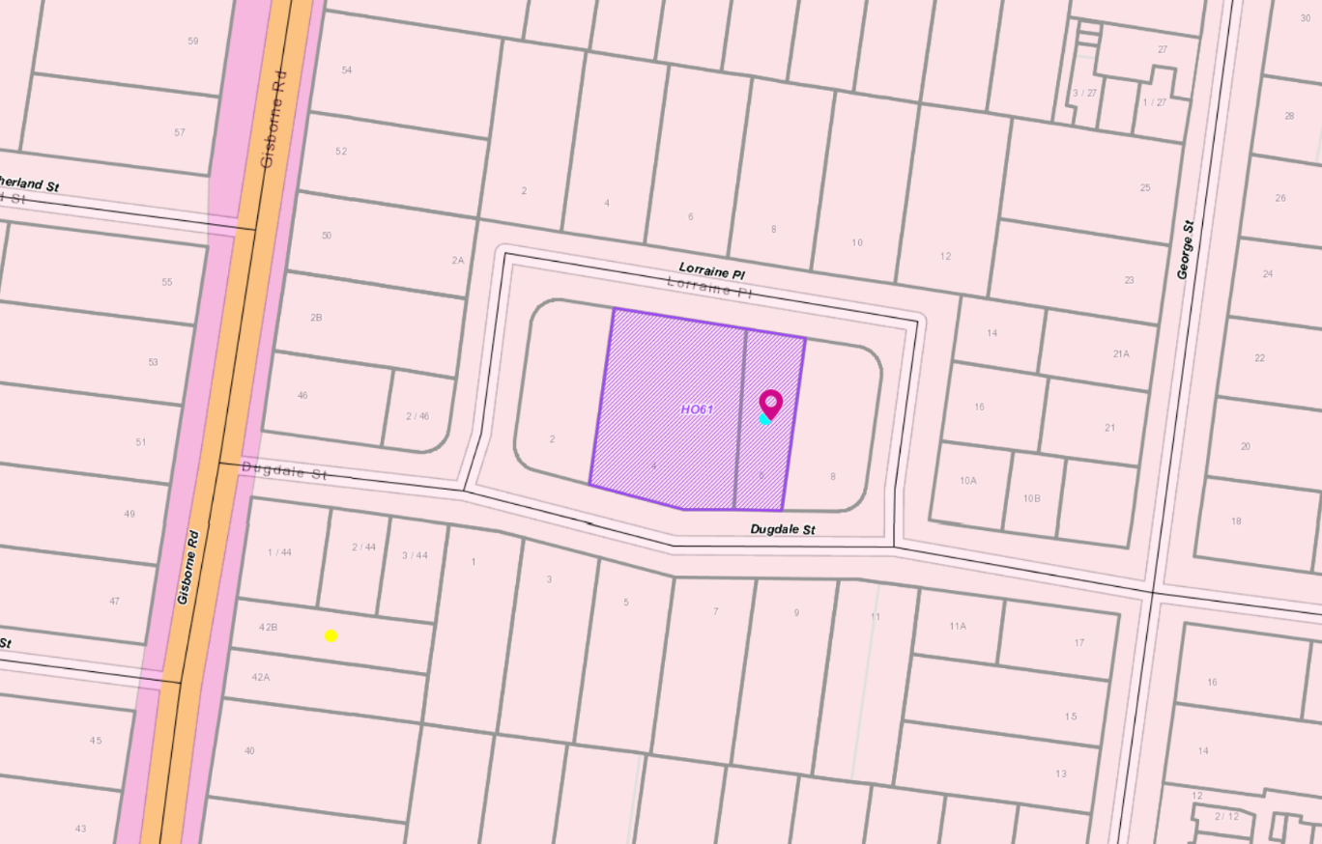
Figure 2: Zone Map with purple area identifying the Heritage Overlay

Planning Scheme Provisions
Council is required to consider the Victoria Planning Provisions and give particular attention to the Planning Policy Framework (PPF), the Local Planning Policy Framework (LPPF) and the Municipal Strategic Statement (MSS).
The relevant clauses are:
• Clause 11.03-3S Peri-urban areas
• Clause 15 Built Environment and Heritage
• Clause 15.01-3S Subdivision design
• Clause 15.01-5S Neighbourhood character
• Clause 15.03-1S Heritage conservation
• Clause 16.01-2S Location of residential development
• Clause 16.01-3S Housing diversity
• Clause 21.02-6 Environmentally Sustainable Development
• Clause 21.03-2 Urban Growth Management
• Clause 21.03-3 Residential Development
• Clause 21.03-4 Landscape and Neighbourhood Character
• Clause 21.06-2 Heritage – Enhance and preserve cultural heritage
• Clause 21.06-2 Objective: Enhance and preserve cultural heritage
• Clause 21.07-2 Managing Urban Growth
The proposal complies with the relevant sections of the PPF and LPPF.

Zone
General Residential Zone
In accordance with Clause 32.08 of the Moorabool Planning Scheme a permit is required to construct two dwellings on a lot.
A development must also meet the minimum garden area requirements of 30% off the site dedicated to garden area.
The purpose of the zone is to:
• Implement the Municipal Planning Strategy and the Planning Policy Framework.
• Encourage development that respects the neighbourhood character of the area.
• Encourage a diversity of housing types and housing growth particularly in locations offering good access to services and transport.
• Allow educational, recreational, religious, community and a limited range of other non-residential uses to serve local community needs in appropriate locations.
Schedule 2 applies to Natural and Greenfield Residential Growth Areas.
The neighbour character objectives to be achieved include to:
• Encourage new development, including innovative and unique development that enhances and responds positively to the existing neighbourhood character.
• Encourage an increase in landscaping within the public and private realm.
• Encourage new development to respect existing setbacks within the streetscape. To encourage new development to have minimal or low scale front fencing.
• Ensure garages, carports, and second storey development do not visually dominate dwellings or streetscapes.
A landscape plan must be provided with an application in accordance with the application requirements of Schedule 2.

Overlays

Heritage Overlay – HO 61

In accordance with the Heritage Overlay a planning permit is required to construct a building or construct or carry out works.

The purpose of the Heritage Overlay is to:
• Implement the Municipal Planning Strategy and the Planning Policy Framework.
• Conserve and enhance heritage places of natural or cultural significance.
• Conserve and enhance those elements which contribute to the significance of heritage places.
• Ensure that development does not adversely affect the significance of heritage places.
• Conserve specified places by allowing a use that would otherwise be prohibited if this will demonstrably assist with the conservation of the significance of the heritage place.

It is considered that the proposal does accord with the decision guidelines of the Heritage Overlay due its location and form which will not affect the significance of the heritage place.

Relevant Policies
Housing Bacchus Marsh to 2041 is Council’s adopted housing strategy to guide residential growth in Bacchus Marsh to suitable locations. The subject site is in Precinct 19 which is identified for ‘natural residential growth’.
The Preferred Neighbourhood Character statement includes the following:
• This precinct will generally maintain a streetscape rhythm of detached dwellings with conventional front and side setbacks. Built form to one boundary may be appropriate where the preferred character of the precinct is not compromised. Boundary to boundary development should be avoided.
• Built form will generally be of a modest scale, however innovative and unique built form, that enhance the character of the precinct will be encouraged. New development located in close proximity to dwellings that exhibit historical architectural styles should not compromise the intact existing character of these dwellings.
• Multi-dwelling developments should minimise the need for additional crossovers to the street, be located on lots within the precinct that are within a walkable distance of some services and facilities and have minimal impact on the streetscape rhythm and pattern. Therefore, some lots within the precinct may not be suitable for further intensification.
• Low scale or no front fencing is preferred which will allow views into landscaped front gardens. Built form will not dominate the lot and will create opportunities for generous private open space and garden plantings. Increasing canopy tree cover will assist in improving the landscape within the precinct, while also achieving a balance between open space and built form.

Particular Provisions
Clause 52.06 Car parking
Under Clause 52.06-5 each two-bedroom dwelling must be provided with at least one car space. The proposed parking provision meets this requirement.
Clause 55
The proposal complies with ResCode (Clause 55), with the exception of the following:
Clause ResCode | Title | Response
Clause 55.03-8 | Landscape plan, Standard B13 | A detailed landscape plan has not been provided and should be conditioned.
Clause 55.05-6 and Clause 55.06-1 | Storage objective B30  Site Services, Standard B34 | Mail boxes and secure externally accessible 6 cubic metre storage sheds have not been shown on the site plan which are minor matters which should be conditioned.

Discussion
The proposal would provide two compact affordable two-bedroom dwellings which the applicant states are in demand in Bacchus Marsh.
Heritage
Initially in this location, beside the Heritage dwelling known as Lorraine, the original design of the development was considered to detract from Lorraine due to its unsympathetic and non-responsive design. The reduced setbacks of two dwellings across a narrow lot adversely affected the significance of the heritage place.
The applicant met with Council’s Heritage Adviser early in the assessment of this application. The front setback from Dugdale street was subsequently increased from under 4m to 9m and revised plans altered the layout to provide better private open space areas and both dwelling designed to better the respect each street frontage.
Neighbourhood Character
The design of the dwellings utilises contemporary features with flat roof forms. A contemporary design is appropriate within an established residential area provided is does not detract or dominate the existing streetscape. This has been achieved due to the large front setback facing Dugdale Street that allows the built form to be recessive compared to the existing housing stock and this setback provides opportunities for extensive landscaping treatments that can soften the built form. The material and colours with dark tones further ensures the proposed dwellings can blend within an existing streetscape.
After a number of discussions and meetings with the applicant, the design and layout now achieves a satisfactory level of compliance with the ResCode standards including the crucial neighbourhood character standard.
Both from a neighbourhood character and heritage aspect, the proposal dwellings now respond to the site constraints.
Objectors have raised concern about the increasing development in this area of Bacchus Marsh and the impact that more apartments, units and medium density dwellings are having on the amenity and safety of the area. While these concerns are understood at a wider level, the impact of two additional small dwellings is not considered to adversely affect the amenity of the area.

General Provisions
Clause 65 – Decision Guidelines have been considered by officers in evaluating this application.
Clause 66 – Stipulates all the relevant referral authorities to which the application must be referred.

Referrals
Authority | Response
Infrastructure | Consent with conditions.
Heritage Adviser | Consent, no conditions

Financial Implications
It is not considered that the recommendation of approval represents any financial risk or implications to Council.

Risk & Occupational Health & Safety Issues
The recommendation of approval of this development does not implicate any risk or OH&S issues to Council.

Communications Strategy
Notice was undertaken for the application, in accordance with s.52 of the Planning and Environment Act 1987, and further correspondence is required to all interested parties to the application as a result of a decision in this matter. All submitters and the applicant were invited to attend this meeting and invited to address Council if required.

Options
• Issue a Notice of Decision to Grant a Planning Permit in accordance with the recommendations of this report; or
• should Council wish to consider a Refusal of the application, Councillor’s need to explore reasons based on the proposal not complying with the Moorabool Planning Scheme.

Conclusion
The application has been re-designed on a couple of occasions. Based on the current plans, it is considered that the proposal to construct two compact dwellings in close proximity to a heritage place, is now consistent with the preservation of the heritage place and complies with the ResCode objectives and standards. The original design and layout caused concern, but the applicant has been able to rectify issues through a re-design which has now achieved an acceptable planning outcome. It is recommended the application be approved with conditions.

7.2 PA2019183 - 2 Lot Subdivision at 2 Appleton Court, Darley
Author: Robert Asquith, Statutory Planner
Authoriser: Henry Bezuidenhout, Executive Manager Community Planning & Economic Development
Attachments: 1. 2 Lot Subdivision Plan, Version 3 (under separate cover)

Application Summary
Permit No: PA2019183
Lodgement Date: 06 August 2019. Amended Application lodged on 18 June 2020
Planning Officer: Robert Asquith
Address of the land: 2 Appleton Court, Darley 3340
Proposal: 2 Lot Subdivision
Lot size: 743sqm
Why is a permit required? Clause 32.08-3 Subdivision of land

Recommendation
That Council, having considered all matters as prescribed by the Planning and Environment Act 1987, issues a Refusal to Grant Planning Permit No. PA2019183 for a 2 Lot Subdivision at Lot 32 on PS111887 located at 2 Appleton Court, Darley, subject to the following grounds:
1. The narrow lot frontages to each lot will lead to the dominance of crossovers and associated driveways that contrasts with the existing and preferred neighbourhood character of Appleton Court.
2. The proposed subdivision creates two small sized lots that are irregularly shaped that will not be reflective of prevailing subdivision pattern of the area.
3. The proposed subdivision does not represent the orderly planning of the area.

Public Consultation
Was the application advertised? | Yes.
Notices on site: | Yes.
Notice in Moorabool Newspaper: | No.
Number of objections: | One.
Consultation meeting: | No consultation was undertaken as the recommendation is for refusal. In discussion with the objector, they did not want to withdraw their objection.

Policy Implications
The Council Plan 2017-2021 provides as follows:
Strategic Objective 2: Minimising Environmental Impact
Context 2A: Built Environment
The proposal to subdivide the existing lot is consistent with the Council Plan 2017 – 2021.

Victorian Charter of Human Rights & Responsibilities Act 2006
In developing this report to Council, the officer considered whether the subject matter raised any human rights issues. In particular, whether the scope of any human right established by the Victorian Charter of Human Rights and Responsibilities is in any way limited, restricted or interfered with by the recommendations contained in the report. It is considered that the subject matter does not raise any human rights issues.

Officer’s Declaration of Conflict of Interests
Under section 80C of the Local Government Act 1989 (as amended), officers providing advice to Council must disclose any interests, including the type of interest.
Executive Manager – Henry Bezuidenhout
In providing this advice to Council as the Executive Manager, I have no interests to disclose in this report.
Author – Robert Asquith
In providing this advice to Council as the Author, I have no interests to disclose in this report.

Executive Summary
Application referred? | Yes. Referred to Council’s Infrastructure and Melbourne Water.
Any issues raised in referral responses? | No.
Preliminary concerns? | Width of lot to provide two access points.
Any discussions with applicant regarding concerns? | There have number of discussions with the applicant regarding the narrow lot frontage widths.
Any changes made to the application since being lodged? | Yes, the applicant lodged an application in process on 18 June 2020 to widen the lot frontage to Lot 2 at the expense of Lot 1.
Brief history. | The site is vacant and has been no prior planning applications.
Previous applications for the site? | No.
General summary. | It is proposed to subdivide the existing vacant lot into two lots of 391sqm and 352sqm, respectively. The proposed subdivision does not adequately address the neighbourhood character of the area with two narrow lots. No specific development plan was proposed with this application. The narrow lot frontages and irregular shape makes it difficult to support a further subdivision of this land without understanding how the proposed lots can be developed.  The application is recommended for refusal.
Summary Recommendation
That, having considered all relevant matters as required by the Planning and Environment Act 1987, Council issue Refusal to Grant a Permit for this two lot subdivision at 2 Appleton Court, Darley in accordance with Section 61 of the Planning and Environment Act 1987.

Site Description
The site is a flat parcel of residential land, located at the end of Appleton Court in Darley. The site is approximately 100m from the Darley Plaza shopping centre, and approximately 2kms to central Bacchus Marsh. Excellent access is afforded to the Western Freeway, local parks, and primary schools.
The site is an irregularly shaped lot, comprising an approximately 10m curved frontage to the bowl end of Appleton Court, between 40m and 23m deep (west and east boundaries respectively) and 743sqm total area. The lot is generally oriented north-west. The site is presently vacant and cleared of all vegetation. It is noted that the site previously contained a significant number of mature medium and large trees. It was formally accessed and used by the adjacent property at 1 Appleton Court without any direct site access or crossover to Appleton Court itself. Apart from the subject site, only two other properties have sole access through Appleton Court, while the property at 10 Jonathan Drive shares dual frontages.
The site is, or can be, fully serviced to urban standard with reticulated water, sewage, and electricity. No vehicle crossovers are present. A sewerage easement runs along the site’s rear boundary. It is noted that a stormwater kerb drain is located within the frontage of the site, though not centrally located.
The subject site is located within Precinct 13 of the Bacchus Marsh Housing Strategy’s Residential Settlement Framework, encompassing lots of similar size and common zoning between Gisborne Road to Cunningham Drive, and Grey Street to Holts Lane. This precinct has been recommended for increased residential growth and generally suitable for infill development and increased densities of development. Average lot sizes of 796sqm, site coverage of 33%, and front setback of 6m have been identified. The precinct is structured around by cul-de-sacs with a limited footpath network and few street trees. Front setbacks within the court are traditional with minimal front gardens common.
2 Appleton Court, Darley
Figure 1 - Subject site within the Bacchus Marsh
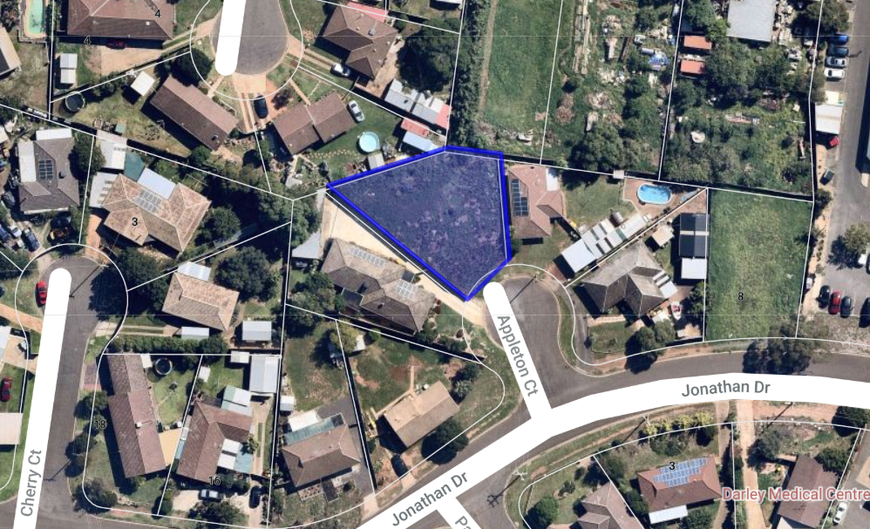
Figure 2 - Subject site in detail

Proposal
It is proposed to subdivide the existing lot into two lots.
Lot 1 (southern portion)
- 391sqm, arc frontage width of 6.6m and up to 39.4m deep.
- Largely regular in shape, with concave street frontage and angles rear boundary.
- Excess of 25% garden area has been demonstrated.
Lot 2 (northern portion)
- 352sqm, arc frontage width of 6.61m, and up to 29.79m deep.
- Irregular ‘diamond-like’ shape, narrow concave street frontage widening through the lot.
- Excess of 25% garden area has been demonstrated.
No development has been formally proposed, however an indicative development plan was submitted which shows that both lots could contain an attached single storey dwelling.
A landscape plan has been provided and approved by Council’s Infrastructure which proposed a mix of native and exotic trees and shrubs.

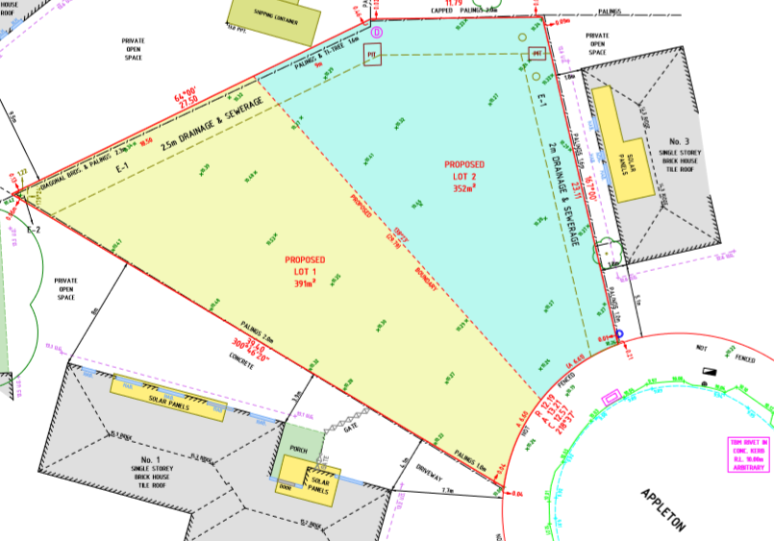
Figure 3 – Plan of Subdivision, Revision 3

Background to Current Proposal
One objection was received on 7 September 2019. The applicant lodged revised plans to alter the alignment of subdivision to give more width to Lot 2 at the expense of Lot 1.

History
There is no recorded history of applications, developments, or compliance issues relating to this land. The subject site has been occasionally known previously as 1 Appleton Court. Presently, the subject site is known as 2 Appleton Court, and the western adjoining property is known as 1 Appleton Court.

Public Notice
The application was notified to adjoining and surrounding landowners.

Summary of Objections
The objections received are detailed below with officer’s comments accompanying them:
Objection | Any Relevant Requirement
There is currently insufficient on-street parking available, which would be exacerbated by the proposal. Rubbish collection vehicles already struggle to navigate the road.
Officer’s Response:
The current street frontage of the subject lot is 9.97m; no crossover or vehicle access is provided. If the lot were to be rightfully developed with a single dwelling (not requiring a planning permit), a vehicle crossover of 3m would necessarily be constructed, leaving just 6.37m of concave road space. This would effectively remove the ability of the remaining street frontage to be used for parking.
Council’s Infrastructure were satisfied that there is adequate space and arrangement for residential rubbish bins to be stored and collected.
The road would suffer increased use and deterioration.
Officer’s Response:
Increased use of road, or any shared public space or service, is an unavoidable result of development. It is not considered that the addition of a second dwelling to what would otherwise be rightfully permitted would result in any undue, unexpected, or increased deterioration on the road beyond what is normal wear and tear.
Council Infrastructure has given consent to the application without any particular regard to concern of road quality.

Locality Map
The map below indicates the location of the subject site and the zoning of the surrounding area. The immediate and majority of wider area is General Residential Zone Schedule 3.
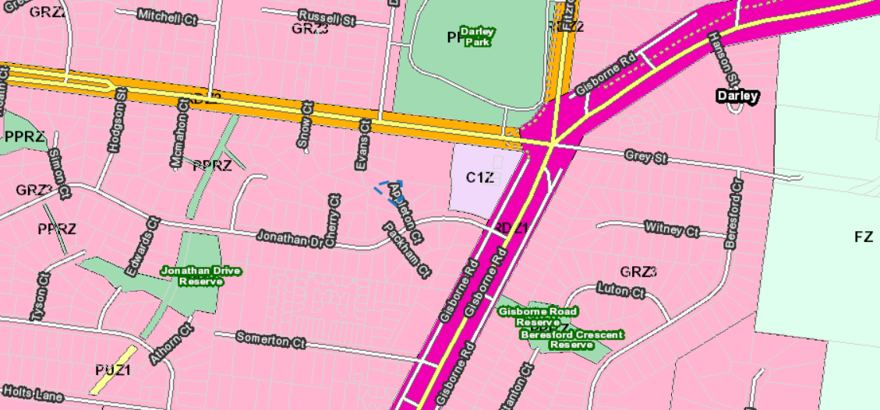
2 Appleton Court, Darley
Figure 3 – Zoning of the subject site and wider area

Planning Scheme Provisions
Council is required to consider the Victoria Planning Provisions and give particular attention to the Planning Policy Framework (PPF), the Local Planning Policy Framework (LPPF) and the Municipal Strategic Statement (MSS).
The relevant clauses are:
• Clause 11.01-1R Settlement – Central Highlands
• Clause 11.02-1S Supply of urban land
• Clause 15.01-3S Subdivision design
• Clause 15.01-5S Neighbourhood character
• Clause 16.01-2S Location of residential development
• Clause 21.03 Settlement and Housing
• Clause 21.07 Bacchus Marsh
The proposal complies with the relevant sections of the state and local Planning Policy Framework including the MSS.

Zone
The subject site is within the General Residential Zone (GRZ) Schedule 3. The GRZ has the following purpose:
• To implement the Municipal Planning Strategy and the Planning Policy Framework.
• To encourage development that respects the neighbourhood character of the area.
• To encourage a diversity of housing types and housing growth particularly in locations offering good access to services and transport.
• To allow educational, recreational, religious, community and a limited range of other non-residential uses to serve local community needs in appropriate locations.
Schedule 3 is defined as for “Increased Residential Growth Areas” with the following Neighbourhood Character Objectives:
• To encourage new development, including innovative and unique development that enhances and responds positively to the existing neighbourhood character.
• To encourage sufficient front setbacks to allow for enhancement of the front garden character including increasing canopy tree plantings.
• To encourage new development to have minimal or low scale front fencing.
• To ensure new garages and carports do not dominate dwellings or streetscapes.
A permit is required under the zone pursuant to Clause 32.08-3 for subdivision.
The proposal is generally inconsistent with the neighbourhood character objectives of the schedule to the zone.
Under Clause 32.08-3 an application to subdivide land that would create a vacant lot less than 400sqm capable of development for a dwelling or residential building, must ensure that each vacant lot created less than 400sqm contains at least 25% as garden area.

Overlays
The land is not affected by any overlays.

Relevant Policies
• Bacchus Marsh Housing Strategy (BMHS)
• Bacchus Marsh Urban Growth Framework (BMUGF)
The BMHS and BMUGF have been implemented into local policy through Clause 21.07 of the Moorabool Planning Scheme and the demarcation of the residential precincts, of which the subject site is in Precinct 13. These policies provide guidance of residential urban growth and development within Bacchus Marsh.
Relevant to this application and subject site are the following:
Clause 21.07-2 Managing urban growth
• Objective: To accommodate sustainable residential growth within the existing settlement boundary of Bacchus Marsh in the short to medium term.
• Strategies:
• Contain short term residential development within the existing settlement boundary (infill and greenfield).
• Ensure that Bacchus Marsh maintains an adequate long term residential land supply to accommodate the projected population growth.
• Implement the Residential Settlement Framework within the existing Bacchus Marsh settlement boundary.
• Promote the establishment of sustainable residential neighbourhoods by:
• Encouraging high quality design of dwellings, open space and the public realm;
• Encouraging infill development that assists in creating walkable and pedestrian scale environments;
• Encouraging quality higher density development close to activity centres and public transport; and
• Ensuring that the form and design of new development responds to walkability and neighbourhood design principles.
Clause 21.07-3 Consolidating land uses within the inner areas of Bacchus Marsh
• Objective: Direct housing to locations that are easily accessible to activity centres and public transport as a priority.
• Strategies:
• Direct housing to locations that are easily accessible to activity centres and public transport as a priority.

Particular Provisions

Clause 53.01 Public Open Space Contribution and Subdivision
It is not considered likely that either of the two lots would be further subdivided due to relatively small lot size and very limited availability of future additional street access.

Clause 56 Residential Subdivision
The application is for a subdivision of two lots of vacant land and thus must be assessed against relevant objectives of Clause 56. The proposal must meet the objectives, and should meet the standards, of the following Clauses: 56.03-5, 56.04-2, 56.04-3, 56.04-5, 56.06-8 to 56.09-2.
The proposal does not meet the following objectives:
Clause ResCode | Title | Response
56.03-5 | Neighbourhood Character | The objective of this standard is to respect the existing neighbourhood character or achieve a preferred neighbourhood character consistent with any relevant neighbourhood character objective, policy or statement set out in this scheme.  There are no examples with the existing neighbourhood of Appleton court of two narrow lots or where two future driveways create minimal landscaping areas in the front setback. The proposed subdivision does not respect the garden character of the surrounding lots.
56.07-4 | Stormwater management objectives | No stormwater management plan or design detail was submitted with the application.
56.08-1 | Site management objectives | No site management plan was submitted with the application.

Discussion
The key failure with this subdivision is the irregular lot configuration and narrow street frontages. These two site constraints do not support a further subdivision of this land. The narrow street frontage will force the creation of two crossovers with associated driveways that will dominate the front setback area and will leave limited area for landscaping treatments. Landscaping in the front setback is an existing character element in Appleton Court. The irregular lot arrangement and side easements further restricts the area of a future dwelling and will lead to either new dwellings being attached or having limited side setbacks. The irregular lot shape will also create difficulties for positioning of any new dwelling. The lot sizes are small, at less 400sqm and this would become a difficult development site for any new purchaser.
One of the decision guidelines under the General Residential Zone Schedule 3 is the subdivision must consider the prevailing subdivision pattern of the area. In this instance, there are no examples in the area of two small sized lots, that are irregularly shaped with narrow street frontages. Small sized lots have been concentrated to corner lots that have the advantage of two street frontages. The proposed subdivision does not address this decision guideline under the zone provision.
With consideration of the subject site’s arrangement and land area of 742sqm the proposed 2 Lot subdivision can therefore be considered as not adhering to neighbourhood character of Appleton Court.

General Provisions
Clause 65 – Decision Guidelines have been considered by officers in evaluating this application.
Clause 66 – Stipulates all the relevant referral authorities to which the application must be referred. No objections were made from any referral authority.

Referrals
Authority | Response
Melbourne Water | Melbourne Water did not object to the proposal and had no conditions.
Infrastructure | Infrastructure did not object to the proposal, subject to conditions.

Financial Implications
There are no financial implications in the recommendation for refusal of this subdivision.

Risk & Occupational Health & Safety Issues
The recommendation of refusal of this subdivision does not implicate any risk or OH&S issues to Council.

Communications Strategy
Notice was undertaken for the application, in accordance with s.52 of the Planning and Environment Act 1987, and further correspondence is required to all interested parties to the application as a result of a decision in this matter. All submitters and the applicant were invited to attend this meeting and invited to address Council if required.

Options
Council could consider the following options:
• issue a Refusal to grant a Planning Permit in accordance with the recommendation contained within this report; or
• issue a Notice of Decision to Grant a Planning Permit. Council would need to consider how the proposal complies with Moorabool Planning Scheme.
CONCLUSION
The proposal for a subdivision of the exiting vacant lot to create two lots of 391sqm and 352sqm is inconsistent with the purposes of the General Residential Zone and in particular the neighbourhood character objectives. The proposal does not sit conformably within the existing or future neighbourhood character due to small lot sizes, irregular lot shapes and the requirement to have two crossovers on a narrow street frontage. The applicant has revised plans to improve the alignment of the two lots but has not addressed the fundamental concerns with a lack of total land area and narrow frontage widths. It is recommended that a refusal to grant a permit be issued with specified grounds.

7.3 PA2019281 - Change of use to a Motel at 32 Grant Street, Bacchus Marsh
Author: Mark Lovell, Coordinator Statutory Planning
Authoriser: Henry Bezuidenhout, Executive Manager Community Planning & Economic Development
Attachments: 1. Plans (under separate cover)

Application Summary
Permit No: PA2019281
Lodgement Date: 9 December, 2019
Planning Officer: Mark Lovell
Address of the land: Lot 2 on LP143683 known as 32 Grant Street, Bacchus Marsh
Proposal: Change of Use to a Motel (9 rooms)
Lot size: 950.53sqm
Why is a permit required? Clause 32.04-1 – Change of Use of the land as a motel
Clause 52.05-2 - Sign

Recommendation
That Council, having considered all matters as prescribed by the Planning and Environment Act 1987, issues a Refusal to Grant a Planning Permit for a change of use to motel (9 rooms) at 32 Grant Street, Bacchus Marsh with the following grounds:
1. The proposed internal layout with each room over two floor levels and reliance on an internal stairwell restricts access to people with limited mobility
2. The proposed internal layout with a number of motel units having one bedroom reliant on glass bricks for natural light and no access natural air flow affords low level of internal amenity.
3. The internal layout is poorly designed and does not readily enable effective use as a motel.
4. The absence of signage as part of this change of use does not demonstrate that the motel can capture passing motorists for short term stays.
5. The proposed change of use does not represent the orderly planning of the area.

Public Consultation
Was the application advertised? | Yes.
Notices on site: | Yes.
Notice in Moorabool Newspaper: | No.
Number of objections: | Three objections.
Consultation meeting: | Not held. The applicant did provide a response. to the objections received.

Policy Implications
The Council Plan 2017-2021 provides as follows:
Strategic Objective 3: Stimulating Economic Development
Context 3A: Land Use Planning
The proposal is consistent with the Council Plan 2017 – 2021.

Victorian Charter of Human Rights & Responsibilities Act 2006
In developing this report to Council, the officer considered whether the subject matter raised any human rights issues. In particular, whether the scope of any human right established by the Victorian Charter of Human Rights and Responsibilities is in any way limited, restricted or interfered with by the recommendations contained in the report. It is considered that the subject matter does not raise any human rights issues.

Officer’s Declaration of Conflict of Interests
Under section 80C of the Local Government Act 1989 (as amended), officers providing advice to Council must disclose any interests, including the type of interest.
Executive Manager – Henry Bezuidenhout
In providing this advice to Council as the Executive Manager, I have no interests to disclose in this report.
Author – Mark Lovell
In providing this advice to Council as the Author, I have no interests to disclose in this report.

Executive Summary
Application referred? | Yes, Council’s Infrastructure, Strategic Planning, Economic Development and the Department of Transport.
Any issues raised in referral responses? | No.
Preliminary concerns? | Required additional detailing of the exact use and how it would be managed.
Any discussions with applicant regarding concerns? | The applicant responded to the request for further information.
Any changes made to the application since being lodged? | Yes, the applicant submitted plans for two internally illuminated business identification signs in response to a request for further information. The applicant requested on 15 June 2020 to remove the signs as they were not part of the original proposal.
Brief history. | The site was originally approved in 2007 for offices and since completion has remained unoccupied due to the lack of interest from prospective tenants. The owner has attempted conversion to residential units, and this was deemed inappropriate by both Council and VCAT on review.
Previous applications for the site? | Several planning applications, see history section.
General summary. | The change of use involves minimal internal modifications. The applicant’s consultant advised there is demand for short term stay in Bacchus Marsh particularly during public events and festivals. The use can support local tourism and assist the local activity centre of Bacchus Marsh.  The existing internal layout with poor levels of internal amenity as motel units and the restricted access between floor levels does not cater for people with limited mobility. This is but one of the key failures when looking at an existing building to convert to an alternative use. The layout of the motel rooms does not support the change of use to a motel.
Summary Recommendation
That, having considered all relevant matters as required by the Planning and Environment Act 1987, Council issue a Refusal to grant a planning permit for a change of use from offices to a motel at 32 Grant Street, Bacchus Marsh.

Site Description
The subject site is located on the eastern side of Grant Street, 60.73m south of Waddell Street, Bacchus Marsh. The lot is 20.25m in width and 46.94m in length for a total site area of 950.53sqm. The site has a flat topography and there is a sewerage easement 3m in width running parallel with the rear property boundary.

The site contains a double storey building reflecting contemporary architectural styling with an open car parking area to the southern side. The front building is single storey in height and has an open plan arrangement. The internal layout for the remaining nine offices is two office rooms and bathroom at the ground floor level and a large kitchen and open office at the first-floor level. Units 1 to 6 have a first floor partially enclosed balcony space and Units 7 to 9 have a small ground floor open space area. To the west of Unit 9 is a bin storage room and an accessible toilet. A food/drink caravan currently occupies the car park area.

The surrounding area is comprised of mixed land uses but predominately detached residential dwellings on moderate sized lots size with generous front setbacks and with established front landscaping treatments.

The opposite side of Grant Street contains the Bacchus Marsh and District Hospital with the main building well setback from the street frontage. There is a large open lawn area and some hard surface car parking bays and associated accessways. There are some border trees located adjacent to the street frontage.

Proposal
The proposal is to utilise the existing building for a motel with a maximum stay period of sixty days.
The front single storey building will be used as a reception room. The existing office area becomes the reception and the existing bathroom and toilet are retained. The double storey office building will only have room identification changes with the ground floor offices labelled as Bed 1 and Bed 2 and the open plan office on the first floor becoming a living/dining space. The ground floor bathroom and toilet remain along with the first floor kitchen. There will be one car space per room located to the southern side of the property with an additional one car space set aside for disabled parking.
No signage is proposed.
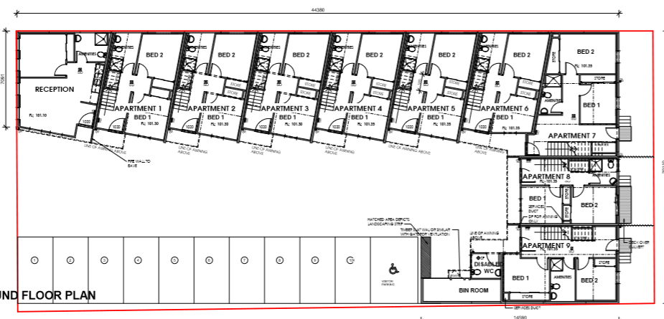
Figure 1 Ground floor plan and car park.

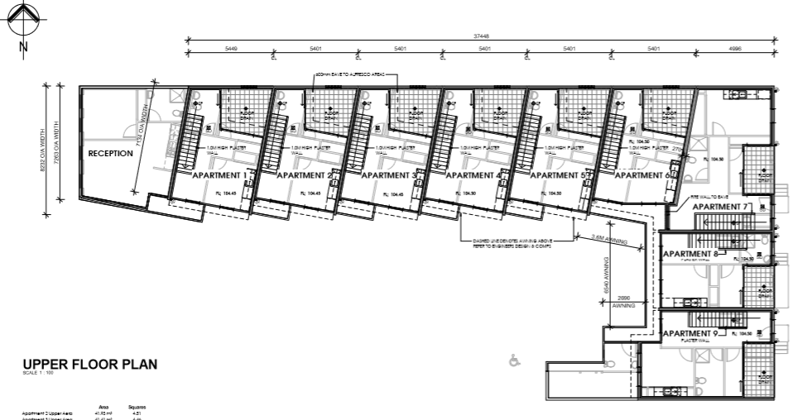

Figure 2: First floor plan (dark outline is first floor layout with the light coloured detail the ground floor)

Background to Current Proposal
The completed building on site has remained unoccupied for several years despite several attempts by the local real estate agent to find tenants.

History
The site has been subject to several previous planning applications with most determined by VCAT on review, as follows:
VCAT Appeal Number P1252/2007 - VCAT directed a planning permit be issued for application number PA2007-069 after Council recommended refusal. The permit issued on 27 November 2007 authorised the development of the land for the purposes of offices, altered access to a Road Zone Category 1, car parking dispensation and a 10-lot subdivision.
VCAT Appeal Number P160/2015 - VCAT determined an enforcement order concerning the use of land for dwellings instead of offices and the permit expiry date. Their order dated 5 February 2016 advised that the permit had expired due to certification of the plan of subdivision not occurring by 27 November 2012 and what had been constructed on the land was ten dwellings.
The member made the following comments ‘I will also order that the development is not to be used for the purpose of dwellings, unless and until a planning permit is obtained authorising same. I make this order mindful of the broad nature of the discretion given to me under section 119 of the Act and its purpose to enable the resolution of planning issues. As such, notwithstanding that use of the land for dwellings is as-of-right under the MUZ, I consider that it is justifiable on the facts before me to make an order preventing the use of what are unauthorised buildings and works for the purpose of dwellings, until such time as the development of the dwellings is authorised’. This order remains on the site until such time as it is removed by VCAT.
VCAT Appeal number P1609/2016 - VCAT directed a planning permit be issued for application number PA2015294 after Council recommended refusal. The permit was issued on 21 April 2017 authorising the construction of buildings and works comprising ten offices located within a part single and part double storey building each with its own access, use of land for offices and reduction in car parking requirements. It required the removal of the certain elements that had been constructed which were related to the use of the buildings for dwelling purposes, ie removal of laundry hand basin.
PA2015295 was planning application of the construction of 10 dwellings. The applicant withdrew the application on 29 March 2016
VCAT Appeal Number 1386/2017 - VCAT affirmed Council’s refusal recommendation and directed no permit to be issued for application number PA2016282 on 18 December 2017. The planning application was for the development of 10 dwellings and a waiver of the visitor car space.
VCAT Appeal Number 2627/2017 - VCAT struck out an appeal against a refusal to endorse plans attached PA2015294 on 8 May 2018. Council determined the plans submitted did not comply with condition 1 of the permit. The applicant submitted further revised plans a few days prior to the appeal which Council endorsed but was insufficient time to enable the applicant to withdraw the appeal.
PA2019010 – A planning permit was issued under delegation for a ten-lot subdivision on 8 July 2019.
A second compliance check was undertaken on 13 August 2019 which involved inspecting the internal layout and fit out to ensure compliance with the endorsed plans of PA2015294. This latest check confirmed the proposed works are in compliance with the permit.

Public Notice
The application was notified to adjoining and surrounding landowners and a large notice displayed on site.

Summary of Objections
The objections received are detailed below with officer’s comments accompanying them:
Objection | Any Relevant Requirement
VCAT refused dwellings/ is this long term stay or short term stay. | VCAT decision P1386/2017
Officer’s Response: The proposal is for a motel, not residential apartments. The applicant advised the proposal is for short term stays and has agreed on limiting a maximum stay period of sixty days.
Accessibility.
Officer’s Response: This motel is not accessible for people with limited mobility such as those in wheelchairs as each motel room is double storey with a connecting stairwell. This motel has no lift facilities and no common first floor walkway.
The motel does not achieve current day standards of providing access to all people including those with limited mobility. The proposed change of use fails to provide an adequate level of accessibility.
Protecting residential amenity/management of the facility/noise.
Officer’s Response: This can be controlled by standard amenity conditions and requiring that an on-site manager must supervise the activities on the land.
Invasion of privacy.
Officer’s Response: There is no change to the existing site conditions which has included screened first floor windows. Additional fencing works to the eastern property boundary can improve the level of privacy to the adjacent eastern neighbours.
Parking. | Clause 52.06.
Officer’s Response: The motel use results in one additional space compared to the minimum requirement under Clause 52.06. There is no reduction to the standard car parking rate.
Property Devaluation. | Requirement under ResCode
Officer’s Response: This has long been established as not a valid ground of planning objection.

Locality Map
The map below indicates the location of the subject site and the zoning of the surrounding area.
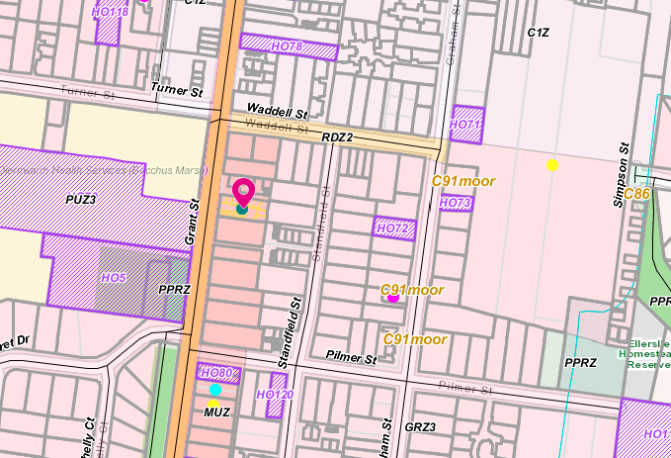
Figure 3: Zone Map
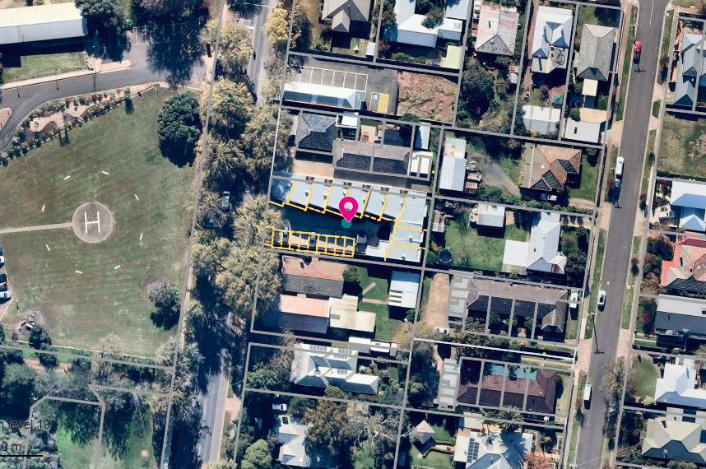
Figure 4: Aerial Photograph.

Planning Scheme Provisions
Council is required to consider the Victoria Planning Provisions and give particular attention to the Planning Policy Framework (PPF), the Local Planning Policy Framework and the Municipal Strategic Statement.
The relevant clauses are:
• Clause 11.01-1R Settlement Central Highlands.
• Clause 11.03-3S Peri-urban areas.
• Clause 15.10-1S Urban Design
• Clause 17.01-1S Diversified Economy
• Clause 17.01-1R Diversified Economy Central Highlands
• Clause 17.02-1S Business
• Clause 21.03-4 Landscape and Neighbourhood Character.
• Clause 21.07-2 Bacchus Marsh
The proposed use does not comply with the following clause.
Clause | Title | Response
15.01-1S | Urban Design | A strategy of this clause is to ensure that the design and location of publicly accessible private spaces, including car parking areas, forecourts and walkways, is of a high standard, creates a safe environment for users and enables easy and efficient use. The layout does not assist people with limited mobility.

Zone
Mixed Use Zone (MUZ)
The purpose of the zone is:
• To implement the Municipal Planning Strategy and the Planning Policy Framework.
• To provide for a range of residential, commercial, industrial and other uses which complement the mixed-use function of the locality. To provide for housing at higher densities.
• To encourage development that responds to the existing or preferred neighbourhood character of the area.
• To facilitate the use, development and redevelopment of land in accordance with the objectives specified in a schedule to this zone.
Under Clause 73.03 of the Moorabool Planning Scheme, a motel is defined as land used to provide Residential hotel accommodation in serviced rooms for persons away from their normal place of residence, and where provision is made for parking guests' vehicles convenient to the rooms.

Under Clause 32.04-1 a permit is required for a Section 2 use. Motel is not listed in either Section 1 or 3 of the table of uses.
Under Clause 32.04-14 has the following decision guidelines

• The Municipal Planning Strategy and the PPF.
• The objectives set out in a schedule to this zone.
• Any other decision guidelines specified in a schedule to this zone.
• The impact of overshadowing on existing rooftop solar energy systems on dwellings on adjoining lots in a Mixed Use Zone or Residential Growth Zone
Under 32.04-15, signs are listed as Category 3 controls of Clause 52.05.

Overlays
Design & Development Overlay Schedule 10 & Design & Development Overlay Schedule 15

DD010 has the following objectives
• To encourage a built form that is consistent with, and complements the scale of, the existing built form character of the hospital and medical centres.
• To encourage high quality new development of a contemporary architectural character. To maintain and enhance the established character of the precinct.
• To encourage the provision of landscaping, where practical, within building setbacks. To ensure that the design of buildings provide elements which protect the amenity of and visually enhance areas of open space and residential interface.
• To encourage non-residential buildings to have an active frontage on the ground floor, with a clearly identifiable entry.
• To ensure that the location and design of car parks, loading bays and services areas do not dominate the public domain and supports safe use and access.
• To ensure that signage and fencing of non-residential buildings is appropriate, and sympathetic to the character of the precinct
DD10 has no requirement for a change of use and is only specific to building and works.
DD015 has the following design objectives.
• To ensure that the height of buildings and works do not encroach on the flight path areas associated with the Bacchus Marsh Hospital helicopter landing site.
• To ensure that the height of development avoids creating a hazard to aircraft using the Bacchus Marsh Hospital helicopter landing site.
DD015 has no requirement for a change of use and is only specific to building and works.

Relevant Policies
No relevant policies.

Particular Provisions
Clause 52.05 Signage
The purpose of particular provision
• To regulate the development of land for signs and associated structures.
• To ensure signs are compatible with the amenity and visual appearance of an area, including the existing or desired future character.
• To ensure signs do not contribute to excessive visual clutter or visual disorder. To ensure that signs do not cause loss of amenity or adversely affect the natural or built environment or the safety, appearance or efficiency of a road.
Category 3 signage controls has the purpose which is to ensure that signs in high amenity areas are orderly, of good design and do not detract from the appearance of the building on which a sign is displayed or the surrounding area.
Any business identification signage is a Section 2 permit required sign. Whilst the applicant has removed signage from their application, there should be a new warning sign altering guests not to disturb the amenity of surrounding residents such as noise and the entering/exiting vehicles. This could be controlled by a permit condition.
Clause 52.29 Land Adjacent to a Road Zone Category 1
Under Clause 52.29-2 a permit is required to create or alter an access. This existing accessway is retained however Department of Transport was notified of the application. The Department of Transport had no objections and no conditions.

Discussion
Use of the land
A motel located adjacent to a main road (Grant Street) and in close proximity to services such as hospital, cafes and a supermarket provides a sufficient drawcard to short term stay guests. A motel can also act as an economic driver as motel guests are likely to visit local attractions, attend special functions or festivals and utilise existing retail shops thereby helping the local economy. Council’s Economic Development unit suggested that hospital staff such as doctors or hospital visitors would have a need for short term accommodation in a convenient and accessible location in proximity to the hospital. The applicant’s consultant advised that Bacchus Marsh only has one motel and three hotels that provide accommodation along with a caravan park. The lack of accommodation for tourists or short term stay guests could be rectified by this change of use and support growth in the Bacchus Marsh township.
Accessibility
The design and internal layout is constrained with an existing building already on the land. The change of use proposes to utilise the layout of poorly arranged offices. A key concern is all motel rooms are reliant on an internal stairwell. A person with limited mobility or confined to a wheelchair would not be able to utilise the room and are therefore denied access to this service. Accessibility is important as the site is opposite a hospital where some visitors and or potential patients maybe seeking short term stay in Bacchus Marsh and would not able to use this site. The internal layout of a motel affords low levels of internal amenity which was clearly demonstrated in the prior applications to change the use to residential dwellings. Some of the motel rooms will have a bedroom that relies on glass bricks for light and no natural ventilation. Not all buildings are suitable for conversion to a motel use which needs a particular layout to serve its function as a short term stay. While the existing building is unoccupied due to the complete lack of interest from office tenants, the motel use also would be expected to have difficulties attracting short term stays given the form of accommodation provided and the awkward internal layout.
Amenity
As identified by objectors, any change of use could present amenity concerns such as noise, light spill or how the site is managed. Given that the building is not purposely designed for a motel use this can’t be adequately mitigated. Some of these can potentially be mitigated by permit conditions but not to the same extent.
Zoning
The zoning of the land is Mixed Use where it is expected residential and commercial activities will coexist and, in some situations, along with industrial activities. This zone also supports mixed land uses on the one site. It is acknowledged there will some amenity impacts for adjacent residents in the Mixed Use Zone with visitors and employees of the motel use frequently utilising the site.
A motel use can be considered consistent with some of the objectives of the Mixed Use Zone and meets the purpose of the zone which is to complement the mixed use function of the locality. The primary concern with this motel use is the existing building has a poor internal layout that will not either properly serve future occupants and is restrictive to people with poor mobility due to the reliance of internal stairwells. The existing building has not been designed for a motel use and would only be suitable for conversion with substantial building modifications.
Functionality as a motel
The issue with this application relates to the applicant wanting to find a quick solution to the dilemma of the existing development. It should be noted that Council was opposed to the original development for reasons of functionality. Officers remain of the view that change of use has not sufficiently addressed the issue of functionality in the building for the use as a motel.
A report into the restoration of regional motels found there are three basic room models for motels which consisted of
51% with an entry and bathroom at front and main room behind over a single floor level.
43% with an entry and main room to the front and bathroom to the rear over a single floor level.
22% with an entry accessing an internal hallway to a building.
Some motels have a combination of two or more of the basic models
The applicant proposes seating area and kitchenette on the first floor level separate from the bedrooms and bathroom on the ground floor. There are no ablution facilities on this floor. Motels also typically have an open plan design with two beds in one open plan area rather than two separate rooms containing beds.
The assessment is the building needs significant and costly modifications to achieve appropriate functionality to operate as a motel. Modifications could include removing walls of adjoining rooms to make for larger motel suites on the ground and first floor which would allow for the removal of the internal staircases. This would provide for an offering of ground floor to cater for disabled persons. The internal layouts could then be designed to provide the appropriate functionality to operate as a motel. The applicant does not want to undertake substantial building modifications.

General Provisions
Clause 65 – Decision Guidelines have been considered by officers in evaluating this application.
Clause 66 – Stipulates all the relevant referral authorities to which the application must be referred.

Referrals
Authority | Response
Department of Transport | No comment.
Infrastructure  Strategic Planning  Economic Development | Consent with three conditions.  Supported the proposal as it is located in proximity to services and the Main Street activity centre.  Supported the proposal and has suggested that the motel will likely be used by hospital staff and people visiting hospital patients and aged care residents.

Financial Implications
There is no financial implication in refusing this change of use.

Risk & Occupational Health & Safety Issues
The recommendation of refusal of this change of use does not implicate any risk or OH&S issues to Council.

Communications Strategy
Notice was undertaken for the application, in accordance with s.52 of the Planning and Environment Act 1987, and further correspondence is required to all interested parties to the application as a result of a decision in this matter. All submitters and the applicant were invited to attend this meeting and invited to address Council if required.

Options
• Issue a Refusal to Grant a permit in accordance recommendation in this report; or
• issue a Notice of Decision to Grant a permit not in accordance with the recommendation of this report.

Conclusion
The proposed change of use from offices to a motel consisting of nine rooms does not fully comply with the provisions of the planning scheme, such as urban design, amenity, etc. This change of use while allowing occupation of a completed office building that has remained unoccupied for several years would create a new use that is poorly arranged for short term stays and provides for low levels of internal amenity. The internal layout while not optimal for an office use would also create problems for future motel occupants and would not allow access to people with limited mobility, thereby discriminating against one segment of society. The proposed change of use is recommended for refusal with specified grounds.

7.4 PA2019261 - Use of an existing dwelling as a Retail Premises (Cafe) at 15 Martin Street Blackwood
Author: Victoria Mack, Statutory Planner
Authoriser: Henry Bezuidenhout, Executive Manager Community Planning & Economic Development
Attachments: 1. Sketch Plans of Cafe Proposal (under separate cover)

Application Summary
Permit No: PA2019261
Lodgement Date: 11 November 2019
Planning Officer: Victoria Mack
Address of the land: 15 Martin Street, Blackwood
Proposal: Use of an existing dwelling as a Retail Premises (Café)
Lot size: 2000sqm
Why is a permit required? Clause 32.05-2, Township Zone, Use of retail premises (café)

Recommendation
That Council, having considered all matters as prescribed by the Planning and Environment Act 1987, issues a Notice of Decision to Grant a Planning permit subject to the following conditions:
1. Before the use and/or development starts, plans to the satisfaction of the Responsible Authority must be submitted to and approved by the Responsible Authority. When approved, the plans will be endorsed and will then form part of the permit. The plans must be drawn to scale with dimensions and two copies must be provided. The plans must show:
(a) A Bushfire Management Plan in accordance with the Country Fire Authority's Condition 19.
(b) Details of the signage proposed including the number of signs, their dimensions, total area, the wording and colour scheme. Total signage area cannot exceed 3sqm.
(c) A detailed floor plan and site plan showing all the operational areas within, and outside the building including car parking, drawn to scale with accurate dimensions. The designated car parking area must show all five car spaces.
Unless otherwise approved in writing by the Responsible Authority, all buildings and works are to be constructed and or undertaken in accordance with the endorsed plans to the satisfaction of the Responsible Authority prior to the commencement of the use.
General Conditions:
2. The approved hours of operation are between 9am and 4pm on Saturday and Sunday.
3. The maximum patron seating is 30.
4. Prior to the commencement of the use, Crown Allotments 10 and 11 Section B Parish of Blackwood must be consolidated in accordance with the Subdivision Act 1988 and a new title issued by the Registrar of Titles.
Amenity:
5. The amenity of the area must not be detrimentally affected by the use or development, through the:
(a) Transport of materials, goods or commodities to or from the land.
(b) Appearance of any building works or materials.
(c) Emission of noise, artificial light, vibration, smell, fumes, smoke, vapour, steam, soot, ash, dust, waste water, waste products, grit or oil.
(d) Presence of vermin.
(e) Any other way.
6. The owner, occupier or manager of the premises must make reasonable endeavours to ensure that people associated with the site do not create a nuisance and annoyance to neighbours or otherwise disturb the amenity of the area.
Environmental Health:
7. In the event that the current modified system in accordance with Western Water’s conditions of this permit should fail then the current onsite wastewater treatment system must be upgraded to an onsite waste water management system with the capacity to treat effluent to a minimum of 20/30/10 (BOD/Suspended Solids and Chlorination).
8. The wastewater management system including all effluent must be wholly contained within the property boundaries at all times.
9. The effluent disposal area must be kept free of buildings, driveways, vehicular traffic and services trenching.
10. All setback distances must be adhered to as dictated by Table 5 of the Code of Practice, Onsite Wastewater Management, EPA Publication Number 891.4.
11. A shallow surface water cut off drain or surface water diversion mound, must be provided on the high side of the disposal areas to divert any surface water flows around the effluent fields.
12. The owner must maintain all drainage lines at all times to divert surface water and subsurface water clear of the effluent disposal field.
13. A commercial size grease trap must be installed by a certified plumber.
14. The kitchen must comply with Food Standards Code 3.2.3 Food Premises and Equipment with regards to design and fit-out.
15. Prior to the use commencing plans are required to be submitted to Environmental Health for assessment against the Food Standards Code. The plans to be submitted must be drawn to a scale not less than 1:100 and clearly show the premises layout, fixtures, fittings and equipment. A description of materials to be used for all surfaces including floors, walls, benches etc must also be provided.
16. All fittings, fixtures and equipment that use water must be connected to reticulated water system.
17. All fittings fixtures and equipment that are designed to be connected to a sewage and wastewater disposal system must be plumbed in and connected to that system.
Country Fire Authority:
18. The bushfire mitigation measures forming part of this permit or shown on the endorsed plans, including those relating to construction standards, defendable space, water supply and access, must be maintained to the satisfaction of the Responsible Authority on a continuing basis. This condition continues to have force and effect after the development authorised by this permit has been completed.
19. Before the development starts, a bushfire management plan must be submitted to and endorsed by the Responsible Authority. The plan must show the following bushfire mitigation measures, unless otherwise agreed in writing by the CFA and the Responsible Authority:
(a) Defendable Space
Show an area of defendable space to the property boundaries where vegetation (and other flammable materials) will be modified and managed in accordance with the following requirements:
• Grass must be short cropped and maintained during the declared fire danger period.
• All leaves and vegetation debris must be removed at regular intervals during the declared fire danger period.
• Within 10m of a building, flammable objects must not be located close to the vulnerable parts of the building.
• Plants greater than 10cm in height must not be placed within 3m of a window or glass feature of the building.
• Shrubs must not be located under the canopy of trees.
• Individual and clumps of shrubs must not exceed 5sqm in area and must be separated by at least 5m.
• Trees must not overhang or touch any elements of the building.
• The canopy of trees must be separated by at least 5m.
• There must be a clearance of at least 2m between the lowest tree branches and ground level.
(b) Construction Standard
Nominate a minimum Bushfire Attack Level of BAL 19 that the building will be designed and constructed.
(c) Water Supply
Show 5,000 litres of effective water supply for firefighting purposes which meets the following requirements:
• Be stored in an above ground water tank constructed of concrete or metal.
• Have all fixed above ground water pipes and fittings required for firefighting purposes must be made of corrosive resistant metal. Include a separate outlet for occupant use.

Western Water:
20. Prior to the use commencing the existing effluent disposal trenches must be inspected by a Council approved plumber who must provide written confirmation to Western Water and Council confirming that the trenches are in a suitable working condition. This will require the effluent trenches to be cleaned out and inspected with a closed-circuit television camera to confirm their current operating condition.
21. Should the effluent disposal trenches not be in a suitable working condition a new secondary wastewater treatment system must be installed to the satisfaction of Western Water and Council in accordance with condition 23 below.
22. Upon confirmation of compliance with condition 20 and to the satisfaction Western Water and Council the following must be installed.
(a) A 5,000-litre load-balancing tank (including 1,400 litres as ballast) must be fitted after the existing septic tank. The load-balancing tank must be designed to provide a maximum wastewater flow of 500 litres a day.
(b) The load-balance tank must be fitted with a water meter to record all outgoing wastewater flows. Should out going wastewater flows exceed 500 litres a day all commercial operations must cease immediately.
(c) The load-balance tank must be fitted with an alarm system that alerts the owner when the tank is three quarters full. Should the alarm be activated the load-balance tank must be pumped out within 12 hours. Should the load-balance tank not be pumped out within 12 hours of the alarm being activated then the use must cease immediately.
(d) A 1,000 litre triple interceptor grease trap must be fitted before the septic tank.
(e) All incoming water and outgoing wastewater must be recorded each day against patronage. All incoming and outgoing meter readings and patronage numbers must be kept in a log book that can be provided to Western Water or Council on request. The log book must contain photo evidence of daily meter readings and must also contain a record of all maintenance works.
(f) A shallow cut off drain must be constructed upslope of the effluent disposal trenches.
(g) The retaining walls and chicken coop must be removed from over the effluent disposal trenches prior to commencement of the use. The effluent disposal trenches must be kept free of any buildings or works that will render them unavailable and should be planted with suitable grasses that will aid in moisture removal.
(h) The café must not operate for more than two days per week unless otherwise agreed to in writing by Western Water and Council.
(i) The grease trap, septic tank and load balance tank must be pumped out every two years or as required. 1,400 litres of ballast must be maintained within the load balance tank at all times.
23. Should the existing wastewater treatment system with required upgrades fail the following conditions will apply.
(a) A wastewater treatment system that produces wastewater to a minimum standard of 20/30/10 (BOD/suspended solids/E.coli) must be installed to the satisfaction of the Council's Environmental Health Officer and Western Water to treat all sullage and sewage waste on site.
(b) Wastewater must be dispersed to the satisfaction of Council's Environmental Health Officer and Western Water using methods that will prevent waste and treated waste from discharging from the property at all times.
(c) The wastewater treatment system must be maintained by a suitably qualified person in accordance with the manufacturer's specifications and EPA requirements.
(d) The wastewater effluent being released from the treatment facility must be monitored annually to ensure compliance with the 20/30/10 standard.
(e) Reports on water quality and maintenance must be submitted to the Responsible Authority at the completion of each maintenance period. This report must be made available to Western Water on request.
(f) The Owner shall meet the costs of the inspections and reports referred to in Condition 23 e).
(g) The owner shall carry out such works including replacing effluent treatment, storage pumping and disposal systems within the time specified to do so by the Council's Environmental Health Officer or Western Water to cease and prevent waste and treated waste from discharging from the property.
(h) If the wastewater program proves to be unsustainable, the land holder must immediately rectify the sewerage disposal system.
(i) The owner shall have the wastewater treatment system desludged at least once every two years and evidence of this fact shall be provided in the annual written report referred to in Condition 23 e).
(j) The effluent disposal field must be protected by being isolated from any building, driveway, livestock, vehicles or permanent recreational area that could render it unavailable in the future and should be planted with suitable grasses that will aid in moisture removal.
(k) No other building works shall be undertaken on the subject land without written approval of Western Water.
(l) Stormwater is to be managed in a way to minimise risk to erosion of the surrounding land. No stormwater should be allowed to move into the effluent disposal field.
(m) A stormwater cut off drain must be constructed above the effluent disposal field.
24. All recommendations and accompanying management plan contained within the Land Capability Assessment prepared by Paul Williams and Associates dated July 2020 Report No. A200708 (or as amended) must be followed and implemented to the satisfaction of Western Water.
Parking and Access
25. Within 12 months of the use commencing on-site car parking provision must be reviewed in consultation with the Responsible Authority. If on site car parking is determined to be required then 5 car spaces must be:
  - Constructed.
  - Properly formed to such levels that they can be used in accordance with the plans.
  - Surfaced with an all-weather-seal coat.
  - Drained.
  - Line marked to indicate each car space and all access lanes.
  - Clearly marked to show the direction of traffic along access lanes and driveways to the satisfaction of the Responsible Authority.
  - A minimum of five on site car spaces must be provided
  - Car spaces, access lanes and driveways must be kept available for these purposes at all times.
Advertising Sign:
26. The location, design, content, colours and materials of all advertising signs must not be altered without the written consent of the Responsible Authority.
27. The advertising signs must be not contain any moving parts or flashing lights.
28. The permit for signage expires 15 years from the date of issue.
Permit Expiry:
29. This permit will expire if one of the following circumstances applies:
(a) the development and the use are not started within two years of the date of this permit; and
(b) the development is not completed within four years of the date of this permit.
Permit Note:
Environmental Health
A permit will be required to register the kitchen under the Food Act 1984. A permit to alter the existing onsite wastewater management system must be submitted to Environmental Health. OR A permit to install an onsite wastewater management system must be submitted to Environmental Health.
Community Safety
A separate permit is required from Council’s Community Safety for seating placed on the road side outside of the title boundary.
Building
The property is required to comply with disability access requirements.
CFA
The Bushfire Management Plan (BMP) referred to CFA is for a proposed shed and is separate to this application. Hence a BMP showing the information above is required to be submitted to the Responsible Authority for endorsement. To assist, a Bushfire Management Plan template (Template 3) can be found on the CFA website: https://www.cfa.vic.gov.au/plan-prepare/bushfire-management-plan.
CFA also recommend that an Emergency Management Plan is developed for the Cafe to identify the risks and procedures in an emergency (in particular a bushfire). If you wish to discuss this matter in more detail, please do not hesitate to contact the Fire Safety Team on (03) 5329 5570.

Public Consultation
Was the application advertised? | Yes.
Notices on site: | Yes.
Notice in Moorabool Newspaper: | No.
Number of objections: | Two.
Consultation meeting: | Not held.

Policy Implications
The Council Plan 2017-2021 provides as follows:
Strategic Objective 3: Stimulating Economic Development
Context 2A: Built Environment
The proposal is not provided for in the Council Plan 2017-2021 and can be actioned by utilising existing resources.

Victorian Charter of Human Rights & Responsibilities Act 2006
In developing this report to Council, the officer considered whether the subject matter raised any human rights issues. In particular, whether the scope of any human right established by the Victorian Charter of Human Rights and Responsibilities is in any way limited, restricted or interfered with by the recommendations contained in the report. It is considered that the subject matter does not raise any human rights issues.

Officer’s Declaration of Conflict of Interests
Under section 80C of the Local Government Act 1989 (as amended), officers providing advice to Council must disclose any interests, including the type of interest.
Executive Manager – Henry Bezuidenhout
In providing this advice to Council as the Executive Manager, I have no interests to disclose in this report.
Author – Victoria Mack
In providing this advice to Council as the Author, I have no interests to disclose in this report.

Executive Summary
Application referred? | Referred to Country Fire Authority, Central Highlands Water, Southern Rural Water, Western Water and to Council’s Environmental Health and Infrastructure.
Any issues raised in referral responses? | Water authorities required further information in relation to the waste water treatment system. This was provided and they, as well as Environmental Health, consented to the application with conditions that the existing older style septic on the site was to either be replaced or enhanced with additional features. The Country Fire Authority required a Bushfire Management Plan, but they have made this a condition of any permit issued.
Preliminary concerns? | Nil.
Any discussions with applicant regarding concerns? | Range of discussions with applicant about referral authority requirements and related matters including objections.  The applicant disagreed with Council’s Environmental Health and Western Water that the current waste water treatment system on the site needed to be replaced and that it was adequate for the use proposed.  Discussion with Environmental Health and Western Water resulted in an independent Land Capability Assessment being commissioned by Western Water.  This has resulted in a review of Western Water’s conditions which require the current system to be modified and limits imposed on the number of patrons that can be served in the café per day.  A 1,000 litre grease trap must be installed prior to the existing septic tank and a 5,000-litre load-balancing tank (including 1400 litres as ballast) must be fitted after the existing septic tank. The load-balancing tank must be designed to provide a maximum wastewater flow of 500 litres a day.
Any changes made to the application since being lodged? | No.
Brief history. | The current owner has advised that:  Lerdies Restaurant at 15 Martin Street first opened in 1987 and continued to operate variously as a wine bar, fine dining restaurant, pizza place and casual eating until 2012. The premises had a liquor license and seated 85 people utilising the house and the garden where live bands would play. Bands and solo performers also played inside the building particularly during its wine bar phase where many international artists played.  Between 2012 (after the restaurant closed) the premise was turned into an antique centre operating Friday Saturday and Sunday and also public holidays. This continued until it was sold in 2015 to the current owner for use as a dwelling.
Previous applications for the site? | PA2007039 being for Variation to Existing On-Premises Liquor Licence issued on 27 June 2007;  PA2008172 being for the Development of a Verandah Ancillary to an Existing Restaurant issued on 22 October 2008; and  PA2019218 being for the Development of Outbuildings Ancillary to Existing Dwelling (Workshop, Tool Shed, Carport & Studio).
General summary. | The applicant, who is the owner and resident of the dwelling on the property, wishes to recommence the use of a café on the site specifically on weekends to provide food and drink for Blackwood’s weekend visitors and tourists.  The café would serve breakfast, morning tea, lunch and afternoon tea from a room of the house (sunroom) and with access to the rear deck with pretty views to the west. It is proposed to also have tables on the deck and at the front of the building on the footpath (weather and relevant footpath dining permits permitting).  A liquor licence is not proposed.  The owner has purchased a portable food van which would be located on the west side of the house where food would be prepared in a dedicated commercial grade “kitchen” for the café.  The maximum number of patrons (seating) requested was 30, and the hours of operation proposed were between 9am – 4pm on both Saturday and Sunday.  Signs would be erected at the front of the building and on the vacant lot on the north in the same ownership with wording along the lines of “The Happy Café - Open weekends 9am – 4pm”.
Summary Recommendation
That, having considered all relevant matters as required by the Planning and Environment Act 1987, Council issues a Notice of Decision to Grant a Planning permit subject to conditions.

Site Description
The site is located on the west side of Martin Street, Blackwood, approximately 32m south of the intersection with Golden Point Road, the Blackwood Hotel and the beginning of Blackwood’s small shopping strip. The site slopes down from the frontage on Martin Street west towards the Greendale Trentham Road and overlooking at least two vacant lots.
The land to the north of the site is a vacant lot in the same ownership. To the south is a dwelling. To the east across Martin Street is public land, then Byres Road and then further to the east is the Blackwood Hall.
The subject site is currently used for a dwelling but prior to March 2015 the building was variously used as a restaurant known as “Lerdies”, and also as a retail premise.
The existing owner furthermore runs a single room bed and breakfast from the dwelling which opened in 2015. In 2017, another room in the dwelling was developed as the Blackwood Hat Shoppe, which is allied with the Gordon Hat Shoppe. This opens on weekends between 11am and 4pm and is considered to be ancillary to the bed and breakfast.
The site has an existing septic system.
An aerial photo of the site which comprises two lots is shown below:
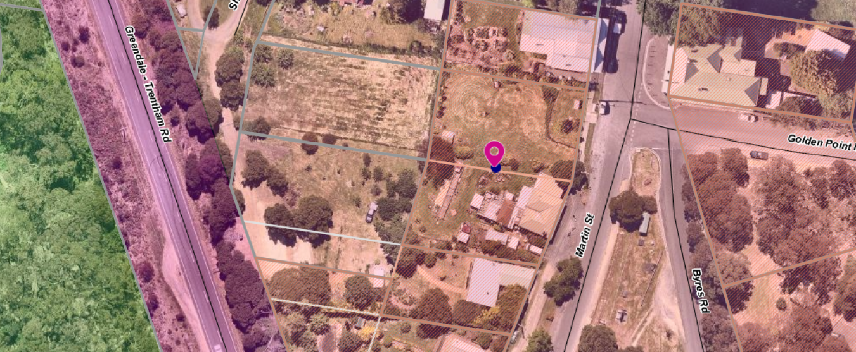
Figure 1: Aerial photograph showing both lots.

Proposal
It is proposed to use one room of the existing dwelling, referred to as the sunroom, for a café which would have space for approximately three tables seating a maximum of 12 patrons. Additionally, the sun room has a doorway to a west facing outside deck which would allow for an additional three tables to seat a further 12 patrons, weather permitting. The application has also included two tables at the front of the dwelling on the footpath which could seat another 6 patrons. This would be subject to a separate Local Laws permit for outdoor dining.
The dwelling has two toilets one of which would meet the requirements of a disabled toilet.
A disabled parking bay would be located on the south side of the dwelling and access for people with disabilities would be available through a south side entrance door.
Four on-site car spaces would be provided on the northern side of the dwelling on the separate vacant lot in the same ownership.
The café would serve breakfast, morning tea, lunch and afternoon tea. A liquor licence is not being sought and the use of a licenced premises has not been requested.
The owner has purchased a portable food van which is to be located on the west side of the house where food would be prepared in a dedicated commercial grade “kitchen” for the café.
The maximum number of patrons is proposed to be 30 (24 seats on site and 6 seats on the footpath (road reserve) which would require an additional approval under Council’s Local Laws. The hours of operation proposed would be 9am – 4pm on both Saturday and Sunday.
Signs are proposed including one at the front of the building hanging from the front verandah and one on the vacant lot on the north, on the vacant lot in the same ownership.
The wording suggested was “The Happy Café - Open weekends 9am – 4pm”. No specific signage details were provided.

BACKGROUND TO CURRENT PROPOSAL
The site was used as a restaurant over many years (1987 – 2012) and mostly traded as ‘Lerdies’ restaurant.
Council determined to defer making a decision as result of the S86 Development Assessment Committee (DAC) meeting held on 20 May 2020. The reason for the deferment was to allow the applicant a chance to further negotiate with Western Water in regard to removal of the condition requiring a new waste water treatment system being installed.
Western Water provided a further response on 17 June 2020 and made the following statements:
It’s not so much the change in use, it’s the increase in waste water volumes the use will generate (almost doubled). The land is considered to be high risk due to its size (1,000sqm), location to river (160m) and only having a primary treatment system. Blackwood is also in a high rainfall area and has poor soils.
Most uses within the township either had systems replaced as part of the localised septic tank program or were old and failing that they had to be replaced anyway. It may be functioning ok when it is servicing just the two-bedroom dwelling but increasing flows also increases the risk.
Discussion with Western Water has been ongoing since June. In early August 2020 Western Water commissioned an independent Land Capability Assessment.
Subsequent discussion between Western Water, Council’s Environmental Health and Planning officers on the basis of the independent Land Capability Assessment has resulted in amended conditions. These conditions include that a 1000 litre grease trap is installed prior to the existing septic tank and a 5000-litre load-balancing tank (including 1400 litres as ballast) must be fitted after the existing septic tank. The load-balancing tank must be designed to provide a maximum wastewater flow of 500 litres a day.

PERMIT History
A search of Council records reveals that the following permits have been issued on the site:
• PA2007039 being for Variation to Existing On-Premises Liquor Licence issued on
• 27 June 2007.
• PA2008172 being for the Development of a Verandah Ancillary to an Existing Restaurant issued on 22 October 2008.
• PA2019218 being for the Development of Outbuildings Ancillary to Existing Dwelling (Workshop, Tool Shed, Carport & Studio).

Public Notice
The application was notified to adjoining and surrounding landowners. Two objections were received both of which are the proprietors of 21 Martin Street, who operate the retail premises known as Martin Street Coffee. It is understood that this business does not operate on weekends.
Both objectors stated that in-principle they were supportive of the application and acknowledged that it would be good for the township. However, their concerns generally related to the suitability of the dwelling at 15 Martin Street to meet the standards required such that the use of a café does not disrupt the amenity of neighbours. There comments are summarised below.
It is also noted that a petition of support with 280 signatories was received by Council. This petition requested a planning permit be granted for a cafe.

Summary of Objections
The objections received are detailed below with officer’s comments accompanying them:
Objection | Any Relevant Requirement
Privacy of neighbours with multiple uses occurring at 15 Martin Street: the residence; the café; bed and breakfast; and Hat Shoppe.
Officer’s Response: Permit conditions can protect the amenity of nearby residents
Waste water should be retained on one lot only and if this cannot be achieved then the lots should be consolidated. The vacant lot, in the same ownership, could be sold at any time. | EPA Victoria - Code of Practice On-Site waste Water Management (publication 891)
Officer’s Response: The application was referred to the relevant water authorities. Western Water, Southern Rural Water and Council’s Environmental Health all determined that the older style septic on the property needed to be replaced with a Waste Water Treatment System that produces wastewater to a minimum standard of 20/30/10 (BOD/suspended solids/E.Coli). This can be satisfied by a permit condition. The existing system cannot support the change of use to a café using current day standards.
The application does not mention a grease trap which would be required with the use of the cafe.
Officer’s Response: The requirement for a grease trap would be dealt with by Council’s Environmental Health Department under the relevant legislation.
Loss of privacy particularly due to the use of rear outdoor space. This is not being respectful of the potential impact on neighbour’s own rear outdoor space: peace, privacy, comfort and rural lifestyle.
Officer’s Response: The impact of a use or development on local amenity in a small township is a planning consideration. The site for the café is within the township boundaries where there are several commercial businesses operating including the Hotel.
As there is no application for a Liquor licence | Clause 52.29 Licenced Premises
Officer’s Response: No liquor licence or use of a licenced premise has been proposed as part of this application.
There are no safety plans referenced in the application.
Officer’s Response: Building and Health regulations can control safety issues
The building does not appear sound for a food premises. There are also chickens in the yard which will attract vermin. | Council’s Environmental Health
Officer’s Response: These concerns will be addressed by Environmental Health’s regulations.
Can a commercial kitchen in a temporary food van remain as a permanent fixture for the café? Does this meet the requirements for food safety and storage? | Council’s Environmental Health
Officer’s Response: These concerns will be addressed by Environmental Health’s regulations.

Locality Map
Figure 2: The map below indicates the location of the subject site and the zoning of the surrounding area.
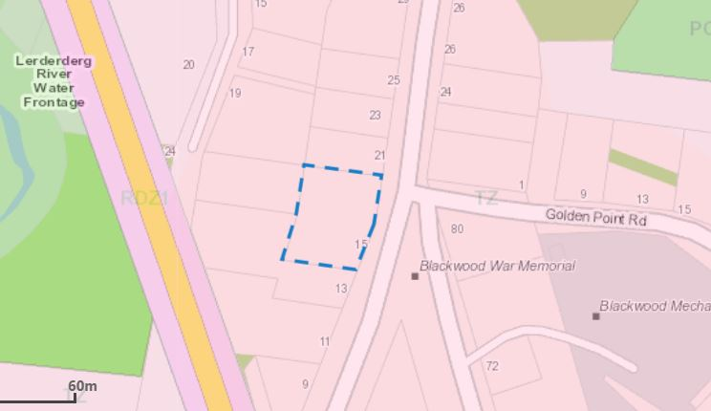

Planning Scheme Provisions
Council is required to consider the Victoria Planning Provisions and give particular attention to the Planning Policy Framework (PPF), the Local Planning Policy Framework (LPPF) and the Municipal Strategic Statement (MSS).
The relevant clauses are:
• Clause 17.01-1R Diversified economy - Central Highlands
• Clause 17.04-1S Facilitating tourism
• Clause 21.09-1 Small Towns and Settlements - Economic Development and Tourism - Blackwood

The proposal generally complies with the relevant sections of the PPF and LPPF.

Zone
Township Zone
In accordance with Clause 32.05-2, Section 2 of the Moorabool Planning Scheme a permit is required for a retail premises (café).
The purpose of the Township Zone is:
• To implement the Municipal Planning Strategy and the Planning Policy Framework.
• To provide for residential development and a range of commercial, industrial and other uses in small towns.
• To encourage development that respects the neighbourhood character of the area.
• To allow educational, recreational, religious, community and a limited range of other non-residential uses to serve local community needs in appropriate locations.

Overlays

Environmental Significance Overlay, Schedule 1

In accordance with Clause 42.01-2 of the Moorabool Planning Scheme a permit is required under this overlay as buildings or works to construct the car parking spaces.

Design and Development Overlay, Schedule 2

In accordance with Clause 42.01-2 of the Moorabool Planning Scheme a permit is not required under this overlay for buildings or works to construct the car parking spaces.

Vegetation Protection Overlay, Schedule 1

In accordance with Clause 42.01-2 of the Moorabool Planning Scheme a permit is not required under this overlay as no vegetation would be removed.

Bushfire Management Overlay
In accordance with Clause 44.06 of the Moorabool Planning Scheme a permit is required for buildings and works associated with the use of land for a retail premises. However, while no buildings or works are occurring on the site it was considered that a referral to the Country Fire Authority was required.

Relevant Policies

Planning Scheme Amendment C78 - Small Towns and Settlements Strategy
Planning Scheme amendment C78 was gazetted into the Moorabool Planning Scheme on 31 May 2018 with Clause 21.09 added to the Local Planning Policy Framework.
Clause 21.09 highlights some specific directions for Blackwood including:
• Economic Development and Tourism – Blackwood.
• Encourage any future commercial/retail development to establish in the existing central area, especially those uses which draw people in from out of area.

PARTICULAR PROVISIONS
Clause 52.05 Signs
The Township Zone is in Category 3 for signs under this Clause 52.05. Category 3 states that a permit is required to display a Business Identification sign. There are no size limits specified within Category 3 for business identification signs.
The application has specified that signs would be required for the café, but details were not complete. This can be satisfied through the submission of revised plans. It is recommended that Council limits the total area of all signs on the premises to 3sqm. This maximum limit is appropriate to provide adequate business identification while not dominating or cluttering the existing commercial streetscape in Blackwood with signage.
Clause 52.06 Car parking
Table 1 of Clause 52.06-5 specifies the number of car spaces required for a range of uses. The use listed as food and drink premise which requires four car spaces for each 100sqm of leasable floor area. The application provides for one disabled space and an additional four car spaces on the vacant lot to the north in the same ownership
It is estimated that the leasable floor area is approximately 75sqm, but the plans did not provide dimensions. The five car spaces would provide adequate car parking on site for this development. It should be noted that these car parks will also be used for the current dwelling and bed and breakfast operation. It is however, not considered that a permit is required for a reduction in car spaces.

Discussion
The application is to use an existing dwelling as a retail premises (café). Between 1987 and 2012 the building was used as variously as a food and drink premises including Lerdies restaurant. Between 2012 and 2015 the building was used as a retail premises to sell antiques until the current owner purchased the building to use as a dwelling.
The owner has advised that the building did have a commercial kitchen which was destroyed when a tree fell onto it and allegedly also a fire.
The owner is not planning to redevelop this kitchen and has purchased a portable commercial grade food van which she has located on the south side of the building to prepare meals for the café.
The hours of operation would be between 9am and 4pm on Saturday and Sunday with a maximum of 30 patrons (seats). A licenced premise to allow for the on-site consumption of liquor is not proposed.
The application was referred to Central Highlands Water who consented to the application without conditions.
However, Western Water and Council’s Environmental Health both required that the existing older style septic system be completely replaced with a new wastewater treatment system. They maintained that the existing septic system, which they believe is at least 35 years old, has well exceeded its functional life expectancy.
It should be noted that most uses within the Blackwood township had systems replaced or upgraded as part of the Blackwood localised septic tank program.
The applicant expressed concerns with the financial impost of a new system. Further discussion between Western Water, Council’s Environmental Health and Planning officers resulted in an independent examination of waste issues and proposed conditions that will allow the current septic system to be retained with an upgrade.
The upgrades required include:
• A 5,000-litre load-balancing tank (including 1,400 litres as ballast) fitted after the existing septic tank designed to provide a maximum wastewater flow of 500 litres a day.
• The load-balance tank to be fitted with a water meter to record all outgoing wastewater flows. Should out going wastewater flows exceed 500 litres a day all commercial operations must cease immediately.
• The load-balance tank to be fitted with an alarm system that alerts the owner when the tank is three quarters full. Should the alarm be activated the load-balance tank must be pumped out within 12 hours. Should the load-balance tank not be pumped out within 12 hours of the alarm being activated then the use must cease immediately.
• A 1,000 litre triple interceptor grease trap must be fitted before the septic tank.
• All incoming water and out going wastewater must be recorded each day against patronage. All incoming and outgoing meter readings and patronage numbers must be kept in a log book that can be provided to Western Water or Council on request. The log book must also keep a record of all maintenance works.
However, if these measures fail at any time then a new waste water treatment system will be required. The permit condition allows for upgrade but also provide protection if the event of a failing wastewater system.
The application was referred to the Country Fire Authority who consented to the application but with a condition that before the development starts, a bushfire management plan must be submitted to and endorsed by the Responsible Authority. The plan must show bushfire mitigation measures listed in the conditions, unless otherwise agreed in writing by the CFA and the Responsible Authority.
The application was referred to Council’s Infrastructure Department who consented to the application, also confirming that the car parking requirements were considered to be satisfactory.
The application was advertised with two objections received. The grounds of objection relate to the use of the outdoor area (deck) and its impact of on the amenity of neighbours. They also questioned such matters as the septic system, waste water management and grease traps, the chooks in the back yard attracting vermin, the suitability of the building for the uses being proposed and fire safety plans.
It is considered that a number of the concerns raised by the objectors will be addressed by permit conditions. These would include: that the waste water treatment system is upgraded or replaced; that noise and other emissions from the site must not affect the amenity of the neighbourhood; that a bushfire safety plan should be provided; and bushfire mitigation measures must be implemented.
A petition with 280 signatories was also received by Council in support of the application to open a weekend café in Blackwood. The petition generally stating that it would be very beneficial to town, both for locals and visitors.
On balance it is considered that the operation of a weekend café to provide food and drink services to locals, visitors and tourists would be beneficial to the small township and meets zone objective of promoting commercial activity.
Clause 21.09 of the Local Planning Policy Framework in relation to Economic development and tourism aims to: Encourage any future commercial/retail development to establish in the existing central area, especially those uses which draw people in from out of area.
It is recommended that the application is supported with conditions.

General Provisions
Clause 65 – Decision Guidelines have been considered by officers in evaluating this application.
Clause 66 – Stipulates all the relevant referral authorities to which the application must be referred.

Referrals
Authority | Response
Western Water  Southern Rural Water  Central Highlands Water  CFA | Consent with amended conditions.  No response.  Consent with conditions.  Consent with conditions.
Infrastructure  Environmental Health | Consent with conditions.  Consent with conditions.

Financial Implications
There is no financial implication associated with an approval to grant a permit.

Risk & Occupational Health & Safety Issues
The recommendation of approval of this application does not implicate any risk or OH&S issues to Council.

Communications Strategy
Notice was undertaken for the application, in accordance with s.52 of the Planning and Environment Act 1987, and further correspondence is required to all interested parties to the application as a result of a decision in this matter. All submitters and the applicant were invited to attend this meeting and invited to address Council if required.

Options
Council could consider the following options:
• issue a Notice of Decision to Grant a permit in accordance with the conditions recommended in this report; or
• issue a Notice of Decision to Grant a permit with varied conditions in this report; or
• issue a Refusal to grant a permit.

Conclusion
The application proposes to meet an identified lack of food and beverage available for visitors at weekends in the small township of Blackwood. While the conditions contained in this report will require the applicant to provide revised plans, to upgrade the existing septic system and undertake adequate bushfire mitigation measures in a bushfire prone area, it is considered that the application is worthy of Council support. As part of the permit conditions, the existing primary wastewater system will need to be upgraded to meet current standards. The conditions limit the operation of the café to two days per week. The upgrade will protect the water quality of natural waterways and the surrounding catchment area in accordance with objectives of the Environmental Significance Overlay Schedule 1.

7.5 PA2019288 - The re-subdivision of five lots into two lots, Use of the land for agriculture on proposed Lot 1 and Development and Use of a Dwelling on proposed Lot 2 at Pearces Road Bullarto South
Author: Victoria Mack, Statutory Planner
Authoriser: Henry Bezuidenhout, Executive Manager Community Planning & Economic Development
Attachments: 1. Plan of proposed resubdivision (under separate cover)
2. Existing 5 Lot layout (under separate cover)
3. Site Plan, Dwelling Plans and Shed Plan (under separate cover)

Application Summary
Permit No: PA2019288
Lodgement Date: 10 December 2019
Planning Officer: Victoria Mack
Address of the land: Pearces Road, Bullarto South; Lots 1, 2, 3, 4 and 5 on TP 85359L
Proposal: The re-subdivision of five lots into two lots, Use of the land for agriculture on proposed Lot 1 and Development and Use of a Dwelling on proposed Lot 2.
Lot size: Combined total area of 5 lots - 13.57ha
Why is a permit required? Rural Conservation Zone
Clause 35.06-3 Rural Conservation Zone – subdivision;
Clause 35.06-1, Section 2, Use of the land for agriculture;
Clause 36.06-1, Section 2, Use of land for a dwelling;
Clause 35.06-5, Buildings and works associated with a use in Section 2 of Clause 35.06-1.
Bushfire Management Overlay
Clause 44.06-2, Buildings and works associated with the use of land for accommodation.

Recommendation
That Council, having considered all matters as prescribed by the Planning and Environment Act 1987, issues a Refusal to Grant a Planning Permit the re-subdivision of five lots into two lots, Use of the land for agriculture on proposed Lot 1 and Development and Use of a Dwelling on proposed Lot 2 at Pearces Road, Bullarto South, otherwise known as Lots 1, 2, 3, 4 and 5 on TP85359L on the following grounds:
1. The proposed re-subdivision would create a small sized lot that is inappropriate within the Rural Conservation Zone of Bullarto South.
2. The proposed subdivision and development of a dwelling does not adequately protect the biodiversity value and the environmental significance of the land.
3. The proposal does not provide for an agricultural use consistent with the conservation values of the land and is not an orderly planning outcome for the Bullarto district.
4. The proposal does not comply with the decision guidelines of Clause 35.06 Rural Conservation Zone of the Moorabool Planning Scheme.
5. The proposal would create an unacceptable precedent in the Bullarto district that small lots can be re-subdivided to create rural residential allotments unrelated to the use of the land for environmental and conservation purposes.

Public Consultation
Was the application advertised? | Yes.
Notices on site: | Yes.
Notice in Moorabool Newspaper: | No.
Number of objections: | One.
Consultation meeting: | Not held as the recommendation is for refusal.

Policy Implications
The Council Plan 2017-2021 provides as follows:
Strategic Objective 2: Minimising Environmental Impact
Context 3A: Land Use Planning
The proposal is not inconsistent with the Council Plan 2017-2021 and can be actioned by utilising existing resources.

Victorian Charter of Human Rights & Responsibilities Act 2006
In developing this report to Council, the officer considered whether the subject matter raised any human rights issues. In particular, whether the scope of any human right established by the Victorian Charter of Human Rights and Responsibilities is in any way limited, restricted or interfered with by the recommendations contained in the report. It is considered that the subject matter does not raise any human rights issues.

Officer’s Declaration of Conflict of Interests
Under section 80C of the Local Government Act 1989 (as amended), officers providing advice to Council must disclose any interests, including the type of interest.
Executive Manager – Henry Bezuidenhout
In providing this advice to Council as the Executive Manager, I have no interests to disclose in this report.
Author – Victoria Mack
In providing this advice to Council as the Author, I have no interests to disclose in this report.

Executive Summary
Application referred? | Yes, Country Fire Authority, Southern Rural Water, Western Water and Council’s Infrastructure, Council’s Environmental Health and Council’s Environmental Planning.
Any issues raised in referral responses? | No, however Infrastructure requested that a proposed Plan of Subdivision was provided.
Preliminary concerns? | The original application showed a building envelope on the proposed northern Lot 1 in addition to the dwelling plans for the proposed southern Lot 2. Inconsistent documentation was submitted in that a dwelling on lot 1 is not applied for but documentation refer to a dwelling on lot 1.  There was concern that the two lots proposed, one of 5.637ha and the other of 7.938ha, would fragment the land in the area which is not consistent with the purpose or decision guidelines of the Rural Conservation Zone. It was considered this would not provide for orderly planning in Bullarto South.
Any discussions with applicant regarding concerns? | Further information was requested. The applicant was asked to remove the building envelope on Lot 1 and from all the documentation provided as no dwelling was being proposed on this lot and a building envelope would not be considered.  Details were requested about the unused road along the western boundary of the site which was proposed to be used for access to Lot 2.  The applicant was also asked to amend the application to include the use of the land for agriculture, and / or land management and that a Farm Management Plan (FMP) or Land Management Plan (LMP) should be provided.  The option of consolidating all five lots into one lot with a total area of 13.57ha with a single dwelling was discussed with the applicant. The applicant affirmed that the owner wished to continue with the application for two lots which can be considered under the Schedule to the Rural Conservation Zone.
Any changes made to the application since being lodged? | The following documents were provided:  • An amended Bushfire Management Statement.  • A combined LMP and FMP.  • A Plan of Subdivision.  • A copy of the agricultural grazing licence held for the unused road.
Brief history. | The land is vacant.
Previous applications for the site? | None recorded.
General summary. | The application originally submitted suggested that a dwelling was being considered for each lot, but plans were inconsistent as it only provided for a dwelling on Lot 2.  On request, the application was amended to only seek approval of one dwelling on Lot 2.  The re-subdivision would create a vacant 5.637ha lot which in this area may create an application for a future dwelling on Lot 1.  The proposed subdivision and development of a dwelling does not protect the environmental significance of the land.  On balance it is considered that this application does not provide an orderly planning outcome in a designated rural conservation area of Bullarto South.
Summary Recommendation
That, having considered all relevant matters as required by the Planning and Environment Act 1987, Council issues a Refusal to Grant a Planning Permit for the re-subdivision of five lots into two lots, Use of the land for agriculture on proposed Lot 1 and Development and Use of a Dwelling on proposed Lot 2. on proposed Lot 2 at Pearces Road, Bullarto South, otherwise known as Lots 1, 2, 3, 4 and 5 on TP85359L.

Site Description
The irregular shaped site comprises five lots with a combined area of 13.575 ha. The lots range in size from 1.317ha to 5.547ha. Pearces Road runs along the north side boundary, Bobbys Lane runs along the east side boundary, and an unused road runs along the west side boundary. The north and west boundaries of the land are the boundary between Moorabool Shire Council and Hepburn Shire Council.
Approximately 8.5ha of the site is pastured flat grazing land on the north and west sides of the property, with the balance of approximately 5ha being pristine native bushland. This bushland contains tall trees and, in places, dense understorey. This land slopes downwards to the south-east corner of the site, where there is also the commencement of an unnamed waterway. There is a farm dam located at the edge of this bushland area.
At the time of the site inspection is was noted that a water tank had been installed near to the proposed dwelling site and sundry machinery and other materials were being stored at the rear of the site, not visible from Pearces Road. The water tank does not require planning approval.
Access is to the site is from Pearces Road via a wide constructed entrance with double farm gates located in the north-west corner of the site.
The unused road running parallel to the west side boundary is currently not fenced or constructed.
Surrounding land to the north and west is in the Hepburn Shire Council and is in the Farming Zone. This land is generally cleared and pastured agricultural land. Land to the south is forested and privately owned and further south is forested crown land. Land to the east is privately owned farming land and land to the south-east is forested crown land.
Below is an aerial photo of the site and surrounds.
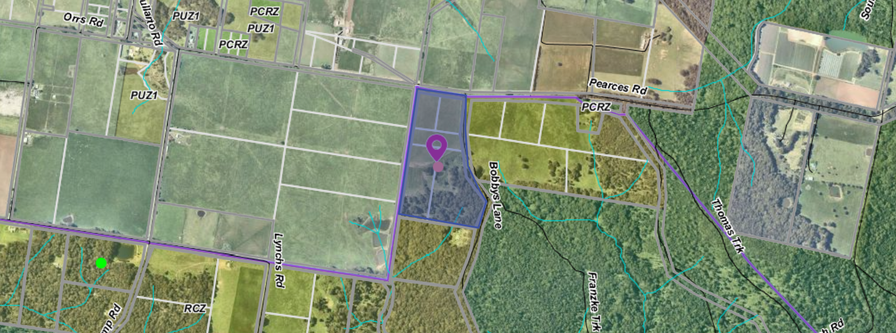
Figure 1: Aerial photograph

Proposal
The proposal provides for:
- Re-subdivision of five lots into two lots. Note: Lot 1 would be on the north side of the land and would have an area of 5.637ha. Lot 2 would be on the south side of the land and would have an area of 7.938ha.
- Proposed Lot 1 will be used for agricultural purposes which requires a permit for this use.
- Proposed Lot 2 will be used for rural living purposes and developed with a dwelling.
The applicant provided a Land Management Plan which covered basic actions including weed and feral animal control and Lucerne production. Trees would be planted in the western windbreak area, but numbers of trees were not provided.
Lot 1 would contain all the flat pastured land which would be cultivated and sown down for Lucerne production in 2020. The sowing and harvesting of Lucerne in the pastured area was documented but only at a preliminary level and for the first 12 months but with ongoing fertiliser mentioned. The Lucene production plan did not provide a five-year timeline of works and no costings or excepted returns were provided. Livestock were mentioned to manage grass, but the type or number of live stock was not provided.
The boundary between Lots 1 and 2 has been selected to follow the natural topography of the site between the proposed lots.
Lot 2 would contain all the bushland and forest and is where the proposed dwelling would be located in a small cleared section. This land slopes from the proposed boundary with Lot 1 down to the south-east corner. A detached shed would be located further to the south, closer to the forest.
The proposed single storey dwelling would have three bedrooms, two bathrooms, a laundry and an open plan kitchen and living area. There would be a verandah on two sides. A garage would be constructed near the dwelling which would be 9m x 6m, or 54sqm. The external cladding would be fire rated timber and metal cladding with toughened glazing. No reflective materials would be used, and the colours would be muted. The floor area of the dwelling would be 140sqm with an additional 120sqm of verandas.
The Bushfire Attack Level (BAL) rating for the dwelling would be 29. The dwelling would be setback 22m from the west boundary and 150m from the south boundary.
Power would be provided off-grid with solar panels and battery storage.
A barn style farm shed would be constructed south of the dwelling and would be 20m x 10.5m and would have a maximum height of 3.6m. No external cladding material has been nominated for the shed.
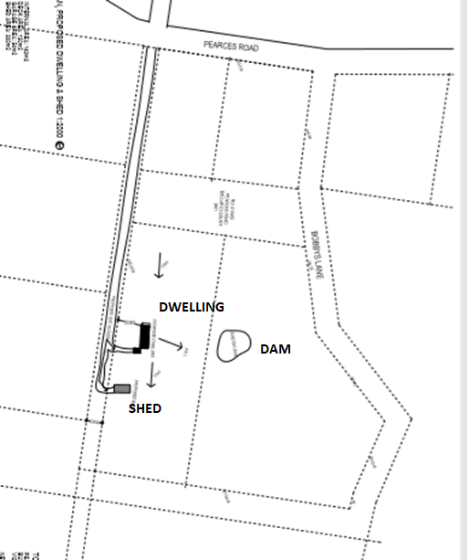

Figure 2: Dwelling and shed location plan showing all five existing lots.
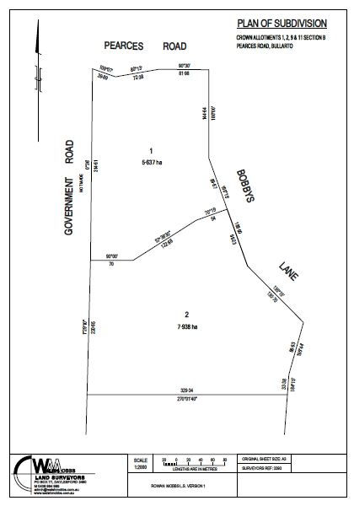
Figure 3: Proposed plan of subdivision

Background to Current Proposal
The original application included a building envelope on the proposed Lot 1. The Bushfire Management Statement also included defendable space around the building envelope on Lot 1 and a Land Capability Assessment with effluent envelope was provided for this building envelope on Lot 1.
The applicant was asked as part of further information requested to remove the building envelope from the application as there was no dwelling proposed and that all documentation should be amended to delete the building envelope on Lot 1.
This was done and the following documents were provided:
• Application form.
• Bushfire Management Statement.
• Planning Report.
• LMP/FMP for the whole of the site, with Lucerne production the primary agricultural activity proposed for the arable land area.
• A copy of the Agricultural Grazing Licence held by the owner.
• The proposed Plan of Subdivision.

History
There is no site history relevant to this application.

Public Notice
The application was notified to adjoining and surrounding landowners. One objection was received.

Summary of Objections
The objections received are detailed below with officer’s comments accompanying them:
Objection | Any Relevant Requirement
I am a farmer in the area and as such I am very passionate about the farming land in this area and its ability to be kept as farming land. I see this as eroding the planning scheme which was put in place to prevent this very development. | Rural Conservation Zone decision guidelines and purpose of the Rural Conservation Zone
Officer’s Response: The Rural Conservation Zone decision guidelines and purpose are addressed in the discussion section of this report.
The property was purchased on the understanding that it was not a lifestyle block hence its zoning. The proposal to create two parcels would enable the future sale of the other half of the property for another lifestyle development. The surrounding this land is Farming Zone and although this land is not zoned as such it has been used for farming. | Rural Conservation Zone decision guidelines and purpose of the Rural Conservation Zone
Officer’s Response: The Rural Conservation Zone decision guidelines and purpose are addressed in the discussion section of this report.
If this development goes ahead it set a precedent that zoning doesn't matter. | Rural Conservation Zone decision guidelines and purpose of the Rural Conservation Zone
Officer’s Response: The Rural Conservation Zone decision guidelines and purpose are addressed in the discussion section of this report.

Locality Map
The map below indicates the location of the subject site and the zoning of the surrounding area.
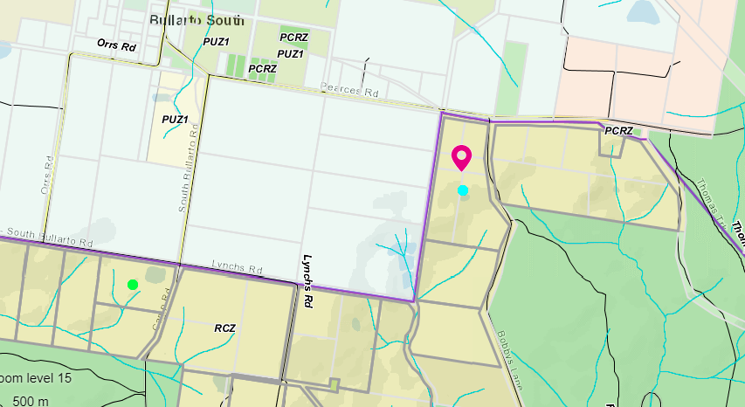
Figure 3: Zone map. Note: The northern side of Pearces Road is covered by the Hepburn Planning Scheme.

Planning Scheme Provisions
Council is required to consider the Victoria Planning Provisions and give particular attention to the Planning Policy Framework (PPF) and the Local Planning Policy Framework (LPPF) The relevant clauses are:
• Clause 12.01 Biodiversity
• Clause 12.01-1S Protection of biodiversity
• Clause 12.05-2S Landscapes
• Clause 12.05-2R Landscapes - Central Highlands
• Clause 13.02-1S Bushfire planning
• Clause 14.01-1S Protection of agricultural land
• Clause 14.01-2S Sustainable agricultural land use
• Clause 14.02-1S Catchment planning and management
• Clause 14.02-2S Water quality
• Clause 15.01-6S Design for rural areas
• Clause 16.01-5S Rural residential development
• Clause 21.02-4 Natural Environment—Biodiversity
• Clause 22.02 Special Water Supply Catchments
The proposal complies with the relevant sections of the PPF and LPPF, with the exception of the clauses outlined in the table below:

PPF | Title | Response
Clause 12.01-1S | Protection of biodiversity | The proposal does not include protection measures to enhance the conservation and biodiversity values of the property.
Clause 14.01-1S | Protection of agricultural land | Objective:  To protect the state’s agricultural base by preserving productive farmland.
Clause 14.01-2S | Sustainable agricultural land use | To ensure agricultural and productive rural land use activities are managed to maintain the long-term sustainable use and management of existing natural resources.  The proposal does not achieve these objectives due to the small land area.
Clause 16.01-5S | Rural residential development | Strategies:  Manage development in rural areas to protect agriculture and avoid inappropriate rural residential development.  Discourage development of small lots in rural zones for residential use or other incompatible uses.  Encourage consolidation of existing isolated small lots in rural zones.  The proposal does not seek the complete consolidation of small lots.
Clause 21.02-4 | Objective—Biodiversity | To positively enhance biodiversity in the Moorabool Shire.  The proposal does not seek to the biodiversity value of the site.

Zone
Rural Conservation Zone
In accordance with Clause 36.06-1, Section 2, of the Moorabool Planning Scheme, a permit is required for the use of land for a dwelling, and for the Use of the vacant second lot for agriculture.

In accordance with Clause 35.06-5, a permit is required for buildings and works associated with a use in Section 2 of Clause 35.06-1. In accordance with Clause 35.06-3 a permit is required for subdivision.
The purpose of the Rural Conservation Zone is:
• To implement the Municipal Planning Strategy and the Planning Policy Framework.
• To conserve the values specified in a schedule to this zone.
• To protect and enhance the natural environment and natural processes for their historic, archaeological and scientific interest, landscape, faunal habitat and cultural values.
• To protect and enhance natural resources and the biodiversity of the area.
• To encourage development and use of land which is consistent with sustainable land management and land capability practices, and which takes into account the conservation values and environmental sensitivity of the locality.
• To provide for agricultural use consistent with the conservation of environmental and landscape values of the area.
• To conserve and enhance the cultural significance and character of open rural and scenic non-urban landscapes.
The decision guidelines of the Rural Conservation Zone state, as relevant to this application, that the responsible authority must consider:
• Whether use or development protects and enhances the environmental, agricultural and landscape qualities of the site and its surrounds.
• Whether the site is suitable for the use or development and the compatibility of the proposal with adjoining land uses.
• Whether the use or development will have an adverse impact on surrounding land uses.
• The protection and enhancement of the natural environment of the area, including the retention of vegetation and faunal habitats and the need to revegetate land including riparian buffers along waterways, gullies, ridgelines, property boundaries and saline discharge and recharge areas.
• How the use and development relate to sustainable land management and the need to prepare an integrated LMP which addresses the protection and enhancement of native vegetation and waterways, stabilisation of soil and pest plant and animal control.
• The location of onsite effluent disposal areas to minimise the impact of nutrient loads on waterways and native vegetation.
• Whether the dwelling will result in the loss or fragmentation of productive agricultural land.
• Whether the dwelling will be adversely affected by agricultural activities on adjacent and nearby land due to dust, noise, odour, use of chemicals and farm machinery, traffic and hours of operation.
• Whether the dwelling will adversely affect the operation and expansion of adjoining and nearby agricultural uses.
• The need to minimise adverse impacts on the character and appearance of the area or features of archaeological, historic or scientific significance or of natural scenic beauty or importance.

Schedule to the Rural Conservation Zone
The schedule to this zone lists the following conservation values:
• to protect land of environmental significance.
• to ensure that the location, siting and design of any development does not adversely impact upon sensitive environments nearby.
The Schedule to the Rural Conservation Zone also shows the land is within Map 6 for Bullarto South where the minimum lot size for subdivision is 6ha.
The proposal does not meet the minimum lot size with the creation of one lot less than 6ha. However, as the application is for a re-subdivision and no additional lots are created, Lot 1 can be less than the minimum requirement.

Overlays
Bushfire Management Overlay
In accordance with Clause 44.06-2 of the Moorabool Planning Scheme a permit is required for buildings and works associated with the use of land for accommodation.

Relevant Policies
There are no relevant policies that apply to the Rural Conservation Zone.

Particular Provisions
Clause 52.12 Bushfire Protection exemptions
Exemption to create defendable space for a dwelling approved under Clause 44.06 of this planning scheme. An exemption for vegetation removal to create defendable space does not apply in the Rural Conservation Zone under Clause 52.12-5.
Clause 52.17 Native vegetation
No native vegetation would be removed as part of this application and Clause 52.17 does not apply in this instance.
Clause 53.02 Bushfire planning
To specify bushfire design and construction measures for a single dwelling or alteration and extension to an existing dwelling that reduces the risk to life and property to an acceptable level.
Clause 53.02-3.1 Decision guidelines
Before deciding on an application, in addition to the decision guidelines in Clause 65, the responsible authority must consider:
• The Municipal Planning Strategy and the Planning Policy Framework.
• The bushfire hazard site assessment and the bushfire management statement submitted with the application.
• Whether all of the approved measures have been incorporated into the application.

Discussion
The subject site is 13.57ha and comprises of five lots. If approved the application would result in the re-subdivision of the five lots into two lots and the development of a dwelling on one lot.
The vacant Lot 1 would be 5.637ha in area with the south side boundary of this lot selected to align with the topography of the land, on this basis the lot size being less than 6ha would be considered acceptable. Lot 2 would contain the proposed dwelling, separate garage and large shed and would be 7.938ha in area
The Bullarto South area is partly an agricultural district and partly native forests. Most surrounding lots to the north are cleared and used for grazing or cropping while to south are native woodland with fire access tracks. It is a sparsely settled area with the township area located to the north in Hepburn Shire Council.
The applicant was advised a better planning outcome would be achieved if the five lots were consolidated into one lot which would discourage rural residential development in the Bullarto South district and it would be more consistent with the objectives of the Rural Conservation Zone. The area is generally a mix of established agricultural enterprises and natural areas of forest and bushland.
However, the applicant advised that the owner wished to pursue the 2 lot re-subdivision with the reasoning that this is a better outcome than the potential of five lots ending up in separate ownership and that the re-subdivision of lots was not prohibited in the Rural Conservation Zone.
The creation of two relatively small allotments in the Bullarto South district is not considered to be an orderly planning outcome. It has the potential to suggest that the newly created lot is suitable for another activity such as a dwelling. There has been insufficient zoning justification on why the land needs to be re-subdivided into two lots and lack of detail about what uses could occur on the lot without the dwelling proposed. The subdivision has not been arranged to protect the environmental significance of the land and is not accordance with the objectives and purpose of the Rural Conservation Zone.
The application has also received one objection following notification. The objector is concerned that if the re-subdivision is approved it will create a precedent for further re-subdivision and rural residential development in the Bullarto South district.
One purpose of the Rural Conservation Zone specifically aims to: ‘provide for agricultural use consistent with the conservation of environmental and landscape values of the area; and to conserve and enhance the cultural significance and character of open rural and scenic non-urban landscapes.’ This has not been achieved with this proposal as the dwelling is not located in the already cleared land area (northern section) that is proposed for farming but rather on the highly vegetated area that should be retained for conversation purposes, without seeking to prevent adverse impacts on highly vegetated Lot 2. A dwelling is typically associated with the farming activities, which is not the case with this application.
A Land Management Plan (LMP) was provided with the application. The LMP divided the whole of the site into five zones: house and garden zone on Lot 2; pasture zone on Lot 1 where Lucerne would be grown; windbreak zone on the west side of Lot 1; a revegetation area on Lot 2; and a forest zone on Lot 2. The plan covered the first year of operation in some detail but did not provide a five-year plan. The LMP was a summary of activities and lacked specific implementation details. No costings or projected returns were provided.
It is not considered that the LMP comprehensively addressed the conservation and sustainable land management purposes of the zone.
It is not considered that this application meets the decision guidelines of the Rural Conservation Zone. The proposal would create two small lots, with one to be used for rural residential development and the other having limited land area for agricultural or conservation purposes. Two lots also would fragment the potential to create an integrated LMP for the whole of the site.
While the development of one dwelling over all lots which total 13.57ha may be acceptable with an integrated LMP the creation of a second lot is not acceptable. The Rural Conservation Zone in Bullarto South has been designed as a buffer between the forest land to the south and the farming land to the north and any re-subdivision which results in small sized lots or continues the fragmentation of rural conservation land should not be supported as it does not achieve the objectives of the zone.
The objectives of the Rural Conservation Zone have also been explored in detail by VCAT. In Tsourounakis vs Hepburn Shire Council 2010 [VCAT 723] Member Naylor and Potts looked at the objectives of the Rural Conservation Zone, in paragraphs 10-13 of their order.
‘10. The purpose of the RCZ is primarily aimed at conservation and protection of environmental values. There is no reference to the use of the land for dwellings or rural living in the purposes. While agricultural land use is a purpose, it is only where such use is consistent with the ‘conservation of environmental and landscape values of the area’.
11.To us it seems that the approach of the Council and Mr Tsourounakis seems to typify many applications for dwellings in a RCZ. This approach is to start by asking ‘how’ can a dwelling be accommodated. Having regard to the purposes of the zone and the overlays that apply, the question should more rightly be put as to ‘why’ a dwelling should be allowed. This is further emphasised by the fact that the use for a dwelling is a section 2, permit required use. This is to be contrasted with the use for a dwelling on other rural land, i.e. the Rural Living and Farming Zones, where a dwelling is a section 1 use, albeit even then on a conditional basis, including the ability to achieve satisfactory on-site wastewater treatment and disposal.
12. In our view if use of this land for agriculture or a rural living dwelling was seen to be strategically supported, then other zones would have been applied to this land. That other zones have not been applied to this land points clearly to a recognition that this land has other values that the purpose of RCZ seeks to support.
13. Accordingly in response to why a dwelling should be allowed, the reasoning by the Council that the land cannot be used for agriculture is irrelevant. The reasoning that there are other dwellings present, a large proportion of which are located in another zone fails to recognise the difference in intended land use as discerned from the difference in the zonings.’
This decision highlighted the importance of protecting environmental significant land from both dwelling uses and agricultural uses.
It is recommended that the application for a re-subdivision with construction of a dwelling on one lot and agricultural use on a second lot is not supported as the proposal is not consistent with the purposes or the decision guidelines of the Rural Conservation Zone.

General Provisions
Clause 65 – Decision Guidelines have been considered by officers in evaluating this application.
Clause 66 – Stipulates all the relevant referral authorities to which the application must be referred.

Referrals
Authority | Response
Western Water  Southern Rural Water  Country Fire Authority | No response provided.  Consent with conditions  Consent with conditions
Infrastructure  Environmental Health  Environmental Planning | Consent with conditions  Consent with conditions  No comment

Financial Implications
It is not considered that the recommendation of refusal represents any financial risk or implications to Council.

Risk & Occupational Health & Safety Issues
The recommendation of refusal of this development and re-subdivision, use and development proposal does not implicate any risk or OH&S issues to Council.

Communications Strategy
Notice was undertaken for the application, in accordance with s.52 of the Planning and Environment Act 1987, and further correspondence is required to all interested parties to the application as a result of a decision in this matter. All submitters and the applicant were invited to attend this meeting and invited to address Council if required.

Options
1. Issue a refusal to the planning permit in accordance with the recommendations of this report; or
2. Should Council wish to consider an approval of the application Council may consider including a condition on the permit that no dwellings are to be constructed on the proposed Lot 1.

Conclusion
The application includes both the re-subdivision of the land, the development and use of a dwelling on one lot and the use of the land for agriculture on a second lot. It is considered that proposal has not sought to protect environmental significance of the land and is not an orderly planning outcome in the Bullarto South district. Not supporting the re-subdivision, uses and development must result in a recommendation that the whole application is refused.

7.6 PA2019174 - 9 Lot Staged Subdivision and Vegetation Removal at 33 Crook Court Ballan
Author: Thomas Tonkin, Statutory Planner
Authoriser: Henry Bezuidenhout, Executive Manager Community Planning & Economic Development
Attachments: 1. Proposed subdivision plan and vegetation removal (under separate cover)
2. Staging plan (under separate cover)

Application Summary
Permit No: PA2019174
Lodgement Date: 22 July 2019
Planning Officer: Tom Tonkin
Address of the land: 33 Crook Court Ballan
Proposal: Nine (9) Lot Staged Subdivision and Vegetation Removal
Lot size: 8,649sqm
Why is a permit required? 32.08 – General Residential Zone, Schedule 4 - Subdivision
42.01 – Environmental Significance Overlay, Schedule 1 – Subdivision and Vegetation Removal

Recommendation
That Council, having considered all matters as prescribed by the Planning and Environment Act 1987, issues a Notice of Decision to Grant Planning Permit PA2019174 for a 9 Lot Subdivision and Vegetation Removal at Lot 19 on PS 209801R known as 33 Crook Court, Ballan 3342, subject to the following conditions:
Endorsed Plans:
1. The formal plan of subdivision lodged for certification must be generally in accordance with the endorsed plan and must not be modified except to comply with statutory requirements or with the written consent of the Responsible Authority.
Subdivision:
2. The plan of subdivision submitted for certification under the Subdivision Act 1988 must be referred to the relevant authority in accordance with Section 8 of that Act.
3. Before the Statement of Compliance is issued under the Subdivision Act 1988, the applicant or owner must pay to the Responsible Authority a sum equivalent to 5% of the site value of all the land in the subdivision for public open space purposes. The permit holder/developer must pay the reasonable costs of Council in having the land valued for this purpose.
4. Prior to the issue of Statement of Compliance, any outbuildings not wholly contained within Lot 1 must be removed or demolished to the satisfaction of the Responsible Authority.
5. The plan of subdivision submitted for certification must include a creation of restriction. The wording of the creation of restriction shall be as follows:
Restriction 1
  - Land to be Burdened: All lots on this plan.
  - Land to Benefit: All lots on this plan.
  - Description of Restriction 1:
    - No fencing within 4m of the street frontage shall be any higher than 1.2m, no dwelling or ancillary outbuildings shall be constructed within 4 metres of the street frontage or within 1m of the side property boundaries.
  - Variation: The restriction can only be varied with the written consent of Moorabool Shire Council.
Restriction 2
  - Land to be Burdened: Lot 1-4 on this plan.
  - Land to Benefit: All lots on this plan.
  - Description of Restriction:
    - No fencing adjoining or within 2 metres of the pedestrian footpath between Crook Court and Fish Court which is within 10m of the lot frontage shall be any higher than 1.2m. No other fence type except timber paling with an anti-graffiti coating facing the walkway can be constructed to the satisfaction of the Responsible Authority.
d) Variation: The restriction can only be varied with the written consent of Moorabool Shire Council.
Telecommunications:
6. The owner of the land must enter into agreements with:
  - A telecommunications network or service provider for the provision of telecommunication service to each lot shown on the endorsed plan in accordance with the provider’s requirements and relevant legislation at the time; and
  - A suitably qualified person for the provision of fibre ready telecommunication facilities to each lot shown on the endorsed plan in accordance with any industry specifications or any standards set by the Australian Communications and Media Authority, unless the applicant can demonstrate that the land is in an area where the National Broadband Network will not be provided by optical fibre.
7. Before the issue of Statement of Compliance for any stage of the subdivision under the Subdivision Act 1988, the owner of the land must provide written confirmation from:
- A telecommunications network or service provider that all lots are connected to or are ready for connection to telecommunications services in accordance with the provider’s requirements and relevant legislation at the time; and
- A suitably qualified person that fibre ready telecommunication facilities have been provided in accordance with any industry specifications or any standards set by the Australian Communications and Media Authority, unless the applicant can demonstrate that the land is an area where the National Broadband Network will not be provided by optical fibre.
Infrastructure:
8. Prior to the development and use commencing, engineering drainage plans and computations must be submitted to the Responsible Authority for approval and shall incorporate the following:
  - The subdivision as a whole must be self draining.
  - All drainage courses within the subdivision must pass through easements or reserves shown on the plan of subdivision.
  - All outfall drainage passing through other land must be provided at the cost of the developer and be constructed within easements shown on the plan of subdivision.
  - Volume of water discharging from the subdivision in a 10% AEP storm shall not exceed the 20% AEP storm prior to development.
  - Flow paths of the 1% AEP storm must be determined, and the subdivision designed so that no property is inundated by such a storm. The flow paths must be indicated on the engineering plans.
  - The drainage system must be designed to include provision to intercept litter.
  - All lots must be provided with a stormwater legal point of discharge at the low point of the lot, to the satisfaction of the Responsible Authority.
  - The drainage design must take into account any applicable drainage or flood management strategy.
If required, the layout of the subdivision must be modified based on the approved stormwater design.
9. Prior to the commencement of the development, design computations for drainage of the whole site must be prepared and submitted to the Responsible Authority for approval, and must include analysis of the existing stormwater drainage system in the area to determine:
  - the requirements for drainage of the whole site.
  - if the existing drainage network has sufficient capacity to cater for the additional runoff from the ultimate development.
  - If additional outfall drainage or upgrading of the existing drainage network is required.
10. The internal road network layout and works within Crook Court must be designed and constructed to the standards detailed in the Infrastructure Design Manual, to the satisfaction of the Responsible Authority.
11. Design computations for all road pavement construction, based on a geotechnical investigation of the site, must be prepared and submitted to the Responsible Authority for approval.
12. Plans and specifications of all road, traffic and drainage works must be prepared and submitted to the responsible authority for approval prior to the commencement of such works and all such works must be carried out in accordance with the approved plans to the satisfaction of the Responsible Authority.

13. Prior to the issue of Statement of Compliance for the subdivision, Crook Court must be constructed along the frontage of the property, to the satisfaction of the Responsible Authority with:
  - Kerb and channel, and pavement widening along the frontage of the site.
  - Stormwater drainage.
  - Nature strip and landscaping.
  - Public lighting.
  - A 1.5m concrete footpath from the existing end up to the southern boundary of the property.
  - A 1.5m concrete footpath is to be constructed within the pedestrian access way linking the footpath in Crook Court to the footpath in Fish Court.
14. Unless otherwise approved by the Responsible Authority there must be no buildings, structures, or improvements located over proposed drainage pipes and easements on the property.
15. An Environmental Management Plan for the road construction works must be submitted to the Responsible Authority for approval prior to the commencement of construction. All works must be performed in accordance with the approved Environmental Management Plan.
16. Sediment discharges must be restricted from any construction activities within the property in accordance with the relevant Guidelines including “Construction Techniques for Sediment Control” (EPA 1991) and “Environmental Guidelines for Major Construction Sites” (EPA 1995).
17. Traffic management treatments must be provided in the form of linemarking, signage and pavement markers at intersections and vehicle turning areas, to the satisfaction of the Responsible Authority.
18. Prior to the issue of Statement of Compliance for the subdivision, street lighting must be provided in accordance with the requirements of AS1158 – Lighting for Roads and Public Places, to the satisfaction of the Responsible Authority. All lighting fittings must be “Standard” fittings maintained by the electricity network provider at no additional cost to Council. All lights must utilise LED type luminaires where available.
19. The development must be provided with open access underground conduits to carry optical fibre at the development stage. (This may be waived if the responsible authority considers provision is unwarranted.) A development plan must show the conduit network for the subdivision, to the satisfaction of the Responsible Authority.
20. Conduits must be provided in accordance with a plan approved by the Responsible Authority. Ownership of a conduit is to be vested in Council and may be transferred to another agency or telecommunications carrier at such time as it may be required.
21. Street names and street signs must be provided to the satisfaction of the Responsible Authority.
22. Permanent survey marks must be provided at a maximum spacing of 200m and registered, to the satisfaction of the Responsible Authority.

23. Street trees must be provided at approved locations in all internal roads of the subdivision at a rate of one tree per lot frontage and one tree per lot sideage, with an approved species to the satisfaction of the Responsible Authority. All street trees must have an existing height of 1.5m upon planting, must be planted to an approved standard incorporating two hardwood stakes, tree ties, Ag pipe, water crystals, 100mm of mulch and initial watering, to the satisfaction of the Responsible Authority.
24. Street trees must be maintained for a minimum period of 18 months including watering, mulching, weeding and formative pruning, to the satisfaction of the Responsible Authority.
25. A security deposit equal to 150% of the cost of planting street trees must be lodged with the Council. The deposit will be returned after the final inspection of street trees, 18 months after the completion of planting of the trees, only if Council requires no further maintenance of the trees to be undertaken.
26. Landscaping within the development must be provided in accordance with an approved landscape plan, to the satisfaction of the Responsible Authority.
27. Landscaping must be maintained for a minimum period of 18 months including watering, mulching, weeding and formative pruning, to the satisfaction of the Responsible Authority.
28. A security deposit equal to 150% of the cost of the landscaping must be lodged with the Council. The deposit will be returned after the final inspection of landscaping, 18 months after the completion of landscaping, only if Council requires no further maintenance of the landscaping to be undertaken.
29. Prior to the issue of a Statement of compliance for each stage of the subdivision, the developer must pay:
  - 0.75% of the total estimated cost of works for the checking of engineering plans associated with that stage of the development.
  - 2.50% of the total estimated cost of works for the supervision of works associated with that stage of the development.
30. Prior to the issue of a Statement of Compliance for the relevant stage of the subdivision, after all engineering works pertaining to the stage have been completed, the following “as constructed” details must be submitted in the specified format to the Responsible Authority:
  - Drainage construction details in “D-Spec” format.
  - Roadworks construction details in “R-Spec” format.
31. Subject to the consent of the Responsible Authority, the data may be provided prior to the end of the maintenance period for the relevant stage of the subdivision.
32. All road and drainage works must be maintained in good condition and repair for a minimum of three months after completion of the works, to the satisfaction of the Responsible Authority.
33. Prior to the issue of a Statement of compliance for each stage of the subdivision, a security deposit of 5% of the total value of engineering works for that stage as approved by the Responsible Authority must be lodged with the Responsible Authority, to cover the maintenance of all works. The deposit will be returned after the final inspection of works, three months after the completion of works, subject to the satisfactory completion of all required maintenance and rectification works.
34. Prior to the commencement of the development and post completion, notification including photographic evidence must be sent to Council’s Asset Services department identifying any existing damage to council assets. Any existing works affected by the development must be fully reinstated at no cost to and to the satisfaction of the Responsible Authority.
Vegetation Removal:
35. Except where exempt under the Moorabool Planning Scheme, no vegetation other than that approved for removal on the endorsed plans shall be removed without further planning approval.
Central Highlands Water:
36. Any plan lodged for certification will be referred to the Central Highlands Region Water Corporation pursuant to Section 8(1)(a) of the Subdivision Act 1988.
37. Reticulated sewerage facilities must be provided to each lot by the owner of the land (or applicant, in anticipation of becoming the owner) to the satisfaction of the Central Highlands Region Water Corporation. This will include the construction of works and the payment of major works contributions by the applicant.
38. A reticulated water supply must be provided to each lot by the owner of the land (or applicant, in anticipation of becoming the owner) to the satisfaction of the Central Highlands Region Water Corporation. This will include the construction of works and the payment of major works contributions by the applicant.
39. The owner will provide easements to the satisfaction of the Central Highlands Region Water Corporation, which will include easements for pipelines or ancillary purposes in favour of the Central Highlands Region Water Corporation, over all existing and proposed sewerage facilities within the proposal.
40. If the land is developed in stages, the above conditions will apply to any subsequent stage of the subdivision.
Downer Utilities:
41. The plan of subdivision submitted for certification must be referred to AusNet Gas Services in accordance with Section 8 of the Subdivision Act 1988.
Southern Rural Water:
42. The plan of subdivision submitted for certification must be referred to the relevant Water Authority in accordance with Section 8 of the Subdivision Act 1988.
43. Each allotment must be connected to the reticulated sewerage system and stormwater infrastructure.
44. The owner of the land must enter into an agreement with the relevant authority for the provision of water in accordance with the authority’s requirements and relevant legislation.
Western Water:
45. Prior to the issue of a Statement of Compliance for the subdivision, a detailed drainage and stormwater management strategy must be submitted to Western Water for approval.

46. All drainage works must be designed to meet the current best practice performance objectives for stormwater quality as contained in the Urban Stormwater – Best Practice Environmental Management Guidelines (1999).
47. Prior to the issue of a Statement of Compliance for the subdivision, an Integrated Water Management Plan (IWMP) that incorporates water efficiency measures and water-sensitive urban design techniques that reduce reliance on potable water by increasing utilisation of fit-for-purpose alternative water supplies must be submitted to Western Water and Central Highlands Water for approval.
48. The IWMP must set out subdivision outcomes that appropriately respond to the site and its context for integrated water management to the satisfaction of Western Water. When approved by Western Water, the IWMP must then form part of the permit.
49. Sediment Pollution Controls shall be employed during construction and maintained until all disturbed areas have regenerated.
Melbourne Water:
50. Prior to the issue of a Statement of Compliance, the Owner shall enter into and comply with an agreement with Melbourne Water Corporation for the acceptance of surface and storm water from the subject land directly or indirectly into Melbourne Water’s drainage systems and waterways, the provision of drainage works and other matters in accordance with the statutory powers of Melbourne Water Corporation.
51. Prior to Certification of any Plan of Subdivision associated with the application, a revised stormwater management strategy, including associated modelling, must be submitted and approved by Melbourne Water and Moorabool Shire Council. The strategy must demonstrate the following:
  - the proposed alignment for any 20% Annual Exceedance Probability (AEP) drainage infrastructure and any associated overland flow paths directions for the 1% AEP flood event;
  - that the lot layout adequately accommodates the overland flows and the current layout and/or number of lots may need to change;
  - the details of the outfall/s for the development and calculate the appropriate flow volumes and flood levels for the 1% AEP storm event within the property;
  - stormwater runoff from the subdivision will achieve State Environment Protection Policy (Waters of Victoria) objectives for environmental management of stormwater;
  - the strategy must demonstrate how the proposed drainage layout of the development correlates with the Ballan South West Development Services Scheme; and
  - the strategy must demonstrate that the stormwater discharge from the site will not cause excessive flooding to the neighbouring properties.
52. Prior to Certification, the Plan of Subdivision must be referred to Melbourne Water, in accordance with Section 8 of the Subdivision Act 1988.
53. Pollution and sediment laden runoff shall not be discharged directly or indirectly into Melbourne Water's drains or waterways. Prior to the issue of a Statement of Compliance for the subdivision, a Site Management Plan detailing pollution and sediment control measures must be submitted to Melbourne Water for our records.
54. Prior to the issue of a Statement of Compliance, a free draining outfall is to be arranged to the satisfaction of Melbourne Water, Council and the affected downstream property owner(s). Written acceptance from downstream landowner(s) and Council is to be forwarded to Melbourne Water for our records. Any temporary outfall is to be arranged to the satisfaction of Melbourne Water, Council and the affected downstream property owner(s).
55. Prior to the commencement of works, a separate application direct to Melbourne Water, must be made for any works on or around our mains, drains and waterways. Applications shall be made online via the Melbourne Water website. Prior to the issue of a Statement of Compliance, copies of all relevant signed practical completion forms from Asset Services must be submitted.
56. Prior to the issue of a Statement of Compliance for the subdivision, engineering plans of the subdivision (in electronic format) must be submitted to Melbourne Water for our records. These plans must show road and drainage details and any overland flow paths for the 1% AEP storm event.
57. All new lots are to be filled to a minimum of; either 300mm above the 1% AEP flood level associated with an existing Melbourne Water drainage asset or 600mm above the 1% AEP flood level associated with an existing or proposed Melbourne Water waterway, wetland or retarding basin whichever one is greater.
58. Prior to the issue of a Statement of Compliance for the subdivision, a certified survey plan prepared by or under the supervision of a licensed land surveyor, showing finished lot levels reduced to the Australian Height Datum, must be submitted to Melbourne Water for our records. The CSP must show the 1% AEP flood levels associated with an existing or proposed major drainage or stormwater quality assets.
59. Prior to the issue of a Statement of Compliance, Melbourne Water requires flood mapping of the major overland flow paths for the subdivision. Melbourne Water requires the submission of these plans to be submitted in one of the following electronic formats:
  - .tab (mapinfo)
  - .mif/mid (mapinfo interchange)
  - .dxf (autocad)
  - .gml (OS mastermap)

60. Stormwater runoff from the subdivision must achieve State Environment Protection Policy (Waters of Victoria) objectives for environmental management of stormwater as set out in the 'Urban Stormwater Best Practice Environmental Management Guidelines (CSIRO) 1999'.
61. Alignment of roads and reserves with any adjoining estates must ensure continuity and provide uninterrupted conveyance of overland flows.
62. Local drainage must be to the satisfaction of Council.
63. All new lots must achieve appropriate freeboard in relation to local overland flow paths to Council’s satisfaction.
64. The subdivision is to make provision for overland flows from the upstream catchment utilising roads and/or reserves.

65. Any road or access way intended to act as a stormwater overland flow path must be designed and constructed to comply with the floodway safety criteria outlined in Section 8 of the Guidelines for Development in Flood Affected Areas (DELWP 2019).
66. Easements or reserves shall be created over existing and proposed Melbourne Water assets on the Plan of Subdivision to the satisfaction of Melbourne Water.
Powercor:
67. The plan of subdivision submitted for certification under the Subdivision Act 1988 shall be referred to the Distributor in accordance with Section 8 of that Act.
68. The applicant shall provide an electricity supply to all lots in the subdivision in accordance with the Distributor’s requirements and standards.
Notes: Extension, augmentation or rearrangement of the Distributor’s electrical assets may be required to make such supplies available, with the cost of such works generally borne by the applicant.
69. The applicant shall ensure that existing and proposed buildings and electrical installations on the subject land are compliant with the Victorian Service and Installation Rules (VSIR). Notes: Where electrical works are required to achieve VSIR compliance, a registered electrical contractor must be engaged to undertake such works.
Operational:
70. Sediment discharges must be restricted from any construction activity to within the property boundaries and any truck movements beyond the site that creates sediment discharges must comply with the Environmental Guidelines for Major Construction Sites (EPA 1995) to the satisfaction of the Responsible Authority.
71. All filling on the site must be carried out, supervised, completed and recorded in accordance with AS 3798 (Guidelines on earthworks for commercial and residential developments) to specifications to the satisfaction of the Responsible Authority.
Permit Expiry:
72. This permit will expire if one of the following circumstances applies:
  - The first stage of the plan of subdivision is not certified within two years of the date of issue of the permit; and
  - each subsequent stage is not certified within two years of the date of certification of the previous stage.
  - Statement of Compliance must be achieved, and certified plans registered at Titles office within five years from the date of certification of each stage.
Permit Note:
73. Powercor Note: It is recommended that applications for electricity supply to each lot be submitted at the earliest opportunity so that the precise requirements of the Distributor can then be determined and accommodated. Applications for electricity supply shall be submitted via the Distributor’s web portal, “mySuppy” which can be accessed via the following link: https://customer.portal.powercor.com.au/mysupply/CIAWQuickCalculator

Public Consultation
Was the application advertised? | Yes.
Notices on site: | Yes, two signs on site.
Notice in Moorabool Newspaper: | No.
Number of objections: | One.
Consultation meeting: | No.

Policy Implications
The Council Plan 2017-2021 provides as follows:
Strategic Objective 2: Minimising Environmental Impact
Context 2A: Built Environment
The proposal does not conflict with the Council Plan 2017 – 2021.

Victorian Charter of Human Rights & Responsibilities Act 2006
In developing this report to Council, the officer considered whether the subject matter raised any human rights issues. In particular, whether the scope of any human right established by the Victorian Charter of Human Rights and Responsibilities is in any way limited, restricted or interfered with by the recommendations contained in the report. It is considered that the subject matter does not raise any human rights issues.

Officer’s Declaration of Conflict of Interests
Under section 80C of the Local Government Act 1989 (as amended), officers providing advice to Council must disclose any interests, including the type of interest.
Executive Manager – Henry Bezuidenhout
In providing this advice to Council as the Executive Manager, I have no interests to disclose in this report.
Author – Tom Tonkin
In providing this advice to Council as the Author, I have no interests to disclose in this report.

Executive Summary
Application referred? | Yes, Council’s Infrastructure, Council’s Strategic Planning, Downer Utilities, Powercor, Melbourne Water, Central Highlands Water, Western Water and Southern Rural Water.
Any issues raised in referral responses? | Yes, Melbourne Water requested a stormwater management strategy and Strategic Planning objected to the proposed layout.
Preliminary concerns? | Removal of established vegetation which contributes to existing neighbourhood character.  Reliance on proposed Fish Court extension as the only point of connection between Lots 3-9 and the surrounding neighbourhood.
Any discussions with applicant regarding concerns? | The Council officer wrote to the applicant and subsequently met with the applicant and proponent.
Any changes made to the application since being lodged? | The proposed plan was amended to provide pedestrian access between Crook Court and the proposed Fish Court extension. Justification was provided for the proposed vegetation removal.
Brief history. | See ‘History’ below.
Previous applications for the site? | PA2013192 for 2 Lot Subdivision was issued by Council on 24 March 2015. The permit has expired but there remains an option for the permit holder to apply for a further extension of time.
General summary. | Overall, the proposal is consistent with relevant planning policy for Ballan by supporting residential growth balanced with respect for neighbourhood character. Subject to conditions, the proposed lot design meets the relevant standards and objectives for residential subdivision. One objection was received raising concerns regarding traffic congestion, pedestrian safety, rubbish and residential amenity.
Summary Recommendation
That, having considered all relevant matters as required by the Planning and Environment Act 1987, Council issue a Notice of Decision to Grant a Permit for this application in accordance with Section 61 of the Planning and Environment Act 1987, subject to the conditions included in this report.

Site Description
The subject site, identified as Lot 19 on Plan of Subdivision PS209801R and known as 33 Crook Court, Ballan, is located on the eastern side of Crook Court approximately 305m south of Old Melbourne Road near the end of a court bowl. The site is an irregular shape of 8,649sqm size with a 63.43m wide frontage, variable depth of 113.32m to 182.22m and a fall of 5.21m from west to east. The site is developed with a brick dwelling with an attic-style second story and a hipped galvanised iron roof, set back approximately 18m from Crook Court. Two vehicle crossovers to Crook Court give access to a semi-circular driveway in the front setback and there are several outbuildings located in the side and rear setbacks. Landscaping mostly comprises planted native and exotic trees adjoining the site boundaries and in the front and rear setbacks of the dwelling. The rear half of the site has previously been developed as a small market garden. The site is not encumbered by any easements.
The site and surrounding neighbourhood is towards the western edge of the Ballan township in the General Residential Zone. Crook Court is a cul-de-sac approximately 400m long, accessed from Old Melbourne Road to the north, and approximately 1km west of the Ballan town centre.
Lot sizes in Crook Court vary from 500sqm to 1.518ha, the variable lot sizes reflecting the incremental subdivision of lots typically >8,000sqm into smaller residential lots. Although elements of the semi-rural character of Crook Court are still evident, the area is gradually transitioning to more intensive residential development. Newly created lots typically range in size from 500-900sqm and typically accommodate single storey brick dwellings with low level landscaping, with only the larger 8,000sqm plus size lots containing established vegetation, usually a mix of native and exotic trees either scattered or planted as windbreaks.
To the south of the subject site is a single storey brick dwelling fronting Crook Court, set back approximately 12m from the common boundary on a lot of 8,321sqm. To the east, beyond a waterway held in a linear Council reserve, are lots approximately 1ha in size fronting Old Geelong Road either vacant or developed with single dwellings. To the north are several lots varying in size from 605sqm – 729 sqm, either vacant or developed with single dwellings, and the Fish Court road reserve with a width of 16m.
To the west, across Crook Court, are lots of between 0.78ha-1.23ha either vacant or developed with single dwellings.

Proposal
It is proposed to subdivide the site into nine lots and to remove vegetation. The existing dwelling would be contained on Lot 1 with an area of 1,438sqm and a 37.93m wide frontage to Crook Court. Lot 2, with an area of 503sqm and an 18.22m wide frontage to Crook Court would lie further to the south, separated from Lot 1 by a 4m wide, 51m long pedestrian footpath connecting Crook Court with the proposed extension of Fish Court. Lots 3-9, ranging in size from 467sqm to 620sqm, would front the 16m wide extension of Fish Court which would terminate in a court bowl and abut a 10.4m wide reserve lying parallel to the east title boundary. All proposed lots would be irregular in shape and the subdivision would be staged with creation of Lot 1 in Stage 1 and the creation of Lots 2-9 in Stage 2. Vegetation within proposed Lot 1 would be retained with all other vegetation proposed to be removed.
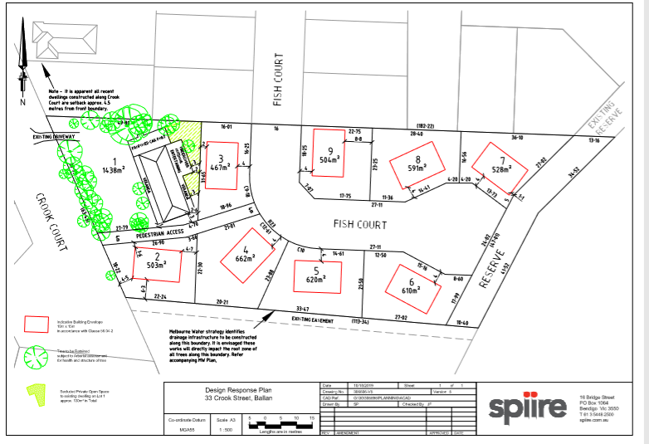
Figure 1: Plan of Subdivision

History
Council approved a two lot subdivision in 2015 to excise the existing dwelling and several outbuildings from the balance of the land, creating a 5865sqm lot at the rear with a 12m wide access to Crook Court. When 27 Crook Court was subdivided, Fish Court was designed to facilitate a potential connection to 33 Crook Court, which the current application utilises.

Public Notice
Notice of the application was given to adjoining and nearby landowners and occupiers by mail and two signs erected on site from 12-26 February 2020. One objection was received.

Summary of Objections
The objection received is detailed below with the officer’s accompanying comments:
Objection | Any Relevant Requirement
Safety impacts of multiple residents trying to exit properties in a fire event whose only vehicle egress point from Crook Court is to Old Melbourne Road. | Clause 56.
Officer’s Response:
Crook Court’s design is sufficient to cope with the traffic demands of existing residents and current proposed subdivisions.
The existing poor condition of the Crook Court carriageway would be exacerbated by increased traffic which creates a traffic hazard. | N/A.
Officer’s Response:
The need for repairs to existing roads are usually addressed through Council’s road maintenance program.
Should the development be approved, conditions relating to damages as a result of the development will be conditioned accordingly and may include reinstatement of the road.
Traffic impacts on noise levels and safety for children walking and riding bikes in the area. | Clause 65.
Officer’s Response:
The proposal would not be expected to impact on noise and safety to an unacceptable extent given the residential nature of the area. Council’s Infrastructure assessed the traffic implications and raised no concerns.
Any traffic safety issues raised at any point in the future due to changed circumstances will be reviewed.
A lack of suitable boundary fencing in a nearby recent subdivision results in rubbish being blown into waterways and our property. The proposal may result in a similar situation. | Clause 56.08-1.
Officer’s Response:
Recommended permit conditions would impose site management requirements to ensure litter traps are in place during the construction period.
The number of unsold recently created vacant lots nearby is due to the unappealing state of the Crook Court area, created by recent subdivisions. | Clauses 11.03-3S, 21.03-2, 21.03-3, 21.08, 32.08 & 56.
Officer’s Response:
Various factors contribute to property sales and the presence of nearby vacant lots. Ballan is an identified peri-urban growth town and accordingly residential growth is encouraged. The proposed subdivision is generally in accordance with relevant planning policy for the area – see ‘Discussion’ below.
The proposed subdivision will impact on traffic congestion in the area, considering that Crook Court is the only access point to the surrounding road network. | Clauses 56.06-4, 56.06-7 & 56.06-8.
Officer’s Response:
Council’s Infrastructure advised that according to Council’s GIS traffic count data collected in December 2017, the annual average daily traffic (AADT) on Crook Court was 227 vehicles per day. There have been small scale developments in the area since then generating additional traffic. The proposed development is likely to generate 80 additional vehicle trips per day. All vehicles generated from the development will be directed to Crook Court via the existing Fish Court and Creek Court. Crook Court is an Access 2 road and has the capacity to accommodate the additional traffic generated by the development.

Locality Map
The map below indicates the location of the subject site and the zoning of the surrounding area.
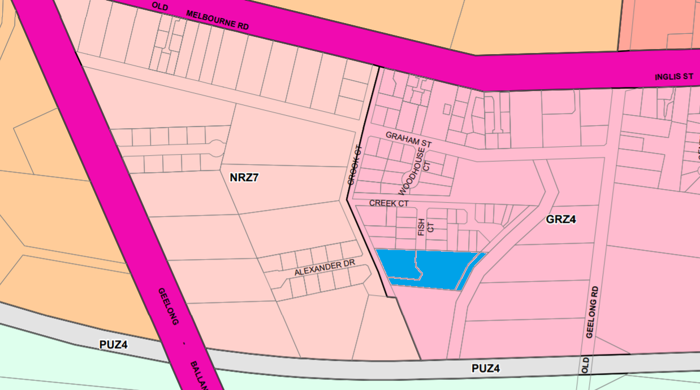
Figure 2: Zone Map
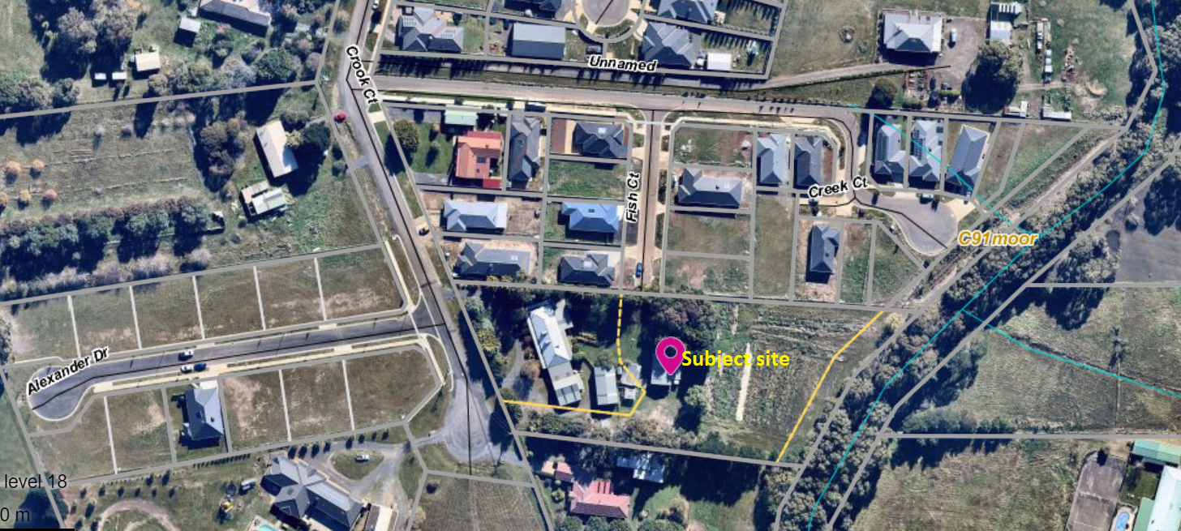
Figure 3: Aerial photograph

Planning Scheme Provisions
Council is required to consider the Victoria Planning Provisions and give particular attention to the Planning Policy Framework (PPF), the Local Planning Policy Framework (LPPF) and the Municipal Strategic Statement (MSS).
The relevant clauses are:
• Clause 11.03-3S Peri-urban areas
• Clause 14.02 Water
• Clause 15.01-3S Subdivision design
• Clause 15.01-5S Neighbourhood character
• Clause 16.01-2S Location of residential development
• Clause 21.02-3 Water and catchment management
• Clause 21.03-2 Urban Growth Management
• Clause 21.03-3 Residential Development
• Clause 21.03-4 Landscape and Neighbourhood Character
• Clause 21.08 Ballan
• Clause 22.02 Special Water Supply Catchments
The proposal generally complies with the relevant sections of the PPF and LPPF.

Zone
The subject site is in the General Residential Zone, Schedule 4 (GRZ4). The purpose of the Zone is:
• To implement the Municipal Planning Strategy and the Planning Policy Framework.
• To encourage development that respects the neighbourhood character of the area.
• To encourage a diversity of housing types and housing growth particularly in locations offering good access to services and transport.
• To allow educational, recreational, religious, community and a limited range of other non-residential uses to serve local community needs in appropriate locations.
Under Clause 32.08-3 a permit is required to subdivide land.
Schedule 4 specifies the following neighbourhood character objectives:
• To maintain a streetscape rhythm of detached dwellings with conventional front and side setbacks.
• To provide for built form that does not dominate the lot and allows for generous private open space and garden plantings, with minimal or low scale front fencing.
• To ensure that new development does not compromise the heritage values and character of precinct.
Subject to conditions, the proposal is generally consistent with the zone provisions.

Overlays
The site is affected by Environmental Significance Overlay, Schedule 1 (Proclaimed Water Catchment Areas).
Under Clause 42.01-2 a permit is required to subdivide land and remove vegetation. There are no relevant exemptions under Schedule 1. All proposed lots would be connected to reticulated sewer and permit conditions would require drainage to be designed to meet Council and Melbourne Water’s requirements. Subject to conditions, the proposal would not cause detriment to potable water quality or supply.
Relevant Policies
The Ballan Strategic Directions (June 2018) policy underpins Planning Scheme Amendment C88 which was recently approved by the Minister for Planning and gazetted on 6 March 2020. The proposal is generally consistent with Amendment C88 adopted by Council.

Particular Provisions
Clause 53.01 Public Open Space Contribution and Subdivision
A person who proposes to subdivide land must make a contribution to the council for public open space, being either a percentage of the land area or a percentage of the site value of such land, or a combination of both. It is understood that no previous contribution has been made for this land and therefore recommended that a condition of approval require a public open space contribution equivalent to 5% of the value of the land.
Clause 56 Residential Subdivision
Subject to conditions, the proposal complies with the relevant objectives and standards of Clause 56.

Discussion
Overall, the proposal is considered to be generally consistent with relevant State and Local planning policy, the General Residential Zone, Environmental Significance Overlay, Clause 56 and the decision guidelines at Clause 65 in the Moorabool Planning Scheme.
Relevant planning policy at the State and local level requires consideration of a range of policy directions which generally support the valued character of Melbourne’s peri-urban settlements whilst ensuring growth is consolidated in suitable locations to ensure no detrimental impacts to the environment or rural land uses. The Central Highlands Regional Growth Plan (Victorian Government 2014) and local policy at Clause 21.08 of the Moorabool Planning Scheme recognise Ballan’s role in supporting residential growth as the Shire’s second largest town. This must be achieved by directing growth to areas within the town with ready access to services and infrastructure, respect for neighbourhood character and integration with surrounding development.
The subject site and surrounding land to the north, east and south is in the General Residential Zone, Schedule 4 (GRZ4). Most existing development nearby reflects Ballan’s growth within the past 10 years, typified by the incremental subdivision of areas west and north-west of the town centre into smaller residential lots of generally 500-900sqm to accommodate single dwellings. The proposed subdivision layout and lot sizes generally reflect the emerging pattern of development in this area of Ballan, integrate with the surrounding street network and provide for increased population growth.
Subject to conditions, the proposal meets the relevant requirements of Clause 56 for residential subdivision. It is recommended that the neighbourhood character objectives of the GRZ4 be implemented by way of a restriction on the plan of subdivision to ensure future development respects the preferred neighbourhood character, as follows:
• Minimum front setback requirement of 4m.
• Minimum side setback requirement of 1m.
• No front fencing or otherwise fencing with a maximum height of 1.2m.
• Side fences within 4m of the front title boundary no higher than 1.2m.
The above recommendations take account of the indicative building envelopes shown on the proposed plan and the proposed lot dimensions, ensuring that future development would not be unreasonably constrained by the above requirements.
All proposed lots must be connected to sewer, and subject to conditions for stormwater drainage and sediment runoff there would be no detrimental impacts on the quality or supply of potable water within the catchment. The proposed removal of trees from Lots 2-9 is required to facilitate the subdivision, notably the removal of trees along the existing south title boundary to ensure space for a future easement as advised by the applicant. On balance, considering the purpose of the tree removal, zoning of the land and relevant planning policies in support of township growth, this is considered reasonable. Future development must meet the garden area requirements of Clause 32.08-4 and a condition of approval would require the planting and maintenance of street trees to Council satisfaction.
It is noted that Strategic Planning’s objection to the application has been addressed in part by the subsequent inclusion of a proposed 4.0m wide public pedestrian footpath between Crook Court and Fish Court to enhance the walkability of the neighbourhood and connections to local neighbourhood features, in particular the waterway to the east of the subject site. However, the proposed design did not resolve Strategic Planning’s concerns regarding lack of connection to the land further to the south or the limited street frontage to the waterway. It is noted that, subject to conditions, Council’s Infrastructure and Council’s Urban Design and Landscape have consented to the proposed footpath provision.

General Provisions
• Clause 65 – Decision Guidelines have been considered by officers in evaluating this application.
• Clause 66 – Stipulates all the relevant referral authorities to which the application must be referred.

Referrals
Authority | Response
Western Water  Southern Rural Water  Melbourne Water  Central Highlands Water  Powercor  Downer Utilities | Consent with conditions  Consent with conditions  Consent with conditions  Consent with conditions  Consent with conditions  Consent with conditions
Infrastructure  Strategic Planning | Consent with conditions  Refusal

Financial Implications
There are no financial implications for Council in approving the application.

Risk & Occupational Health & Safety Issues
The recommendation to approve this application does not have any risk or OH&S implications for Council.

Communications Strategy
Notice was undertaken for the application, in accordance with s.52 of the Planning and Environment Act 1987, and further correspondence is required to all interested parties to the application as a result of a decision in this matter. The objector and the applicant were invited to attend this meeting and invited to address Council if required.

Options
• Issue a Notice of Decision to Grant a Permit in accordance with the conditions in the recommendation of this report; or
• issue a Notice of Decision to Grant a Permit with amendments to the conditions in the recommendation of this report. Either of these options may result in the objector appealing Council’s decision to VCAT; or
• issue a Refusal to Grant a Permit on grounds. Council would need to consider what reasonable grounds there would be to refuse the application. This option may result in the applicant appealing Council’s decision to VCAT.

Conclusion
Overall, the proposal is consistent with relevant planning policy for Ballan in a manner which contributes positively to integrated growth, residential amenity and respect for neighbourhood character. The proposed lot design and layout integrates with the surrounding neighbourhood and, subject to conditions, meets the relevant requirements of Clause 56 for residential subdivision. It is recommended that the application be approved and a Notice of Decision to grant a permit be issued.

7.7 PA2020037 - Variation of Restrictive Covenants PS713320G and AL852514W to enable construction of an outbuilding with a maximum height of 7.344m at 17 Eden Crescent, Hopetoun Park
Author: Thomas Tonkin, Statutory Planner
Authoriser: Henry Bezuidenhout, Executive Manager Community Planning & Economic Development
Attachments: Nil

Application Summary
Permit No: PA2020037
Lodgement Date: 20 February 2020
Planning Officer: Tom Tonkin
Address of the land: 17 Eden Crescent, Hopetoun Park 3340
Proposal: Variation of Restrictive Covenants PS713320G & AL852514W to enable construction of an outbuilding with a maximum height of 7.344m.
Lot size: 8055sq m
Why is a permit required? Clause 52.02 Easements, Restrictions and Reserves – Variation of a Restriction.

Recommendation
That Council, having considered all matters as prescribed by the Planning and Environment Act 1987, issues a Notice of Decision to Grant Planning Permit PA2020037 for a Variation of Restrictive Covenants PS713320G & AL852514W to enable construction of an outbuilding with a maximum height of 6.5m at Lot 605 on PS 713320G known as 17 Eden Crescent, Hopetoun Park 3340, subject to the following conditions:
1. The plan of variation of the restriction must be certified under Section 6 of the Subdivision Act 1988 and then must be registered with the Registrar of Titles before a Building Permit is issued.
2. This permit will expire if the approved variation of the restrictions is not registered with the Land Titles Office within two years of the date of this permit. The wording has been approved as follows:
a) Item (c) on Covenant PS713320G has been approved as follows:
i. Build or allow to be built on the lot any dwelling, house or building with a ridge line or highest point which exceeds 6.5m above the finished surrounding ground level.
b) Item (d) on Covenant AL852514W has been approved as follows:
i. Construct or permit construction of a dwelling house or outbuilding which has a ridge line or highest point exceeding 6.5m above finished surrounding ground level.
Permit note:
The use of the outbuilding approved pursuant to this permit must only be for purposes ancillary to a dwelling or otherwise in accordance with the relevant provisions of the Moorabool Planning Scheme.

Public Consultation
Was the application advertised? | Yes.
Notices on site: | One.
Notice in Moorabool Newspaper: | Yes.
Number of objections: | One.
Consultation meeting: | No, the parties were consulted separately.

Policy Implications
The Council Plan 2017-2021 provides as follows:
Strategic Objective 2: Minimising Environmental Impact
Context 2A: Built Environment
The proposal does not conflict with the Council Plan 2017 – 2021.

Victorian Charter of Human Rights & Responsibilities Act 2006
In developing this report to Council, the officer considered whether the subject matter raised any human rights issues. In particular, whether the scope of any human right established by the Victorian Charter of Human Rights and Responsibilities is in any way limited, restricted or interfered with by the recommendations contained in the report. It is considered that the subject matter does not raise any human rights issues.

Officer’s Declaration of Conflict of Interests
Under section 80C of the Local Government Act 1989 (as amended), officers providing advice to Council must disclose any interests, including the type of interest.
Executive Manager – Henry Bezuidenhout
In providing this advice to Council as the Executive Manager, I have no interests to disclose in this report.
Author – Tom Tonkin
In providing this advice to Council as the Author, I have no interests to disclose in this report.

Executive Summary
Application referred? | No, not required.
Any issues raised in referral responses? | Not applicable.
Preliminary concerns? | Potential amenity impacts of shed given its bulk and height.
Any discussions with applicant regarding concerns? | Informally prior to advertising.
Any changes made to the application since being lodged? | No.
Brief history. | None applicable.
Previous applications for the site? | None.
General summary. | Subject to a condition which requires the maximum building height lowered from the proposed 7.344m to be 6.5m, it is recommended that the application for variation of covenant be approved. It is considered that this requirement would achieve compliance with the requirements of the Moorabool Planning Scheme, in particular the applicable covenant tests set out in Section 60(2) of the Planning and Environment Act 1987. The shed does not need a planning permit once the variation of covenant is approved.
Summary Recommendation
That, having considered all relevant matters as required by the Planning and Environment Act 1987, Council issue a Notice of Decision to Grant a Permit for this application for a variation of covenant in accordance with Section 61 of the Planning and Environment Act 1987, subject to the conditions included in this report.

Site Description
The subject site, identified as Lot 605 on PS 713320G and known as 17 Eden Crescent, Hopetoun Park, is located on the north side of Eden Crescent approximately 100m west of View Gully Road. The site is irregular in shape, with a 116.9m wide frontage, variable depth of 62.65-77m and overall site area of 8,055sqm. The site contains a recently constructed single storey dwelling positioned almost centrally on the site. Vehicle access is via two single crossovers located towards the side boundaries. The site has generally flat topography.
The site and surrounding land is in the Low Density Residential Zone (LDRZ1) and characterised by single dwelling development on lots of a similar size to the subject site. Outbuildings of varying sizes are a common feature of the area, including the immediate neighbourhood.

Proposal
It is proposed to vary Restrictive Covenants PS713320G and AL852514W to enable construction of a shed with a maximum height of 7.344m. Both covenants specify a maximum building height of 5.4m, unless with Council’s written consent, and that outbuildings be constructed to minimise visual impact from the street or public open space. The proposed shed would be sited 25m east of the dwelling, set back 20m from the front boundary behind the front wall of the dwelling, a minimum 5m from the east side boundary and 10m from the rear boundary. The proposed shed would be 600sqm in size with dimensions of 20m width x 30m length, wall height of 5.4m and overall ridge height of 7.344m. The shed would have two roller doors on the front façade and four roller doors on the west side for vehicle access and a pedestrian door on the west side.
The shed would be used for personal storage including a caravan, boats and cars. The applicant has advised that the roller door design of approximately 4.8m in height provides the desired high clearance for vehicles and the overall height provides space for a mezzanine level so that the occupants do not need to stoop when using it.

History
None applicable.

Public Notice
Notice of the application was given to the beneficiaries of the covenant and to adjoining nearby landowners and occupiers by mail and a sign erected on site from 31 May 2020 until 16 June 2020.
One objection was received. Following the Council planning officer’s consultation with the applicant and objector, the objector made a further submission.

Summary of Objections
The objection received is detailed below with officer’s accompanying comments:
Objection | Any Relevant Requirement
The VicRoads website states that the height limit for general access vehicles is 4.3m which includes semi-trailers and would include caravans. The covenant allows for outbuildings no higher than 5.4m which would be more than adequate for the storage of the applicant’s vehicles. | Clause 52.02.
Officer’s Response:
The applicant advises that they require the proposed shed height so that a mezzanine level may be installed in future to maximise storage capacity and enable occupants to not have to stoop to use the space.
As a beneficiary of the covenant, such a large proposed outbuilding would definitely create a loss arising from change to the character of the neighbourhood as a Low Density Residential Zone (LDRZ). | Clause 52.02 and s.60(2) of the Planning and Environment Act 1987.
Officer’s Response:
The objector’s property is not identified in the title documents as being a beneficiary of the covenants (unlike several other properties), but it is understood that Council must nevertheless consider the nature of the objections raised See ‘Discussion’ below.
The applicant has an excavating and earth moving business, and although I appreciate that future use of the outbuilding cannot be foreseen, I believe that the outbuilding will be used for the storage of vehicles related to the excavation business, which is not permitted under the LDRZ and the Victoria Planning Provisions (Clause 32.03-1, Section 3.) | Clauses 32.03-1 & 52.02.
Officer’s Response:
The applicant advises that the use of the shed would be for personal storage ancillary to the dwelling. If the shed is used for purposes other than personal storage which are Section 2 or 3 uses under the LDRZ then Council is able to take enforcement action.
It is requested that the proposed overall shed height be reduced from 7.344m to 6.5m. The shed would be positioned where we enjoy the sunrise from our living spaces, but its proposed height would create a significant obstruction/imposition on, and reduce the amenity of, the area. Reducing the shed height to 6.5 metres would allay this concern. | Clause 52.02 and s.60(2) of the Planning and Environment Act 1987.
Officer’s Response:
See ‘Discussion’ below.

Locality Map
The map below indicates the location of the subject site and the zoning of the surrounding area.
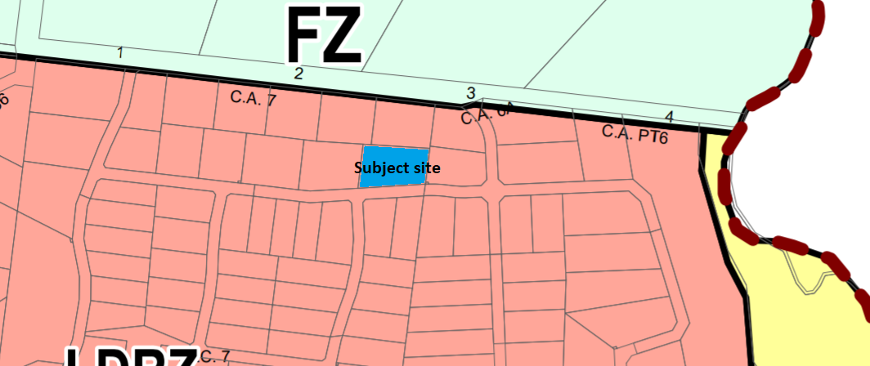
Figure 1: Zone Map

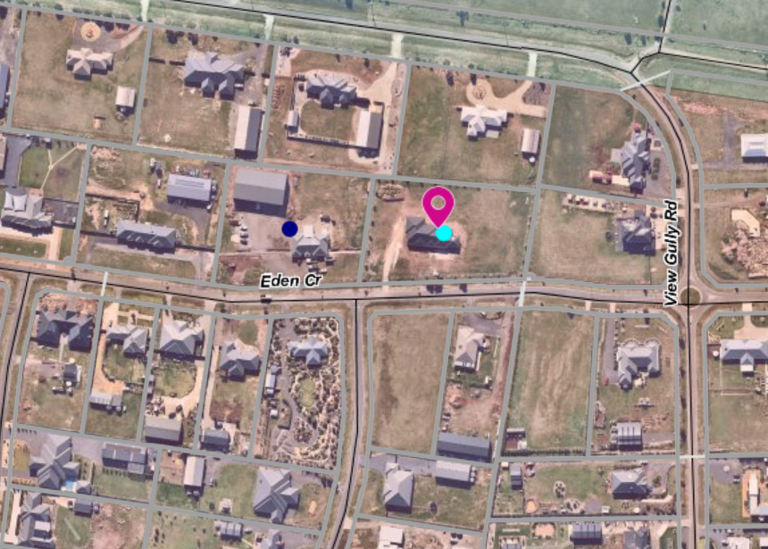
Figure 2: Aerial Photograph

Planning Scheme Provisions
Council is required to consider the Victoria Planning Provisions and give particular attention to the Planning Policy Framework (PPF), the Local Planning Policy Framework (LPPF) and the Municipal Strategic Statement (MSS).
The relevant clauses are:
• Clause 11.03-3S Peri-urban areas
• Clause 15.01-5S Neighbourhood character
• Clause 21.03-4 Landscape and Neighbourhood Character
Subject to conditions, the proposal is generally consistent with the relevant sections of the PPF and LPPF.

Zone
The subject site is in the Low Density Residential Zone (LDRZ). The purpose of the Zone is:
• To implement the Municipal Planning Strategy and the Planning Policy Framework.
• To provide for low-density residential development on lots which, in the absence of reticulated sewerage, can treat and retain all wastewater.
There is no permit requirement under the zone provisions for a variation of covenant.

Overlays
The site is affected by Development Plan Overlay, Schedule 2 (Hopetoun Park Estate) (DPO2).
There is no permit requirement under the overlay provisions for a variation of covenant.

Relevant Policies
There are no Council policies applicable to the assessment of this application.

Particular Provisions
Clause 52.02 Easements, Restrictions and Reserves
A permit is required before a person proceeds under Section 23 of the Subdivision Act 1988 to vary or remove a restriction.

Discussion
The relevant consideration for assessment of this application are the provisions of Section 60(2) of the Planning and Environment Act 1987 Under Section 60(2) of that Act, the Responsible Authority must not grant a permit which allows the variation of a restriction (within the meaning of the Subdivision Act 1988) unless it is satisfied that the owner of any land benefited by the restriction will be unlikely to suffer the following as a consequence of the variation of the restriction:
a) financial loss
VCAT have consistently stated that the impact of financial loss cannot be easily determined and would require expert evidence. The objector has not provided any information which convinces Council that this is the case.
b) loss of amenity
The covenant currently allows for the development of buildings with a maximum height of 5.4m. The proponent seeks approval to vary the covenant to allow an additional 1.944m height. The site is zoned for residential use, which allows for outbuildings ancillary to dwellings, and development in the area generally reflects this, evidenced by a variety of shed sizes, although the majority are smaller than that proposed. It is important to note that the covenants do not restrict the floor area of a building, only height.
The objector has raised concerns about a loss of amenity based on the proposed shed height, but it is noted that no direct beneficiaries of the covenant objected to the application. Notwithstanding this, the height of the shed contributes to its relatively large mass in the residential context of generously spaced, mostly single storey dwellings with low pitched hipped roofs on either flat or gently sloping land. It is acknowledged that there are nearby outbuildings of a similar height, notably at 15 Eden Crescent, but they are atypical of the area and it is considered that approval of the proposed shed height does present a likely loss of amenity to some extent, such as enjoyment of views or general outlook, considering the low-density residential setting. However, the objector’s advice that a 6.5m maximum building height would address their concerns is considered a reasonable compromise.
c) loss arising from change to the character of the neighbourhood
The character of the neighbourhood is defined by single dwellings on lots of roughly 5,500sqm to 8,500sqm in size. Dwellings are predominantly single storey with ancillary outbuildings of varying sizes. The area is characterised by its lot sizes and configuration, general low-rise scale of development and views of the distant landscape in some areas. Large bulky sheds are occasionally present but visually prominent, also contributing to the character of the area, although as previously noted are usually lower in height than the current proposal. The subject site and surrounding lots to the north and west, but not including the objector’s property, are affected by a covenant which allows for development of buildings up to 5.4m in height. It is reasonable to conclude that the covenant envisages single storey dwellings on these lots with sheds of a similar or smaller scale, particularly relating to height.
The applicant wishes to construct to 7.344m height to facilitate a preferred design. As discussed above, buildings in the area are predominantly single storey and a maximum of 5.4m high, noting that Council has approved variations to this to enable dwellings in this subdivision with a slightly higher roof pitch. Council must satisfy itself that the covenant’s beneficiaries will be unlikely to suffer loss arising from change to the character of the neighbourhood if the maximum allowable height is increased from 5.4m to 7.344m. It is not considered that the development of a 7.344m high outbuilding would be in keeping with the neighbourhood character, as described above. The objector has expressed concerns that the character of the area would change as a result of the proposed variation of the covenant. Notwithstanding that the objector is not identified on the applicable covenants as a beneficiary, based on observations of the site and surrounding area, it is difficult to argue that a beneficiary of the covenant would not be unlikely to suffer loss arising from change to the character of the neighbourhood. The objector’s advice that a 6.5m maximum building height would address their concerns is considered a reasonable compromise, noting that the height reduction would be more consistent with outbuildings in the area, which as previously stated are typically lower in height than proposed. It is considered that this height reduction from the proposed 7.344m to 6.5m would also improve the streetscape presentation and ensure consistency with the covenant provisions for limited impact on the streetscape.
d) any other material detriment
The objector raised concerns about the potential use of the shed for purposes other than ancillary to a dwelling, which may be prohibited or require specific permission under the Moorabool Planning Scheme. It is considered reasonable to accept the applicant’s declared use of the shed, noting that Council is able to enforce any breach of the Moorabool Planning Scheme in the event that this were to occur in future. The objector did not identify any other material detriment and based on site observations it is not considered that the proposal would cause any other material detriment.

General Provisions
Clause 65 – Decision Guidelines have been considered by officers in evaluating this application.
Pursuant to Clause 65 of the Moorabool Planning Scheme, the Responsible Authority must consider, among other things, the matters set out in Section 60 of the Planning and Environment Act 1987, as per the ‘Discussion’ above.
Clause 66 – Stipulates all the relevant referral authorities to which the application must be referred.

Referrals
Authority | Response
None applicable | None applicable

Financial Implications
There are no financial implications for Council in approving the application for a variation of covenant.

Risk & Occupational Health & Safety Issues
The recommendation to approve this application for a variation of covenant does not have any risk or OH&S implications for Council.

Communications Strategy
Notice was undertaken for the application, in accordance with s.52 of the Planning and Environment Act 1987, and further correspondence is required to all interested parties to the application as a result of a decision in this matter. The objector and applicant were invited to attend this meeting and address Council if required.

Options
Issue a Notice of Decision to Grant a Permit in accordance with the conditions in the recommendation of this report; or
Issue a Notice of Decision to Grant a Permit with amendments to the conditions in the recommendation of this report.
Either of these options may result in the objector appealing Council’s decision to VCAT; or
Issue a Refusal to Grant a Permit on grounds. Council would need to consider what reasonable grounds there would be to refuse the application. This option may result in the applicant appealing Council’s decision to VCAT.

Conclusion
Overall, the proposal is only considered to be acceptable subject to the condition that the proposed building height be reduced from the proposed 7.44m to a maximum of 6.5m to respect the character of the area. Based upon this requirement, it is deemed that the proposal would satisfy the relevant requirements of the Moorabool Planning Scheme, in particular the decision guidelines at Clause 65 which require consideration of section 60(2) of the Planning and Environment Act 1987. No beneficiaries objected to the application and the concerns expressed by non-beneficiary to the covenant were considered in the assessment. The variation of covenant is recommended for approval. This would then allow the applicant to apply for building permit and not contravene a restrictive covenant on title.

7.8 PA2018277 - 4 Lot Subdivision at 80 Steiglitz Street (previously 151 Inglis Street), Ballan
Author: Victoria Mack, Statutory Planner
Authoriser: Henry Bezuidenhout, Executive Manager Community Planning & Economic Development
Attachments: 1. Plan of existing conditions (under separate cover)
2. Proposed Plan of Subdivision (under separate cover)

Application Summary
Permit No: PA2018277
Lodgement Date: 19 October 2018
Planning Officer: Victoria Mack
Address of the land: 80 Steiglitz Street, Ballan
Proposal: Four (4) lot subdivision
Lot size: 2571sqm
Why is a permit required? Commercial 1 Zone – Subdivision of land
Environmental Significance Overlay, Schedule 1- Subdivision of land

Recommendation
That Council, having considered all matters as prescribed by the Planning and Environment Act 1987, issues a Refusal to Grant a Planning Permit for a 4-lot subdivision at 80 Steiglitz Street, Ballan otherwise known as Lot 2 on PS735543L on the following grounds:
1. The land is located within the Ballan town centre in the Commercial 1 Zone which is an unsuitable location for a small lot vacant land subdivision and is unsuitable for the applicant’s intention for future dwellings.
2. No commercial development response was submitted with the application.
3. The application fails to address the purpose of the Commercial 1 Zone to create vibrant mixed-use commercial centres for retail, office, business, entertainment and community uses.
4. The application fails to demonstrate how subdivision is complementary to the role and scale of the commercial centre.
5. The application does not accord with strategic planning policies for the Ballan town centre to promote commercial activity.
6. The subdivision does not represent the orderly planning of the area.

Public Consultation
Was the application advertised? | Yes.
Notices on site: | Yes.
Notice in Moorabool Newspaper: | No.
Number of objections: | Nil.
Consultation meeting: | Not required as there are no objectors.

Policy Implications
The Council Plan 2017-2021 provides as follows:
Strategic Objective 3: Stimulating Economic Development
Context 3A: Land Use Planning
The proposal is not provided for in the Council Plan 2017-2021 and can be actioned by utilising existing resources.

Victorian Charter of Human Rights & Responsibilities Act 2006
In developing this report to Council, the officer considered whether the subject matter raised any human rights issues. In particular, whether the scope of any human right established by the Victorian Charter of Human Rights and Responsibilities is in any way limited, restricted or interfered with by the recommendations contained in the report. It is considered that the subject matter does not raise any human rights issues.

Officer’s Declaration of Conflict of Interests
Under section 80C of the Local Government Act 1989 (as amended), officers providing advice to Council must disclose any interests, including the type of interest.
Executive Manager – Henry Bezuidenhout
In providing this advice to Council as the Executive Manager, I have no interests to disclose in this report.
Author – Victoria Mack
In providing this advice to Council as the Author, I have no interests to disclose in this report.

Executive Summary
Application referred? | Yes, Central Highlands Water, Downer, Melbourne Water, Powercor, Southern Rural Water, and Council’s Economic Development, Infrastructure, and Strategic Planning and Development.
 | Strategic Planning and Development raised concerns about the suitability of a residential style subdivision in the centre of the Ballan township in the commercial precinct. The vacant site in the Commercial 1 Zone is required for commercial expansion as the town grows and therefore unsuitable for the use of dwellings.
Preliminary concerns? | The Commercial 1 Zoning of the land and the location of the proposed subdivision in the commercial centre of the Ballan township.
Any discussions with applicant regarding concerns? | Yes, discussions were held with the applicant about finding commercial or business investors to develop the land for commercial uses. Informal discussions with the Council officers about the opportunity for Council to acquire the site, due to its close proximity to other Municipal and community buildings and the town centre. This was not progressed.
Any changes made to the application since being lodged? | No.
Brief history. | The subject site was subdivided from the Commercial Hotel to the north by PA2016194 which approved a 2 lot subdivision on 12 September 2017.  The Commercial Hotel site including the rear carpark became Lot 1 with an area of 1,387sqm. The subject site became Lot 2 which was vacant land with an area of 2571sqm. Statement of Compliance for the 2 lot subdivision was issued on 24 June 2019.
Previous applications for the site? | PA2016194 – 2 lot subdivision.  PA2010055 - Development of Additions Ancillary to an Existing Hotel and Waiver of Car Parking.  PA2004348 - Buildings and Works Associated with Alterations and Additions to an Existing Building (New Amenity Facilities).
General summary. | The application is a standard 4 Lot subdivision of land with the layout design to facilitate residential development.  However, this site is in the Commercial 1 Zone and within approximately 140m of the centre of the Ballan township. A residential style subdivision in this location is an inappropriate use of the land and if approved would very likely see the lots used for dwellings.  The proposal is not in accordance with the strategic planning of the area to provide land for future commercial growth identified for Ballan. The land is prime commercial land abutting a host of community and service facilities and the Ballan supermarket.  The proposal was not supported by Council’s Strategic Planning and Development for reasons detailed further in this report.  Allowing this subdivision would see commercial land lost for Ballan’s economic and commercial expansion as the town grows.
Summary Recommendation
That, having considered all relevant matters as required by the Planning and Environment Act 1987, Council issues a Refusal to grant a planning permit for a 4-lot subdivision at 80 Steiglitz Street, Ballan otherwise known as Lot 2 on PS735543L.

Site Description
The site is 2,571sqm and is in the Commercial 1 Zone. It is rectangular in shape and flat. Access to the land is from Steiglitz Street. The Commercial Hotel which faces Inglis Street is located on the north side boundary. Between the Commercial Hotel and the north boundary of the subject site is the Hotel car parking area.
Land on the east side boundary contains community buildings including Ballan and District Community House, Mechanics Institute Hall and Ballan Library, Ballan Neighbourhood House and Men’s Shed, the Senior Citizens Centre, the Country Fire Authority Depot and car parking areas to service these facilities. Further to the east is the Ballan Supermarket.
To the west of the site are two dwellings also in the Commercial 1 Zone. To the north-west of the site is the rear yard of the former Commercial Bank which has a Heritage Overlay HO23 and is now used as a dwelling.
South of the site across Steiglitz Street are single dwellings in lots with areas ranging from 700-800sqm in the General Residential Zone, Schedule 4. To the south-east is a completed medium density 6 dwelling development.
Below is an aerial photo of the site:
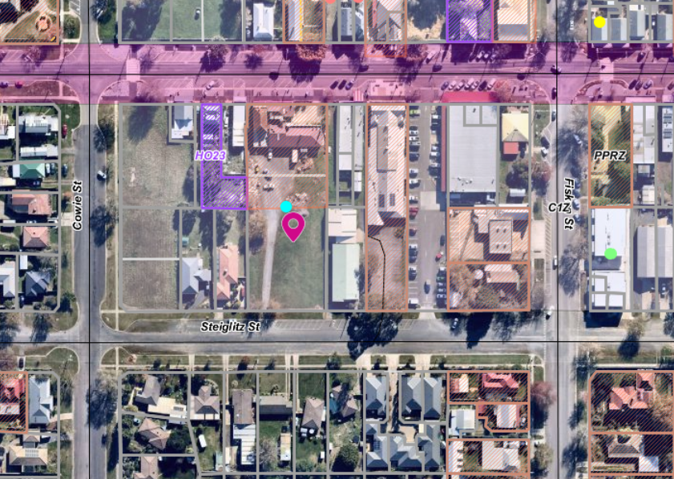
Figure 1: Aerial photograph.

Proposal
The proposal is for a 4 Lot subdivision of the land which has a total area of 2,571sqm. The land is rectangular in shape with a frontage width of 38.7m. Two lots would have direct access from Steiglitz Street. Two rear lots would be located behind the front lots. The rear lots would have access to Steiglitz Street via a 6m wide common property driveway up the centre of the site with a length of approximately 43m and a small court bowl at the end.
The lots would have the following details:
- Lot 1 would be 525sqm in area located in the rear north-west corner. It would have width of 19.66 m and length of 28.03m.
- Lot 2 would be 528sqm in area located in the rear north-east corner. It would have width of 19.64 m and length of 28.92m.
- Lot 3 would be 607sqm in area located in the front south-east corner. It would have width of 16.35m and length of 37m.
- Lot 4 would be 605sqm in area located in the front south-west corner. It would have width of 16.35 m and length of 37.07m.
Below is the proposed plan of subdivision:
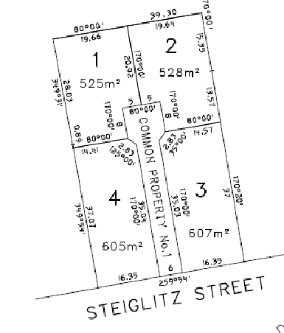
Figure 2: Plan of Subdivision

Background to Current Proposal
The issue with this application is that the land is in the Commercial 1 Zone (C1Z). It is located behind the Commercial Hotel and very close to the commercial centre of the Ballan township. This site is best suited for commercial opportunities rather than residential ones. If approved, it is very likely that residences would be constructed on the lots.
It is noted that dwellings would require planning approval in the C1Z which would afford Council an opportunity to determine what is constructed. The lots are configured as typical residential lots and it is unlikely to attract interest from commercial users who need to develop the site in a manner that could also accommodate on-site car parking for the commercial use.

History
The site was originally 3,958sqm. It was subdivided into two lots in 2017 consisting of Lot 1 containing the Commercial Hotel and rear car parking area with an area of 1,387sqm and Lot 2, the subject site, which is vacant land with an area of 2,571sqm.
The whole of Lot 1 and part of Lot 2 is now covered by the interim West Moorabool Heritage Overlay (WMHO) in accordance with Planning Scheme Amendment C85. The interim overlay covers part of the subject site, Lot 2, for a distance of approximately 16m inside the north side boundary.
The Commercial Hotel has been operating from this site since at least 1871.

Public Notice
Advertising was required and was undertaken for this application in accordance with Section 52 of the Planning and Environment Act 1987.
No objections were received as a result of the advertising process.

Locality Map
The map below indicates the location of the subject site and the zoning of the surrounding area.

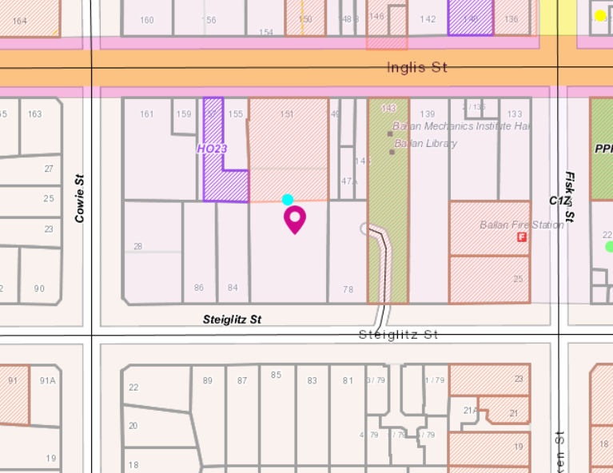
Figure 3: Zone Map

Planning Scheme Provisions
Council is required to consider the Victoria Planning Provisions and give particular attention to the Planning Policy Framework (PPF), the Local Planning Policy Framework (LPPF) and the Municipal Strategic Statement (MSS).
The relevant clauses are:
• Clause 11.02-1S Supply of Urban Land
• Clause 11.03-3S Peri-Urban areas
• Clause 14.02-1S Catchment Planning and Management
• Clause 17.02-1S Business
• Clause 21.03-2 Urban Growth Management
• Clause 21.03-3 Residential Development
• Clause 21.04-3 Commercial
• Clause 21.08-8 06 Objective - Town Centre Ballan
• Clause 22.02 Special Water Supply Catchments
The proposal complies with the relevant sections of the PPF and LPPF, except for the clauses outlined in the table below:
PPF | Title | Response
Clause 11.02-1S | Supply of Urban Land | The objective of this clause is to ensure sufficient supply of urban land for residential, commercial, retail, industrial, recreational, institutional and other community uses.  The proposal has the potential to create lots which will not be conducive for use as commercial or retail premises.
Clause 17.02-1S | Business | The objective of this clause is to encourage development that meets the community’s needs for retail, entertainment, office and other commercial services.  The proposed subdivision would not contribute to Ballan’s future commercial development.
LPPF | Title | Response
Clause 21.04-3 | Commercial | The objective of this clause includes to reinforce the role of Ballan as a regional centre for employment, shopping, tourism, industry, business, and cultural services.  The proposed subdivision denies Ballan of future commercial growth and economic development opportunities within the town centre. The site should be retained for commercial purposes, not residential use.
Clause 21.08-1 | Ballan | The relevant section of this clause states:  The town centre will retain its existing compact form and core, and new commercial use and development will be encouraged to locate within the town centre. New commercial use and development should be compatible with existing amenity and streetscape. Development of increased local level convenience retail facilities will be supported in the town centre. Use of existing shops in the town centre will be encouraged prior to construction of new buildings on the fringe of the town centre. Additionally, the built form of the town centre is highly important, and it is necessary to ensure that future development responds meaningfully to the strong historic elements.  It is considered that this application does not support future opportunities for the commercial development of the Ballan town centre.
Clause21.08-8 | Objective - Town Centre | The objective of this clause is to retain the town centre core as the main commercial and retail precinct with supporting non-residential uses. Strategies include to:  • Encourage commercial development to be consolidated within the existing town centre through infill development, the redevelopment of underutilised sites and where possible, the retrofitting of existing buildings to provide for commercial or office uses.  • Ensure new development complements the character of the town core.  • The proposed subdivision does not accord with the objective or intent of this policy. The subdivision has been designed for dwellings which in this location would deny Ballan future strategic commercial and business growth opportunities.

Zone
Commercial 1 Zone
In accordance with Clause 34.01-3 a permit is required to subdivide land.
The purpose of the Commercial 1 Zone is to:
• Implement the Municipal Planning Strategy and the Planning Policy Framework.
• Create vibrant mixed-use commercial centres for retail, office, business, entertainment and community uses.
• Provide for residential uses at densities complementary to the role and scale of the commercial centre.
The decision guidelines of the Commercial 1 Zone in relation to subdivision require the Responsible Authority to consider:
• Provision for vehicles providing for supplies, waste removal and emergency services and public transport.
• The effect the subdivision will have on the potential of the area to accommodate the uses which will maintain or enhance its competitive strengths.

Overlays

Environmental Significance Overlay, Schedule 1
In accordance with Clause 42.01-2 a permit is required to subdivide land.

Relevant Policies

Planning Scheme Amendment C88 – Ballan Strategic Directions

The Amendment was based on implementation of the Strategy called ‘Ballan Strategic Directions’ (adopted by Council in November 2017, and updated June 2018).
In Ballan Strategic Directions at 4.6.2 Non-Residential Uses & Local Employment it states that:
Ballan will continue to have a centralised commercial/retail Precinct and it is important that this approach is retained to ensure the long-term jeopardy of the town centre core including creating and enhancing the town centre as the ‘heart’ to the town. To ensure the town centre core remains attractive, convenient and economically viable it is important that uses that complement and enhance the town centre are encouraged.
The following objective and strategies within the Ballan Strategic Directions are considered relevant to this proposal:
Objectives
To retain the town centre core as the main commercial and retail Precinct with supporting non-residential uses.
Strategies
Encourage commercial development to be consolidated within the existing town centre of Ballan through infill development. This extends also to community and social facilities.
• Promote the redevelopment of underutilised sites and where possible, the retrofitting of existing buildings to provide for commercial or office uses.
The Ballan Strategic Directions lists several actions. Under heading of “Community Facilities & Services Action Implementation”, are two actions that may be affected by the permit application.
Actions
A2 - Develop a strategic improvement program for community facilities in line with the Moorabool Community Infrastructure Framework, including consideration of a new contemporary multipurpose community facility and any site allocation this would require.

A4 - Review opportunities to improve the Mechanics Institute Hall, Ballan Neighbourhood House and Men’s Shed, the Senior Citizens Centre, CFA and car parks between Inglis Street and Steiglitz Street to function as a community hub.
Amendment C88 sought to:
• Provide greater certainty over the level of housing change envisaged across Ballan and ensuring new development is directed to appropriate locations capable of accommodating change.
• Ensure that new development is consistent with the preferred neighbourhood character objectives for each precinct within Ballan.
• Recognise the objectives of the Ballan Strategic Directions related to character and sense of place, environment, growth and infill development, the town centre and non-residential uses outside of the town centre.
C88 was gazetted into the Moorabool Planning Scheme on 6 March 2020.

Council’s Strategic and Sustainable Development Department noted:

The Strategic Directions aims to create a busy and vibrant retail centre for Ballan, with community and commercial spaces clustered within the town centre functioning as an activity hub. Residential usage of this site would further fragment the town centre as well as inhibit growth of the commercial and community usages.
The Moorabool Shire Council Retail Strategy 2041 in relation to Ballan noted that:
By 2041, once the population of the region reaches 11,500 residents, a total of around 13,000 – 14,000sqm of retail floorspace is considered supportable in the Ballan (Central) region. There is around 12,000sqm of vacant land within the Ballan Town Centre, which could potentially accommodate around 8,000 – 9,000sqm of retail floorspace. This amount of floorspace would sustain the indicative floorspace demand in the Ballan Town Centre up to around 2041.
Action 8 of Retail Strategy is to enable Ballan Town Centre to grow by being proactive about identifying available development sites in the town centre.
The proposed residential subdivision would result in a loss of 2,571sqm of vacant commercially zoned land, which, if used for residential purposes, would result in a loss of potential retail floorspace, impacting significantly on the ability of the Ballan township to provide for the retail floorspace required to support the population at 2041.
Council’s Strategic Planning and Development riased a number of grounds for not supporting the application including
• The proposed residential subdivision is not considered complimentary to the role and scale of the commercial centre.
• The proposed residential subdivision will not maintain or enhance the competitive strengths of the town centre.
• Adjacent local and state government owned sites are key community infrastructure locations. The applicant’s intended residential usage will limit the potential of these sitees to cater for Ballan’s increasing population.
• The land parcel comprises a significant proportion of the available undeveloped land within the Ballan town centre and will be required to meet the retail floorspace needs of Ballan as identified in the Moorabool Retail Strategy.

Particular Provisions
Clause 53.01 Public Open Space Contribution and Subdivision
A person who proposes to subdivide land must make a contribution to the council for public open space in an amount specified in the schedule to this clause (being a percentage of the land intended to be used for residential, industrial or commercial purposes, or a percentage of the site value of such land, or a combination of both). If no amount is specified, a contribution for public open space may still be required under section 18 of the Subdivision Act 1988.
No exemptions apply to this subdivision as detailed in Clause 53.01-1 or Clause 53.01-2 of the Moorabool Planning Scheme. A Public Open Space contribution is required for this subdivision if approved.

Discussion
Council expressed concerns with the subdivision layout in the earlier stages of the subdivision. Council’s Strategic Planning objected to the application, specifically, if the land was subdivided and sold for dwellings, this would be a lost opportunity for Ballan’s future commercial and services growth in the town centre.
The subdivision is residential in design, located in the Commercial 1 Zone and is considered to be inappropriate being within the core of the Ballan town centre.
The purpose of the Commercial 1 Zone is to create vibrant mixed-use commercial centres for retail, office, business, entertainment and community uses; and to provide for residential uses at densities complementary to the role and scale of the commercial centre.
The subdivision is not complimentary to the role and scale of the commercial centre. It would not compliment the development of a vibrant mixed-use commercial centre of Ballan. The proposal would result in a loss of floor space for retail activity and be inconsistent Council’s retail strategy.
It is clear from Planning Scheme amendment C88 that the core town centre was to be retained for current and future commercial uses and expansion as Ballan grows.
This subdivision contravenes Ballan’s strategic objectives and runs counter to Ballan’s future commercial growth opportunities.

General Provisions
Clause 65.02 Approval of an application to subdivide land
Before deciding on an application to subdivide land, the responsible authority must also consider, as appropriate:
• The suitability of the land for subdivision.
• The existing use and possible future development of the land and nearby land.
• The availability of subdivided land in the locality, and the need for the creation of further lots.
It is considered that this proposal does not align with these three considerations as detailed in Clause 65.02.
Clause 66
Stipulates all the relevant referral authorities to which the application must be referred.

Referrals
Authority | Response
Central Highlands Water  Southern Rural Water  Melbourne Water  Powercor  Downer (gas)  Dept of Transport | Consent with conditions  Consent with conditions  Consent  Consent with conditions  Consent with conditions  Consent

Infrastructure  Economic Development  Strategic and Sustainable Development | Consent with conditions  Consent  Objection to the proposal

Financial Implications
There is no financial implication associated with this refusal to grant a permit for this subdivision

Risk & Occupational Health & Safety Issues
The recommendation of refusal of the planning application does present any OH&S issues to Council.

Communications Strategy
Notice was undertaken for the application, in accordance with s.52 of the Planning and Environment Act 1987, and further correspondence is required to all interested parties to the application as a result of a decision in this matter. All submitters and the applicant were invited to attend this meeting and invited to address Council if required.

Options
Council could consider the following options:
• issue a refusal to grant a permit in accordance with the recommendations of this report; or
• issue a permit with conditions outside of the recommendations of this report.

Conclusion
No commercial development response was submitted with the application. The 4 Lot subdivision layout is residential in layout and design. It is very likely that the lots would be sold for future dwellings. It is noted that a permit would be required for a dwelling on each lot.
The subdivision has not been arranged to allow for a commercial use and associated on site car parking.
With the site very close to the Ballan town centre, the development of dwellings on this site would deny the Ballan township commercial expansion opportunities in contravention of the objectives of the Commercial 1 Zone.
It is recommended that the application be refused with specified grounds.

8 Update on Trends, Issues and Other Matters

9 Process Forward and Work Program

10 Update on VCAT Decisions

11 Other Business

12 Date of Next Meeting

13 Meeting Close

